Create a custom docker image for nginx and deploy it using docker-compose, where the volume mount should be at /var/opt/nginx location. Push the created custom docker image to your docker hub.

Github link for Nginx Application using docker-compose

Build docker image using docker-compose

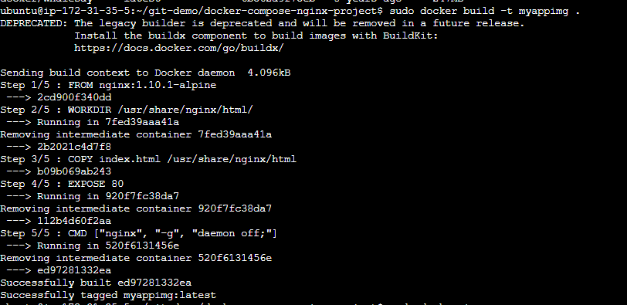

Image Created



Run Docker-Compose

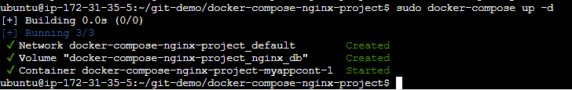

Volume that is attached

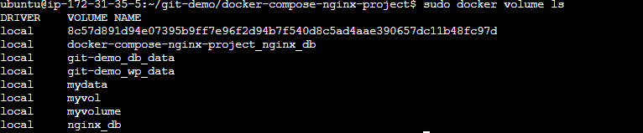

Volume path

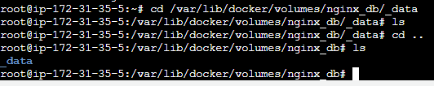

Output on Browser

