**Install docker on EC2 and explore the docker commands (docker images, containers)**

Step1: Install docker on ec2 instance

Commands:

sudo apt update

sudo apt install docker.io

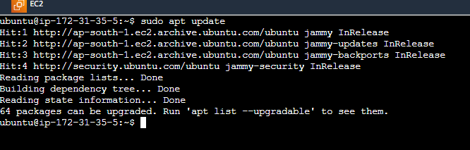

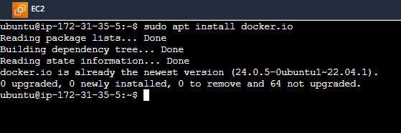

Step2: Build docker image

Commands: sudo docker build -t mytaskimage .

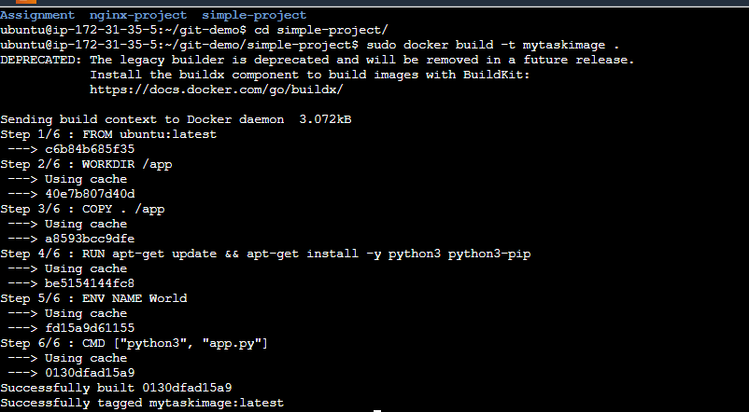

Step3: View images

Commands:

sudo docker images



Step4: Run container using image

Commands:

sudo docker run -d –name mytaskcontainer -p 8000:8000 mytaskimage

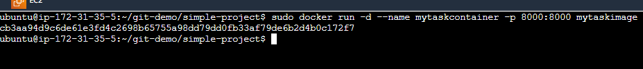

Step5: View running containers

Commands:

Docker ps



Step6: View all containers

Commands:

Docker ps -a



Output:

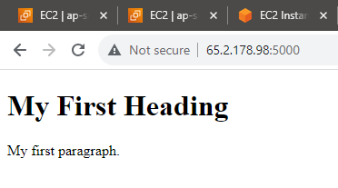

Commands:

docker rm mytaskcontainer

