Launch a t2.micro instance in Mumbai region where ssh can be done only from your IP address with docker and docker-compose installed in it.

1. Create IAM account
2. Set user,roles,policies
3. Create a ec2 instance
4. Ssh to that instance
5. Install aws cli
6. Create keypair using below commands



1. Create security group settings

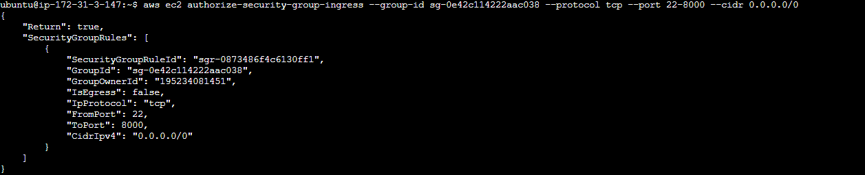

1. Create user-data shell script and run the command to create the instance with image id for ubuntu, instance type, key pair, security group, user-data shell script and numb of ec2 instance count

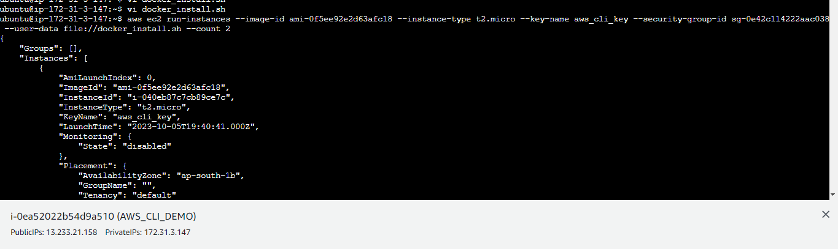

9.output of new 2 ec2 instance

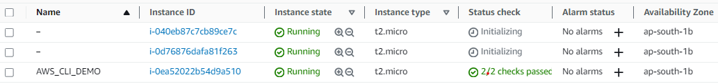

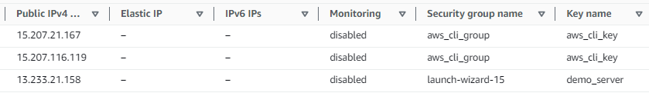

10. Docker and docker-compose installed and their versions output

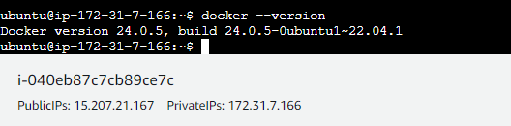

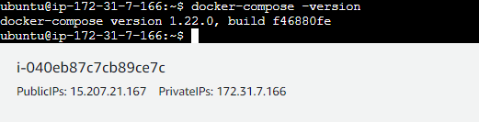

Userdata shell script file to install docker and docker compose

