KARNATAK LAW SOCIETY’S

GOGTE INSTITUTE OF TECHNOLOGY

UDYAMBAG, BELAGAVI-590008

(An Autonomous Institution under Visvesvaraya Technological University, Belagavi)

**(APPROVED BY AICTE, NEW DELHI)**

Department of Electronics and Communication Engineering



*Course Activity Report on*

**Movie ticket booking system**

**in**

***C/C++***

***Submitted by***

Shrihari.D(2GI17EC124)

Shrilakshmi Desai(2GI17EC131)

Sinchana Shetty(2GI17EC138)

Vinit Sanakal(2GI17EC158)

**Guide**

Prof. Uttam Despande

(Assistant Professor)

**2019-2020**

**OBJECTIVE:**

Implementation of movie ticket booking in C using structures, functions and looping constructs, with the following functionalities

* Booking a seat
* Cancelling a seat
* Exit

**CODE:**

#include<stdio.h>

struct info{ //structure initialisation

char name[100];

int age;

long long int pno;

};

int sno,ind=0,p=0,z=0;

int sar[10];

struct info s;

void data(int h)

{

sar[p]=h;

p++;

}

void seats() //To display availability of seats

{

int i,j,count=1;

for(i=0;i<10;i++)

{

printf("\t");

for(j=0;j<10;j++)

{

printf("%d\t",count);

count++;

}

printf("\n");

z++;

}

}

void showinfo() //Function to display details

{

printf("||||||||||||||||||||||||||||||||||||||||\n");

printf("\tName : %s\n",s.name);

printf("\tAge : %d\n",s.age);

printf("\tPhone number : %lld\n",s.pno);

printf("\tYour seat number is : %d\n",sno);

printf("||||||||||||||||||||||||||||||||||||||||\n");

}

void getinfo() //function to input data

{

printf("Enter your name : ");

getchar();

gets(s.name);

printf("Enter your age : ");

scanf("%d",&s.age);

printf("Enter your phone number : ");

scanf("%lld",&s.pno);

showinfo();

}

int main() //Main function

{

int l,choice,m;

char a;

printf("\t\t*****NARTAKI THEATRE*****\n");

rip :

printf("\tWelcome to Nartaki theatre\nWelcome to ticket booking system\n");

printf("\t1. Book a ticket\n\t2. Cancel a ticket\n\t3. Exit\n");

printf("Enter the choice : \n");

scanf("%d",&choice);

switch(choice)

{

case 1 :

printf("*****TICKET BOOKING*****\n");

seats();

pass :

printf("Enter the seat number you want to book\n");

scanf("%d",&sno);

for(m=0;m<ind;m++)

{

if(sar[m]==sno)

{

printf("Seat already booked\n\n");

goto rip;

}

}

ind++;

data(sno);

getinfo();

break;

case 2 :

printf("Enter your seat no. : ");

scanf("%d",&sno);

for(l=0;l<ind;l++)

{

if(sar[l]==sno)

{

printf("*********The seat has been canceled**********\n");

sar[l]=0;

}

else

{

printf(“This seat is not booked”);

}

}

break;

case 3 :

exit(0);

}

goto rip;

}

**OUTPUT:**

**Case 1:**

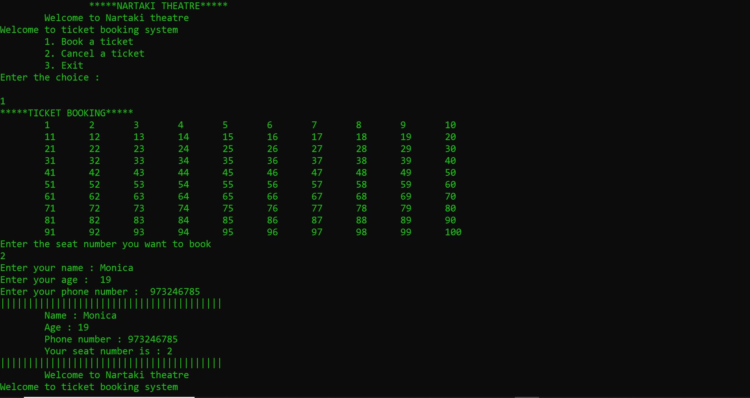

**Case 2:**

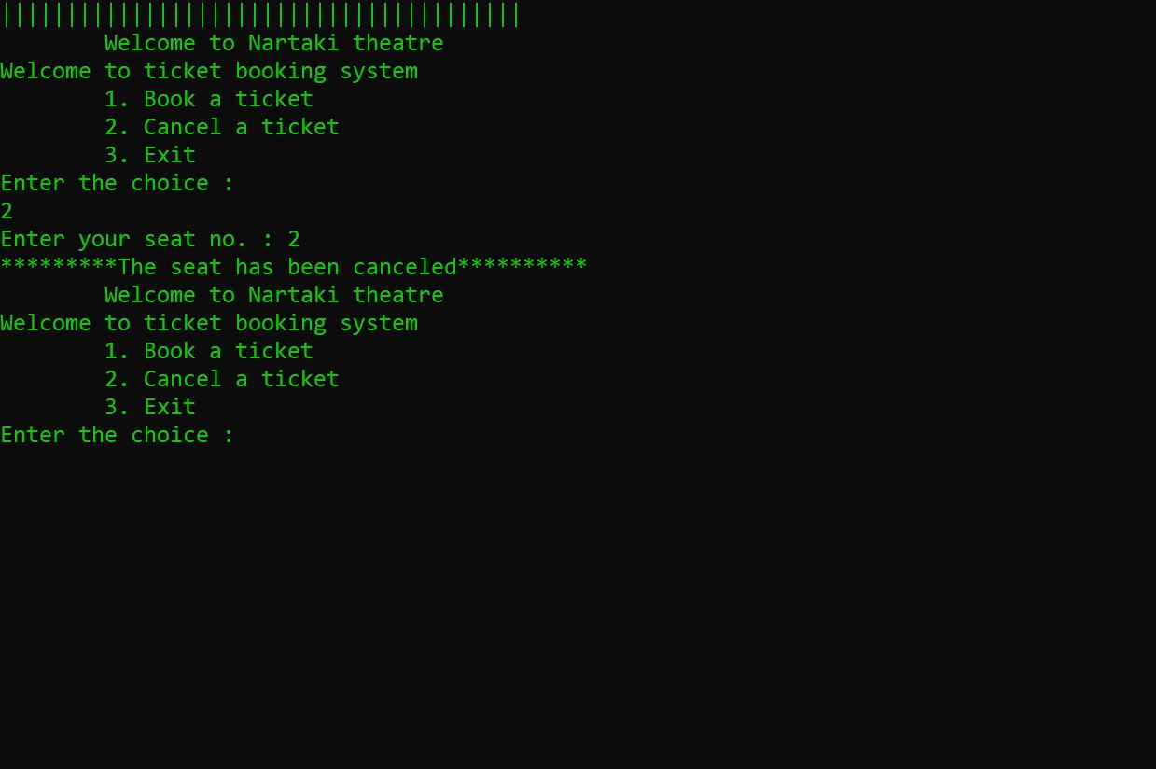

**Case 3:**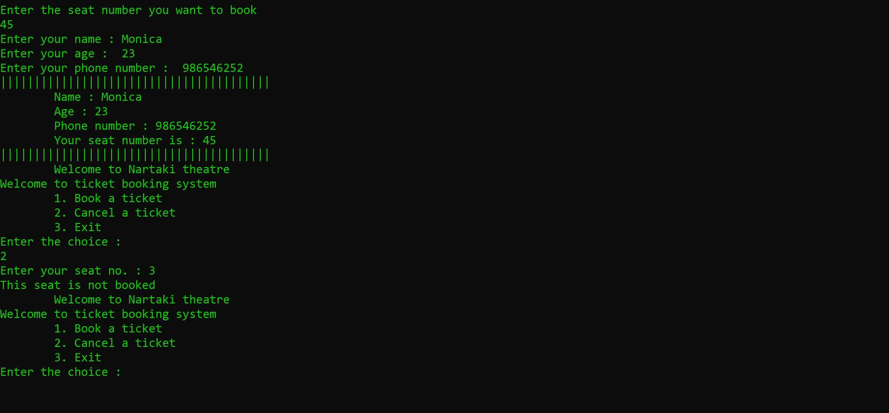

**Case 4:**

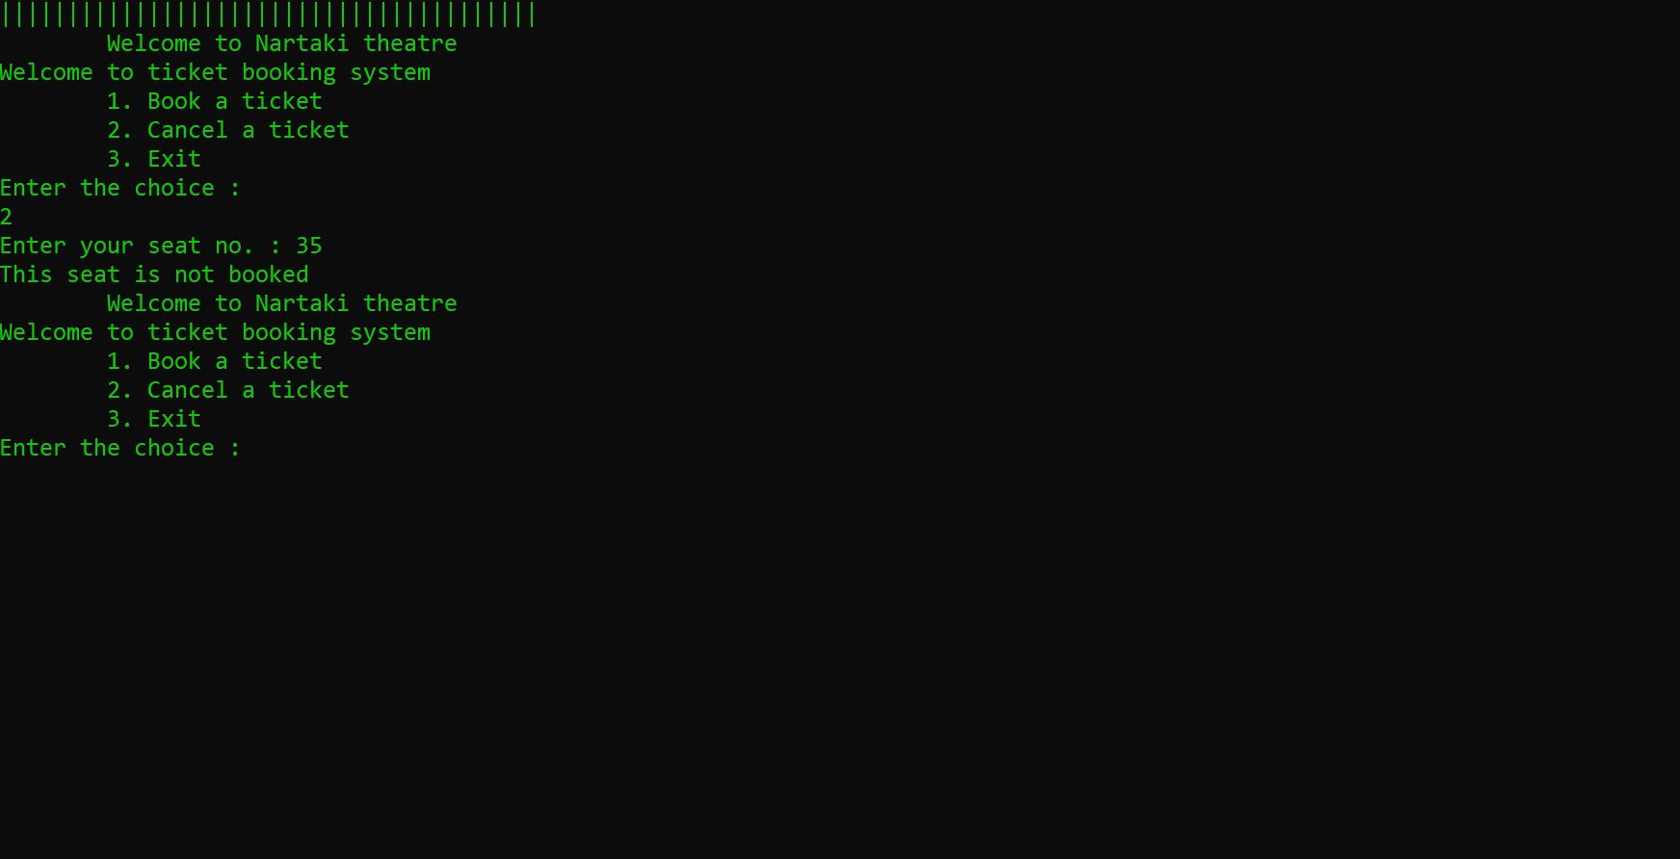

**Limitations:**

* Cannot book multiple seats at a time
* Code has restricted stored data

**Improvements:**

* Displaying a message regarding cancelling of unbooked ticket
* Displaying 10 digit phone number considering all combinations.