AREA PROGRAM1,CODE,READONLY

ENTRY

MAIN

LDR R0,VALUE

LDR R1,[R0]

MOV R2,#0X0000000F

MOV R3,#0X000F0000

AND R4,R1,R2

;LDR R1,[R0,#2]

AND R5,R1,R3

LSR R5,R5,#16

ADD R6,R4,R5

LDR R0,RESULT

STR R6,[R0]

SVC &11

VALUE DCD &40000004

;MASK1 DCD &0000000F

;MASK2 DCD &000F0000

RESULT DCD &4000000C

END

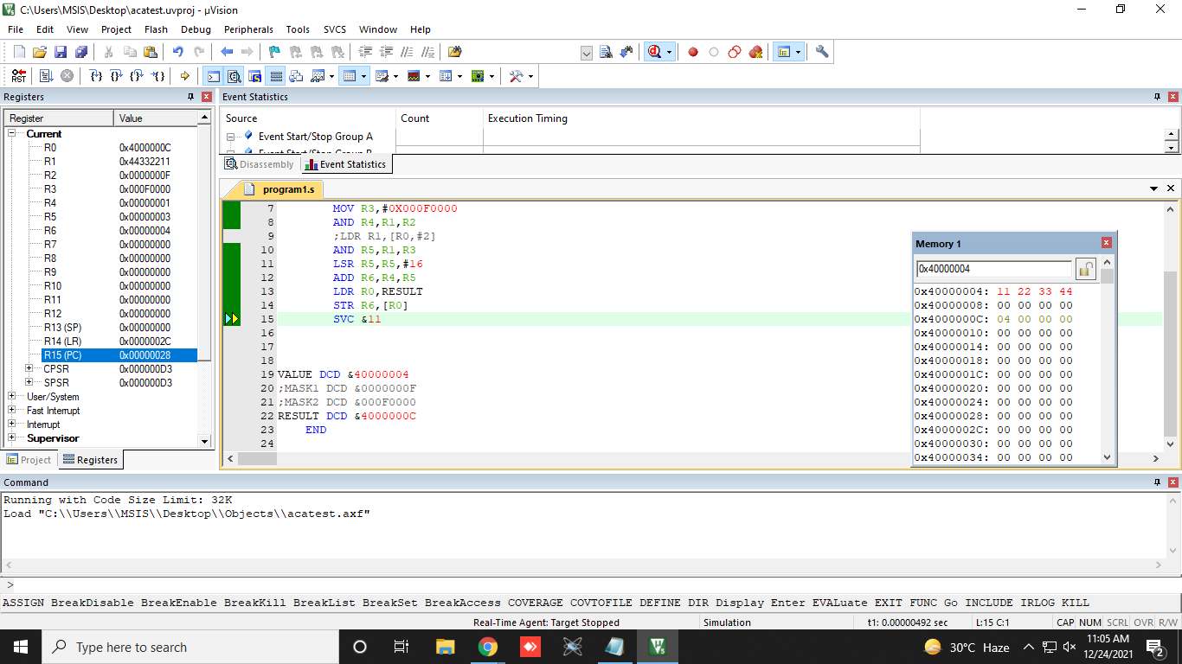

AREA ADD_ARRAY,CODE,READONLY   
ENTRY   
MAIN   
LDR R0,TABLE   
LDR R2,[R0]   
EOR R3,R3,R3   
LOOP   
CMP R2,#0    
BEQ DONE   
LDR R1,[R0,#4]!    
CMP R1,#0   
BMI LOOP1    
  
ADD R3,R3,R1  ;If the number is positive Add it with R3 register content   
SUB R2,R2,#1  ;Decrement the count   
B LOOP   
LOOP1   
SUB R2,R2,#1   
CMP R2,#0   
BEQ DONE   
BNE LOOP   
DONE LDR R4,RESULT   
STR R3,[R4]  ;Load the Result in R3 to desired location   
STOP B STOP   
   
TABLE DCD &40000000   
RESULT DCD &4000003C   
END

