WEEK 1: PL/SQL PROGRAMMING

Q1 : Control Structures
Program:
CREATE TABLE customers (
customer_id NUMBER PRIMARY KEY,
date_of_birth DATE,
balance NUMBER,
isvip VARCHAR2(5) DEFAULT 'FALSE'
);

CREATE TABLE loans (
loan_id NUMBER PRIMARY KEY,
customer_id NUMBER,
interest_rate NUMBER,
status VARCHAR2(20),
due_date DATE,
CONSTRAINT fk_customer
FOREIGN KEY (customer_id)
REFERENCES customers(customer_id)
);

INSERT INTO customers
VALUES (1, TO_DATE('01-JAN-1950','DD-MON-YYYY'),15000,'FALSE');

INSERT INTO customers
VALUES (2, TO_DATE('01-JAN-1990','DD-MON-YYYY'),5000,'FALSE');

-- Insert Loans
INSERT INTO loans
VALUES (101,1,5,'ACTIVE',SYSDATE+20);

INSERT INTO loans
VALUES (102,1,4.5,'CLOSED',SYSDATE+15);

INSERT INTO loans
VALUES (103,2,6,'ACTIVE',SYSDATE+40);

COMMIT;

DECLARE

CURSOR c_customers IS
SELECT c.customer_id,
l.loan_id,
l.interest_rate
FROM customers c
JOIN loans l
ON c.customer_id = l.customer_id
WHERE MONTHS_BETWEEN(SYSDATE,c.date_of_birth)/12 > 60
AND l.status='ACTIVE'
FOR UPDATE;

v_discount_rate NUMBER := 0.01;
v_count NUMBER := 0;
v_vip_count NUMBER := 0;
v_reminder_count NUMBER := 0;

BEGIN

DBMS_OUTPUT.PUT_LINE('=== STARTING BANK OPERATIONS ===');

-- Scenario 1
FOR cust_rec IN c_customers LOOP

UPDATE loans
SET interest_rate = GREATEST(interest_rate-v_discount_rate,0)
WHERE loan_id=cust_rec.loan_id;

v_count:=v_count+1;

DBMS_OUTPUT.PUT_LINE('Discount applied to Loan '
||cust_rec.loan_id);

END LOOP;

DBMS_OUTPUT.PUT_LINE('Loans Updated: '||v_count);

-- Scenario 2

FOR vip_rec IN
(
SELECT customer_id
FROM customers
WHERE balance>10000
FOR UPDATE
)
LOOP

UPDATE customers
SET isvip='TRUE'
WHERE customer_id=vip_rec.customer_id;

v_vip_count:=v_vip_count+1;

END LOOP;

DBMS_OUTPUT.PUT_LINE('VIP Customers: '||v_vip_count);

-- Scenario 3

FOR due_rec IN
(
SELECT customer_id,
loan_id,
due_date,
TRUNC(due_date-SYSDATE) days_remaining
FROM loans
WHERE due_date BETWEEN SYSDATE AND SYSDATE+30
AND status='ACTIVE'
)
LOOP

v_reminder_count:=v_reminder_count+1;

DBMS_OUTPUT.PUT_LINE(
'Reminder for Loan '
||due_rec.loan_id||
' Due in '
||due_rec.days_remaining||
' days.'
);

END LOOP;

DBMS_OUTPUT.PUT_LINE('Reminders Sent: '
||v_reminder_count);

COMMIT;

EXCEPTION
WHEN OTHERS THEN
ROLLBACK;
DBMS_OUTPUT.PUT_LINE(SQLERRM);
END;
/
Output:
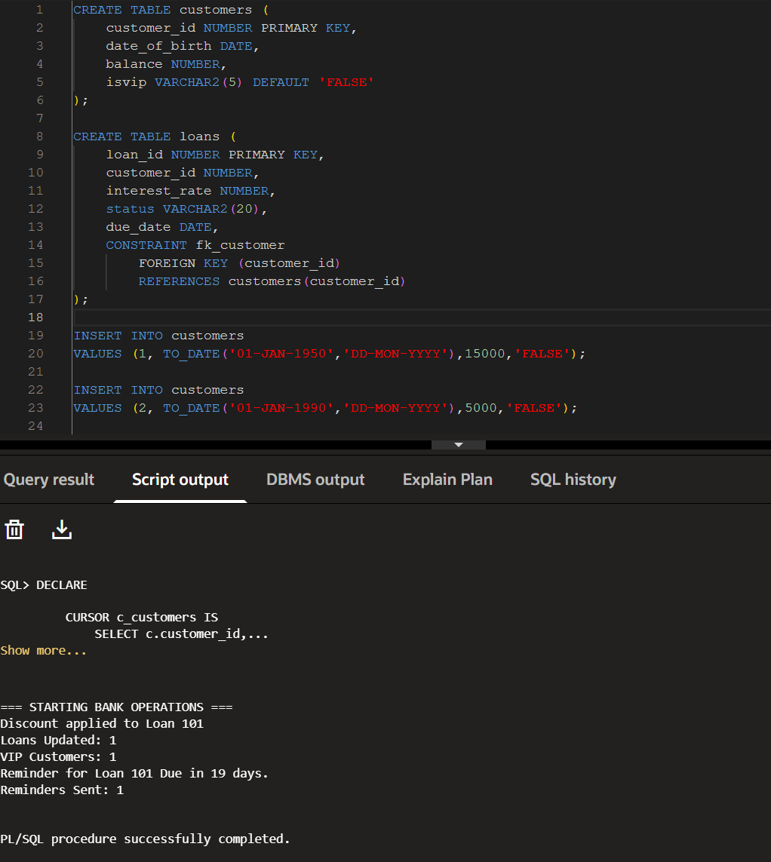

Q3 : Stored Procedures

Program:

CREATE TABLE Accounts (
AccountID NUMBER PRIMARY KEY,
AccountHolder VARCHAR2(100),
Balance NUMBER(10,2),
AccountType VARCHAR2(20)
);

CREATE TABLE Employees (
EmpID NUMBER PRIMARY KEY,
EmpName VARCHAR2(100),
Department VARCHAR2(50),
Salary NUMBER(10,2)
);

INSERT INTO Accounts VALUES (1, 'Harshaa', 10000, 'Savings');
INSERT INTO Accounts VALUES (2, 'Shree', 15000, 'Savings');
INSERT INTO Accounts VALUES (3, 'Priya', 8000, 'Current');
INSERT INTO Accounts VALUES (4, 'Shaa', 5000, 'Savings');

INSERT INTO Employees VALUES (101, 'Ravi', 'HR', 50000);
INSERT INTO Employees VALUES (102, 'Priya', 'HR', 52000);
INSERT INTO Employees VALUES (103, 'Amit', 'Sales', 48000);
INSERT INTO Employees VALUES (104, 'Neha', 'Sales', 55000);

COMMIT;

----------------------------------------------------------
-- SCENARIO 1 : Process Monthly Interest
----------------------------------------------------------

CREATE OR REPLACE PROCEDURE ProcessMonthlyInterest
AS
BEGIN
UPDATE Accounts
SET Balance = Balance + (Balance * 0.01)
WHERE UPPER(AccountType) = 'SAVINGS';

COMMIT;

DBMS_OUTPUT.PUT_LINE('Monthly interest processed successfully.');
END;
/

BEGIN
ProcessMonthlyInterest;
END;
/

SELECT * FROM Accounts;

----------------------------------------------------------
-- SCENARIO 2 : Update Employee Bonus
----------------------------------------------------------

CREATE OR REPLACE PROCEDURE UpdateEmployeeBonus(
dept_name IN VARCHAR2,
bonus_percent IN NUMBER
)
AS
BEGIN
UPDATE Employees
SET Salary = Salary + (Salary * bonus_percent / 100)
WHERE Department = dept_name;

COMMIT;

DBMS_OUTPUT.PUT_LINE('Employee bonus updated successfully.');
END;
/

BEGIN
UpdateEmployeeBonus('HR',10);
END;
/

SELECT * FROM Employees;

----------------------------------------------------------
-- SCENARIO 3 : Transfer Funds
----------------------------------------------------------

CREATE OR REPLACE PROCEDURE TransferFunds(
from_account IN NUMBER,
to_account IN NUMBER,
amount IN NUMBER
)
AS
insufficient_balance EXCEPTION;
balance_from NUMBER;
BEGIN

SELECT Balance
INTO balance_from
FROM Accounts
WHERE AccountID = from_account;

IF balance_from < amount THEN
RAISE insufficient_balance;
END IF;

UPDATE Accounts
SET Balance = Balance - amount
WHERE AccountID = from_account;

UPDATE Accounts
SET Balance = Balance + amount
WHERE AccountID = to_account;

COMMIT;

DBMS_OUTPUT.PUT_LINE('Fund transfer completed successfully.');

EXCEPTION
WHEN insufficient_balance THEN
RAISE_APPLICATION_ERROR(-20001,'Insufficient balance in source account.');

WHEN NO_DATA_FOUND THEN
RAISE_APPLICATION_ERROR(-20002,'One of the accounts does not exist.');
END;
/

BEGIN
TransferFunds(2,4,1000);
END;
/

SELECT * FROM Accounts;

Output:

After Running ProcessMonthlyInterest
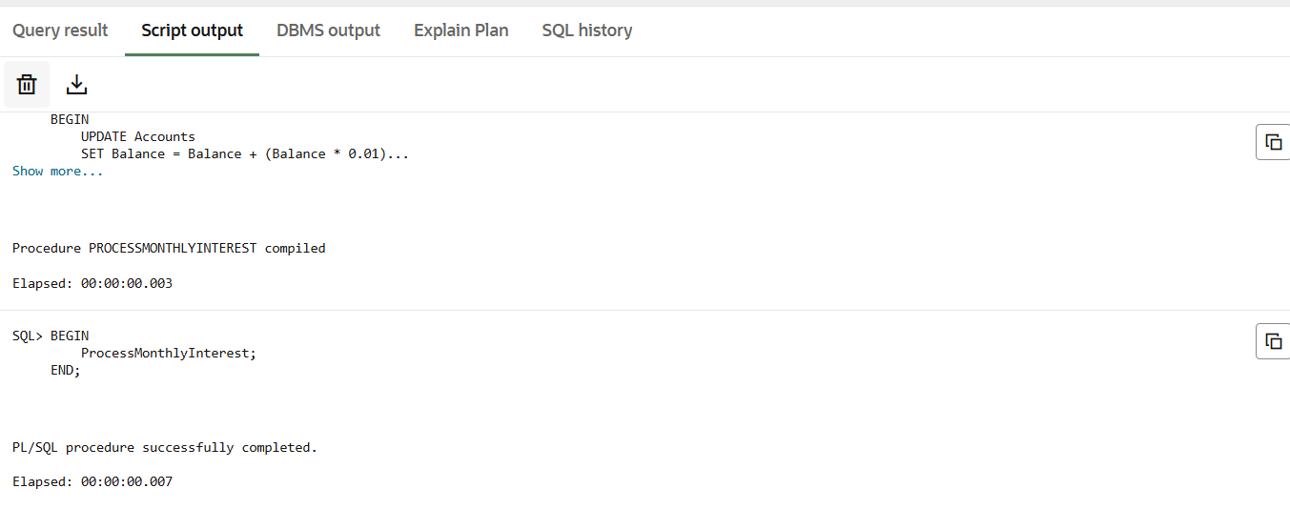

After Running UpdateEmployeeBonus('HR', 10)

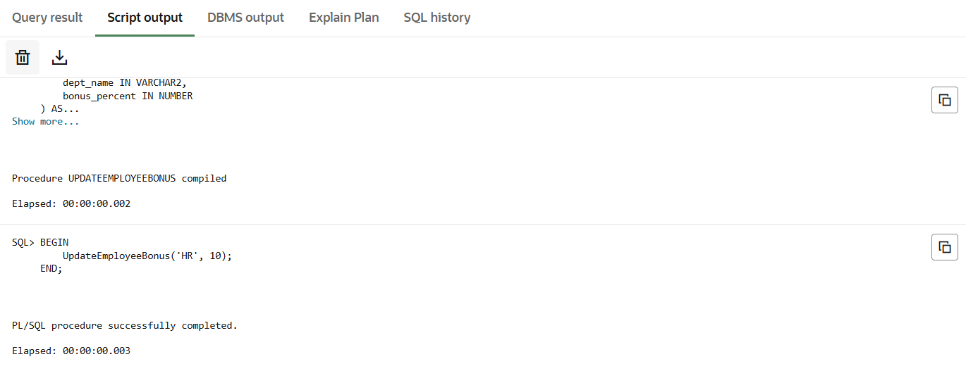

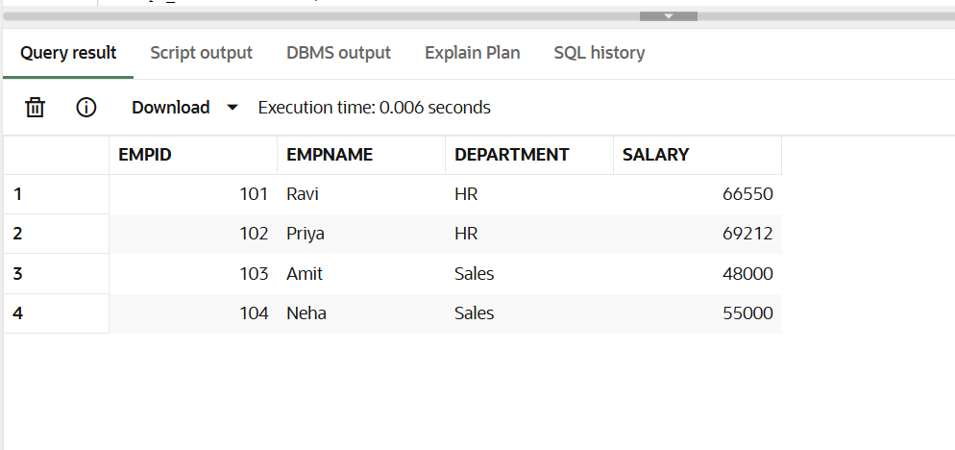

After Running TransferFunds(2, 4, 1000)

