CREATE TABLE EVENT(  
EVENT_ID INT PRIMARY KEY AUTO_INCREMENT,  
EVENT_NAME VARCHAR(255),  
EVENT_DATE DATE,

EVENT_TIME TIME  
);

INSERT INTO EVENT (EVENT_ID, EVENT_NAME, EVENT_DATE, EVENT_TIME) VALUES

(1, 'Tech Conference', '2025-08-05', '09:00:00'),

(2, 'Art Expo', '2025-08-06', '10:30:00'),

(3, 'Music Festival', '2025-08-07', '15:00:00'),

(4, 'Startup Pitch', '2025-08-08', '14:00:00'),

(5, 'Book Fair', '2025-08-09', '11:15:00'),

(6, 'Science Exhibition', '2025-08-10', '13:30:00'),

(7, 'Food Carnival', '2025-08-11', '12:45:00'),

(8, 'Film Screening', '2025-08-12', '18:00:00'),

(9, 'Job Fair', '2025-08-13', '09:00:00'),

(10, 'Photography Workshop', '2025-08-14', '10:00:00'),

(11, 'Dance Show', '2025-08-15', '17:00:00'),

(12, 'Coding Bootcamp', '2025-08-16', '08:00:00'),

(13, 'Chess Tournament', '2025-08-17', '10:30:00'),

(14, 'Hackathon', '2025-08-18', '09:30:00'),

(15, 'Open Mic Night', '2025-08-19', '19:00:00'),

(16, 'Marathon', '2025-08-20', '06:00:00'),

(17, 'Charity Gala', '2025-08-21', '20:00:00'),

(18, 'Fashion Show', '2025-08-22', '17:30:00'),

(19, 'Product Launch', '2025-08-23', '14:30:00'),

(20, 'Yoga Retreat', '2025-08-24', '07:00:00');

CREATE TABLE ATTENDEE (

ATTENDEE_ID INT AUTO_INCREMENT PRIMARY KEY,

NAME VARCHAR(255),

PH_NUMBER VARCHAR(20),

EVENT_ID INT,

FOREIGN KEY (EVENT_ID) REFERENCES EVENT(EVENT_ID)

);

ALTER TABLE ATTENDEE MODIFY ATTENDEE_ID INT AUTO_INCREMENT;

ALTER TABLE ATTENDEE AUTO_INCREMENT = 101;

INSERT INTO ATTENDEE (ATTENDEE_ID, NAME, NUMBER, EVENT_ID) VALUES

(101, 'Alice Johnson', '1234567890', 1),

(102, 'Bob Smith', '9876543210', 2),

(103, 'Charlie Lee', '5551234567', 3),

(104, 'Diana Evans', '4445678901', 4),

(105, 'Ethan Clark', '3214567890', 5),

(106, 'Fiona Davis', '6789012345', 6),

(107, 'George Brown', '8901234567', 7),

(108, 'Hannah Scott', '4567890123', 8),

(109, 'Ian Miller', '2345678901', 9),

(110, 'Julia Adams', '7654321098', 10),

(111, 'Kevin Wilson', '1230984567', 11),

(112, 'Laura Green', '5678901234', 12),

(113, 'Mike Turner', '6789123456', 13),

(114, 'Nina Carter', '7890123456', 14),

(115, 'Owen Hall', '8901345678', 15),

(116, 'Paula White', '9012345678', 16),

(117, 'Quinn Brooks', '3456789012', 17),

(118, 'Rachel Young', '4561237890', 18),

(119, 'Sam Harris', '5678912345', 19),

(120, 'Tina Lopez', '6789012456', 20);

INSERT INTO ATTENDEE (NAME, PH_NUMBER, EVENT_ID) VALUES

('Alice Johnson', '1234567890', 1),

('Bob Smith', '9876543210', 2),

('Charlie Lee', '5551234567', 1),

('Diana Evans', '4445678901', 3),

('Ethan Clark', '3214567890', 4),

('Fiona Davis', '6789012345', 5),

('George Brown', '8901234567', 1),

('Hannah Scott', '4567890123', 2),

('Ian Miller', '2345678901', 3),

('Julia Adams', '7654321098', 4),

('Kevin Wilson', '1230984567', 6),

('Laura Green', '5678901234', 7),

('Mike Turner', '6789123456', 8),

('Nina Carter', '7890123456', 9),

('Owen Hall', '8901345678', 10),

('Paula White', '9012345678', 15),

('Quinn Brooks', '3456789012', 11),

('Rachel Young', '4561237890', 12),

('Sam Harris', '5678912345', 13),

('Tina Lopez', '6789012456', 14);

🧠 Note:

The ATTENDEE_ID will automatically start from 101 because of your AUTO_INCREMENT = 101 setting.

All phone numbers are strings (VARCHAR) and valid formats for basic insert testing.

You can modify or extend these names and phone numbers as needed.

CREATE TABLE VENUE(  
VENUE_ID INT PRIMARY KEY,  
VENUE_NAME VARCHAR(255),  
CAPACITY INT  
);

INSERT INTO VENUE (VENUE_ID, VENUE_NAME, CAPACITY) VALUES

(1, 'Grand Hall', 500),

(2, 'City Auditorium', 800),

(3, 'Skyline Conference Center', 300),

(4, 'Downtown Expo Arena', 1000),

(5, 'Lakeside Pavilion', 200),

(6, 'Heritage Banquet Hall', 400),

(7, 'Summit Convention Hall', 750),

(8, 'Crystal Ballroom', 350),

(9, 'Open Air Theater', 1200),

(10, 'Cultural Center Hall', 600);

CREATE TABLE VENDOR(  
VENDOR_ID INT PRIMARY KEY,  
NAME VARCHAR(255),  
AVAILABILITY VARCHAR(10)  
);

INSERT INTO VENDOR (VENDOR_ID, NAME, AVAILABILITY) VALUES

(1, 'Elite Catering Co.', 'Yes'),

(2, 'SoundTech Solutions', 'No'),

(3, 'Floral Designs', 'Yes'),

(4, 'Stage Masters', 'Yes'),

(5, 'EventLights Inc.', 'No'),

(6, 'Gourmet Bites', 'Yes'),

(7, 'SecureNow Security', 'Yes'),

(8, 'Sparkle Decorators', 'No'),

(9, 'Live Beats Band', 'Yes'),

(10, 'Royal Rentals', 'Yes');

///// CREATE TABLE TASK(  
TASK_ID INT PRIMARY KEY,  
NAME VARCHAR(255),  
EVENT_ID INT FOREIGN KEY REFERENCES EVENT(EVENT_ID)  
); ///////////////

CREATE TABLE SCHEDULE(

SCHEDULE_ID INT PRIMARY KEY,

EVENT_ID INT,

FOREIGN KEY (EVENT_ID) REFERENCES EVENT(EVENT_ID),

START_DATE DATETIME,

END_TIME DATETIME

);

INSERT INTO SCHEDULE (SCHEDULE_ID, EVENT_ID, START_DATE, END_TIME) VALUES

(1, 2, '2025-08-10 09:00:00', '2025-08-10 12:00:00'),

(2, 10, '2025-08-11 13:00:00', '2025-08-11 16:00:00'),

(3, 6, '2025-08-12 10:00:00', '2025-08-12 14:00:00'),

(4, 1, '2025-08-13 15:00:00', '2025-08-13 18:00:00'),

(5, 5, '2025-08-14 11:00:00', '2025-08-14 14:00:00'),

(6, 1, '2025-08-15 09:30:00', '2025-08-15 11:30:00'),

(7, 2, '2025-08-16 10:00:00', '2025-08-16 13:00:00'),

(8, 9, '2025-08-17 14:00:00', '2025-08-17 17:00:00'),

(9, 4, '2025-08-18 08:00:00', '2025-08-18 10:00:00'),

(10, 5, '2025-08-19 12:00:00', '2025-08-19 15:00:00'),

(11, 12, '2025-08-20 09:00:00', '2025-08-20 12:00:00'),

(12, 14, '2025-08-21 13:00:00', '2025-08-21 16:00:00'),

(13, 13, '2025-08-22 10:00:00', '2025-08-22 13:00:00'),

(14, 11, '2025-08-23 11:00:00', '2025-08-23 14:00:00'),

(15, 10, '2025-08-24 15:00:00', '2025-08-24 18:00:00');

CREATE TABLE BUDGET(

BUDGET_ID INT,

EVENT_ID INT,

FOREIGN KEY (EVENT_ID) REFERENCES EVENT(EVENT_ID),

TOTAL_BUDGET DECIMAL(10,2)

);

INSERT INTO BUDGET (BUDGET_ID, EVENT_ID, TOTAL_BUDGET) VALUES

(1, 1, 5000.00),

(2, 2, 7500.50),

(3, 13, 3200.75),

(4, 14, 10000.00),

(5, 5, 4500.25),

(6, 3, 5200.00),

(7, 4, 7800.00),

(8, 6, 3000.00),

(9, 14, 11000.00),

(10, 7, 4800.00);

Notes:

Make sure the EVENT table has these EVENT_IDs to satisfy foreign key constraints.

**Relational Database Model for Event Management**

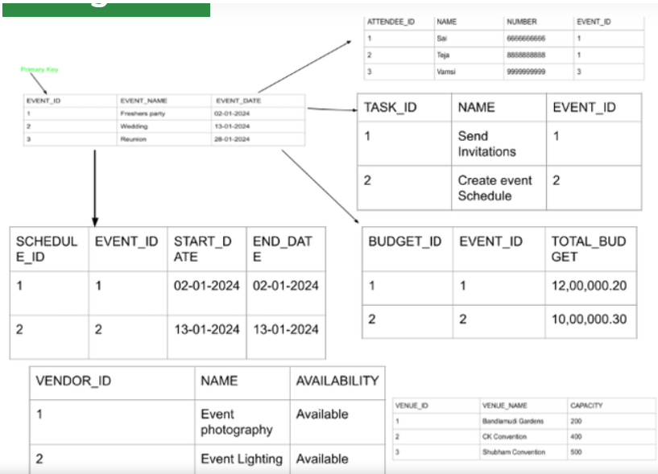

**Budget entity**

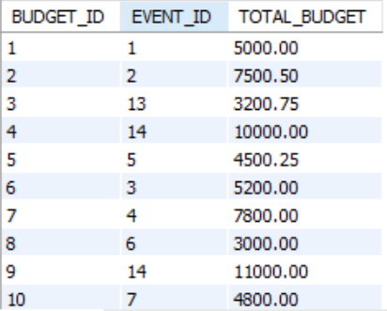

**Event entity**

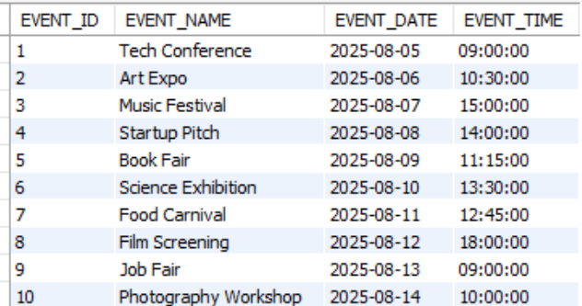

**Attendee entity**

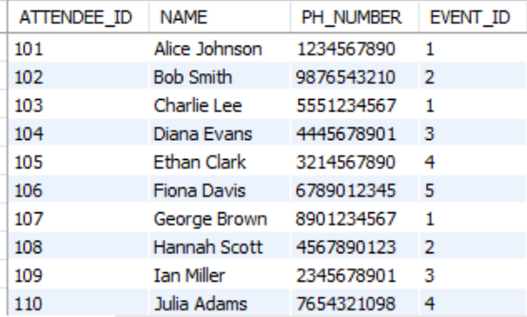

**schedule entity**

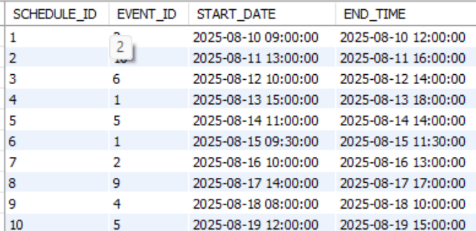

**vendor entity**

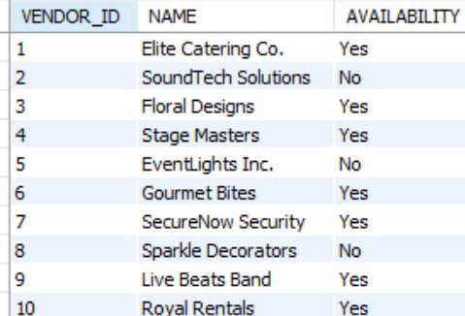

**Venue entity**

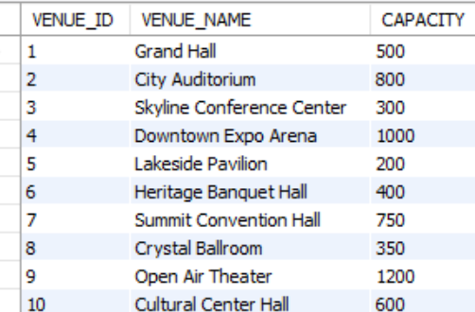

Sql queries

1. **1. Retrieve all upcoming events:**

SELECT *

FROM Events

WHERE EventDate >= CURDATE()

ORDER BY EventDate;

***OR (TO DISPLAY IN DATE FORMAT)***

SELECT EVENT_ID, EVENT_NAME, DATE_FORMAT(EVENT_DATE, '%d-%m-%Y') AS EVENT_DATE, EVENT_TIME

FROM event

WHERE EVENT_DATE >= CURDATE()

ORDER BY EVENT_DATE ;

1. **Find attendees for a specific event:**

SELECT A.AttendeeName, A.AttendeeEmail  
FROM Attendees AS A  
JOIN Events AS E ON A.EventID = E.EventID  
WHERE E.EventName = 'Conference on AI';

Or

SELECT COUNT(A.ATTENDEE_ID) AS attendee_count, A.NAME, A.PH_NUMBER

FROM attendee A

JOIN event E ON E.EVENT_ID = A.EVENT_ID

WHERE E.EVENT_NAME = 'Film Screening'

GROUP BY A.NAME, A.PH_NUMBER;

OR

SELECT A.ATTENDEE_ID, A.NAME, A.PH_NUMBER, E.EVENT_DATE,E.EVENT_TIME

FROM attendee A

JOIN event E ON E.EVENT_ID = A.EVENT_ID

WHERE E.EVENT_NAME = 'Film Screening';

1. **Count the number of attendees for each event:**

SELECT E.EVENT_NAME, COUNT(A.ATTENDEE_ID) AS NumberOfAttendees

FROM event AS E

LEFT JOIN attendee AS A ON E.EVENT_ID = A.EVENT_ID

GROUP BY E.EVENT_NAME;

**4. List all events held at a particular venue:**

**SELECT E.EVENT_NAME, E.EVENT_DATE, E.EVENT_TIME**

**FROM event AS E**

**JOIN Venue AS V ON E.VENUE_ID = V.VENUE_ID**

**WHERE V.VENUE_NAME = 'city auditorium';**

**5.Add a new event:**

**INSERT INTO Events (EventName, EventDate, VenueID, Description)  
VALUES ('Tech Expo 2025', '2025-11-15', 101, 'Showcasing the latest**

**6. Update an event's details:**

**UPDATE Events  
SET EventDate = '2025-12-01', Description = 'An updated description for the event.'  
WHERE EventName = 'Annual Gala Dinner';**

**7. Delete an event:**

**DELETE FROM Events  
WHERE EventName = 'Charity Run';**

**\---------------------------------**

**1. List all events**

**sql**

**CopyEdit**

**SELECT * FROM EVENT;**

**👥 2. Show all attendees of a specific event (e.g., EVENT_ID = 101)**

**SELECT * FROM ATTENDEE WHERE EVENT_ID = 101;**

**🧑‍💼 3. List all vendors who are available**

**SELECT * FROM VENDOR WHERE AVAILABILITY = 'Yes';**

**📅 4. Show the schedule for a specific event**

**SELECT * FROM SCHEDULE WHERE EVENT_ID = 103;**

**💰 5. Find the total budget for each event**

**SELECT EVENT_ID, SUM(TOTAL_BUDGET) AS TOTAL FROM BUDGET GROUP BY EVENT_ID ORDER BY TOTAL DESC;**

**🏟️ 6. Show all venues with capacity greater than 500**

**SELECT * FROM VENUE WHERE CAPACITY > 500;**

**📈 7. List events with their schedule**

**SELECT E.EVENT_ID, E.EVENT_NAME, S.START_DATE, S.END_TIME**

**FROM EVENT E**

**JOIN SCHEDULE S ON E.EVENT_ID = S.EVENT_ID;**

**👥 8. Count number of attendees per event**

**SELECT EVENT_ID, COUNT(*) AS ATTENDEE_COUNT**

**FROM ATTENDEE**

**GROUP BY EVENT_ID;**

**💸 9. List events where budget exceeds 7000**

**SELECT * FROM BUDGET WHERE TOTAL_BUDGET > 7000;**

**🗂️ 10. List unique event names with budgets**

**SELECT DISTINCT E.EVENT_NAME, B.TOTAL_BUDGET**

**FROM EVENT E**

**JOIN BUDGET B ON E.EVENT_ID = B.EVENT_ID;**

**10) Goal: Get event details with venue name, schedule time, and total budget (via subquery)**

SELECT

e.event_id,

e.EVENT_name,

v.venue_name,

s.start_DATE,

s.end_time,

b.total_budget

FROM event e

LEFT JOIN venue v ON e.venue_id = v.venue_id

LEFT JOIN schedule s ON e.event_id = s.event_id

LEFT JOIN (

SELECT event_id, SUM(TOTAL_BUDGET) AS total_budget

FROM budget

GROUP BY event_id

) b ON e.event_id = b.event_id;