Configuration of Bahmni as per Your wants
Each hospital has its own forms, templates, rules, and workflows. Bahmni permits you to piece the program as per your wants. These screenshots were taken from a number of our implementation configurations to convey you a style of the probabilities that exist. we have a tendency to still add options that facilitate hospitals implement closer-to-life screens, with fast navigation and straightforward data entry.

First doctor needs to login each one will have unique username and password and along with that they need to mention the location for example username-superman and pasword-Admin123
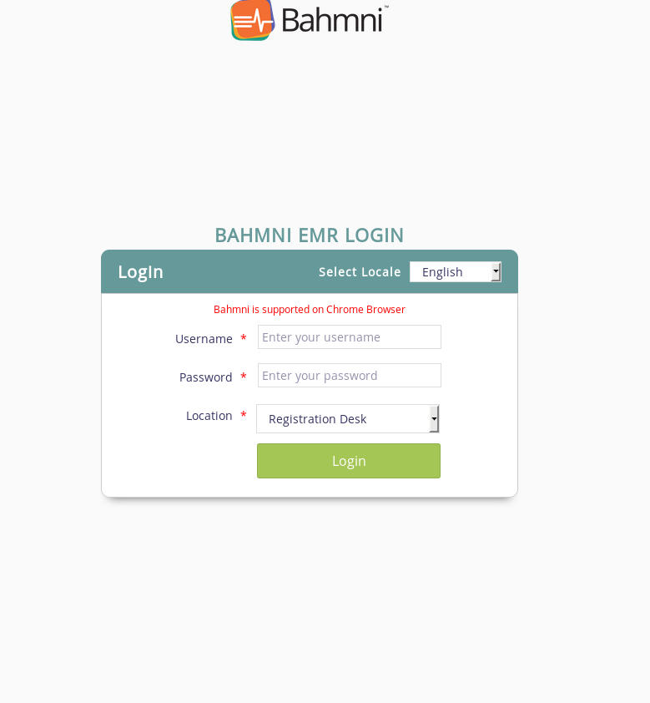

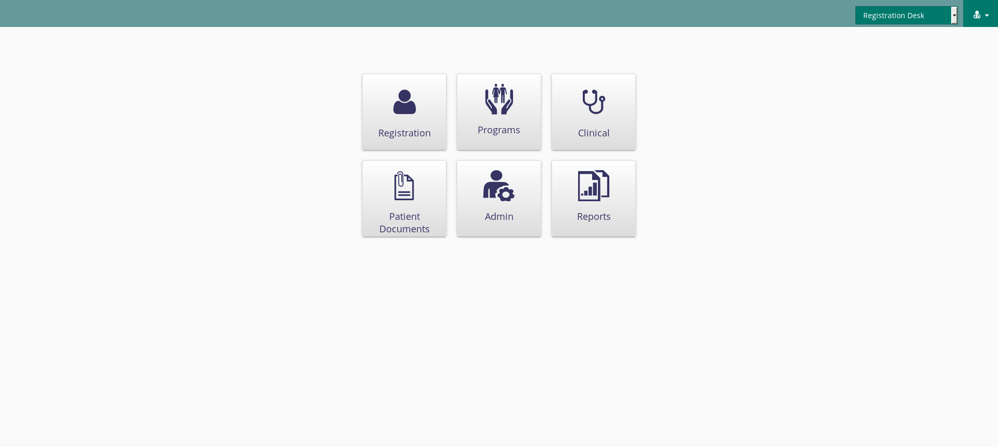
This is the main screen of Bahmni we have customise it according to our needs.

After selecting Registration we get this.In this we can search the following the existing patient.
By writing patient id or if the patient is new then we need to select create new.

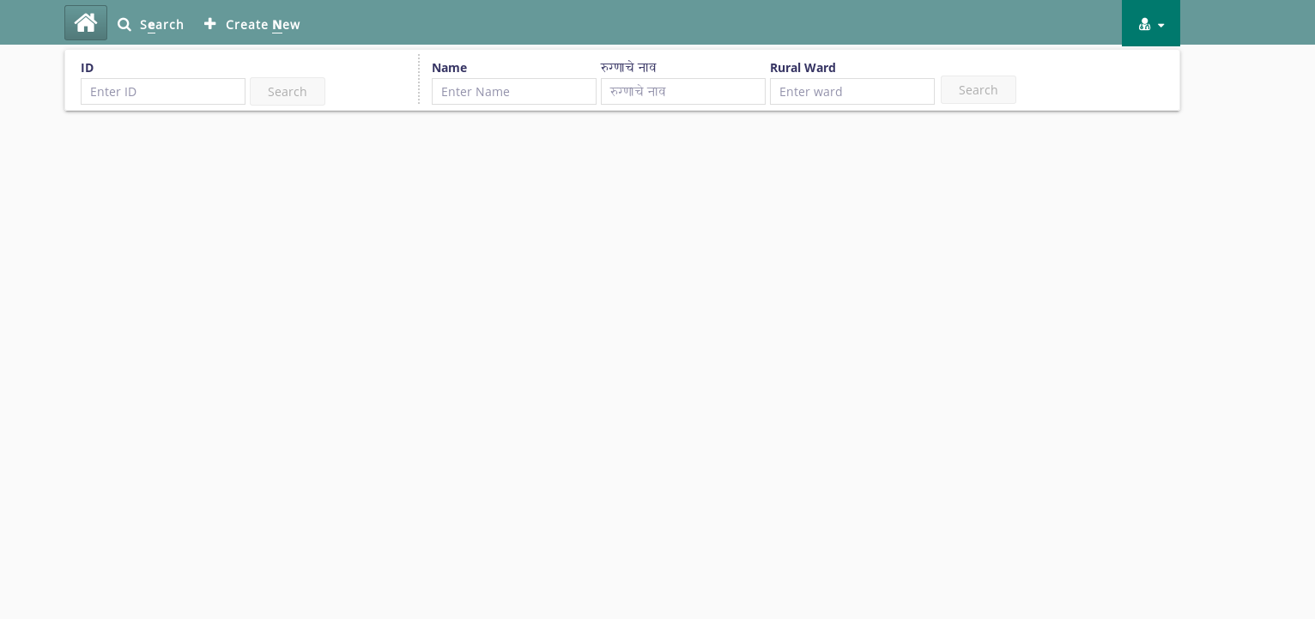

If a patient is new then after selecting create new that person need to fill the form.
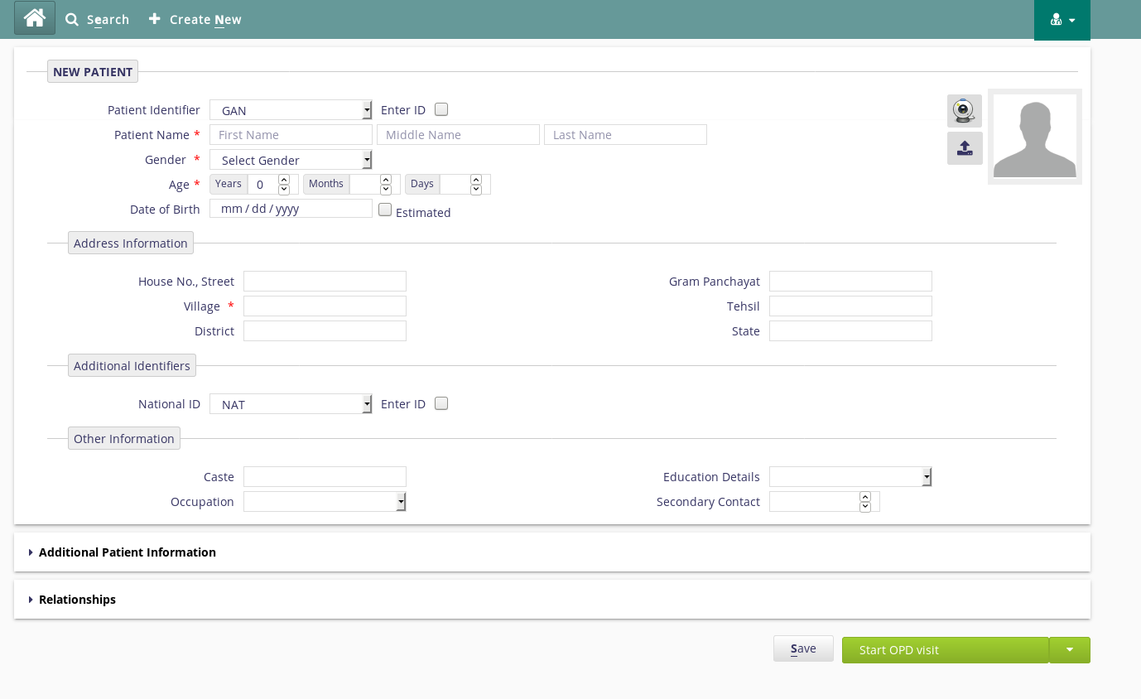
The mandatory details like Patient Name,Gender,Age etc to be filled.After completion of
form we we need to select Start OPD visit.

After registration we have Programs

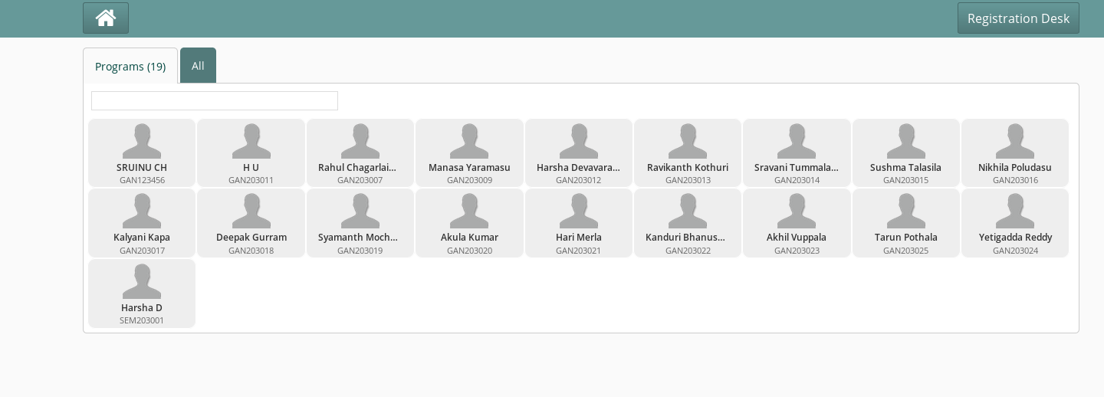

In Programs we have the patients we already exist. We should select the particular patient we want to see the details of

From this we can get what is the present condition of the particular patient by entering the program name that is from the problem which he is suffering from and start date and the most important id number.

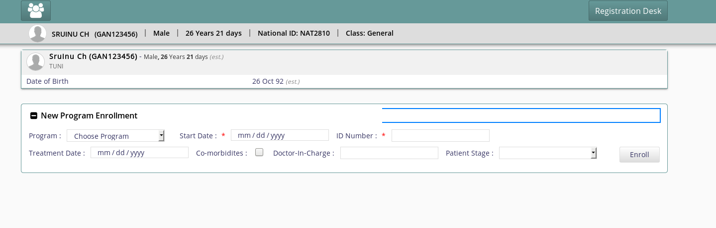

After that in Clinical we can modify the data.
This task needs to be done we a patient is going through multiple processes

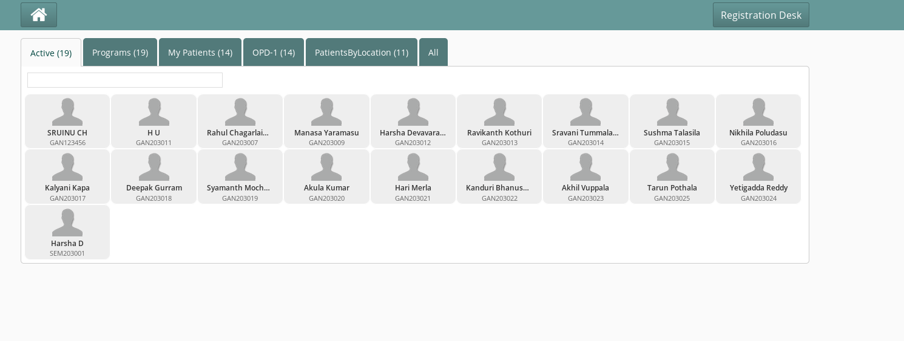
After selecting Clinical these are the patients list which will be there in patient queue or we can search the patient by using patient id.

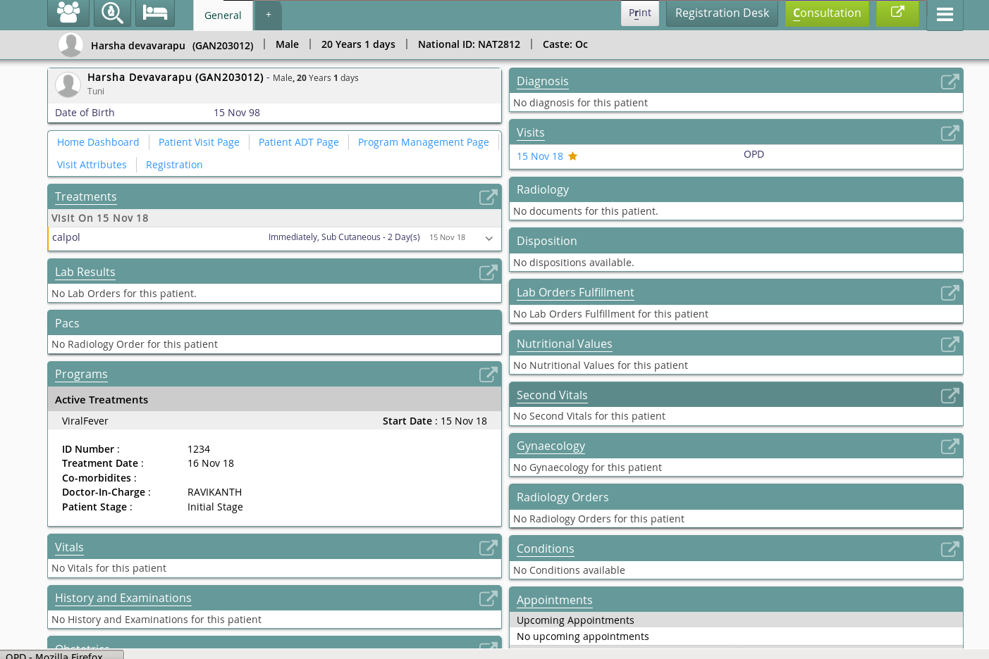
Ater selecting a particular patient we can get the dashboard.All the fields in the dashboard are configurable.These dispaly control are configurable to a particalar hospiatl.After this the doctor will click on consultation

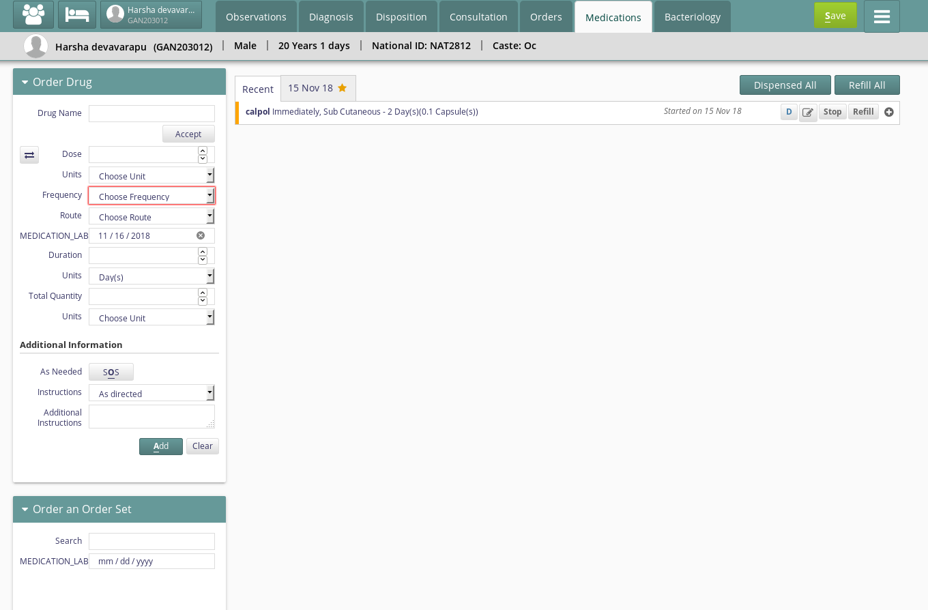
In medicines doctor needes to mention medicines that patient should take and the duration also he should mention and select save.

