CA1

1

package com.zest.CA1;

import org.openqa.selenium.By;

import org.openqa.selenium.WebDriver;

import org.openqa.selenium.WebElement;

import org.openqa.selenium.chrome.ChromeDriver;

import org.openqa.selenium.chrome.ChromeOptions;

import io.github.bonigarcia.wdm.WebDriverManager;

public class CA1_1 {

public static void main(String[] args) {

ChromeOptions co=new ChromeOptions();

co.addArguments("--remote-allow-origins=*");

WebDriverManager.*chromedriver*().setup();

WebDriver driver=new ChromeDriver(co);

driver.get("https://www.amazon.in/gp/cart/view.html?ref_=nav_cart");

driver.manage().window().maximize();

String CurrentTitle=driver.getTitle();

String ExpectedTitle="Amazon.in Shopping Cart";

if(CurrentTitle.equals(ExpectedTitle))

{

System.***out***.println("TITLE MATCHED.");

}

else

{

System.***out***.println("TITLE NOT MATCHED.");

}

driver.get("https://www.amazon.in/TIMEWEAR-Functioning-White-Chain-Watch/dp/B07MDGSP8F/ref=sr_1_7?crid=3UKRU96NGUY9Z&keywords=watches&qid=1681289971&sprefix=w%2Caps%2C1254&sr=8-7");

WebElement sub=driver.findElement(By.*xpath*("//input[@id=\"add-to-cart-button\"]"));

sub.click();

}

}

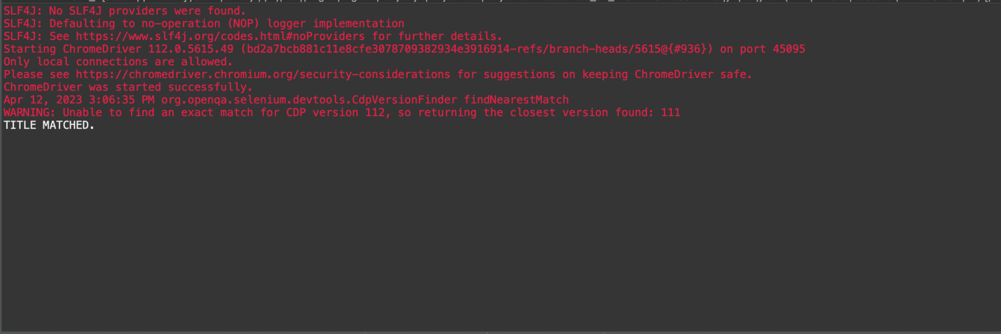

2

package com.zest.CA1;

import java.util.List;

import org.openqa.selenium.By;

import org.openqa.selenium.WebDriver;

import org.openqa.selenium.WebElement;

import org.openqa.selenium.chrome.ChromeDriver;

import org.openqa.selenium.chrome.ChromeOptions;

import io.github.bonigarcia.wdm.WebDriverManager;

public class CA1_2 {

public static void main(String[] args) {

WebDriverManager.*chromedriver*().setup();

ChromeOptions co=new ChromeOptions();

co.addArguments("--remote-allow-origins=*");

WebDriver driver=new ChromeDriver(co);

driver.get("https://www.amazon.in/");

driver.manage().window().maximize();

driver.findElement(By.*xpath*("//*[@id=\"twotabsearchtextbox\"]")).sendKeys("Watches");

driver.findElement(By.*xpath*("//*[@id=\"nav-search-submit-button\"]")).click();

String a=driver.getTitle();

if(a.equals("Amazon.in : Watches")) {

System.***out***.println("Title is Matched\n");

}

else {

System.***out***.println("Title is Mismatched");

}

List<WebElement> li=driver.findElements(By.*className*("s-line-clamp-1"));

for(int i=0;i<5;i++) {

System.***out***.println(li.get(i).getText());

}

driver.findElement(By.*xpath*("//*[@id=\"a-autoid-0-announce\"]")).click();

}

}

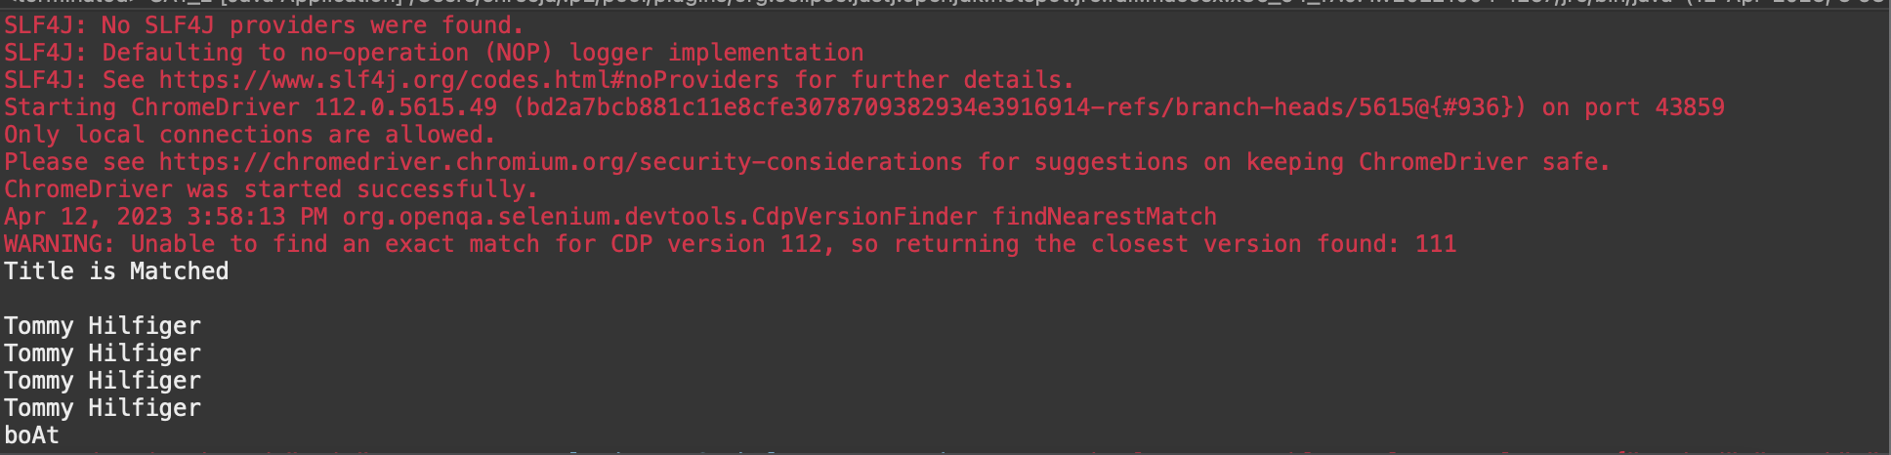

3

package com.zest.CA1;

import org.openqa.selenium.By;

import org.openqa.selenium.WebDriver;

import org.openqa.selenium.WebElement;

import org.openqa.selenium.chrome.ChromeDriver;

import org.openqa.selenium.chrome.ChromeOptions;

import io.github.bonigarcia.wdm.WebDriverManager;

public class CA1_3 {

public static void main(String[] args) throws InterruptedException{

WebDriverManager.*chromedriver*().setup();

ChromeOptions co=new ChromeOptions();

co.addArguments("--remote-allow-origins=*");

WebDriver driver=new ChromeDriver(co);

driver.get("https://www.amazon.in/");

driver.get("https://www.amazon.in/ap/signin?openid.pape.max_auth_age=0&openid.return_to=https%3A%2F%2Fwww.amazon.in%2F%3Fref_%3Dnav_ya_signin&openid.identity=http%3A%2F%2Fspecs.openid.net%2Fauth%2F2.0%2Fidentifier_select&openid.assoc_handle=inflex&openid.mode=checkid_setup&openid.claimed_id=http%3A%2F%2Fspecs.openid.net%2Fauth%2F2.0%2Fidentifier_select&openid.ns=http%3A%2F%2Fspecs.openid.net%2Fauth%2F2.0&");

driver.findElement(By.*xpath*("//*[@id=\"ap_email\"]")).click();

driver.findElement(By.*xpath*("//*[@id=\"ap_email\"]")).sendKeys("shreejaelangovan214@gmail.com");

driver.findElement(By.*xpath*("//*[@id=\"continue\"]")).click();

driver.findElement(By.*xpath*("//*[@id=\"ap_password\"]")).click();

driver.findElement(By.*xpath*("//*[@id=\"ap_password\"]")).sendKeys("shreeja@2101");

driver.findElement(By.*xpath*("//*[@id=\"signInSubmit\"]")).click();

Thread.*sleep*(3000);

driver.findElement(By.*xpath*("//*[@id=\"nav-link-accountList\"]")).click();

WebElement acc=driver.findElement(By.*xpath*("//*[@id=\"a-page\"]/div[2]/div/div[1]/h1"));

String actual=acc.getText();

String expected="Your Account";

if(actual.equals(expected)) {

System.***out***.println("Your Account page is displayed");

}

driver.findElement(By.*xpath*("//*[@id=\"a-page\"]/div[2]/div/div[2]/div[1]/a/div")).click();

WebElement ord=driver.findElement(By.*xpath*("//*[@id=\"a-page\"]/section/div[1]/div[2]/div[1]/h1"));

String act=ord.getText();

String exp="Your Orders";

if(act.equals(exp)) {

System.***out***.println("Your Order page is displayed");

}

String act1=ord.getText();

String exp1="Your orders";

if(act.equals(exp)) {

System.***out***.println("User is able to track package");

}

System.***out***.println("User is able to view their products");

}

}

