**DAY 10**

**TASK :1**

**package** com.Demo.Demo;

**import** java.util.concurrent.TimeUnit;

**import** org.openqa.selenium.By;

**import** org.openqa.selenium.WebDriver;

**import** org.openqa.selenium.chrome.ChromeDriver;

**import** org.openqa.selenium.chrome.ChromeOptions;

**import** org.testng.Assert;

**import** org.testng.ITestResult;

**import** org.testng.annotations.AfterMethod;

**import** org.testng.annotations.AfterTest;

**import** org.testng.annotations.BeforeClass;

**import** org.testng.annotations.Test;

**import** com.aventstack.extentreports.ExtentReports;

**import** com.aventstack.extentreports.ExtentTest;

**import** com.aventstack.extentreports.Status;

**import** com.aventstack.extentreports.reporter.ExtentHtmlReporter;

**import** com.aventstack.extentreports.reporter.configuration.ChartLocation;

**import** com.aventstack.extentreports.reporter.configuration.Theme;

**import** io.github.bonigarcia.wdm.WebDriverManager;

**public** **class** d101 {

**static** ExtentTest *test*;

**static** ExtentReports *extent*;

ExtentHtmlReporter htmlReporter;

@BeforeClass

**public** **void** startReport() {

//ExtentSparkReporter htmlReporter = new ExtentSparkReporter("extentReport.html");

//htmlReporter = new ExtentHtmlReporter(System.getProperty("user.dir")+"/test-output/extentReport.html");

htmlReporter = **new** ExtentHtmlReporter("/Users/shreeja/Documents/Testing/Day10/extr2.html");

*extent* = **new** ExtentReports();

*extent*.attachReporter(htmlReporter);

//configuration items to change the look and feel

//add content, manage tests etc

htmlReporter.config().setChartVisibilityOnOpen(**true**);

htmlReporter.config().setDocumentTitle("Simple Automation Report");

htmlReporter.config().setReportName("Test Report");

htmlReporter.config().setTestViewChartLocation(ChartLocation.***TOP***);

htmlReporter.config().setTheme(Theme.***STANDARD***);

// htmlReporter.config().setTimeStampFormat("EEEE, MMMM dd, yyyy, hh:mm a '('zzz')'");

}

@Test

**public** **void** f() {

WebDriverManager.*chromedriver*().setup();

WebDriver driver;

ChromeOptions co = **new** ChromeOptions();

co.addArguments("--remote-allow-origins=*");

driver=**new** ChromeDriver(co);

driver.get("https://www.godaddy.com/en-in");

driver.manage().window().maximize();

String actualTitle="Domain Names, Websites, Hosting & Online Marketing Tools - GoDaddy IN";

String extractedTitle=driver.getTitle();

Assert.*assertEquals*(actualTitle, extractedTitle);

String actualURL="https://www.godaddy.com/en-in";

String extractedURL=driver.getCurrentUrl();

Assert.*assertEquals*(actualURL, extractedURL);

System.***out***.println("Smoke test");

driver.quit();

*test* = *extent*.createTest("Test Case 1", "The test case 1 has passed");

}

@Test

**public** **void** f1() **throws** Exception {

WebDriverManager.*chromedriver*().setup();

WebDriver driver;

ChromeOptions co = **new** ChromeOptions();

co.addArguments("--remote-allow-origins=*");

driver=**new** ChromeDriver(co);

driver.get("https://www.godaddy.com/en-in");

driver.manage().window().maximize();

driver.navigate().refresh();

//driver.manage().timeouts().implicitlyWait(5, TimeUnit.SECONDS);

//driver.manage().timeouts().implicitlyWait(10,TimeUnit.SECONDS);

Thread.*sleep*(10);

driver.findElement(By.*xpath*("//*[@id=\"id-e6aaf13d-272e-44df-903a-e07e539d57c7\"]/span[1]")).click();

//driver.findElement(By.linkText("Domain Name Search")).click();

System.***out***.println(driver.getTitle());

System.***out***.println("Regressiontest");

*test* = *extent*.createTest("Test Case 2", "The test case 2 has passed");

//driver.quit();

}

@Test

**public** **void** f2() {

ChromeOptions co=**new** ChromeOptions();

co.addArguments("--remote-allow-origins=*");

WebDriverManager.*chromedriver*().setup();

WebDriver driver=**new** ChromeDriver(co);

driver.get("https://www.godaddy.com/en-in");

driver.manage().window().maximize();

driver.manage().timeouts().~~implicitlyWait~~(10,TimeUnit.***SECONDS***);

driver.findElement(By.*xpath*("//*[@id=\"id-631b049a-e9c0-4d24-8710-c504745206dd\"]/div[2]/div[1]/ul/li[1]/button")).click();

driver.findElement(By.*xpath*("//*[@id=\"id-631b049a-e9c0-4d24-8710-c504745206dd\"]/div[2]/div[1]/ul/li[1]/div/div[2]/div[1]/ul/li[2]/a")).click();

String et="GoDaddy Domain Search - Buy and Register Available Domain Names";

String ct=driver.getTitle();

System.***out***.println(ct);

Assert.*assertEquals*(et,ct);

System.***out***.println("Regressiontest");

*test* = *extent*.createTest("Test Case 3", "The test case 3 has passed");

}

@AfterMethod

**public** **void** getResult(ITestResult result) {

**if**(result.getStatus() == ITestResult.***FAILURE***) {

*test*.log(Status.***FAIL***,result.getThrowable());

}

**else** **if**(result.getStatus() == ITestResult.***SUCCESS***) {

*test*.log(Status.***PASS***, result.getTestName());

}

**else** {

*test*.log(Status.***SKIP***, result.getTestName());

}

}

@AfterTest

**public** **void** tearDown() {

//to write or update test information to reporter

*extent*.flush();

}

}

**CONSOLE OUTPUT:**

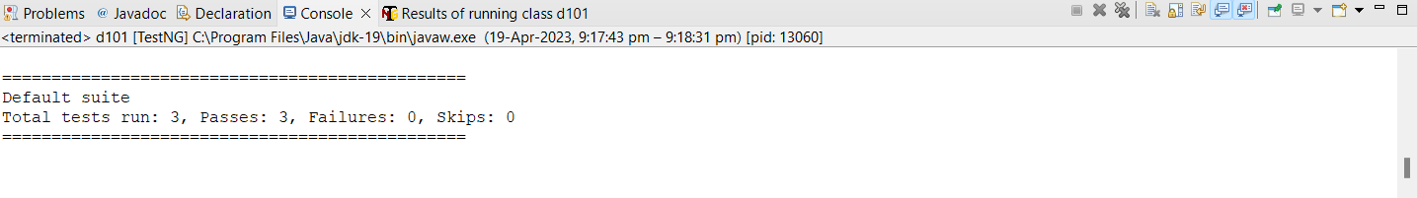

**EXTENDED REPORT:**

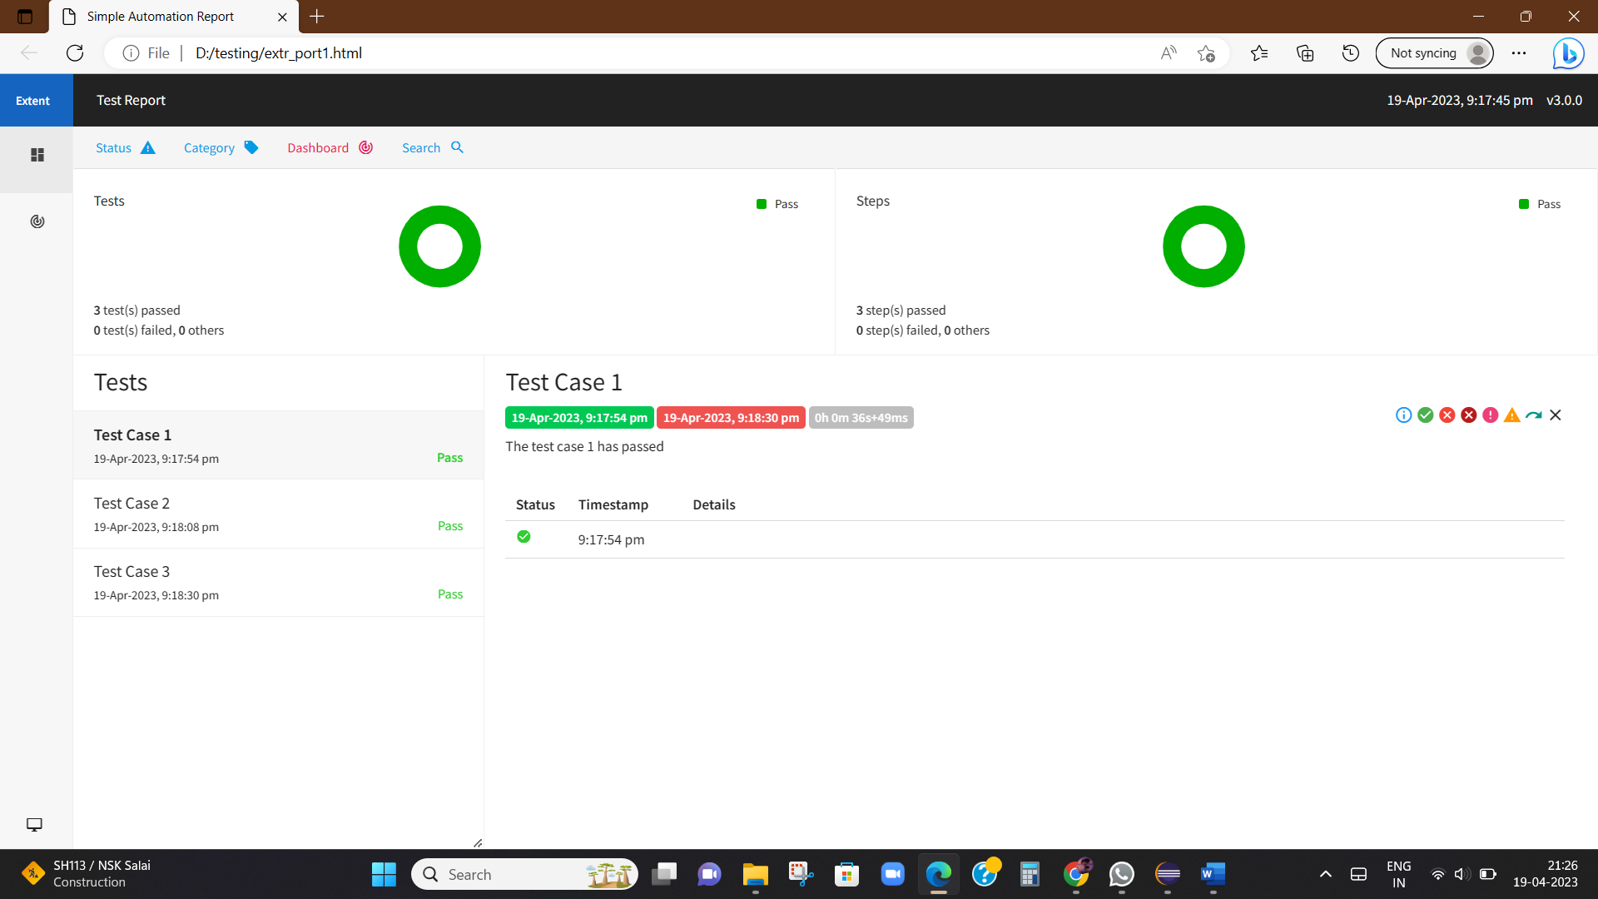

**TASK 4:**

**package** com.Demo.Demo;

**import** org.testng.annotations.Test;

**import** com.aventstack.extentreports.ExtentReports;

**import** com.aventstack.extentreports.ExtentTest;

**import** com.aventstack.extentreports.Status;

**import** com.aventstack.extentreports.reporter.ExtentHtmlReporter;

**import** com.aventstack.extentreports.reporter.configuration.ChartLocation;

**import** com.aventstack.extentreports.reporter.configuration.Theme;

**import** io.github.bonigarcia.wdm.WebDriverManager;

**import** org.testng.annotations.BeforeMethod;

**import** org.openqa.selenium.By;

**import** org.openqa.selenium.WebDriver;

**import** org.openqa.selenium.WebElement;

**import** org.openqa.selenium.chrome.ChromeDriver;

**import** org.openqa.selenium.chrome.ChromeOptions;

**import** org.testng.Assert;

**import** org.testng.ITestResult;

**import** org.testng.annotations.AfterMethod;

**import** org.testng.annotations.AfterTest;

**import** org.testng.annotations.BeforeClass;

**public** **class** d104

{

WebDriver driver;

**static** ExtentTest *test*;

**static** ExtentReports *extent*;

ExtentHtmlReporter htmlReporter;

@BeforeClass

**public** **void** startReport()

{

//ExtentSparkReporter htmlReporter = new ExtentSparkReporter("extentReport.html");

//htmlReporter = new ExtentHtmlReporter(System.getProperty("user.dir")+"/test-output/extentReport.html");

htmlReporter = **new** ExtentHtmlReporter("/Users/shreeja/Documents/Testing/Day10/extr2.html");

*extent* = **new** ExtentReports();

*extent*.attachReporter(htmlReporter);

//configuration items to change the look and feel

//add content, manage tests etc

htmlReporter.config().setChartVisibilityOnOpen(**true**);

htmlReporter.config().setDocumentTitle("Simple Automation Report");

htmlReporter.config().setReportName("Test Report");

htmlReporter.config().setTestViewChartLocation(ChartLocation.***TOP***);

htmlReporter.config().setTheme(Theme.***STANDARD***);

// htmlReporter.config().setTimeStampFormat("EEEE, MMMM dd, yyyy, hh:mm a '('zzz')'");

}

@Test

**public** **void** max_wid() {

WebElement from=driver.findElement(By.*xpath*("//*[@id=\"app\"]/div[1]/div/div[1]/div/div[2]/div[2]/form/div[1]/div/div[2]/input"));

from.sendKeys("Admin");

WebElement to=driver.findElement(By.*xpath*("//*[@id=\"app\"]/div[1]/div/div[1]/div/div[2]/div[2]/form/div[2]/div/div[2]/input"));

to.sendKeys("admin123");

WebElement submitBtn=driver.findElement(By.*xpath*("//*[@id=\"app\"]/div[1]/div/div[1]/div/div[2]/div[2]/form/div[3]/button"));

submitBtn.click();

String CurrentUrl=driver.getCurrentUrl();

String ExpectedUrl="https://opensource-demo.orangehrmlive.com/web/index.php/dashboard/index";

Assert.*assertEquals*(CurrentUrl, ExpectedUrl);

System.***out***.println("Smoke test");

driver.quit();

*test* = *extent*.createTest("Test Case", "The test case has passed");

}

@BeforeMethod

**public** **void** beforeMethod() **throws** InterruptedException {

WebDriverManager.*chromedriver*().setup();

ChromeOptions co=**new** ChromeOptions();

co.addArguments("--remote-allow-origins=*");

driver=**new** ChromeDriver(co);

driver.get("https://opensource-demo.orangehrmlive.com/web/index.php/auth/login");

driver.manage().window().maximize();

Thread.*sleep*(3000);

}

@AfterMethod

**public** **void** getResult(ITestResult result)

{

**if**(result.getStatus() == ITestResult.***FAILURE***)

{

*test*.log(Status.***FAIL***,result.getThrowable());

}

**else** **if**(result.getStatus() == ITestResult.***SUCCESS***)

{

*test*.log(Status.***PASS***, result.getTestName());

}

**else** {

*test*.log(Status.***SKIP***, result.getTestName());

}

}

@AfterTest

**public** **void** tearDown()

{

//to write or update test information to reporter

*extent*.flush();

}

}

**CONSOLE OUTPUT:**

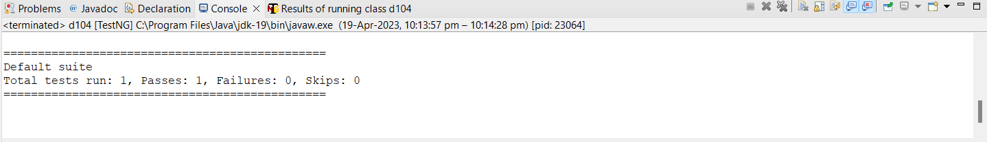

**EXTENDED REPORT:**

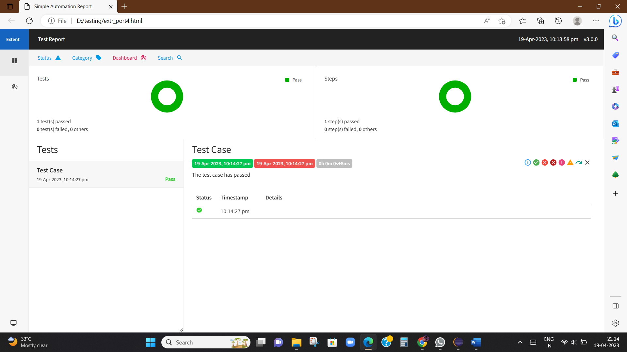

**TASK 5:**

**package** com.Demo.Demo;

**import** org.testng.annotations.Test;

**import** com.aventstack.extentreports.ExtentReports;

**import** com.aventstack.extentreports.ExtentTest;

**import** com.aventstack.extentreports.Status;

**import** com.aventstack.extentreports.reporter.ExtentHtmlReporter;

**import** com.aventstack.extentreports.reporter.configuration.ChartLocation;

**import** com.aventstack.extentreports.reporter.configuration.Theme;

**import** io.github.bonigarcia.wdm.WebDriverManager;

**import** org.testng.annotations.BeforeMethod;

**import** org.openqa.selenium.By;

**import** org.openqa.selenium.WebDriver;

**import** org.openqa.selenium.WebElement;

**import** org.openqa.selenium.chrome.ChromeDriver;

**import** org.openqa.selenium.chrome.ChromeOptions;

**import** org.testng.Assert;

**import** org.testng.ITestResult;

**import** org.testng.annotations.AfterMethod;

**import** org.testng.annotations.AfterTest;

**import** org.testng.annotations.BeforeClass;

**public** **class** d105

{

WebDriver driver;

**static** ExtentTest *test*;

**static** ExtentReports *extent*;

ExtentHtmlReporter htmlReporter;

@BeforeClass

**public** **void** startReport()

{

htmlReporter = **new** ExtentHtmlReporter("/Users/shreeja/Documents/Testing/Day10/extr2.html");

*extent* = **new** ExtentReports();

*extent*.attachReporter(htmlReporter);

htmlReporter.config().setChartVisibilityOnOpen(**true**);

htmlReporter.config().setDocumentTitle("Simple Automation Report");

htmlReporter.config().setReportName("Test Report");

htmlReporter.config().setTestViewChartLocation(ChartLocation.***TOP***);

htmlReporter.config().setTheme(Theme.***STANDARD***);

}

@Test

**public** **void** max_wid()

{

WebElement from=driver.findElement(By.*xpath*("//*[@id=\"app\"]/div[1]/div/div[1]/div/div[2]/div[2]/form/div[1]/div/div[2]/input"));

from.sendKeys("Suvitha");

WebElement to=driver.findElement(By.*xpath*("//*[@id=\"app\"]/div[1]/div/div[1]/div/div[2]/div[2]/form/div[2]/div/div[2]/input"));

to.sendKeys("12345");

WebElement submitBtn=driver.findElement(By.*xpath*("//*[@id=\"app\"]/div[1]/div/div[1]/div/div[2]/div[2]/form/div[3]/button"));

submitBtn.click();

String CurrentUrl=driver.getCurrentUrl();

String ExpectedUrl="https://opensource-demo.orangehrmlive.com/web/index.php/auth/login";

Assert.*assertEquals*(CurrentUrl, ExpectedUrl);

System.***out***.println("Smoke test");

driver.quit();

*test* = *extent*.createTest("Test Case", "The test case has passed");

}

@BeforeMethod

**public** **void** beforeMethod() **throws** InterruptedException

{

WebDriverManager.*chromedriver*().setup();

ChromeOptions co=**new** ChromeOptions();

co.addArguments("--remote-allow-origins=*");

driver=**new** ChromeDriver(co);

driver.get("https://opensource-demo.orangehrmlive.com/web/index.php/auth/login");

driver.manage().window().maximize();

Thread.*sleep*(3000);

}

@AfterMethod

**public** **void** getResult(ITestResult result)

{

**if**(result.getStatus() == ITestResult.***FAILURE***)

{

*test*.log(Status.***FAIL***,result.getThrowable());

}

**else** **if**(result.getStatus() == ITestResult.***SUCCESS***)

{

*test*.log(Status.***PASS***, result.getTestName());

}

**else** {

*test*.log(Status.***SKIP***, result.getTestName());

}

}

@AfterTest

**public** **void** tearDown()

{

*extent*.flush();

}

}

**CONSOLE OUTPUT:**

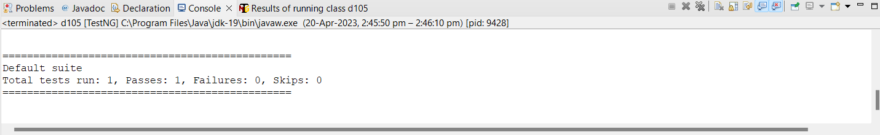

**EXTENDED REPORT:**

