Herald College, Kathmandu


Concepts and Technologies of AI

5CS037
Title of the project-HDI Data Analysis Report
Student name-Shreejaya Bhandari
Student ID-2462004
Course name-Concepts and Technologies of AI
Date of submission-10 January 2026

Table of Contents
1. Introduction 2
1.1. Background: 2
1.2. Objectives: 2
1.3. Scope 3
2. Problem 1A – Single Year HDI Exploration 3
2.1. Methodology / Approach: 3
2.2. Key results: 3
2.2.1. HDI Statistics (2022) 3
2.2.2. High HDI Countries and Income-Based Ranking (2022) 4
2.2.3. HDI Category Distribution (2022) 4
2.3. Interpretation and Discussions 4
3. Problem 1B – HDI Trend Analysis 5
3.1. Methodology / Approach: 5
3.2. Key results: 5
3.2.1. Line Chart: Country-Level HDI Trends (2020–2022) 5
3.2.2. Bar Chart: Average HDI by Region 5
3.2.3. Box Plot: HDI Distribution Across Years 5
3.2.4. Scatter Plot: HDI vs GNI per Capita 5
3.3. Visualization: 6
3.3.1. Line Chart — HDI Trend (Country-Level): 6
3.3.2. Bar Chart: Average HDI by Region (2020–2022) 6
3.3.3. Box Plot: HDI Distribution for 2020, 2021, and 2022 7
3.3.4. Scatter Plot: HDI vs. GNI per Capita 7
3.4. Interpretation and Discussions: 7
4. Problem 2-Advanced HDI Exploration 8
4.1. Methodology / Approach: 8
4.2. Key Results: 8
4.2.1. Composite Score Ranking: 8
4.2.2. Outlier Detection (HDI vs GNI per Capita): 9
4.2.3. Relationship Between HDI and Development Indicators: 9
4.2.4. GNI–HDI Gap Analysis: 9
4.3. Visualization: 10
4.3.1. Composite Development Score: 10
4.3.2. Outlier Detection: 10
4.3.3. Exploring Metric Relationships: 11
4.3.4. Gap Analysis: 11
4.4. Interpretation and Discussions: 11
5. Problem 3-Comparative Regional Analysis: South Asia vs Middle East 12
5.1. Methodology / Approach: 12
5.2. Key Results: 12
5.2.1. Descriptive Statistics (Regional Comparison): 12
5.2.2. Top and Bottom Performers: 13
5.2.3. Metric Comparisons Across Regions: 13
5.2.4. HDI Variability Analysis 13
5.2.5. Correlation and Outlier Analysis 13
5.3. Visualization 14
5.3.1. Descriptive Statistics: 14
5.3.2. Top and Bottom Performers: 14
5.3.3. Metric Comparisons: 15
5.3.4. HDI Disparity: 15
5.3.5. Correlation Analysis: 16
5.3.6. Outlier Detection: 17
5.4. Interpretation and Discussions: 18
6. Conclusion 18
7. References 18

Introduction

Background:
(UNDP, n.d.)In this document, the results of the statistical interpretation and exploratory data analysis performed on the Human Development Index dataset over various years and regions will be presented. The goals of the proposed research include analyzing the trends of HDI values within the most up-to-date year, advanced analysis based on metrics within South Asia, and the comparison of regions with regard to their development achievements between South Asia and the Middle Eastern regions. Coding has been performed using various libraries such as Pandas, NumPy, and Seaborn.

Objectives:
• To perform statistical interpretation and exploratory data analysis (EDA) on the HDI dataset
• To examine HDI patterns across countries and years
• To recognize trends in human development over time
• To compare development levels between different regions
• To study the relationship between HDI and its contributing indicators

Scope
The focus of this report is to analyze and explain human development trends by utilizing a Human Development Index (HDI) dataset from 2020-2022. The focus is also to explore HDI globally, HDI trends, a detailed study of a specific region, South Asia, and a comparison study done between South Asia and the Middle East regions based upon important development variables, HDI, life expectancy, gender HDI, and GNI per capita.

Problem 1A – Single Year HDI Exploration

2.1. Methodology / Approach:
The dataset of Human Development Index was first loaded to recognize all available years, after which the latest year (2022) was extracted for focused analysis and saved as hdi_2022_df. Basic investigative data analysis techniques were applied, including data inspection, missing value checks, and descriptive statistics. Data cleaning steps such as handling missing values, removing duplicates, and converting incorrect data types were performed to ensure data quality.
Data cleaning was conducted, including identifying missing values, wrong data types and duplicate entries in the 2022 HDI dataset. Texts projected as numeric and the corresponding numerical variables/values were found and (if necessary) corrected. Leading and trailing white space was removed from country names. Special characters like “–” were converted to NaN in NumPy. Considering that HDI is the longest measured variable, and based on several missing cases, we excluded the rows containing missing HDI values; gaps in other numeric columns were filled with median. These procedures avoided dataset inconsistency and were appropriate for analysis.

Key results:

HDI Statistics (2022)
- Mean HDI: 0.7229
- Median HDI: 0.7395
- Standard Deviation of HDI: 0.1530
- Country with highest HDI: Switzerland
- Country with lowest HDI: Somalia
The average global HDI value of 0.7229 is a sign that human development is high to moderate in the majority of countries. The median of 0.7395, which is slightly higher than the mean value indicates that HDI values are negatively skewed, that is, more countries are concentrated at the higher end of HDIs. A Standard Deviation of 0.1530 indicates wide disparities in development levels among the different countries of the world. The highest HDI was achieved in Switzerland which is having a good performance in all dimensions of human development and the lowest HDI observed for Somalia which got high developmental challenges.

High HDI Countries and Income-Based Ranking (2022)
The total number of countries whose HDI value exceeds 0.800 and that came under the very high human development criterion was 71. When the countries were arranged according to their GNI per capita, the country that ranked at the top for the highest HDI value of 0.942 and highest GNI per capita of 146,673.24 was Liechtenstein. This was followed by Qatar for an HDI value of 0.875 and GNI per capita of 95,944.38, then Singapore for an HDI value of 0.949 and GNI per capita of 88,761.15, and finally Ireland for an HDI value of 0.950 and GNI per capita of 87,467.51. This shows that although countries with higher incomes also have higher levels of human development, yet there are countries that show the opposite trend because countries with very high incomes do not show exactly the same level for HDI.

HDI Category Distribution (2022)
The graph showing the classification of countries according to their HDI values shows a distinct scatter of points according to the level of development. There are a total of 71 countries that belong to the Very High HDI (≥ 0.800) category, followed by 54 countries that belong to the High HDI (0.700–0.799) category. The Medium HDI (0.550–0.699) category encompasses 44 countries, and there are a total of 35 countries that belong to the Low HDI (<0.550) category. The classification shows that despite the fact that a large number of countries have made substantial progress towards high or very high human development, there is still a large number of countries facing severe development issues.

Interpretation and Discussions
The study of the 2022 Human Development Index (HDI) results reveals that inequalities between developed and developing countries still exist. Though the mean and median of HDI describe an index of moderate to high human development, the standard deviation portrays great variability, as indicated by huge disparities in human development among countries across the globe. The assessment of countries with very high HDI shows that merely developing countries with rich economic prosperity are not experiencing advancing human development, as indicated by Qatar, with an HDI value lower than countries like Ireland, which succeeded in gaining higher HDI despite low economic prosperity, and countries like Singapore. Though only 60% of countries’ human development falls within the Highly Developed or Very Developed categories, many countries are still facing great challenges with human development across the globe, requiring an emphasis on global human development.

Problem 1B – HDI Trend Analysis

3.1. Methodology / Approach:
The data analysis for Problem 1B concentrated on short-term changes in HDI data for the period spanning 2020 and 2022. To get the data relevant for the period required, the HDI data was filtered using the .isin() function, and data for 2020, 2021, and 2022 was obtained. However, since changes might end up occurring in the actual HDI data, the .copy()function was used with the goal of forming an independent data frame.
Data cleaning procedures were carried out to guarantee accuracy and validity. Missing data or null values within critical variables like country, year, and HDI were resolved, duplicates were removed, and fields with numerical data represented in text format or with non-numerical markers were formatted appropriately in numerical form. Data was analyzed using visualization and statistical procedures to evaluate country-specific trends, regional means, and any associated data distribution and correlation with HDI.

Key results:

Line Chart: Country-Level HDI Trends (2020–2022)
Now, to analyze the trends of HDI at a country level, this cleaned dataset was used to create a line chart. The dataset was filtered for five selected countries, and their HDI values for the years 2020, 2021, and 2022 were plotted against time. This visualization allows one to compare directly in country-level development trends and view changes during the selected period in HDI.

Bar Chart: Average HDI by Region
For comparison of the mean HDI scores of the regions in each year, a bar graph was plotted. The data was grouped by regions for each year by the groupby() function, and the mean value of the HDI was determined for every group.The graph helped in easily comparing the mean levels of human development among regions in each of the years.

Box Plot: HDI Distribution Across Years
To understand the distribution and variation of HDI scores, a box plot for the years 2020, 2021, and 2022 was created. The purpose of this analysis was to understand the distribution and variability in HDI scores and understand how differences in development among nations affected this distribution.

Scatter Plot: HDI vs GNI per Capita
A scatter plot was used to explore how HDI is related to Gross National Income (GNI) per capita. The plot allowed for an observation of how HDI is related to GNI per capita. HDI was used along with GNI per capita to see if there is a relationship between income levels and HDI results for a country.

Visualization:

Line Chart — HDI Trend (Country-Level):
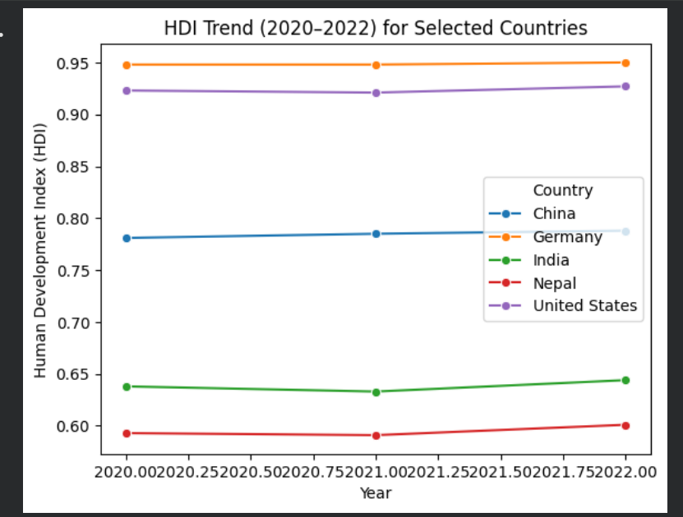
The above line chart illustrates the variation in the Human Development Index (HDI) scores for China, Germany, India, Nepal, and the United States from 2020 through 2022.

Bar Chart: Average HDI by Region (2020–2022)
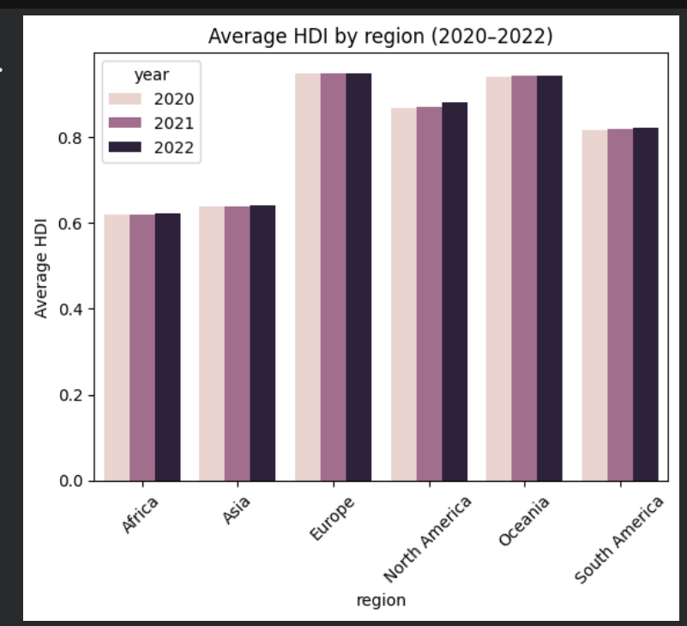
This bar graph highlights the average HDI scores for various regions between the years 2020 and 2022, suggesting that the regions with the highest HDI scores are Europe and Oceania, and the lowest are Africa and Asia.

Box Plot: HDI Distribution for 2020, 2021, and 2022
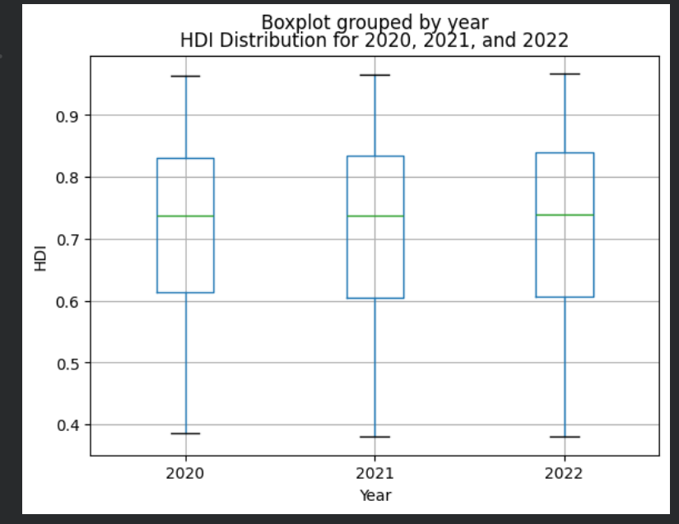
This box plot illustrates the distribution of HDI values for 2020, 2021, and 2022, showing a similar spread across years with a slight upward shift in median HDI by 2022, indicating gradual recovery in human development.

Scatter Plot: HDI vs. GNI per Capita
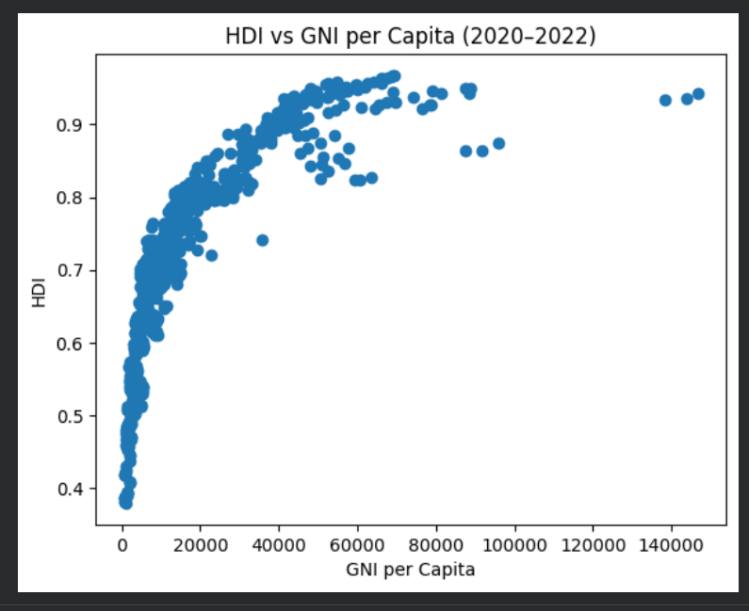
The scatter plot shows a strong positive relationship between GNI per capita and HDI, indicating that countries with higher income levels generally achieve higher human development, though gains tend to level off at higher income ranges.

Interpretation and Discussions:
The line graph shows that most countries had gradual improvement in HDI from 2020 to 2022, albeit slight stagnation or decrease in 2020-2021. These developments are related to the impact of the COVID-19 crisis on the countries chosen in terms of their HDI levels. Most countries had shown signs of recovery in 2022.
The bar chart: The regional bar chart clearly reveals regional disparities in average HDI, with more developed regions always scoring higher. The box plot: The box plot illustrates some stability in HDI, with only a slight reduction in dispersion in 2022, hinting at initial stabilization effects of the pandemic on HDI.
The scatter graph above shows a positive correlation between HDI and GNI per capita, which reinforces the significance of income in the development process. However, the scatter in the data implies that HDI is affected by a number of factors not measured by income.

Problem 2-Advanced HDI Exploration

4.1. Methodology / Approach:
Problem 2, Analysis of Advanced Exploration of Human Development Patterns in South Asia: The code started by defining the predetermined list of countries for South Asia: Afghanistan, Bangladesh, Bhutan, India, Maldives, Nepal, Pakistan, and Sri Lanka. From this list, the filtering of the original HDI dataset was done by adding the observations for these selected countries. This subset was then saved into another dataset for focused regional analysis.
A Composite Score was obtained by weighted summation of the Life Expectancy Index and GNI per capita. The countries were ranked on the Composite Scores and a horizontal bar graph was prepared to compare the best-performing countries. The outliers for HDI and GNI per capita were identified by the IQR method and analyzed graphically by means of scatter diagrams.
The correlation analysis was done by calculating the correlation coefficients of HDI with a set of indicators such as life expectancy and Gender Development Index. Graphs were created to represent correlation. Finally, the last task was to create a gap analysis by calculating the difference between GNI per capita and HDI; then rank the countries according to this difference. Also, bar charts were created to represent the biggest positive and negative difference.

Key Results:

Composite Score Ranking:
A ranking table was created where South Asian nations were ranked based on their Composite Score, so it is possible to compare their ranking with that of their HDI ranking. The formula used for calculating the Composite Score is as follows:
Composite score = 0.30 × Life Expectancy Index + 0.30 × GNI per Capita Index
This composite metric ranks on a weighted scale the health and economic aspects of a country’s development. Furthermore, a bar graph has been constructed on a horizontal scale to compare the first five countries in the list regarding their score on the criteria of overall development.

Outlier Detection (HDI vs GNI per Capita):
The scatter graphs for the HDI and GNI per capita data for South Asia were used to spot the outliers. Spotting the outliers can be done using the method known as the Interquartile Range (IQR), wherein the boundaries are calculated:
Lower Bound = Q1 – 1.5 × IQR
Upper Bound = Q3 + 1.5 * IQR
Nations whose HDI or GNI values of per capita output exceeded or was less than the specified ranges were highlighted through the use of specific markers.

Relationship Between HDI and Development Indicators:
Additional scatter plots with regression lines are created to explore the relationship between life expectancy and HDI and between HDI and Gender Development Index. The strength of these relationships can be quantified using Pearson correlation coefficient, which can be calculated as:
r = cov(X, Y) / (σₓ × σ)
Taking into consideration that X denotes the selected development indicator (life expectancy or gender development index), Y denotes HDI, and cov(X, Y) symbolizes the covariance between the variables, this representation enables an analysis of the nature and degree of relationship that exists or lacks between HDI and the development indicators.

GNI–HDI Gap Analysis:
The results of the gap analysis were summarized in tables ranking South Asian countries based on their GNI–HDI Gap. The GNI– HDI Gap was computed in the code by the expression:
GNI–HDI Gap = GNI per Capita − HDI
It basically calculates the gap between the economic performance of a country and its human development level. The countries were then listed in descending and ascending order based on this gap. Bar charts were drawn showing the top positive gap (high income with comparatively lower HDI) and top negative gap (lower income but relatively higher HDI), enabling clear comparison across countries.

Visualization:

Composite Development Score:
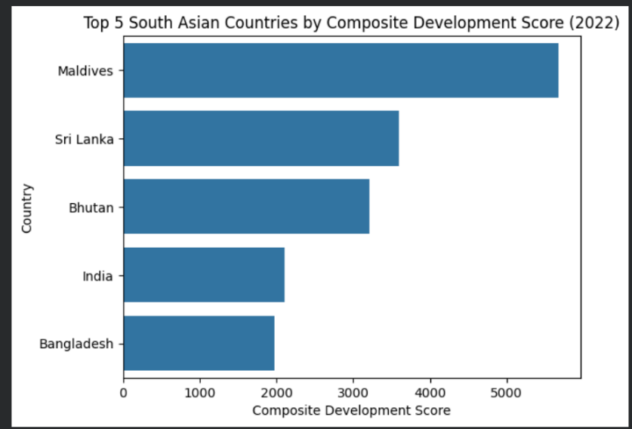
The bar chart shows that Maldives leads the South Asian countries by Composite Development Score, followed by Sri Lanka and Bhutan, thus indicating stronger combined performance in income and life expectancy than the others.

Outlier Detection:
c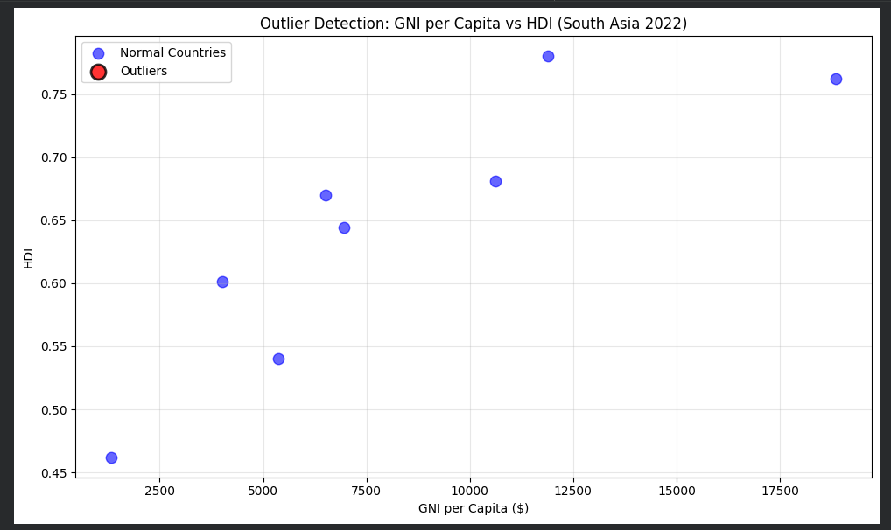
In this scatter graph, the outlier countries in South Asia emerge whose GNI per capita deviates considerably in being very high or very low relative to their HDI.

Exploring Metric Relationships:
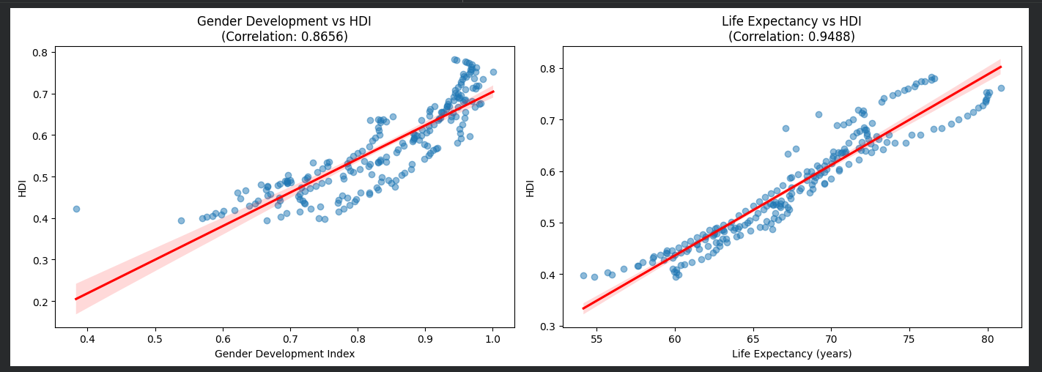
These scatter plots reflect that there is a strong positive linear relationship between HDI with both GDI and Life Expectancy, but life expectancy has a stronger relationship, meaning a closer association to the overall human development.

Gap Analysis:

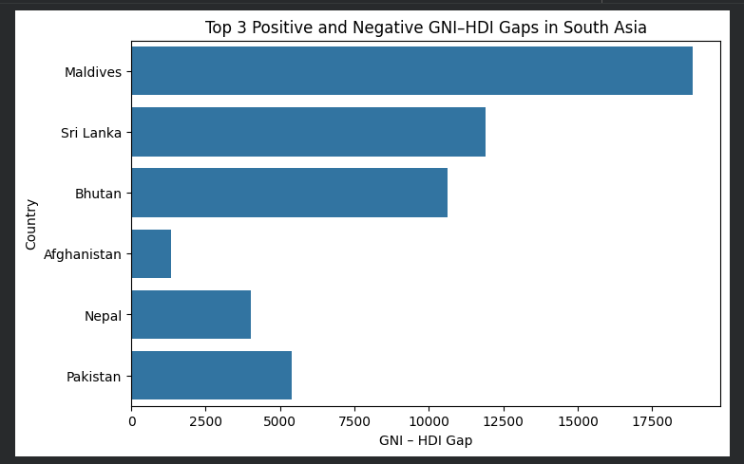
The graph indicates that countries like Maldives, Sri Lanka, and Bhutan have large differences of positive GNI-HDI gaps because of their income status being high in comparison to their human development, while countries like Afghanistan, Nepal, and Pakistan demonstrate negative gaps because of their better human development performance despite being at lower income statuses.

Interpretation and Discussions:
Analysis shows that there is a large variation of development outcomes between South Asian nations. The variance between the ranking based on Composite Score and HDI shows that while giving importance to certain indicators like income and longevity, a different development performance is recognized, emphasizing the extensive coverage that is included under HDI.
Outlier analysis helps to identify the countries with high or low GNI per capita in relation to HDI, denoting differences in the economic structure of various countries and health/education disparities. The result for correlation analysis reveals that the impact of life expectancy on HDI is more important than other factors, underlining the significance of health in regard to human development.
The GNI-HDI gap analysis again emphasizes the discrepancies occurring between economic growth and development achievements as some nations being deficient in their ability to transform their income into social welfare, while others make relatively better developmental achievements with less economic capability. In general, the result confirms that human development is multi-dimensional in South Asia.

Problem 3-Comparative Regional Analysis: South Asia vs Middle East

5.1. Methodology / Approach:
The comparison of human development in South Asia and the Middle East for Problem 3 was conducted by analyzing the cleaned HDI data for the periods 2020-2022. A list of countries in the two regions was established in the code and the data filtered accordingly.
Mean and standard deviation of HDI was used for the comparison of averages, as well as variability, to identify the top and bottom countries for each region. The comparison of regions was also extended by the use of the Life Expectancy Index, Gender Development Index, and the GNI per Capita, which was depicted by the grouped bar chart.
The consistency of HDI values was measured through range and coefficient of variation, while correlation analysis was employed to explore the relationship between HDI variables and key indicators. The IQR-based outlier detection was then employed to test for the existence of countries with highly anomalous HDI or income measures.

Key Results:

Descriptive Statistics (Regional Comparison):
A summary table was created with mean and SD for HDI, South Asia, and Middle East. Using the following formula:
Mean = ΣX / N
SD = √( Σ (X − Mean)² / N )
If there is an insignificant difference in the performance among schools, OR - Most of the variation lies between individual students rather than between schools. This table made it possible to compare directly the average development performance and dispersion between the two regions.​

Top and Bottom Performers:
The top three and bottom three countries in South Asia and the Middle East in regard to HDI were established using the HDI value for each country. The approach to carry out this task entailed the arrangement of the HDI value in a descending manner to determine the top-performing countries, as well as in an ascending manner to determine the lowest-performing countries.

Metric Comparisons Across Regions:
Bar charts grouped together were used to compare regional averages of:
- Life Expectancy Index
- Gender Development Index
- GNI per capita
Then, the regional mean for each indicator was calculated using the following equation:
Regional Mean = ΣX / N
These visualizations made comparison directly between South Asia and the Middle East and facilitated the identification of which indicator showed the highest regional disparity.

HDI Variability Analysis
For testing the consistency of development within regions, the value of HDI and Coefficient of Variation (CV) was determined by the following formulas:
Range =Max HDI-Min HDI
CV=Standard Deviation/Mean
​​ To facilitate the comparison of the levels of inequality and variations of human development between the two regions, a table was created based on these values.

Correlation and Outlier Analysis
The Pearson product-moment correlation was calculated according to the following formula and used to carry out a correlation analysis between HDI and development indicators:
r=cov(X,Y)​/σX​⋅σY​
X denotes a selected indicator (Life Expectancy Index or Gender Development Index),Y represents HDI, and σ\sigmaσ denotes standard deviation.
Outlier detection was done using IQR, which used the following boundaries:
Lower Bound=Q1−1.5×IQR
Upper Bound=Q3+1.5×IQR
Upper Bound=Q3+1.5×IQR Countries with values falling outside these thresholds were considered outliers and visualized by scatter plots.

Visualization

Descriptive Statistics:
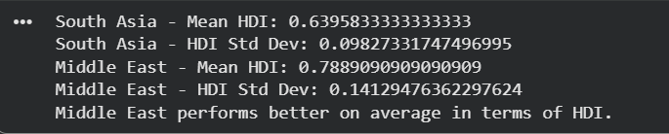
Analysis of the results indicates that the Middle East has a relatively high average HDI value of 0.789 compared to South Asia with an HDI value of 0.640, thus performing better in human development. Despite having a high standard deviation, it is apparent that the Middle East performs better compared to South Asia in the area of human development.

Top and Bottom Performers:
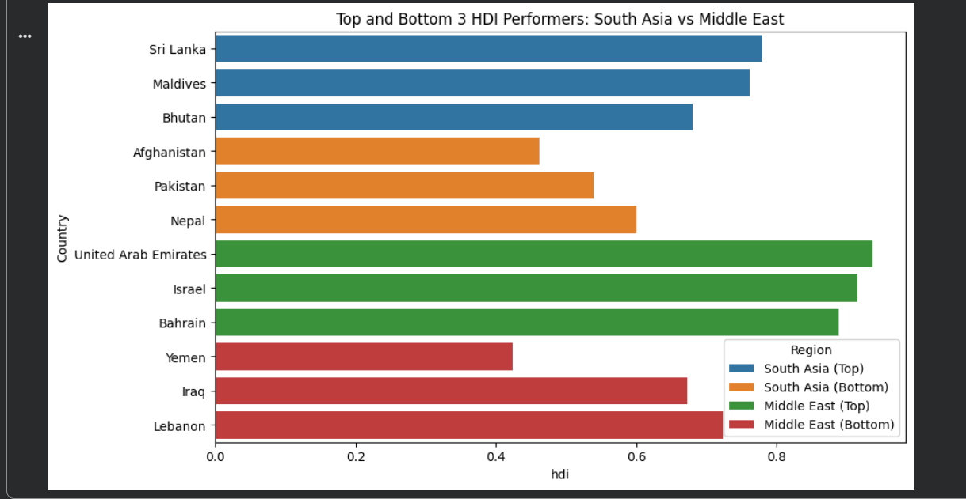
Based on the bar graph provided below, a comparison is made between the best and lowest three countries performing on HDI for South Asia and the Middle East, and it is illustrated that the best three countries on HDI performance in the Middle East have a much higher performance compared to South Asia’s best three countries, and that there are low-performing countries within both regions.

Metric Comparisons:
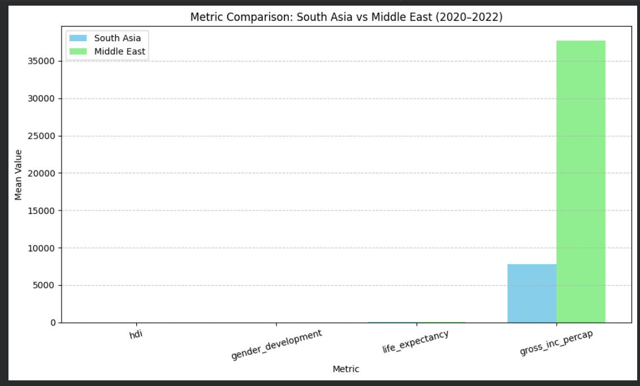
The bar chart has revealed that the Middle East is performing better than the South Asian regions in all the indicators of development, but the biggest gap can be noticed in the GNI per capita, as it clearly shows a vast economic potential and variation in the HDI, life expectancy, and female-development indicators.

HDI Disparity:
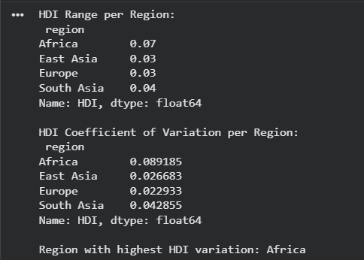
From this result, it is observed that Africa has the highest inequality level of HDI among regions; this is indicated by the highest HDI variation range of 0.07 and highest HDI variation coefficient of 0.089 compared to the other regions of East Asia, Europe, or South Asia, with more equal HDI levels.

Correlation Analysis:

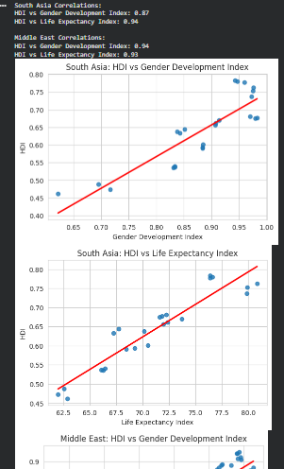
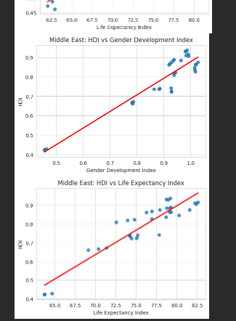
These scatter diagrams demonstrate a positive relationship in the HDI and the Gender Development Index and Life Expectancy in the South Asia and Middle East regions; however, the correlation of Life Expectancy appears to be stronger. This highlights the fact that the relationship between enhanced health performance and Human Development outstrips the performance related to the Development associated with the opposite gender.

Outlier Detection:
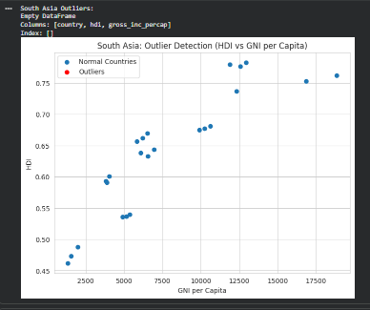
This shows that there are no outliers for South Asia in the HDI and GNI per capita relationship since all countries fall within the IQR-based range, implying that the trend for income and development for the countries is fairly consistent.
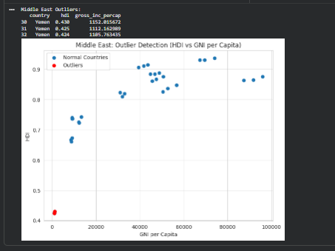
This output shows that outliers were detected in the Middle East, with Yemen (and another low-HDI, low-income observation) falling outside the IQR thresholds, indicating exceptionally low HDI and GNI per capita relative to the rest of the region, while most other countries follow a higher and more consistent income–development pattern.

Interpretation and Discussions:
The comparison indicates that there is a better average performance for the Middle East compared to South Asia in relation to HDI, while South Asia is underdeveloped compared to the Middle East. The disparity is greatest for GNI per capita, while life expectancy is a major HDI determinant for both regions. Through correlation and outlier analysis, there is a need for concern with health performance, while there is a deviation from both regions for some nations. The overall outcome indicates that human development varies in dimensions that need holistic approaches.

Conclusion
This study comprehensively explores the global and regional pattern in human development using HDI data. It underlines disparities in human development, the role of non-economic development indicators, and inequality across regions. Where income remains essential, health and education are key drivers of human development.
Limitations of the present study are the reliance on secondary data and use of restricted indicators. Further analysis could be done with more social and environmental factors, which would give more insight into human development on a sustainable basis.

References
UNDP, n.d. Human Development report.

