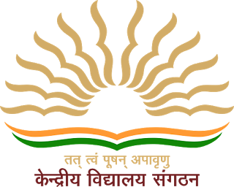 **Kendriya Vidyalaya No. - 2, Gwalior**

**CLASS – XII - A**

Subject : Chemistry

**INVESTIGATORY PROJECT**

on

**Study Of Common Food Adulterants**

Session : 2021-22

Submitted By : Submitted To :

**Shreeji Tiwari** **Mrs. Chitra Parmar**

Class 12 A PGT-Chemistry

Roll no. :

_________________ __________________________

ACKNOWLEDGEMENT

In the accomplishment of this project successfully many people have bestowed on me their blessing and their immense support.

I would like to express my special thanks of gratitude to my teacher Mrs. Chitra Parmar mam as well as our Principal sir Mr. Sanjeev Kumar Sambharia who gave me the golden opportunity to do this wonderful project on the topic

“To study the common food adulterants in fat, oil, sugar, turmeric powder, chili powder and pepper”

Which also helped me in doing a lot of research and I came to know about so many new things.

Secondly, I would also like to thank my parents who helped me a lot in finalizing this project within the given time.

Finally, I would like to thank all the people who helped me directly or indirectly during the completion of this project.

Shreeji Tiwari

Class 12th A

CERTIFICATE

This is to certify that the investigatory project on the topic

“Study of common food adulterants in fat, oil, sugar, turmeric powder, chili powder and pepper”

is a bonafide work done by **Shreeji Tiwari** of **Class XII A** in the Academic year **2021-2022** in the partial fulfilment of CBSE AISSCE Examination 2022 and has been carried out under my direct supervision and guidance.

**Mrs. Chitra Parmar**

PGT - Chemistry