Subversion

1. Checking If Subversion is installed

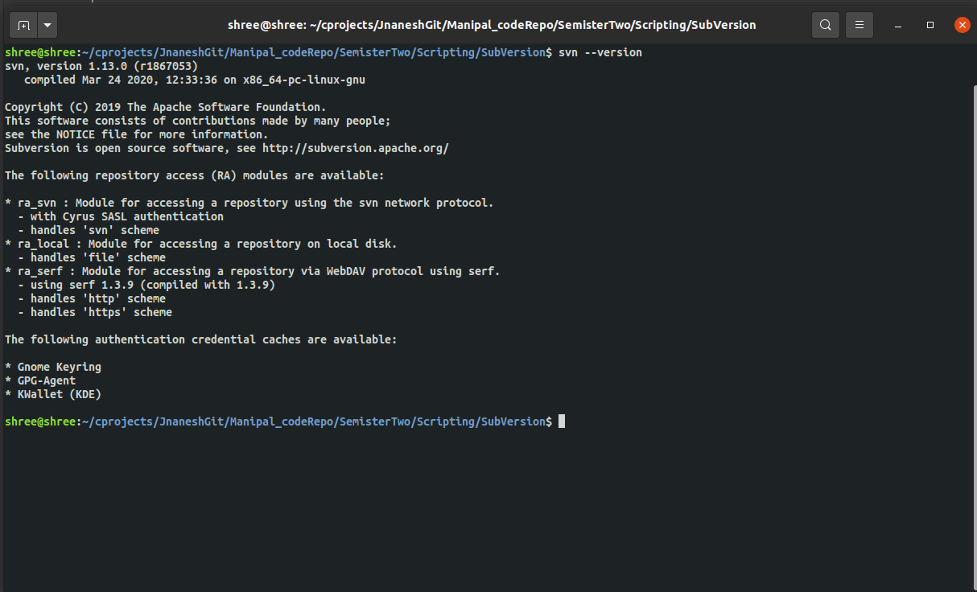

1. Create a SVN Repository

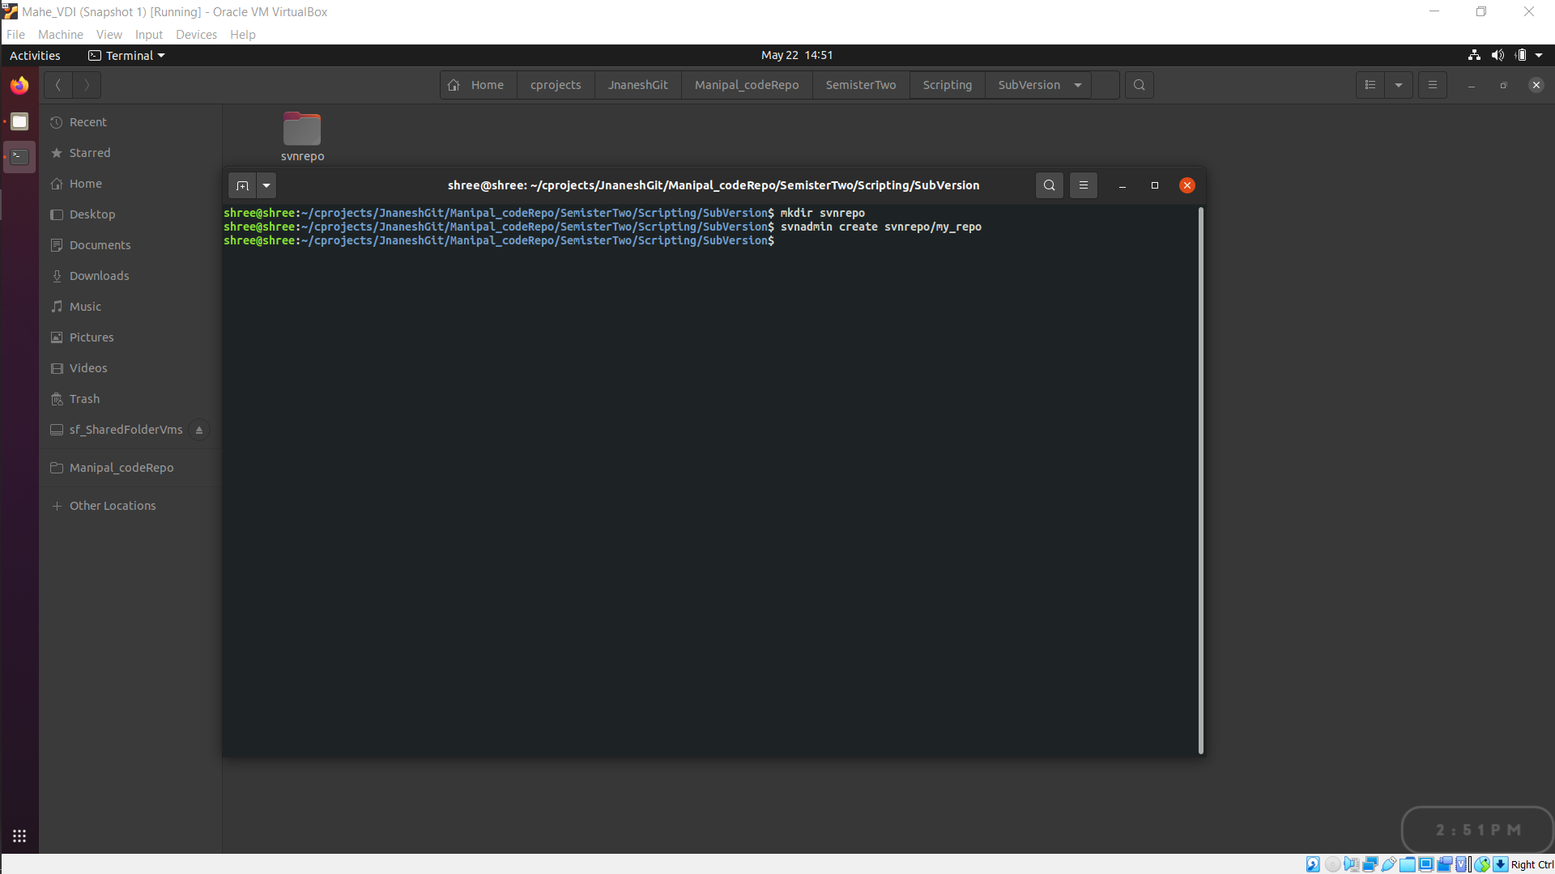

1. Checkout at working directory (local repo)

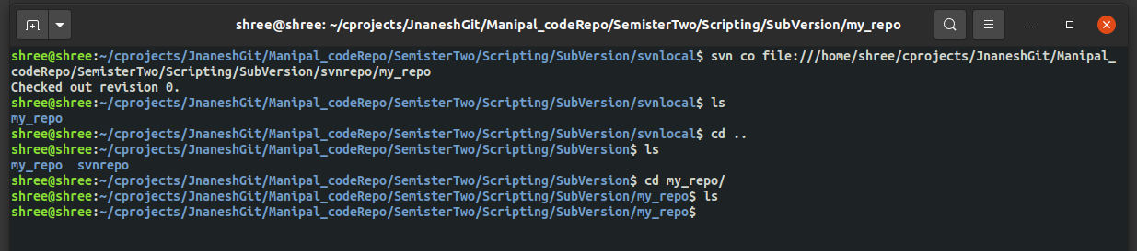

1. create some files inside working directory. add the files to local repo, commit the changes with proper message (mandatory) in the local repo. Each commit creates an ID which can be utilized to revise are verify.

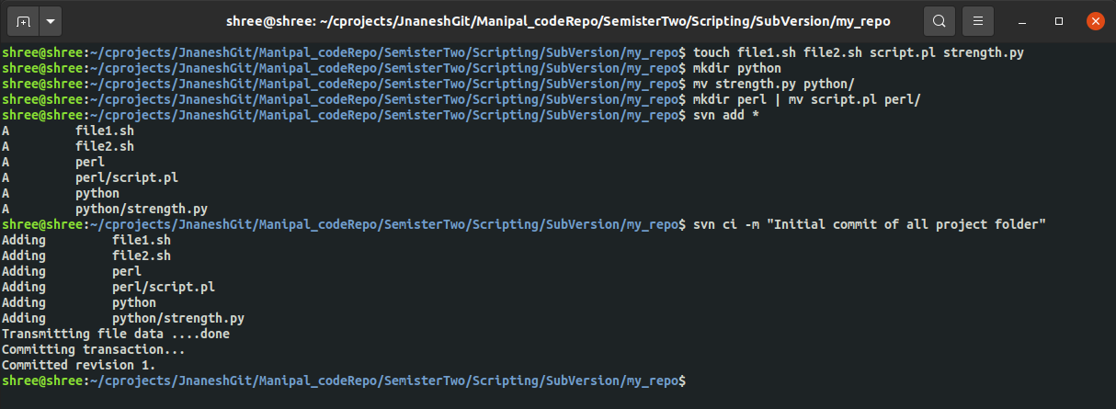

1. Checkout in a different directory to demonstrate multiple users connecting to a same repository.

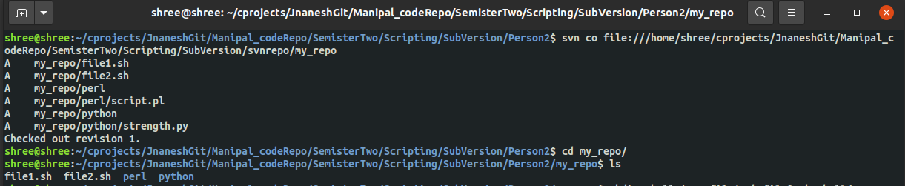

1. Check status of the files before modification if there is any changes.



1. Make some modifications in the new local repository and then commit changes to the remote repo

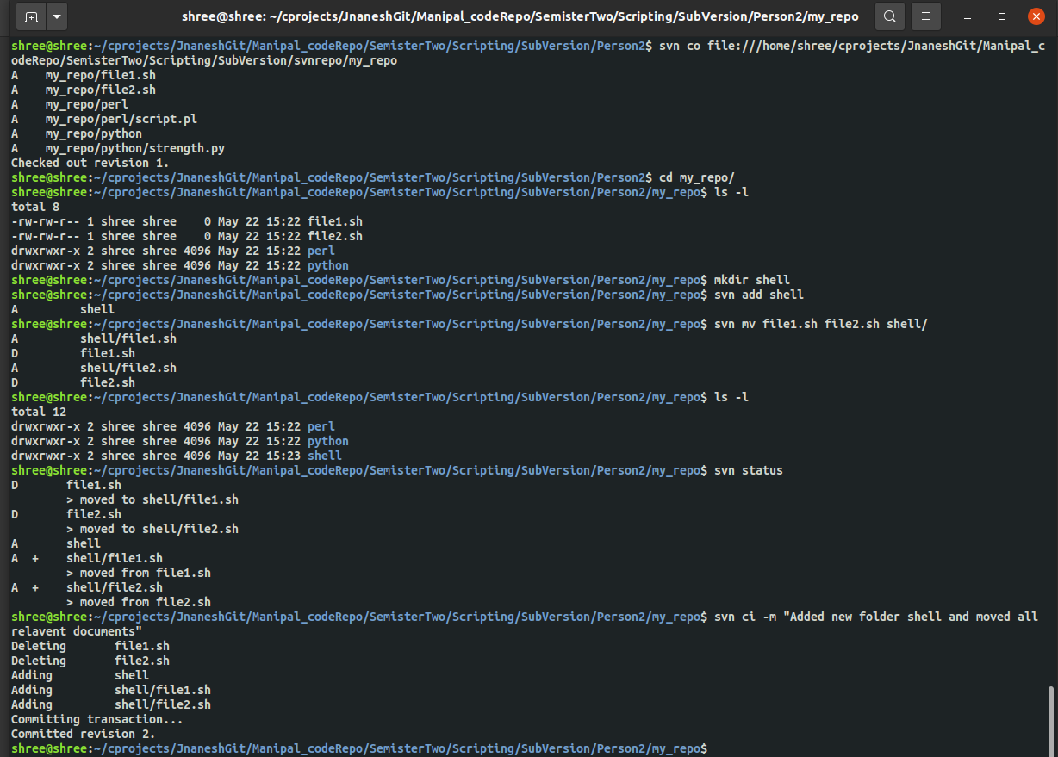

1. Print the log of different commits.

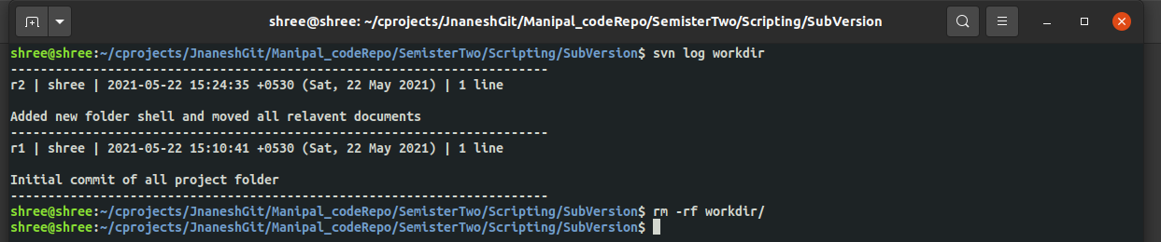

Logs can be extracted in 2 ways.

1. Using svn remote URL

**Svn log <Remote url(local/web/server)>**

1. Using local directorty (normally it shows the log of the instance when it is pulled, to get exact update the local repo using **svn up**), use below command inside working dir

**Svn log**

1. Update the old local repository with current version using Update.

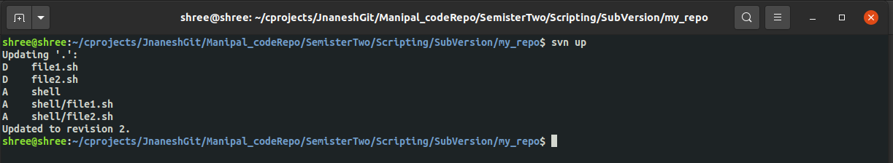

1. Basic CRUD operations
   1. Add files and folders.

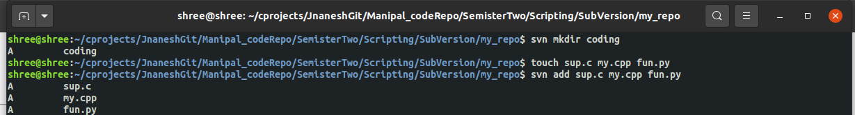

* 1. Rename Files



* 1. Copy files from one directory to another.



* 1. Delete files (Make sure all files are committed before deleting).



* 1. Move Files

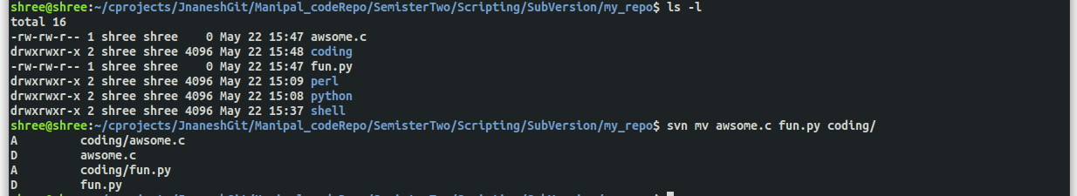

1. List all the files from the repo

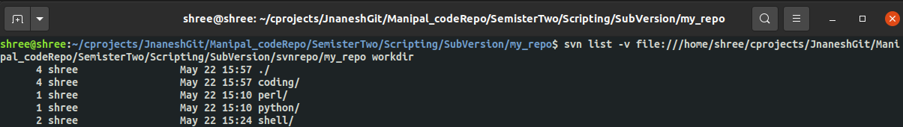

1. Information about the repo

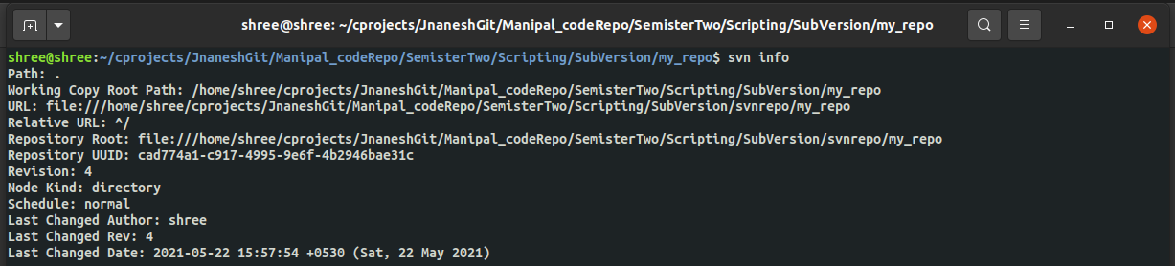

1. Access the file contents with respect to their version (mention the revision).

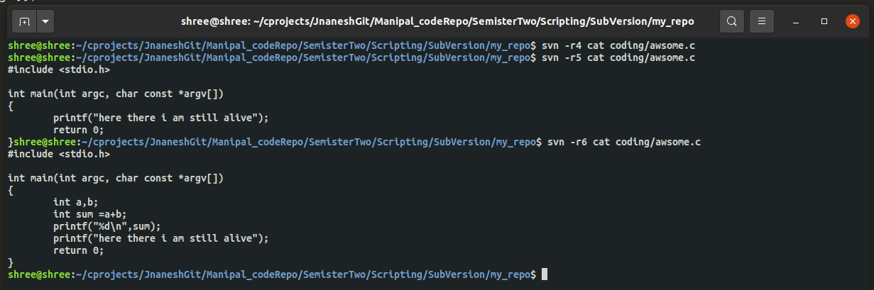

1. Svn diff commands used to check various changes across each version wrt previous version.

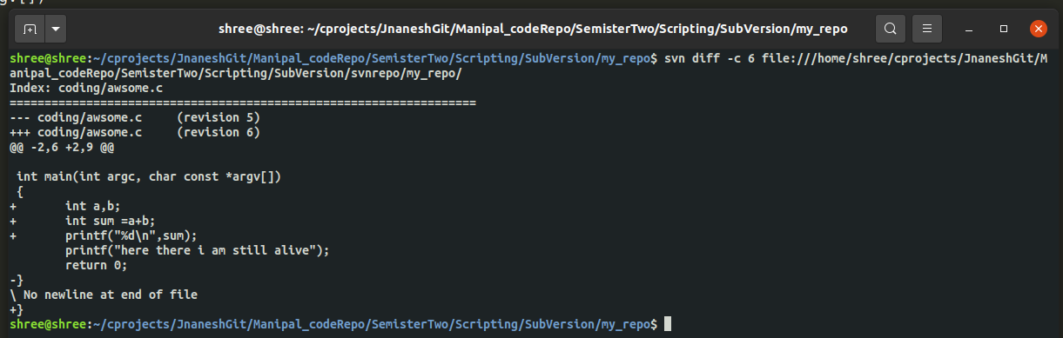

1. Import files from different folder to the repository

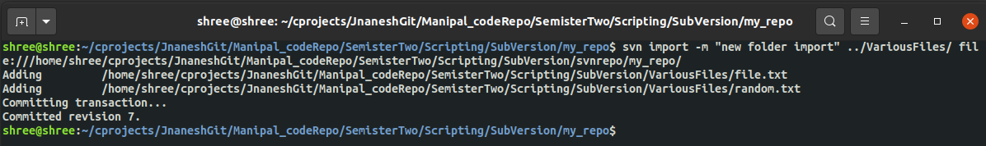

1. Summary of all log files

