import pandas as pd import numpy as np
import matplotlib.pyplot as plt
In [249…
In [250… df = pd.read_csv("C:/Users/shri/Downloads/StudentsPerformance_Prac2_100.csv")
In [251… df
Out[251… Math_Score Reading_Score Writing_Score Placement_Score Club_Join_Date

0 64 NaN 70.0 88.0 2020.0
1 | 68 |  | 94.0 | 62.0 | 79.0 | 2020.0
2 | 72 |  | 88.0 | 77.0 | 90.0 | 2018.0
3 | 77 |  | 80.0 | 63.0 | 99.0 | 2020.0
4 | 80 |  | 93.0 | 60.0 | 96.0 | 2020.0
... | ... |  | ... | ... | ...
...
95 61 84.0 69.0 68.0 NaN
96 | 72 |  | 75.0 | 86.0 | NaN | 2020.0
97 | 95 |  | 85.0 | 80.0 | 61.0 | 2021.0
98 | 69 |  | 88.0 | 55.0 | 99.0 | NaN
99 | 67 |  | 84.0 | 62.0 | 81.0 | NaN
100 rows × 6 columns
df.head()
Math_Score | Reading_Score | Writing_Score | Placement_Score | Club_Join_Date
In [252…
Out[252…
0 64 NaN 70.0 88.0 2020.0
1 |  | 68 | 94.0 | 62.0 | 79.0 | 2020.0
2 |  | 72 | 88.0 | 77.0 | 90.0 | 2018.0
3 |  | 77 | 80.0 | 63.0 | 99.0 | 2020.0
4 |  | 80 | 93.0 | 60.0 | 96.0 | 2020.0
In [253… df.shape
Out[253… | (100, 6)
In [254… df.columns
Out[254… Index(['Math_Score', 'Reading_Score', 'Writing_Score', 'Placement_Score',
'Club_Join_Date', 'Placement_Offer_Count'], dtype='object')
df.dtypes
Math_Score int64
Reading_Score float64
Writing_Score float64
Placement_Score float64
Club_Join_Date float64 Placement_Offer_Count int64
dtype: object
df.isnull().sum()
Math_Score 0
Reading_Score 9
Writing_Score 7
Placement_Score 3
Club_Join_Date 22 Placement_Offer_Count 0
dtype: int64
df.isnull().sum().sum()
np.int64(41)
series = pd.isnull(df["Math_Score"]) df[series]
Math_Score Reading_Score Writing_Score | Placement_Score | Club_Join_Date
In [255…
Out[255…
In [256…
Out[256…
In [257…
Out[257…
In [258…
Out[258…P
In [259… df['Math_Score'] = df['Math_Score'].fillna(df['Math_Score'].mean()) df['Reading_Score'] = df['Reading_Score'].fillna(df['Reading_Score'].median()) df['Writing_Score'] = df['Writing_Score'].fillna(df['Writing_Score'].mode()) df['Placement_Score'] = df['Placement_Score'].fillna(df['Placement_Score'].mea
In [260… df
Out[260… Math_Score Reading_Score Writing_Score Placement_Score Club_Join_Date

0 64 85.0 70.0 88.000000 2020.0
1 | 68 |  | 94.0 | 62.0 |  | 79.000000 |  | 2020.0
2 | 72 |  | 88.0 | 77.0 |  | 90.000000 |  | 2018.0
3 | 77 |  | 80.0 | 63.0 |  | 99.000000 |  | 2020.0
4 80 93.0 60.0 96.000000 2020.0
... | ... |  | ... | ... |  | ...
95 | 61 |  | 84.0 | 69.0 |  | 68.000000 |  | NaN
96 | 72 |  | 75.0 | 86.0 |  | 87.804124 |  | 2020.0
97 | 95 |  | 85.0 | 80.0 |  | 61.000000 |  | 2021.0
98 | 69 |  | 88.0 | 55.0 |  | 99.000000 |  | NaN
99 | 67 |  | 84.0 | 62.0 |  | 81.000000 |  | NaN
...
100 rows × 6 columns
In [261… df['Club_Join_Date'] = df['Club_Join_Date'].fillna(df['Club_Join_Date'].mode() df
Out[261… Math_Score Reading_Score Writing_Score Placement_Score Club_Join_Date

0 64 85.0 70.0 88.000000 2020.0
1 | 68 |  | 94.0 |  | 62.0 | 79.000000 | 2020.0
2 | 72 |  | 88.0 |  | 77.0 | 90.000000 | 2018.0
3 | 77 |  | 80.0 |  | 63.0 | 99.000000 | 2020.0
4 | 80 |  | 93.0 |  | 60.0 | 96.000000 | 2020.0
... | ... |  | ... |  | ... | ...
95 | 61 |  | 84.0 |  | 69.0 | 68.000000 | 2020.0
96 | 72 |  | 75.0 |  | 86.0 | 87.804124 | 2020.0
...
97 95 85.0 80.0 61.000000 2021.0
98 69 88.0 | 55.0 | 99.000000 2020.0
99 67 84.0 | 62.0 | 81.000000 2020.0
100 rows × 6 columns
col = ['Math_Score', 'Reading_Score', 'Writing_Score'] df.boxplot(col) plt.show()
In [262…
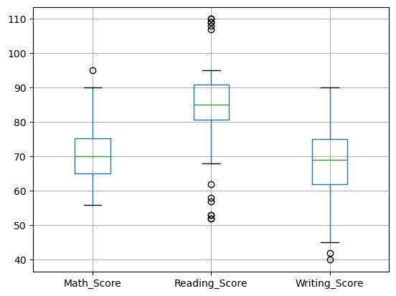
col = ['Placement_Score']
df.boxplot(col) plt.show()
In [263…
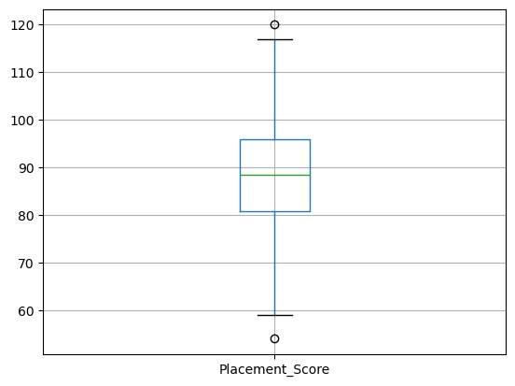
import numpy as np from scipy import stats
z = np.abs(stats.zscore(df['Math_Score'])) print(z)
In [264…
[0.89567475 0.31594999 0.26377476 0.98843071 1.42322428 0.84349952
0.26377476 1.04060594 0.75074356 0.31594999 0.26377476 0.1710188
1.04060594 0.98843071 0.84349952 1.33046832 1.47539951 0.40870595 0.98843071 0.69856833 0.98843071 0.60581237 2.05512426 0.60581237
1.04060594 1.18553713 0.84349952 1.18553713 1.27829309 0.26377476 0.11884358 1.33046832 1.27829309 0.40870595 0.84349952 1.1333619
0.02608761 0.26377476 1.42322428 0.75074356 0.84349952 1.42322428 0.75074356 1.18553713 0.40870595 0.11884358 0.1710188 1.18553713 0.40870595 1.27829309 0.02608761 1.42322428 0.26377476 0.11884358
0.75074356 1.18553713 0.31594999 0.31594999 0.46088118 0.40870595 0.69856833 1.33046832 1.47539951 0.02608761 0.69856833 1.1333619
1.27829309 1.18553713 0.11884358 0.98843071 0.46088118 0.89567475 0.46088118 0.02608761 1.04060594 0.60581237 1.42322428 1.04060594 0.26377476 0.84349952 1.27829309 0.69856833 0.02608761 1.47539951 0.75074356 1.33046832 0.02608761 0.40870595 1.18553713 2.87253617
0.26377476 1.6203307 0.26377476 0.60581237 0.60581237 1.33046832
0.26377476 3.59719212 0.1710188 0.46088118]
In [284… np.where
Out[284… <function where at 0x00000214EC9B1630>
In [285… threshold = 3
np.where(z > threshold)
Out[285… | (array([97]),)
sorted_rscore = sorted(df['Reading_Score']) q1 = np.percentile(sorted_rscore, 25) q3 = np.percentile(sorted_rscore, 75)
IQR = q3 - q1 lower = q1 - (1.5 * IQR) upper = q3 + (1.5 * IQR)
print("Lower Bound:", lower) print("Upper Bound:", upper)
In [286…
Lower Bound: 73.0
Upper Bound: 97.0
outliers = [] for i in sorted_rscore:
if i < lower or i > upper:
outliers.append(i)
outliers
In [287…
Out[287… [68.0]
plt.scatter(df['Placement_Score'], df['Placement_Offer_Count']) plt.xlabel("Placement Score") plt.ylabel("Placement Offer Count") plt.show()
In [288…
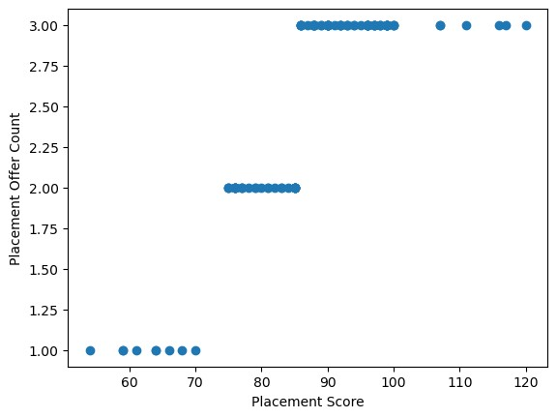
print(np.where((df['Placement_Score'] > 85) & (df['Placement_Offer_Count'] <
In [289…3
(array([], dtype=int64),)
Q1 = df['Reading_Score'].quantile(0.25)
Q3 = df['Reading_Score'].quantile(0.75)
IQR = Q3 - Q1 lower = Q1 - 1.5 * IQR upper = Q3 + 1.5 * IQR
In [290…
median = np.median(sorted_rscore)
df['Reading_Score'] = np.where( df['Reading_Score'] > upper,
median,
df['Reading_Score']
)
df['Reading_Score'] = np.where( df['Reading_Score'] < lower, median,
In [291…
df['Reading_Score']
) df
Math_Score Reading_Score | Writing_Score | Placement_Score Club_Join_Date
Out[291…
0 64 85.0 70.0 88.000000 2020.0
1 | 68 |  | 94.0 |  | 62.0 | 79.000000 |  | 2020.0
2 | 72 |  | 88.0 |  | 77.0 | 90.000000 |  | 2018.0
3 | 77 |  | 80.0 |  | 63.0 | 99.000000 |  | 2020.0
4 | 80 |  | 93.0 |  | 60.0 | 96.000000 |  | 2020.0
... | ... |  | ... |  | ... | ...
95 | 61 |  | 84.0 |  | 69.0 | 68.000000 |  | 2020.0
96 | 72 |  | 75.0 |  | 86.0 | 87.804124 |  | 2020.0
97 | 95 |  | 85.0 |  | 80.0 | 61.000000 |  | 2021.0
98 | 69 |  | 88.0 |  | 55.0 | 99.000000 |  | 2020.0
99 | 67 |  | 84.0 |  | 62.0 | 81.000000 |  | 2020.0
...
100 rows × 8 columns
df.loc[df['Placement_Score'] < 75, 'Placement_Offer_Count'] = 1
df.loc[
(df['Placement_Score'] >= 75) & (df['Placement_Score'] <= 85),
'Placement_Offer_Count'
] = 2
df.loc[df['Placement_Score'] > 85, 'Placement_Offer_Count'] = 3
In [292…
In [295… df['Reading_Score'].plot(kind='hist') plt.title("Before Log")
plt.show()
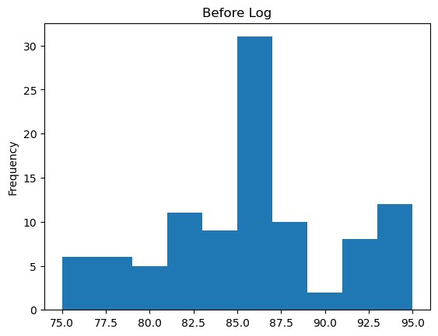
df['log_reading'] = np.log10(df['Reading_Score'])
df['log_reading'].plot(kind='hist')
plt.title("After Log")
plt.show()
In [294…
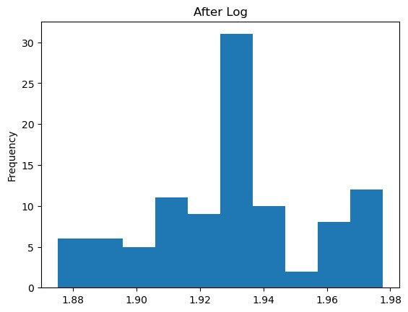
df.loc[df['Placement_Score'] > 85, 'Placement_Offer_Count'] = 3
In [296…
df['log_math'] = np.log10(df['Math_Score'])
df['log_math'].plot(kind='hist')
plt.title("After Log")
plt.show()
In [297…
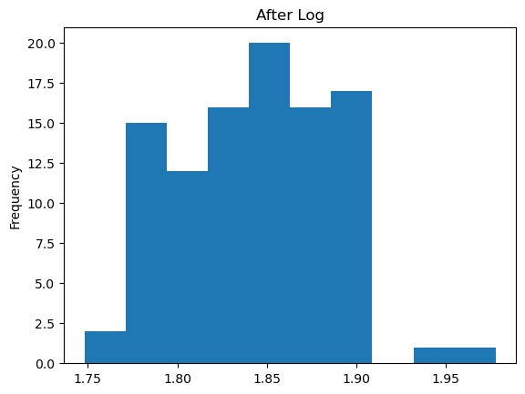
In
[
]:

