**MOBILES ARE BANNED**

**M.S. Ramaiah Institute of Technology**

**(Autonomous Institute, Affiliated to VTU)**

**Department of Information Science & Engg.**

|  |  |  |  |
| --- | --- | --- | --- |
| **Term:** | 13.08.2015 to 16.12.2015 | **Course Code:** | IS523 |
| **Course:** | Intellectual Property Rights | **Semester:** | V – A, B & C |
| **CIE:** | Test – II | **Max Marks:** | 30 |
| **Date:** | 30-10-2015 | **Time:** | 9:30 AM – 10:30 AM |

**Portions for Test:** Unit-II and Unit-III

**Instructions to Candidates:** Answer any 2 questions.

|  |  |  |  |  |  |
| --- | --- | --- | --- | --- | --- |
| **Sl#** |  | **Question** | **Marks** | **Course Outcome** | **Bloom’s Level** |
| 1. | a) | What is a Specification? List out the contents of the complete specification as specified under Section 10 of Patent Act. | 10 | CO2 | Remember |
| b) | Discuss the principles for deciding the question of similarity of two trademarks. | 05 | CO3 | Under stand |
| 2. | a) | Describe the fundamental principles of Registration of Trademarks. | 10 | CO3 | Understand |
| b) | What is a claim? How do you categorize claims? | 05 | CO2 | Analyze |
| 3. | a) | Describe the procedure for Registration of Patent. | 05 | CO2 | Under stand |
| b) | Discuss the essential elements of a Trademark. | 10 | CO3 | Under stand |

**M.S. Ramaiah Institute of Technology**

**(Autonomous Institute, Affiliated to VTU)**

**Department of Information Science & Engg.**

|  |  |  |  |
| --- | --- | --- | --- |
| **Term:** | 13.08.2015 to 16.12.2015 | **Course Code:** | IS523 |
| **Course:** | Intellectual Property Rights | **Semester:** | V – A, B & C |
| **CIE:** | Test – II | **Max Marks:** | 30 |

**Scheme and Solution**

**1a)** The description of the patent is called specification. The specification is an essential part of patent application. **(2 Marks)**

The contents of the complete specification as specified under Section 10 of Patent Act:  **(8 Marks)**

1. Title sufficiently indicating the subject-matter to which the invention relates.
2. A full and particular description of the invention and its operation or use and the method by which it is to be performed.
3. A disclosure of the best method of performing invention which is known to the applicant and for which he seeks to claim protection.
4. The claim(s) defining the scope of the invention.
5. The specification must be accompanied by an abstract to provide technical information on the invention.
6. In case of international application designating India, the title, description, drawings, abstract and claims to be filed with an application.
7. A declaration as to the inventorship of the invention.
8. A complete specification may include claims in respect of
   * developments of,
   * additions to, the inventions described in the provisional specification.

1b) **Principles of deciding similar marks – (5 Marks)**

* The marks should be compared as a whole, not microscopic examination
* Visual and Phonetic tests must be applied
* Mark to be viewed from a person of average intelligence and imperfect recollection
* Factors to be considered for deciding deceptive similarity
* They are phonetically, visually and structurally similar
* Similar in nature, character and performance of the goods
* The nature of goods in respect of which they are used as trademarks

2a) **Fundamental Principles include: (point 1 to 6 🡪 1 Mark each + point 7 and 8 🡪 2 Marks each)**

1. A trader cannot claim absolute proprietary right on any word or symbol – (Section 28(3))
2. Descriptive words, surnames and geographical names are not prima facie(based on the first impression; accepted as correct until proved otherwise) registrable. Eg: ‘Sharma’ cannot be used for confectionary goods.
3. The interest of the public is to be safe gaurded. Should not mislead the public regarding the origin of the good(s).
4. The provision that one mark is to denote one origin is not absolute i.e., two traders may have been using a similar marks in respect of goods over a period of time, each oblivious of the use of such mark by other.
5. The life of a trade mark depends on its actual use. Section 47 of the Act provides that a trade mark may be removed from the Register on ground of non-use.
6. A trade mark is a form a property, the proprietorship of the trade mark is assignable and transmissible as in case of other forms of property.

7. 🡪 The property rights in a trade mark acquired by the use are superior to similar rights obtained by registration under act.

🡪Prior users of trade marks are protected against any exercise of monopoly rights by people having registered similar marks though later in time.

8. 🡪 The trade mark law is not coded with the aim of protecting the interest of traders only.

🡪 The interest of others too are safe guarded by giving them opposition to the registration.

🡪 Opposition can be raised after the mark has been registered.

2b) Claim- the most important part of a specification **(1 Mark)**

Claims not to be vague or broad

Broadest claim as possible

Claims **(4 Marks)**

* Main Claim- State the invention in broadest terms possible
* Subordinate claim- Additional features of the invention
* Omnibus Claim- relates to any arrangement substantially as described and as shown in drawings

**3a)**  The procedure for Registration of Patent. **(5 Marks)**

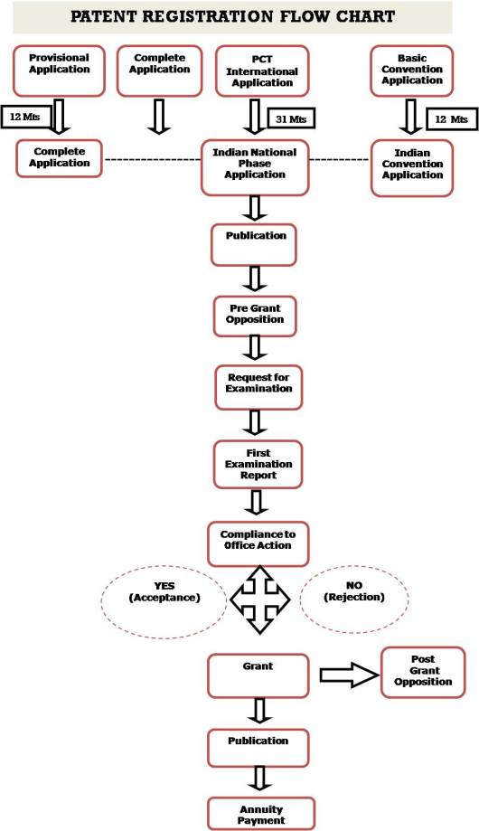

**3b) Essential elements of trademark include: (10 Marks)**

* Distinctiveness of the trademark,
* Class dependent
* Distinctiveness maybe inherent or acquired
* Should be preferably an invented word
* The trademark should be a word or name ,easy to pronounce
* Easy to spell correctly and write legibly
* Should be short
* Appeal to the eye and ear
* Satisfy the requirements of registration
* Should not belong to the class of marks prohibited for registration