M S RAMAIAH INSTITUTE OF TECHNOLOGY
(Autonomous Institute, affiliated to VTU)
DEPARTMENT OF INFORMATION SCIENCE & ENGINEERING
Term: | 13.08.2015 to 16.12.2015 | Course Code: | IS511
Course: | Data Communications | Semester: | V – A, B & C
CIE: | Test – II | Max Marks: | 30
Date: | 29.10.2015 | Time: | 9.30 AM – 10.30 AM
Portions for Test: Lecture Nos. from 19 to 36 as per lesson plan.
Instructions to Candidates: answer any two questions.
Note: Mobiles and Programmable Calculators are strictly prohibited.
Sl. # | Question | Marks | Bloom’s Level # | COs
1. | - Calculate quantization and encoding of a given sampled signal {-6.1, 7.5, 16.2, 19.7, 11.0,-5.5, -11.3, -9.4, -6.0}. Assume amplitude between -20 V & +20V and eight level. | 7 | Apply | CO2
1. | - Given the Dataword 1001 and the divisor 1011, generate the codeword at the sender site using CRC polynomial division. Assuming no error calculate the syndrome at the receiver site. | 8 | Apply | CO3
2 | - Illustrate the components of PCM encoder. | 5 | Understand | CO2
2 | - With necessary algorithm, illustrate Go Back N Automatic Repeat Request protocol. | 10 | Understand | CO3
3 | - What is sampling? Illustrate sampling of a clock with only one hand using T_{s}=6 hours and T_{s}= 9 hours. | 5 | Apply | CO2
3 | - Illustrate why the size of sender window in selective repeat ARQ is equal to 2^{m-1}. Calculate the check sum for a text of 8 characters “Forouzan” at sender and receiver side (assume F=46, o=6F, r=72, u=75 ,z=7A,a=61, n=6E) . | 10  (6+4) | Apply | CO3

M S RAMAIAH INSTITUTE OF TECHNOLOGY
(Autonomous Institute, affiliated to VTU)
DEPARTMENT OF INFORMATION SCIENCE & ENGINEERING
Term: | 13.08.2015 to 16.12.2015 | Course Code: | IS511
Course: | Data Communications | Semester: | V – A, B & C
CIE: | Test – II | Max Marks: | 30
Date: | 21.09.2015 | Time: | 9.30 AM – 10.30 AM
Answer scheme
Ans 1a: delta value calculation 1 Mark
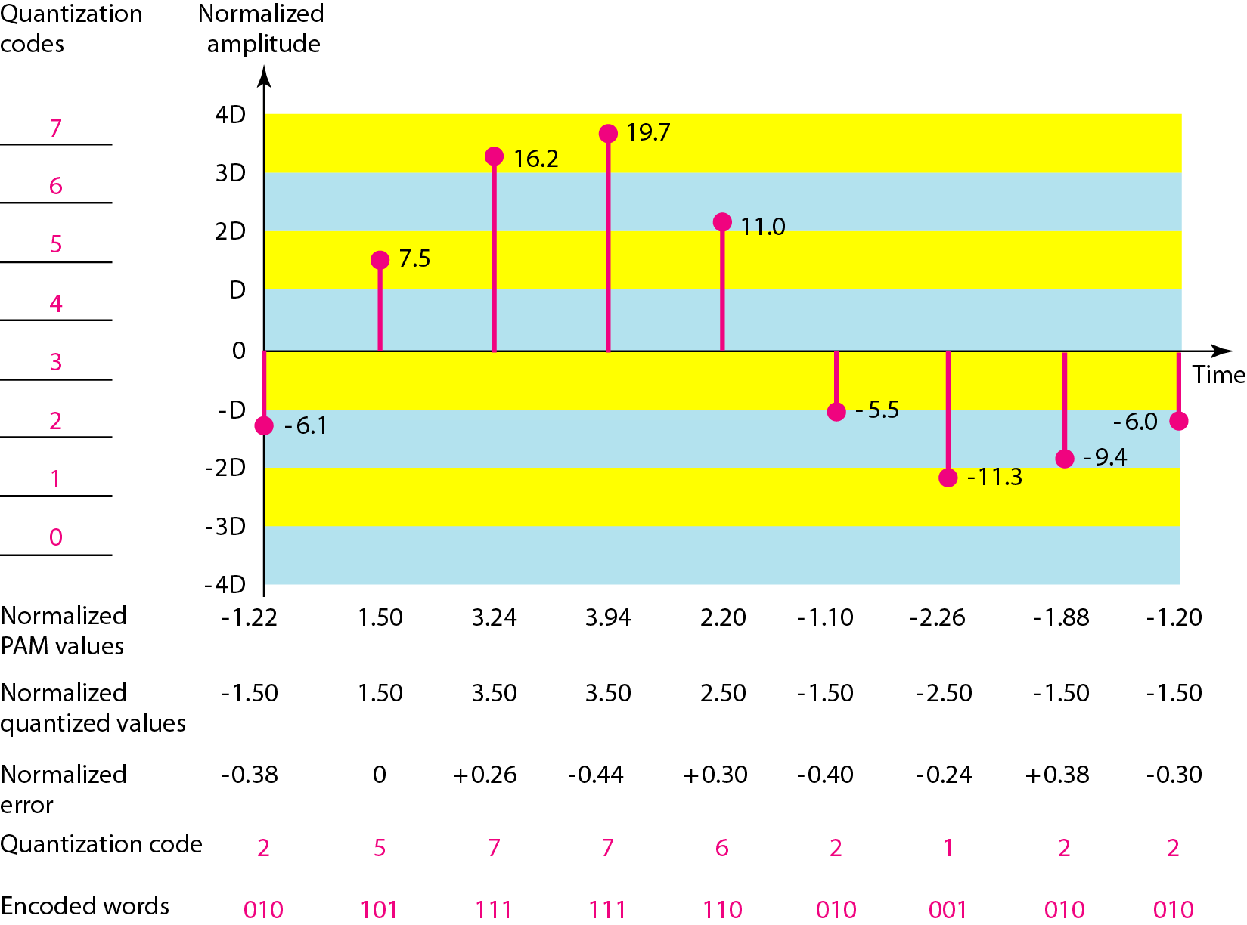

6 Mark

Ans 1b. convert the Dataword( 1001) and the divisor( 1011) into polynomial

Augmented dataword: x⁶+x³ (1marks)
Divisor: x³+x+1
Sender side (4 marks)

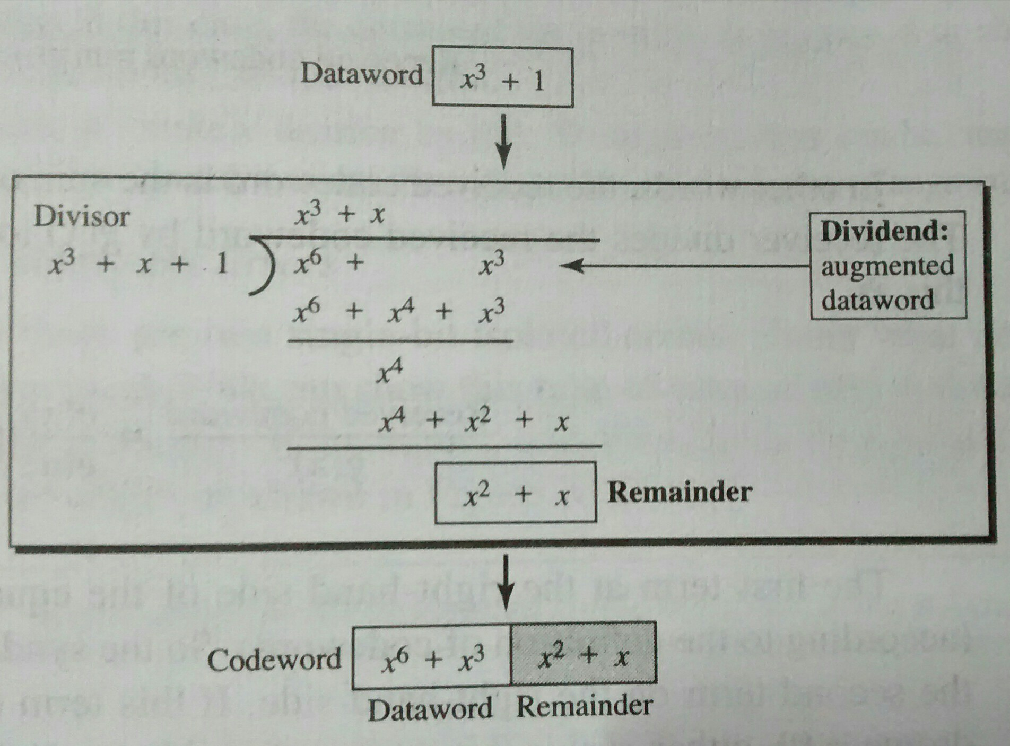
Codeword : x⁶+x³+x²+x
Receiver side : with no error (3marks)

Ans 2a.
components of PCM encoder: sampling quantization, encoding
explanation: 3 Marks
Diagram: 2 Marks

Ans 2b.

Sender algorithm (6 marks)
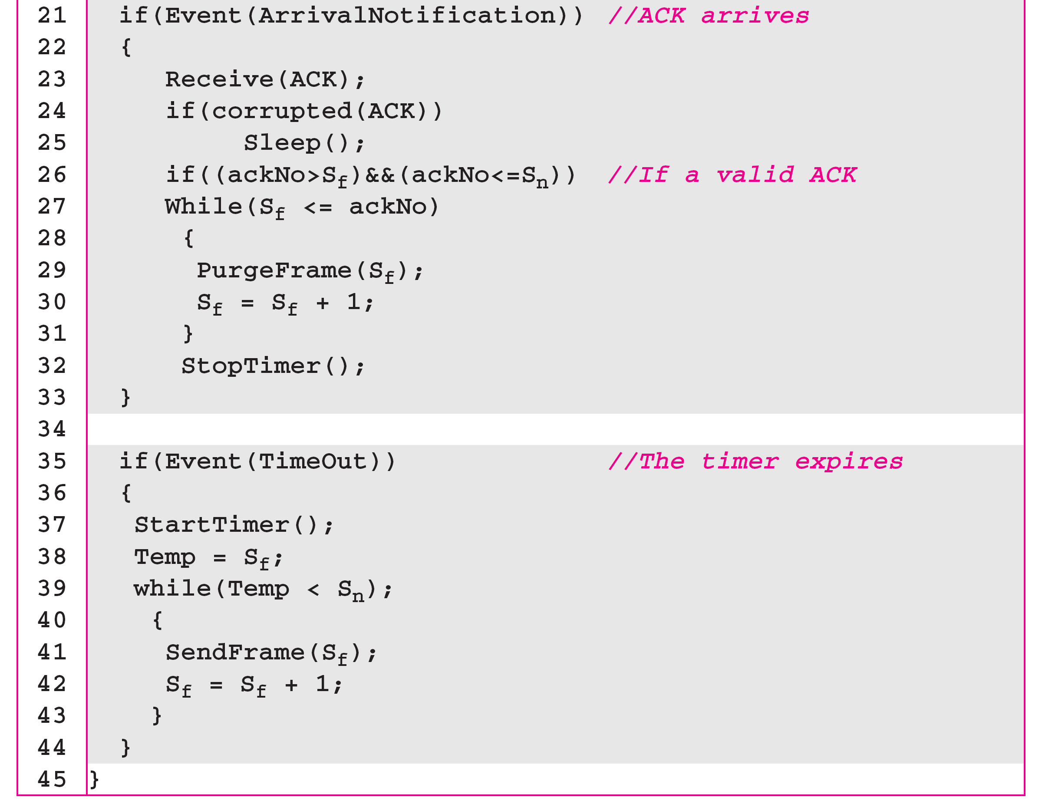
Receiver algorithm (4 marks)

Ans 3a.
Sampling definition : 2 Marks
Clock diagram for hours 9 and 6: 3 Marks

Ans 3b.

Selective Repeat ARQ, window size
Explanation + diagram, window size = 2^{m-1} (3 marks)
Explanation + diagram, window size > 2^{m-1} (3 marks)
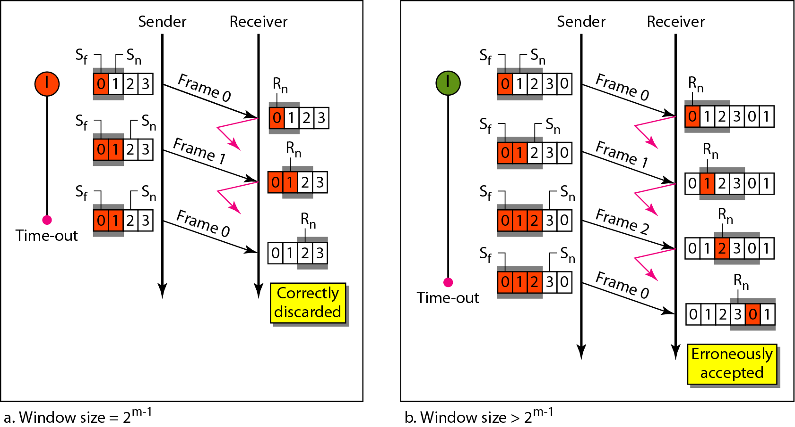

sender and receiver side check sum (4 marks)

