Please provide the general information for your paper below. (This page does not count in the page limit of the full paper).

Paper title: | Sentiment Analysis of Online Course Reviews Using Attention-Based Bi-LSTM Approach
Paper category | Full Paper ( 12 pages)
Paper tracks | Scholarly Practice
Sub-themes: | Technology-Driven Innovations in Education
Attendance Mode | Virtual

Sentiment Analysis of Online Course Reviews Using Attention-Based Bi-LSTM Approach
Shreelakshmi Joshi, Sakshata Katageri, Vijayalakshmi Lamani and Kaushik Mallibhat
Electronics and Communication Engineering, KLE Technological University, Hubli, Karnataka, India
shreelakshmipjoshi@gmail.com, katagerisakshata@gmail.com, vijayalakshmipl913@gmail.com, kaushik@kletech.ac.in

ABSTRACT
BACKGROUND & CONTEXT
Online education has gained momentum due to advancement in technology and increased reachability. However, one of the challenges the learner faces is to pick a most appropriate course as per their requirements. Most often the learner chooses the course based on the course reviews by the peer learners. However, it was evident from the available reviews that most course reviews expressed mixed emotions and confuses new learners. Thus, the proposed study aims to perform sentiment analysis on the learner's review and classify the satisfaction level of the learner into positive, negative and neutral classes. The outcomes of the work not only help the new learners but also serve as feedback to the instructors.
PURPOSE OR GOAL
The proposed work focuses on building a multi-class classifier to classify the learner’s review on online courses into positive, negative, and neutral categories through the qualitative analysis of the reviews given by learners in the textual form.
APPROACH OR METHODOLOGY
The proposed work uses 100K Coursera’s course reviews dataset and attention based Bi-LSTM methodology, to perform the qualitative analysis on the textual data provided by learners in the form of reviews.
OUTCOMES
Attention based Bi-LSTM method provided an effective solution for sentiment analysis to make accurate classifications. The paper demonstrates three class classification model and for each sentiment class, evaluation parameters including accuracy, precision and recall were computed to evaluate the performance of the Bi-LSTM model. Weighted average precision, and recall values are computed to check the overall performance of the model with respect to classes. Train accuracy and test accuracy were observed as 0.97 and 0.90. The weighted average metrics show that, on average, the model is good at precision and recall across all classes, thus underlining the general effectiveness of the model in sentiment analysis. The results suggest that attention-based sentiment analysis, coupled with Bi-LSTM, can be a valuable tool for assessing courses based on learners’ feedback.

CONCLUSION
The proposed work focus on building a three-class classifier for categorization of online course reviews into positive, negative and neutral classes. The proposed method uses attention based Bi-LSTM for sentiment analysis and is performing better than BERT and Bi-LSTM model with an accuracy of 90% on reviews in the form of textual information. The outcomes of the proposed work helps both course instructors and learners. For course instructors to quickly identify the areas of improvement to enhance the learners’ experience and for learners to make an appropriate choice for enrollment. Further there exists scope in terms of integrating the model with the online platforms or learning management system to provide better learning experience.
KEYWORDS
machine learning, online education, review based, sentiment analysis, student feedback.

Introduction
Technology advancements have accelerated the development of online education, enabling educational institutions to provide a wide range of courses and programs through digital platforms. There is a broad range of courses available online to support learners in their educational pursuits. The contemporary virtual learning environment provides excellent chances for students to create their flexible learning environment. With this growth, understanding students' perceptions and experiences in online courses has become essential for educators, course designers, and institutions aiming to enhance the quality of education.
Online education, increasingly favoured for its flexibility and reach, often faces challenges such as higher dropout rates and mismatched learner expectations. As stated in (Onah et al, 2014) only 34,850 students were able to complete the course out of 3,09,628 enrollers indicating 89% of dropout rate in University of Edinburgh MOOC. In Duke university’s Bio-electricity MOOC 313 completed the course among 12,175 registered students resulting in a 97.4% dropout rate. Only 30-60 participants actively participated out of 2,420 registrations in UK Open University's OLDS MOOC. The stated facts highlight the consistent high dropout rates in the online courses.
Learners often find it challenging to choose the most suitable course among the numerous options covering the same content and effective communication between instructors and students is vital for better learning experiences. Student feedback, often provided in the form of textual reviews, serves as a rich source of information for identifying assets, shortcomings, and areas for enhancement in online courses.
The textual responses gathered from the learners are summed up and taken as measure for the determination of learner satisfaction of the particular course under discussion. First, the multiclass classifier model is created so that it can classify the review of the learner into positive, negative, and neutral categories. Several approaches are devised for carrying text-based sentiment analysis of the reviews of the student. Details of the existing approaches and their limitations are discussed in the related works section of the paper. The details of the proposed approach are discussed in the methodology section followed with obtained results in the subsequent section of the paper.

Related Works
Systematic Literature Review was conducted using the PRISMA method and used keywords and database search methods. For the preliminary identification of the initial keywords, Google scholar was utilized. The IEEE, ACM, and research gate databases were used to identify the papers. The considered time span was from 2017 to 2024.
Sentiment analysis refers to a process that uses natural language processing, and machine learning to identify and classify emotional tone in textual data. It works by determining whether an input is expressing a positive, negative, or neutral sentiment. Sentiment analysis looks at linguistic features and context to determine emotional intent. Sentiment analysis is a significant field that aids us to understand text-based reviews and pull out feelings from text using methods like classification, feature extraction, and preprocessing.

- What are the various application areas of sentimental analysis and ‘What is the state of art methods towards sentiment analysis on the student review data and what are their reported performance metrics?’
Sentiment analysis, a vital field in machine learning, has found applications across various domains, each with unique importance. Product-based reviews (e-commerce) are one of the most prominent areas where sentiment analysis is used extensively. Here, user reviews about products are analyzed to assess customer satisfaction and product quality. For example, reviews on platforms like Amazon or Flipkart(Kim et al, 2023) are evaluated to derive insights into customer feedback. Similarly, in service-based reviews, analyzing sentiment of reviews from platforms like TripAdvisor or Booking.com(Bonny et al,2024), where customers share their experiences about hotels, flights, and tourist destinations.
Sentiment analysis in the entertainment domain, such as movies(Khan et al,2024)(Obiedat et al, 2022) and social media(Priescu et al,2024)-(Ibrahim et al, 2023), focuses on evaluating viewer sentiment towards movies or social media posts. Sentiment analysis in movie reviews helps in audience feedback analysis and social media monitoring while enhancing movie recommendation systems. Another crucial domain is education, which leverages sentiment analysis to evaluate feedback from learners and educators on educational courses.
Another important domain is education, that uses sentiment analysis to analyse comments from learners and instructors about courses offered online. Education-based sentiment analysis can identify insights that can aid in curriculum and technology adoption improvement for course improvements. Learners' reviews assist in improving the courses (Quadad et al, 2024)-(Huang et al,2024) or help teachers improve performance (Bhatnagar et al,2018) (Bhowmik et al, 2023). Methods like K-means and Valence Aware Dictionary for Sentiment Reasoning (VADER) summarize the free response of students in the algebra-based physics course (Khanal et al, 2023).
NLP methods, specifically cluster analysis and sentiment analysis of free responses received by students at the end of the semester when answering the SALG (Student Assessment of their Learning Gains) survey conducted at the start of an introductory physics course. The data collected are those responses submitted from 2019 to 2021 on the SALG survey, all of which was preprocessed by applying TF-IDF for numerical expression. PCA and tSNE were used to reduce the dimensions, and K-means was used for clustering. Responses were classified using VADER into positive, negative, and neutral. Statistical comparison showed that free-text responses have more emotional depth and detail than Likert-scale ratings (Kim et al, 2023). Evaluating faculty teaching performance using Aspect-Based Sentiment Analysis (ABSA) on students' textual feedback. In addition to sentiment analysis of the 5000 students' comments, the domain experts identified aspects in areas teaching pedagogy, behaviour, knowledge, assessment, and experience that were classified. The sentences were broken down to focus on a single aspect. A two-layered LSTM model was utilized, where the first layer extracted the aspect being discussed in a sentence and the second produced its sentiment orientation. The model reached 91% accuracy for aspect extraction and 93% for sentiment classification (Sindhu et al, 2019).
The model classifies online course feedback as having positive, neutral, or negative sentiments using 100K Coursera’s course reviews dataset, which contains 107,018 records. The pre-processing involved the removal of HTML tags, punctuation, digits, and stop words. Normalization of text was achieved through tokenization and lemmatization. TF-IDF vectorization was used to extract text features. TextBlob was used to assign polarity scores (-1 to 1). This paper proposes six machine learning models that include logistic regression, random forest, support vector machine, decision trees, naive Bayes, and AdaBoost. Superior performance was obtained with logistic regression. This framework advances educational sentiment analysis, assisting in the betterment of online learning platforms (Islam et al,2020).
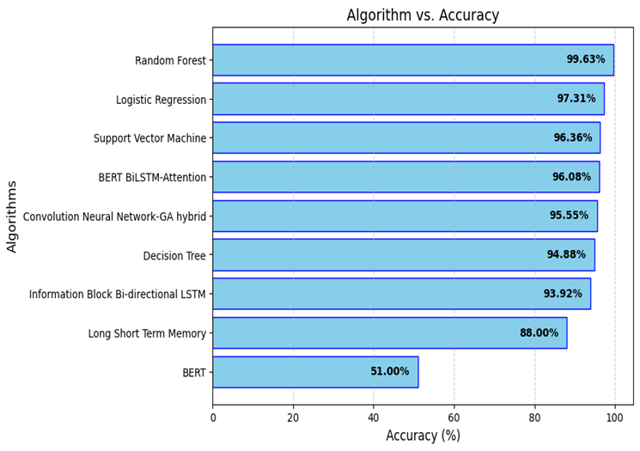
The study utilizes aspect-based sentiment analysis (ABSA) to analyse the performance of teachers based on reviews from students. It analyses more than 2 million data records. This study applies natural language processing techniques and machine learning models for the extraction of insights out of student reviews. Algorithms used are Bi LSTM for sentiment classification, as it captures more complex patterns in the data by considering both past and future information, and a random forest to improve the accuracy and reliability of the model by combining multiple decision trees. The ABSA approach focuses on specific aspects of teaching, namely teaching style and course content. It uses the application of sentiment analysis to ensure detailed evaluations of these aspects. Data pre-processing gives high-quality input, while using domain adaptation gives better performance by the model. Thorough pre-processing, domain adaptation, and use of performance metrics ensure a more robust and objective evaluation (Bhowmik et al, 2023). Figure 1 depicts the performance of various algorithms.

Figure 1: Accuracy comparison of different machine learning algorithms (2017-2024)

Methodology
Previous studies on sentiment analysis employed Bi-LSTM model to capture the sentiment in the given review. The model treats all words uniformly, potentially missing key sentiment-bearing terms. Hence, Attention based Bi-LSTM model addresses classification and de-contextualization challenges to offer precise and comprehensive feedback. The results will help to bridge the gap between educator and learner expectations, fostering an adaptive and effective online learning environment.
The core of the research is Attention based Bi-LSTM methodology, which is incorporated to conduct a detailed analysis of learner’s sentiment using reviews or feedback given by the students. Attention based approach is essential to concentrate on the most fundamental parts of the sentiment throughout the student input. Figure 2 represents the proposed pipeline of sentimental analysis.
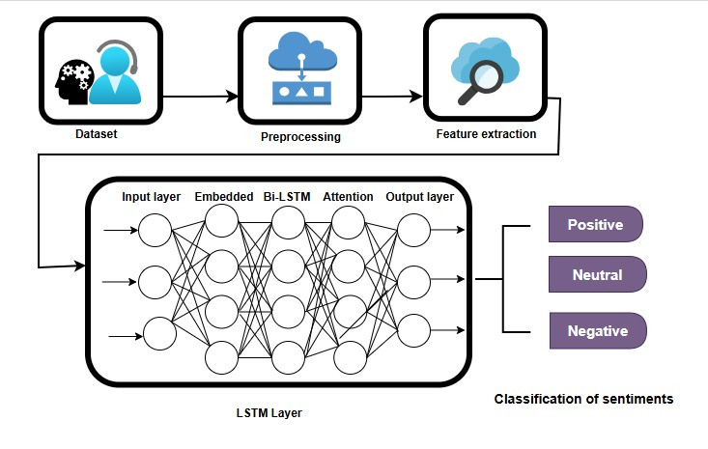
Figure 2: Implementation pipeline for sentiment analysis of students review.

Dataset
100K Coursera’s Course reviews dataset is utilized to analyse the sentiment which comprises 107,018 data records containing learner’s reviews and comments.
Pre-processing
- Converting text into lower case
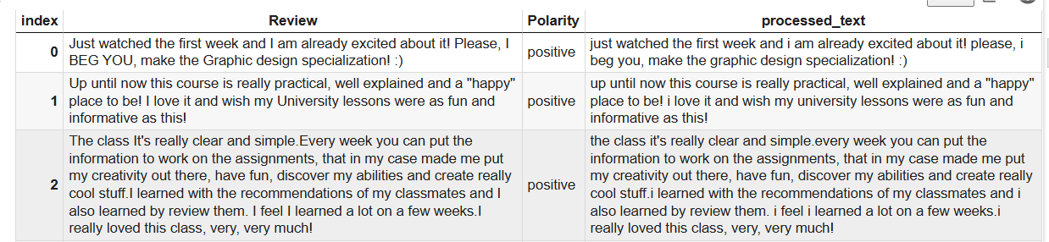
Here the text is converted into lower case to prevent models interpreting the same word differently for ex: “Happy” and “happy” both words should be considered the same.

Figure 3: Representation of processed text after converting text into lower case
- Stop word removal
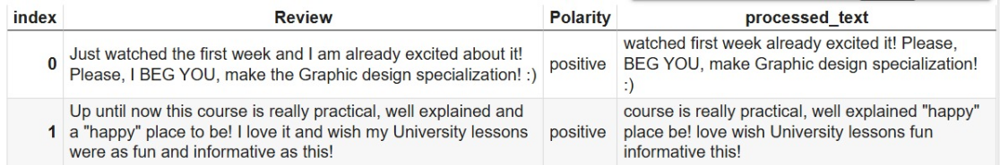
Removing stop words is a crucial pre-processing step to reduce dimensionality and focus on the more meaningful terms in a dataset. So therefore stop words such as "and", "is", "the" and "of" are eliminated during the step. Important thing is to retain the negation words such as couldn’t, can’t, wasn’t which plays a vital role in carrying the emotion of the sentences. The below mentioned diagram depicts the changes in text after stop word removal.

Figure 4: Representation of processed text after the stop removal process.
- Tokenization

Tokenization is the process that breaks text into small units. It is a fundamental step by which machines can perceive and analyse textual data. In the tokenization step the review splits into words. Figure 6 depicts the tokenization step.
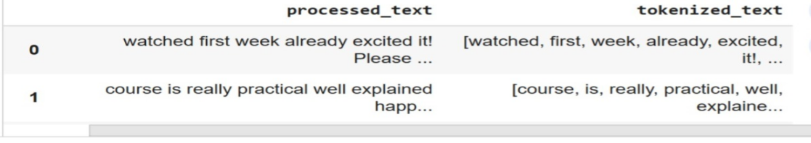

Figure 5: Representation of tokenized text after the tokenization process.
- Removal of special characters and retaining important punctuation
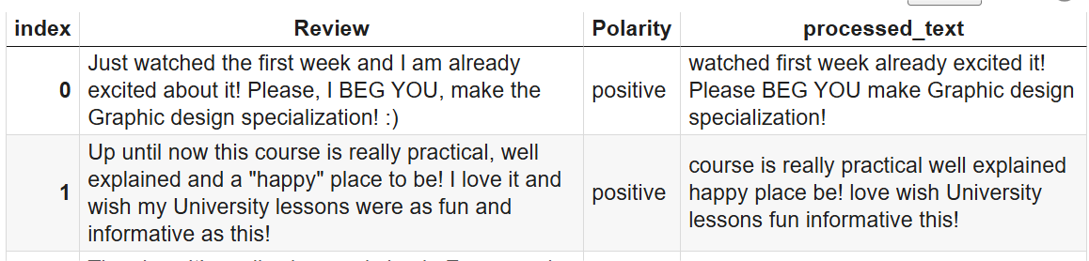
Here in the step special characters such as @ , #, $ etc are removed from the review to improve effective analysis. But retaining essential punctuation like question marks and exclamation points becomes important for preserving the sentiment of the text. The same is shown in figure 6.

Figure 6: Representation of processed text after the elimination of special characters.
- Handling NULL values & removing of extra space
Extra spaces and NULL values are removed from the text during preprocessing to ensure data quality and consistency.
- Stemming
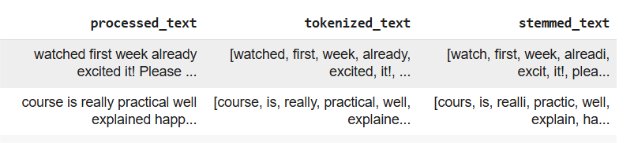
Words are condensed to their base or root form by removing the "ing", "ed" etc of the words. Stemming helps to normalize the words in the sentence .It also helps in consolidating different word forms into single representation For example, "playing," "played," and "plays" are all reduced to "play".

Figure 7: Representation of stemmed text.

Attention Based Bi-LSTM model architecture
The proposed model is built for sentiment analysis, classifying text into positive, neutral, or negative. Labels are first converted into numbers using a LabelEncoder. Then, text is tokenized with a tokenizer and padded to ensure all sequences are of the same length.
The embedding layer of 128 dimensions maps words into dense vectors, making them easier to process. A bidirectional LSTM captures context from both former and later parts of the text. An attention layer is then used to highlight the most important words for classification.
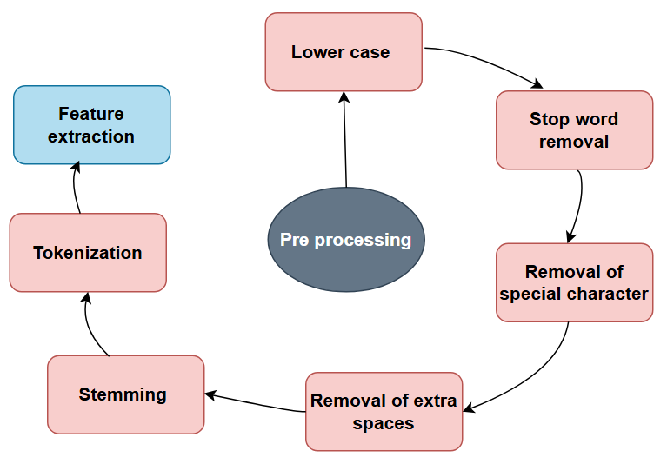
The attention output is summarized using global average pooling. A dense layer is added with 64 units with a Rectified Linear Unit (ReLU) activation mechanism and a dropout layer to refine the features. The final dense layer uses softmax to predict probabilities for the three sentiment classes. The combination of both LSTMs and attention is done to focus on the most important context in text.

Figure 8: Data preprocessing pipeline

RESULTS
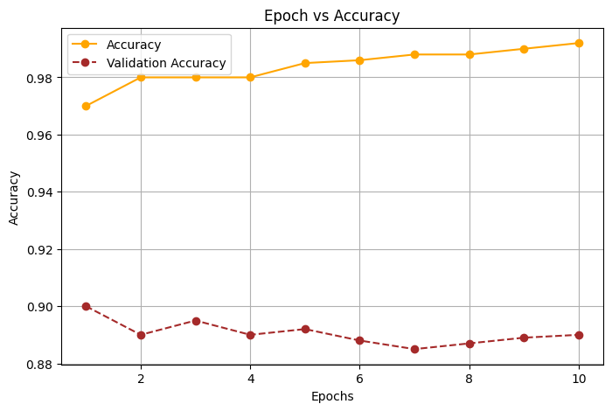
The section presents and discusses outcomes of the proposed model on text based sentiment analysis through Attention based Bi-LSTM. The aim was to enhance course performance while providing educators with constructive feedback. Attention based Bi-LSTM method provided an effective solution for sentiment analysis to make accurate predictions. The selected features were classified and 90% classification accuracy was reported. The analysis of epoch and accuracy curves for the proposed model is illustrated in figure 9. These curves provide insights into the model’s performance during training and validation phases. Training and validation accuracy remained consistently high throughout. It depicts good generalization and no significant over fitting. Performance of model is robust across all epochs.

Figure 9: Validation accuracy and accuracy across epochs

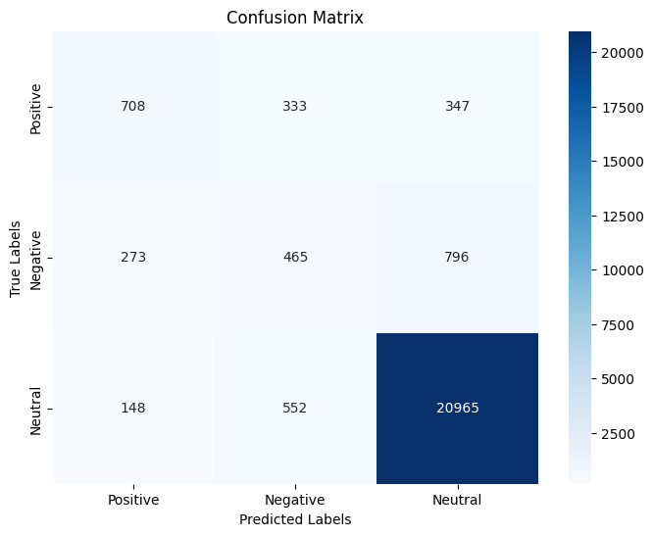
A confusion matrix is used to evaluate the performance of the classification model. The confusion matrix gives an overall view of the classification performance by the model and also signifies its ability to distinguish between classes of sentiments. The metrics of the confusion matrix are as in figure 10.

Figure 10: Confusion matrix for sentiment analysis
The performance matrix provides a more detailed view of the model's classification accuracy and its ability to differentiate between sentiment categories. The main metrics obtained from the performance matrix are shown. In a matrix, the x-axis represents the predicted labels and the y-axis represents the true labels. The diagonal values represent true values, that is, 708 positive samples, 465 negative samples, and 20,965 neutral samples. Among positive samples, 333 were misclassified as negative and 347 as neutral. For Negative samples, 273 were classified as Positive, and 796 as Neutral. Among all neutral samples, 148 were misclassified as positive and 552 as negative.
The holistic representation allows the effectiveness of the model in classifying sentiment in text data to be evaluated, and its strengths and weaknesses in terms of different categories of sentiment. The model seems to perform quite well in the Neutral class as there are significantly more correct predictions (20,965). In the Positive and Negative classes, the classification accuracy is lower, indicating that the model is not very effective at distinguishing these sentiments.
For each sentiment class, precision, recall, and F1-score are computed to evaluate the performance of the LSTM model. Weighted average precision, recall, and F1-score values are computed to check the overall performance of the model with respect to classes. Train accuracy and test accuracy were observed as 0.97 and 0.90. The weighted average metrics show that, on average, the model is good at precision, recall, and F1-score across all classes, thus underlining the general effectiveness of the model in sentiment analysis. The results suggest that Attention Based Sentiment Analysis, coupled with Bi-LSTM, can be a valuable tool for assessing courses based on learners’ feedback. These findings contribute to ongoing efforts to enhance performance evaluations in educational settings and open avenues for addressing challenges related to sentiment analysis in the future. Figure 11
Table 1: Performance Comparison of Sentiment Analysis Models on different datasets
Paper | Dataset | Algorithm | Accuracy | F1 Score
Bhowmik et al, (2023) | Student feedback from American International University-Bangladesh (AIUB)( 2,204,523 feedback) | BiLSTM (Bidirectional LSTM) | - | 86
Islam et al, (2020) | 100K Coursera’s course reviews dataset | TextBlob (Lexicon-based)  Naïve Bayes  Decision Tree  Random Forest  AdaBoost  Support Vector Machine (SVM)  Logistic Regression  Attention Based Bi-LSTM | 85.23  89.45  90.12  92.67  94.08  95.76  97.31  90 | -  -  -  -  -  -  -  -
Alshaikh et al, (2020) |  | Bidirectional Encoder Representations from transformers (BERT) | 88.4 | 81.8
Proposed Model |  | Attention Based Bi-LSTM | 90
The table includes a quantitative performance comparison of different machine learning and deep learning models for sentiment analysis on different datasets.
CONCLUSION
The proposed work focuses on building a multiclass classifier for categorization of online course reviews into positive, negative and neutral classes. The proposed method uses Attention Based Bi-LSTM for sentiment analysis and is performing better than Bi-LSTM model with an accuracy of 90%. The work leverages the reviews in the form of textual information and work helps course instructor to quickly identify the areas of improvement to enhance the learners’ experience. Further there exists scope in terms of refinement of the attention mechanism to incorporate the domain specific knowledge could be explored in future. The attention-based Bi-LSTM model is a promising and well-effective solution for sentiment analysis of student feedback and provides valuable insights for improving the quality of education and enhancing the general experience of students.

References
Onah, D.F.O., Sinclair, J., & Boyatt, R. (2014). Dropout Rates of Massive Open Online Courses: Behavioural Patterns. Conference Paper. https://doi.org/10.13140/RG.2.1.2402.0009
Kim, H., & Qin, G. (2023). Summarizing students’ free responses for an introductory algebra-based physics course survey using cluster and sentiment analysis. IEEE Access, 11, 88924–88938. https://doi.org/10.1109/ACCESS.2023.3305260
Bonny, E. L., & Liang, D. (2024). Exploring Sentiment Polarity of P2P Guests Through Online User Reviews: A Multimodal Fuzzy Approach. IEEE Transactions on Engineering Management, 71(6), 1558–1574. https://doi.org/10.1109/TEM.2023.3294426
Khan, A., & Malik, A. K. (2024). Sentiment analysis of movie review using hybrid optimization with convolutional neural network in English language. In 2024 International Conference on Computing, Communication, and Intelligent Systems (ICCCIS) (pp. 735–740). IEEE. https://doi.org/10.1109/ICCCIS58764.2024.10301365
Obiedat, R., Qaddoura, R., Al-Zoubi, A. M., Al-Qaisi, L., Harfoushi, O., Alrefai, M., & Faris, H. (2022). Sentiment Analysis of Customers’ Reviews Using a Hybrid Evolutionary SVM-Based Approach in an Imbalanced Data Distribution. IEEE Access, 10, 29229–29246. https://doi.org/10.1109/ACCESS.2022.3149482
Priescu, I., Ghiculescu, L. D., & Priescu, C. M. (2024). Analysis of YouTube video comments with NLP methods. In 2024 19th International Conference on Engineering of Modern Electric Systems (EMES) (pp. 1–6). IEEE. https://doi.org/10.1109/EMES55757.2024.10229565
Shah, S. A. A., & Bhise, R. S. (2024). Conceptual level semantic sentiment analysis using Twitter data. In 2024 International Conference on Advances in Data Engineering and Intelligent Computing Systems (ADICS) (pp. 1–7). IEEE. https://doi.org/979-8-3503-6482-8/24/$31.00
Ibrahim, S., & Irfan, M. (2023). Text sentiment analysis of film reviews using Bi-LSTM and GRU. In 2023 International Conference on Inventive Computation Technologies (ICICT) (pp. 1–6). IEEE. https://doi.org/10.1109/ICICT58218.2023.10182768
Ouadad, R., & Mouncif, H. (2024). Sentiment analysis of students feedback in online courses using supervised, ensemble, and transfer learning methods. In The 7th International Conference On Networking, Intelligents Systems and Security (NISS 2024) (pp. 1–7). New York, NY: ACM. https://doi.org/10.1145/3659677.3659733
Uddin, M. R., Khan, M. R., & Rahman, M. M. (2023). Sentiment analysis in E-Commerce platforms: A review of current techniques and future directions. IEEE Access, 11, 122757-122780. https://doi.org/10.1109/ACCESS.2023.3307308
Huang, S., & Raga, Jr, R. C. (2024). A deep learning model for student sentiment analysis on course reviews. IEEE Access, 12, 121623–121636. https://doi.org/10.1109/ACCESS.2024.3463793
Bhowmik, A., Mohd Noor, N., Miah, M. S. U., Masjid-Ul-Haque, M., & Karmaker, D. (2023). Evaluating Teachers’ Performance through Aspect-Based Sentiment Analysis. AIUB Journal of Science and Engineering (AJSE), 22(2), 200–213.
Khanal, B., Jeong, B. S., & Chae, Y. (2023). A Survey on Sentiment Analysis Methods and Applications. Electronics, 12(7), 1622. https://doi.org/10.3390/electronics12071622
Mode
Sindhu, I., DaudpOta, S. M., Badar, K., Bakhtyar, M., Baber, J., & Nurunnabi, M. (2019). Aspect-based opinion mining on student’s feedback for faculty teaching performance evaluation. IEEE Access, 7, 101080–101092. https://doi.org/10.1109/ACCESS.2019.2928872
Islam, M. R., Khan, I. K., & Ullah, M. A. (2020). Sentiment analysis based on online course feedback using Textblob and machine learning techniques. In 2020 International Conference on Contemporary Computing and Applications (IC3A) (pp. 100–104). IEEE. https://doi.org/10.1109/IC3A48986.2020.9243857
Sunar, A. S., & Khalid, M. S. (2023). Natural Language Processing of Student’s Feedback to Instructors: A Systematic Review. IEEE Transactions on Learning Technologies, PP, 1–13.1
Ahmad, K., Iqbal, W., El-Hassan, A., Qadir, J., Benhaddou, D., Ayyash, M., & Al-Fuqaha, A. (2023). Data-Driven Artificial Intelligence in Education: A Comprehensive Review. IEEE Transactions on Learning Technologies, 16(6), 2299-2319. https://doi.org/10.1109/TLT.2023.3314610
Li, L., Huang, Y., & Ren, C. (2024). Research on MOOC reviews oriented sentiment analysis by awareness of emotional distinctions. IEEE Access, 12, 144632–144643. https://doi.org/10.1109/ACCESS.2024.3482232
Rahman, M. A., Begum, M., Mahmud, T., Hossain, M. S., & Andersson, K. (2024). Analyzing sentiments in eLearning: A comparative study of Bangla and Romanized Bangla text using transformers. IEEE Access, 12, 101047–101067. https://doi.org/10.1109/ACCESS.2024.3419024
Alshaikh, K. A., Almatrafi, O. A., & Abushark, Y. B. (2024). BERT-based model for aspect-based sentiment analysis for analyzing Arabic open-ended survey responses: A case study. IEEE Access, 12, 76686–76703. https://doi.org/10.1109/ACCESS.2023.3348342
Saravanan, R., & Sujatha, R. (2023). A hybrid deep learning technique for sentiment analysis in E-learning platform with natural language processing. ICT Express, 9(4), 476–487. https://doi.org/10.1016/j.icte.2022.06.002
Shumaly, A., & Mousavi, S. M. (2021). Modeling sentiment analysis for educational texts by combining BERT and FastText. PeerJ Computer Science, 7, e22. https://doi.org/10.7717/peerj-cs.2021.e22
Ayyash, M., & Al-Fuqaha, A. (2023). Data-driven artificial intelligence in education: A comprehensive review. IEEE Transactions on Learning Technologies, 16(6), 2299-2319. https://doi.org/10.1109/TLT.2023.3314610

