Game Design Document

Fill up the following document

1. Write the title of your project.

The Healthy Game

1. What is the goal of the game?

The boy needs to eat only the vegetable not junk food.

1. Write a brief story of your game.

The boy will eat the vegetables the score will increase by 10. When, the boy eats the junk food the game will be over.

1. Which are the playing characters of this game?

* Playing characters are the ones who respond to the user based on the input from the user.
* Cars, monkeys, dinos, wizards, etc., are the playing characters in the game.

|  |  |  |
| --- | --- | --- |
| Number | Character Name | What can this character do? |
| 1 | Boy | Move with up and down arrow keys. |
| 2 |  |  |
| 3 |  |  |
| 4 |  |  |
| 5 |  |  |
| 6 |  |  |
| 7 |  |  |
| 8 |  |  |

1. Which are the Non-Playing Characters of this game?

* Non-Playing characters are the ones that don't have an action or behavior when the user interacts with the game.
* Hurdles, stones, bananas, coins, etc., are non-playing characters in the game.

|  |  |  |
| --- | --- | --- |
| Number | Character Name | What can this character do? |
| 1 | Vegetables | When the boy eats it the score will increase. |
| 2 | Junk food | When the boy eats junk food the game will be over. |
| 3 |  |  |
| 4 |  |  |
| 5 |  |  |
| 6 |  |  |
| 7 |  |  |
| 8 |  |  |

Draw your imagination of this game. What does this game look like?

* Draw the game either on your computer or on paper.
* Add images of the game scenes to show each of the playing and non-playing characters at least once.

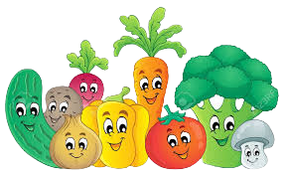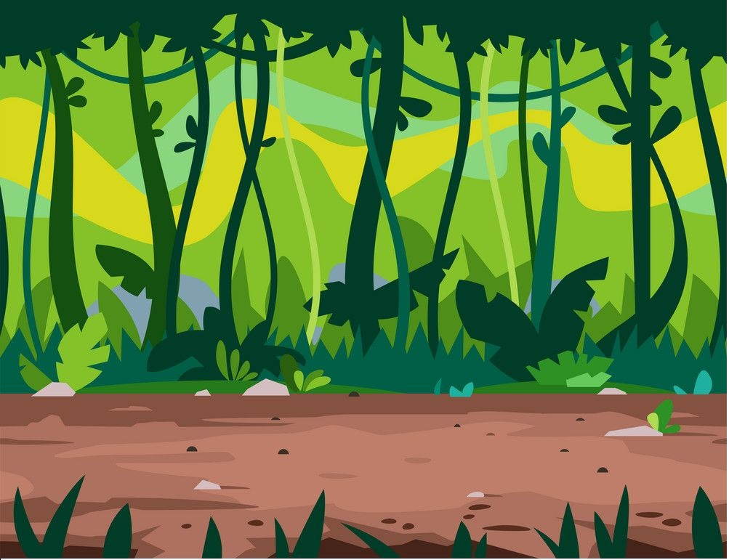

How do you plan to make your game engaging?

I will add background to the game then the I will step by step add playing character features. Then I will add movement of the boy.