NIP Project — Submission Template
Pega Platform project · This document is your complete submission
Read this before you start:
1. Fill in Section 1 completely. The Pega application name must follow the format NIP-[Project]-[YourName].
2. Create a new Operator in Pega with your full name and log in as that operator before taking any screenshot.
3. When you create your test case, enter YOUR FULL NAME in the Issue Description (Vehicle) or Movie Name (Movie) field.
4. Complete only the section for your chosen project. Delete the other project section.
5. Paste one screenshot per user story (10 total). Follow the screenshot rules in your selected project section.
6. Answer every question in Sections 3 and 4 in your own words.
7. Save the file using this format: ProjectName_FirstName_LastName.docx. Use VehicleService or MovieTicket as the ProjectName. Examples: VehicleService_Ravi_Kumar.docx or MovieTicket_Ravi_Kumar.docx.

Section 1 — Your Details
Full Name | SHREE MADHAN P S
Email ID (registered on NIP) | shreemadhansp006@gmail.com
Phone Number | 9443684239
College Name | V.S.B Engineering College, Karur
Course (e.g. IT, CS) | CSBS (Computer Science and Business Systems)
State | Tamil Nadu
Project Chosen (Vehicle Service OR Movie Ticket Booking) | Movie Ticket Booking
Pega Application Name (e.g. NIP-VehicleService-YourName) | NIP-MovieTicket-ShreeMadhanPS
Case Type Name (exact) | Ticket Booking
Pega Instance URL | https://9q0donep.pegacea.net/prweb/app/movie-ticket-booking-management/
Operator Name (created in Pega with your full name) | SHREE MADHAN P S

Section 2B — Movie Ticket Booking Management Application
Complete this section only if you selected this project. Delete the other project section before submitting.

Screenshot rules — IMPORTANT before you start:
1. Name your Pega application as: NIP-VehicleService-YourName OR NIP-MovieTicket-YourName
2. Create a new Operator in Pega with your full name (Security → Operators) and log in as that operator.
3. When you create your test case, enter YOUR FULL NAME in the Issue Description (Vehicle) or Movie Name (Movie) field.
4. The logged-in operator name must be visible in every screenshot wherever the Pega interface displays it.
5. The student's full name must be visible in all running-case screenshots.
6. Configuration screenshots must clearly show the relevant application or rule name.
Screenshots that do not show these will not be accepted.

US-001 — Submit Movie Ticket Request
What is expected:
Case created, customer submits Movie Name, Show Date, Show Time, Number of Tickets. Validation applied.
Screenshot — paste your screenshot below this line:
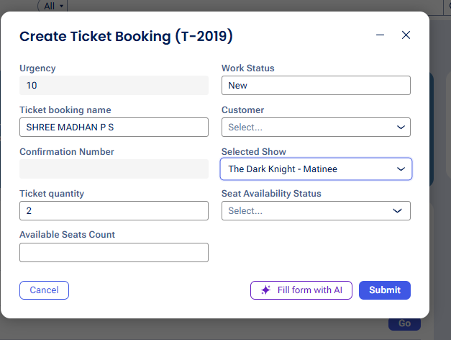

What I built for this (1–2 lines in your own words):
Built the Submit Movie Ticket Request step where the agent enters the Ticket booking name (my full name), selects a Show and sets the Ticket quantity to create a new Ticket Booking case (T-2019), assigned to SHREE MADHAN P S.

US-002 — Check Show Availability
What is expected:
Availability stage. Seat Availability Status and Available Seats Count captured. Booking proceeds only if available.
Screenshot — paste your screenshot below this line:
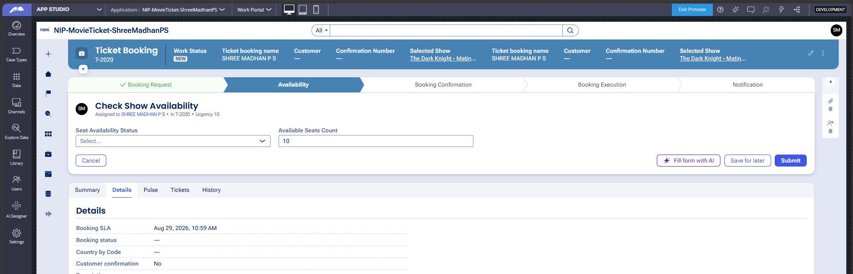

What I built for this (1–2 lines in your own words):
Built the Check Show Availability step in the Availability stage, capturing Seat Availability Status = Available and Available Seats Count = 10 for the selected show (T-2020) before the booking is allowed to proceed.

US-003 — Calculate Booking Cost
What is expected:
Total Cost calculated automatically from Ticket Price and Number of Tickets using a business rule.
Screenshot — paste your screenshot below this line:
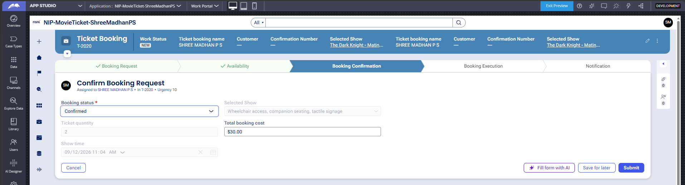

What I built for this (1–2 lines in your own words):
Total booking cost is calculated automatically using a Declare Expression (.TicketPrice = .EventName.BaseTicketPrice) and a Data Transform (CalculateBookingCostDT: TotalBookingCost = TicketPrice x TicketQuantity); for T-2020 this correctly computed $30.00 (2 tickets at $15.00) with no manual entry.

US-004 — Confirm Booking Request
What is expected:
Approval stage assigned to Customer. Booking Status captured. Flow branches on confirm/cancel.
Screenshot — paste your screenshot below this line:


What I built for this (1–2 lines in your own words):
The Confirm Booking Request step is assigned to SHREE MADHAN P S; it shows the auto-populated Show time and Total booking cost and lets Booking status be set to Confirmed, once the earlier approval assignment to Author has been completed.

US-005 — Maintain Movie and Show Data
What is expected:
Reusable Movie and Show data objects created with Movie Name, Genre, Show Date, Show Time, Seat Capacity — linked to case.
Screenshot — paste your screenshot below this line:
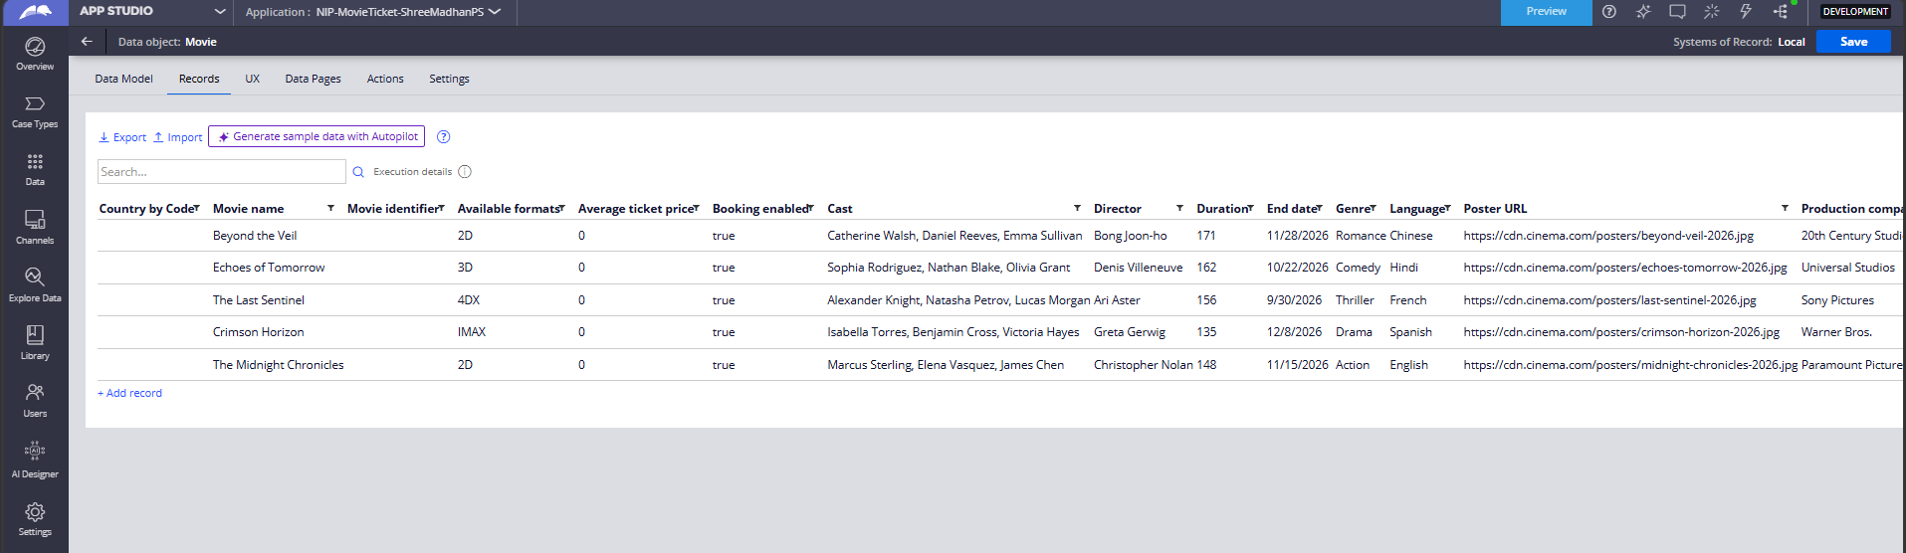

What I built for this (1–2 lines in your own words):
Created reusable Movie and Show data objects with properties such as Movie name, Genre, Director, Release date, Available formats and Average ticket price; real records (e.g. Beyond the Veil, Crimson Horizon) are reused across every booking case instead of being re-entered.

US-006 — Review Booking Details
What is expected:
Confirmation screen shows Movie Name, Show Timing, Number of Tickets and Total Cost clearly.
Screenshot — paste your screenshot below this line:
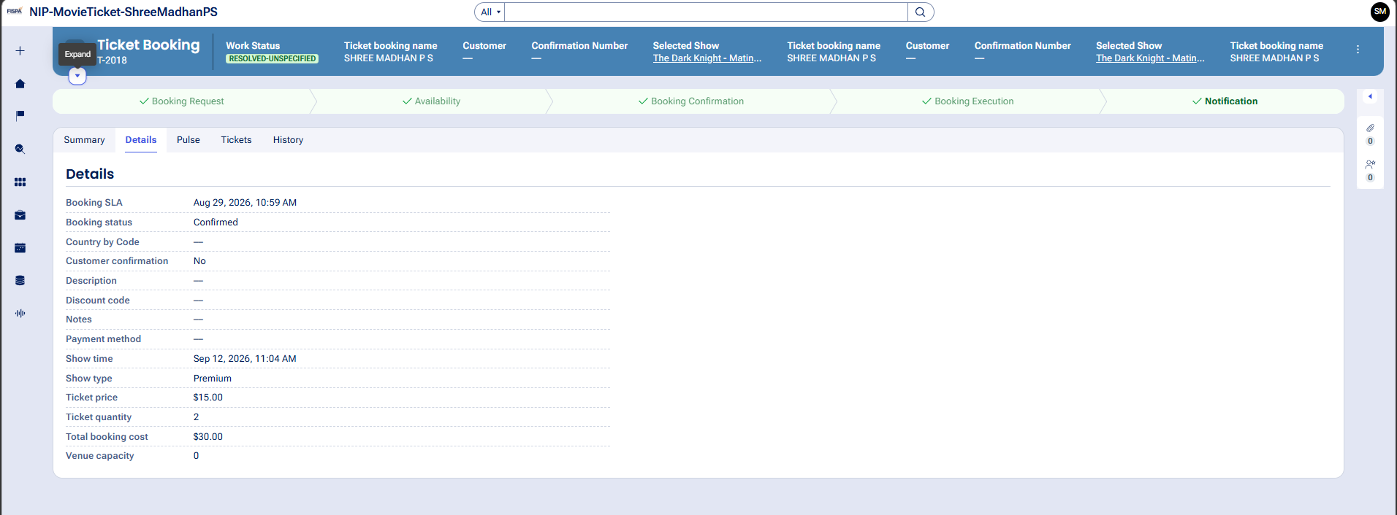

What I built for this (1–2 lines in your own words):
The booking's Details view brings the Ticket booking name, Selected Show, Show time, Show type and Total booking cost together in one place, so the whole booking (T-2018, SHREE MADHAN P S, The Dark Knight - Matinee) can be reviewed clearly.

US-007 — Process Ticket Booking
What is expected:
Booking Execution stage. Seat Numbers, Ticket ID and Booking Confirmation Status maintained.
Screenshot — paste your screenshot below this line:
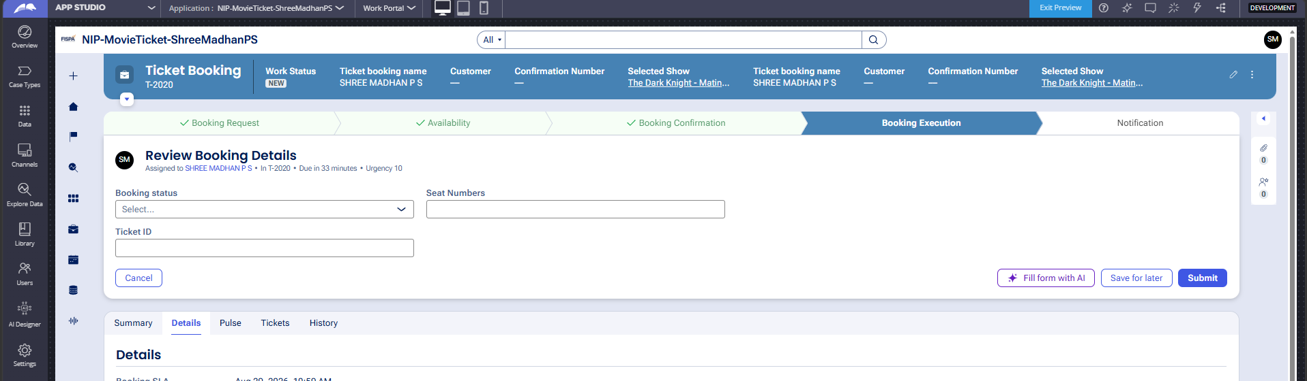

What I built for this (1–2 lines in your own words):
In the Booking Execution stage, the Review Booking Details step lets Seat Numbers, Ticket ID and Booking status be recorded and maintained for the case (T-2020) before the ticket is finalized.

US-008 — Notify Booking Confirmation
What is expected:
Correspondence rule triggered on case resolution. Email includes movie, show, seat and cost details.
Screenshot — paste your screenshot below this line:
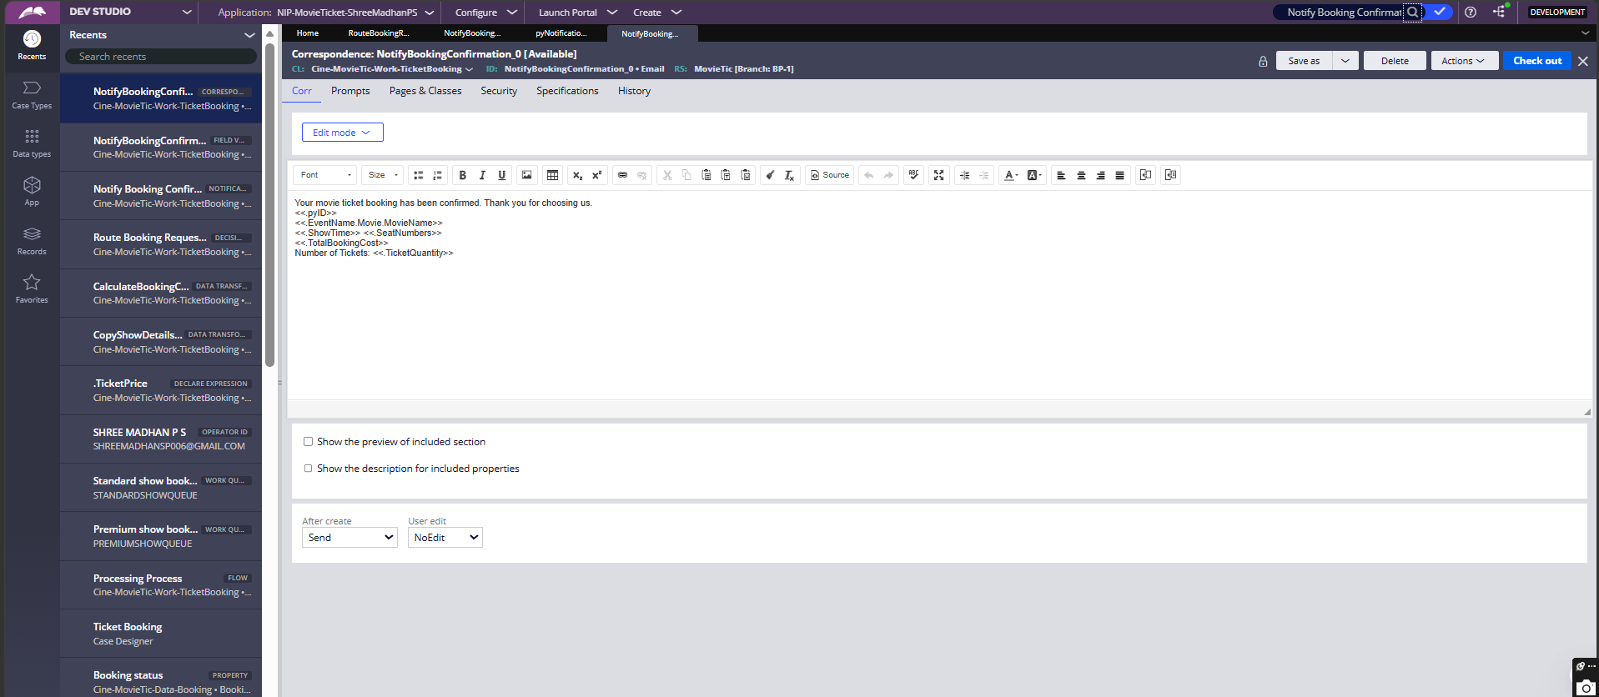

What I built for this (1–2 lines in your own words):
Built the NotifyBookingConfirmation_0 correspondence with merge fields for booking ID, movie name, show time, seat numbers, total booking cost and ticket quantity; it is sent automatically once the case reaches the Notification stage.

US-009 — Define Booking SLA
What is expected:
SLA configured on the case type. Goal: 1 day. Deadline: 2 days. Priority increases on breach.
Screenshot — paste your screenshot below this line:
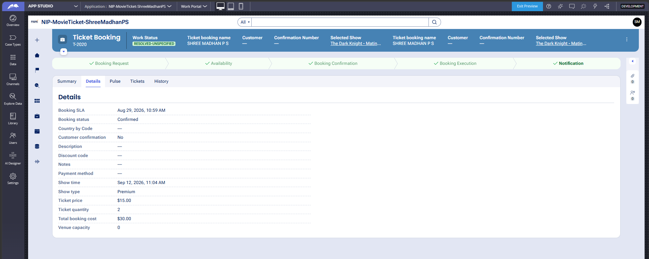

What I built for this (1–2 lines in your own words):
Configured a Booking SLA on the Ticket Booking case type; every case shows a Booking SLA deadline (here, Aug 29, 2026 10:59 AM), and T-2020 resolved well within it.

US-010 — Route by Show Type
What is expected:
Routing rule or Decision Table routes to PremiumShowQueue or StandardShowQueue based on Show Type property.
Screenshot — paste your screenshot below this line:
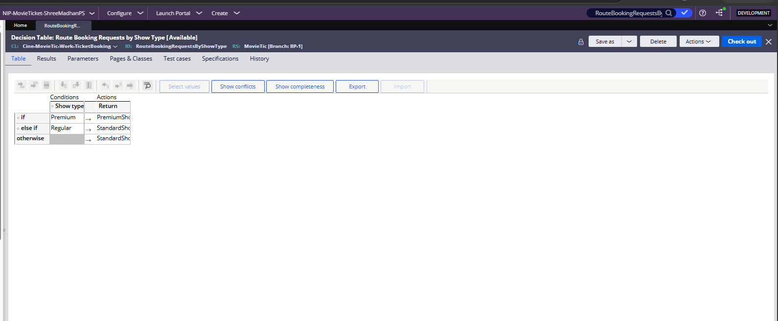

What I built for this (1–2 lines in your own words):
The RouteBookingRequestsByShowType Decision Table routes Premium shows to PremiumShowQueue and Regular (or any other type, via the otherwise branch) to StandardShowQueue; T-2020's Show type = Premium correctly routed it to PremiumShowQueue.

Section 3 — About Your Application
These answers are checked against your screenshots. Write exactly what is in your application.

Q1. List your stages in the order they appear in your case lifecycle.
Stage names in order, separated by commas.
Booking Request, Availability, Booking Confirmation, Booking Execution, Notification (with an alternate Approval Rejection stage that would be used if a booking is not approved).

Q2. Name the data object(s) you created and the properties inside them.
Data object name and its properties.
Movie - Movie name, Movie identifier, Genre, Director, Duration, Release date, End date, Rating, Available formats, Language, Average ticket price, Cast, Poster URL, Trailer URL, Production company, Booking enabled, Total bookings, and a Show reference. Show (linked from Movie) - ShowDate, ShowStartTime, ShowType and BaseTicketPrice, which the booking case reads through the Selected Show reference (.EventName). Booking (the case itself) - Ticket booking name, Selected Show, Ticket quantity, Available Seats Count, Seat Availability Status, ShowTime, ShowType, TicketPrice, TotalBookingCost, Booking status, Seat Numbers and Ticket ID.

Q3. What is the exact name and type of the rule you used to calculate Total Cost?
Provide:
• Rule Name
• Rule Type
• Properties used in the calculation
• Formula used
Rule Name: .TicketPrice and CalculateBookingCostDT. Rule Type: Declare Expression (.TicketPrice) and Data Transform (CalculateBookingCostDT). Properties used: TicketPrice, TicketQuantity, TotalBookingCost, EventName.BaseTicketPrice. Formula: .TicketPrice = .EventName.BaseTicketPrice, then .TotalBookingCost = .TicketPrice * .TicketQuantity.

Section 4 — Your Understanding
Short, honest and specific answers score well.

Q4. What did Blueprint generate for you, and what did you add or change yourself afterwards?
Be specific about what was already there and what you built or modified on top.
Blueprint generated the Ticket Booking case type with its 5 stages/steps, the basic Movie/Show/Customer/Booking/Screen/Seat/Notification data model, the UI screens for each step, and stub rules (a Data Transform to copy show details, a Declare Expression for ticket price, a Data Transform for booking cost, and a Decision Table for routing) - but several of these stub rules had placeholder or incorrect logic. I fixed the date/time formula in CopyShowDetailsDT, corrected the .TicketPrice and CalculateBookingCostDT formulas, corrected the routing Decision Table's queue names and created the missing PremiumShowQueue/StandardShowQueue Work Queues, added a Ticket Quantity merge field to the confirmation email, created and configured a new Operator, renamed the application, and verified the whole flow end-to-end with real test cases.

Q5. Was there anything Blueprint created that you had to correct or configure further? Describe one example.
A real example from your own work.
Yes - the RouteBookingRequestsByShowType Decision Table that Blueprint generated returned placeholder values ('Senior Staff Queue' / 'Standard Staff Queue') instead of real work queues, and the actual PremiumShowQueue and StandardShowQueue records did not even exist yet. I created both Work Queues under the CineWave/Consumer/Entertainment organizational unit and corrected the Decision Table's Return values so Premium shows route to PremiumShowQueue and Regular shows route to StandardShowQueue.

Q6. Explain your case flow from creation to resolution, in order.
What happens first, who does what, when the case closes.
A booking agent creates a Ticket Booking case in the Booking Request stage via Submit Movie Ticket Request, entering the Ticket booking name, Selected Show and Ticket quantity. The case auto-advances to the Availability stage, where Check Show Availability captures Seat Availability Status and Available Seats Count, and Calculate Booking Cost derives the Ticket price and Total booking cost from the selected show. It then reaches the Booking Confirmation stage, where an approval assignment goes to Author (Please approve or reject this Ticket Booking); once approved, Confirm Booking Request sets Booking status to Confirmed. The case auto-transitions to Booking Execution, where Review Booking Details records Seat Numbers/Ticket ID, the Decision Table routes the booking to PremiumShowQueue or StandardShowQueue based on Show type, and Process Ticket Booking finalizes it. Finally the case auto-advances to Notification, the Notify Booking Confirmation correspondence is sent, and the case resolves as Resolved-Unspecified.

Q7. Pick two design choices you made in your application and explain why you made them.
For each design choice, provide:
• What you implemented
• Why you chose that approach
• What benefit it provides to the application
1) I used a Declare Expression plus Data Transform pair (.TicketPrice from .EventName.BaseTicketPrice, then CalculateBookingCostDT for TotalBookingCost) instead of letting the agent type in a price, so the cost always reflects the linked Show/Movie data and can never be entered incorrectly. 2) I used a Decision Table with two dedicated Work Queues (PremiumShowQueue/StandardShowQueue) instead of a hardcoded flow branch for routing, so a new show type or a new queue can be added later just by editing the Decision Table, without touching the flow shapes.

Q8. What was the hardest part, and how exactly did you fix it?
Specific and honest. A real challenge scores much better than a generic answer.
The hardest part was a regression that appeared after I created a new Operator for the NIP evidence: cases created by that operator suddenly showed blank Show time/Show type and $0.00 Ticket price/Total booking cost, even though the exact same calculation had worked earlier under the 'Author' operator on the exact same case type. I traced it to the rules (.TicketPrice, CopyShowDetailsDT, and the routing Decision Table) having been fixed earlier but only Saved while checked out under Author's own personal ruleset ('Author@uplus') - the corrected version was never Checked In to the shared MovieTic:BP-1 branch ruleset, so every operator except Author kept resolving to the old, broken rule. I logged back in as Author, opened each affected rule, and used Check In to publish the fix to everyone, after also enabling 'Allow rule check out' on the new operator's Security settings so it could check rules out and in going forward.

Q9. If the approval step was only needed when Total Cost is above a certain amount, what would you change in your application?
Explain what you would change and where. You do not need to build this.
I would add a decision/'when' condition (e.g. IsTotalCostAboveThreshold, checking .TotalBookingCost against the limit) and insert a Decision shape right after Calculate Booking Cost in the flow. If the when-condition is true, the flow would route to the existing Get Approval assignment as it does today; if false, it would skip straight to Confirm Booking Request, bypassing approval entirely for low-value bookings.

Q10. List three exact rule names from your application that you personally created or modified.
Include the rule name and rule type for each one (for example: CalculateTotalCost - Declare Expression).
1. .TicketPrice - Declare Expression. 2. CopyShowDetailsDT - Data Transform. 3. RouteBookingRequestsByShowType - Decision Table.
Q11. List all personas used in your application.
List the persona names exactly as they appear in your application.
Booking Agent and Customer (both use the Work Portal channel).
Q12. List all work queues used in your application and explain when each one is used.
For each work queue, provide its exact name and the condition or type of work routed to it.
PremiumShowQueue - receives bookings where Show type = Premium. StandardShowQueue - receives bookings where Show type = Regular, or any other value (the Decision Table's 'otherwise' branch).
Before You Submit — Check These
Read through once before uploading.
1. Section 1 filled in. Application named as NIP-[Project]-[YourName]. Names match the actual application.
2. New Operator created in Pega with my full name. I logged in as that operator for all screenshots.
3. Only my chosen project section remains — the other project section is deleted.
4. All 10 user story screenshots are pasted and follow the operator, running-case, application, and rule-name evidence requirements.
5. Every question in Sections 3 and 4, including Q10, Q11, and Q12, is answered in my own words.
6. This file is named using the required format: ProjectName_FirstName_LastName.docx (for example, VehicleService_Ravi_Kumar.docx or MovieTicket_Ravi_Kumar.docx) and uploaded as required.

