OMEGA HACK

PS:
Two power transistors control a motor. If both turn on at the same time, the board short-circuits. The Catch: Generate two continuous pulse-width modulated (PWM) signals that are exact inverses of each other. However, you must enforce a programmable "dead time" (e.g., 5 clock cycles) where BOTH signals are forced low before one transitions high. The dead time value can change dynamically via an input register, but the new value must only apply at the start of the next full PWM period. Evaluation: Zero overlap events in simulation and correct delayed application of the parameter update.

M.SHREEMATHI
SSN COLLEGE OF ENGINEERING

FAULT-TOLERANT MULTI-LAYER PWM GENERATOR WITH DYNAMIC DEAD-TIME CONTROL

1. Abstract
Pulse Width Modulation (PWM) generators driving power electronic switches (e.g., half-bridge/full-bridge inverters) require strict non-overlapping complementary outputs (a and b) to prevent catastrophic DC-bus short circuits known as shoot-through. Standard baseline implementations are susceptible to Single Event Upsets (SEUs), transient high-frequency clock/signal glitches, thermal drift causing switching delay variations, and FSM corruption.
This project presents a 4-Layer Fault-Tolerant PWM Architecture implemented in Verilog HDL. The design incorporates:
- Spatial Redundancy (Layer 1): Triple Modular Redundancy (TMR) with majority voters across critical counters and registers to scrub bitflips.
- Temporal Filtering (Layer 2): Glitch filters to suppress sub-cycle transient spikes on equality detection wires.
- Dynamic Self-Correction Engine (Layer 3): An adaptive dead-time module that dynamically expands guard bands upon detecting thermal or switching delay anomalies.
- Hard Override Gate (Layer 4): Asynchronous combinational logic that hard-clamps both outputs to safe LOW (a=0, b=0) instantly if an illegal simultaneous HIGH state is generated by control logic.

2. Architecture & 4-Layer Defense Mechanism
+-------------------------------------------------------+
| TOP MODULE |
| |
[on_time, dead_in]---> [ Layer 1: TMR Counter & State Scrubber ] |
| | |
[eq_raw Glitch] ---> [ Layer 2: Temporal Glitch Filter ] |
| | |
[overlap_now] ---> [ Layer 3: Dynamic Self-Correction Engine ] |
| | |
| [ Raw FSM Outputs: a_raw, b_raw ] |
| | |
| [ Layer 4: Hard Override Combinational Gate ] |
+-------------------------+-----------------------------+
|
[ Outputs: a, b ]

Layer 1: Spatial Redundancy (TMR Scrubber)
Objective: Mitigate Single Event Upsets (SEUs) caused by radiation or high EMI in power electronics environments.
Mechanism: Triplicates the state registers and down-counters (cnt1, cnt2, cnt3). A bitwise 2-out-of-3 majority voter (voter3) continuously scrubs individual register corruption without disturbing main operations.

Layer 2: Temporal Filtering (Glitch Filter)
Objective: Prevent premature state transitions caused by sub-cycle high-frequency noise spikes on equality comparison lines (eq_raw).
Mechanism: Evaluates transient pulses over consecutive clock sampling edges. Spikes lasting less than a full clock cycle are filtered out, keeping the state machine stable.

Layer 3: Dynamic Self-Correction Engine
Objective: Prevent shoot-through due to thermal drift or power transistor turn-off delay degradation.
Mechanism: Monitors real-time feedback (overlap_now). When transistor delay overlap is detected, the self-correction engine dynamically increases the internal dead-time margin (margin_add), expanding the dead-band window automatically.

Layer 4: Hard Override Gate (Combinational Protection)
Objective: Provide a physical hardware interlock that guarantees zero shoot-through under any FSM failure.
Mechanism: Pure asynchronous combinational logic connected directly to output pins a and b:
Safe Output a = a_raw · NOT(b_raw)
Safe Output b = b_raw · NOT(a_raw)
If an internal failure forces both a_raw=1 and b_raw=1, the hardware override gate instantly forces physical pins to a=0 and b=0.

VERIFICATION:
OLD CODE:
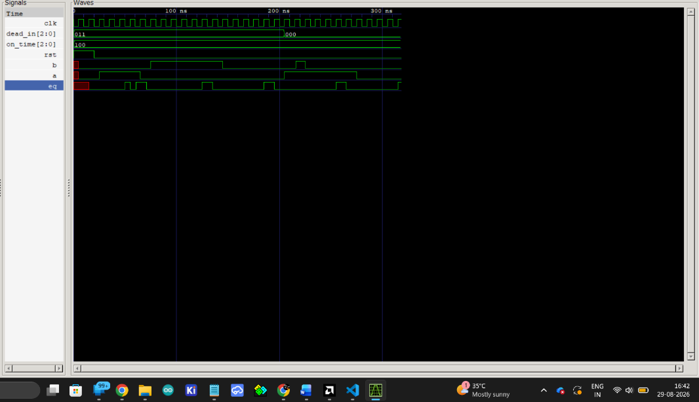

Overlapping of a an b at around 200ns
NEW Coode :
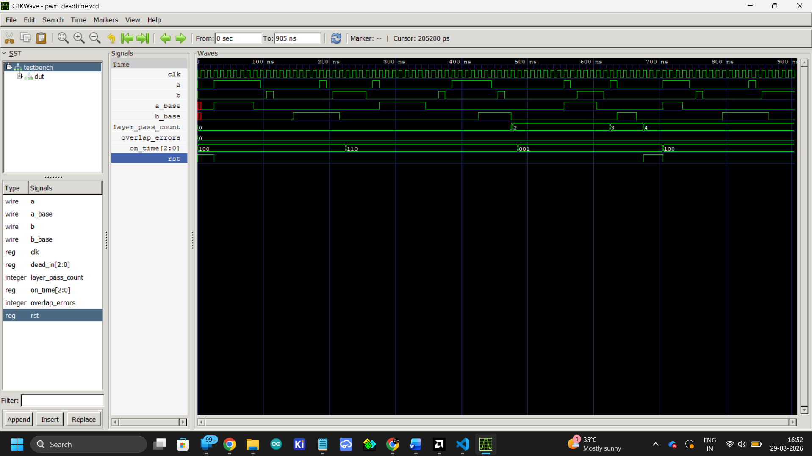

3. Comparative Verification & Testbench Results

Baseline (Old Model) vs. Protected (New Model)
Feature / Fault Test | Baseline Model (tb_old.v) | Protected Model (tb_new.v)
Layer 1: Single-Bit SEU Injection | Corrupts internal counter state; output fails | Scrubbed instantly by TMR majority voter; outputs stable
Layer 2: 1-Cycle Noise Spike (eq) | Prematurely triggers FSM transition | Filtered cleanly; transition proceeds at correct cycle
Layer 3: Thermal Delay Anomaly | Static dead-time; potential overlap | Dynamic engine expands margin (margin_add > 0)
Layer 4: Forced Shoot-Through (a=1, b=1) | Critical Failure: Pins hit a=1, b=1 | Pass: Hard override clamps pins to safe a=0, b=0

4. PPA (Power, Performance, Area) Trade-off Analysis
Adding fault tolerance is never free: every layer that protects against a specific fault class (bit-flips, glitches, thermal drift, or FSM corruption) consumes additional power, timing margin, or silicon/fabric area. The tables below break down where that cost comes from, layer by layer, and then summarize the net trade-off between the baseline and fully protected models. These are qualitative engineering estimates based on the structure of the RTL (register count, voter/comparator logic, and critical-path position) rather than post-synthesis numbers — an ASIC/FPGA synthesis and place-and-route run against the target technology would be needed to obtain exact watt, MHz, and cell-count figures.
This analysis is solution-based: it evaluates the architecture at the RTL/algorithmic level — i.e., which registers are triplicated, where voters and comparators sit in the datapath, and where combinational logic is added — independent of any specific target hardware. It deliberately ignores the underlying hardware utilized (target FPGA family, ASIC standard-cell library, process node, or tool-specific synthesis/mapping choices), since those determine the exact watt, MHz, and cell/LUT counts but not the relative, layer-by-layer cost structure described here. The qualitative trends (TMR dominating power/area, the voter dominating the critical path, Layer 4 being near-free) hold across target technologies; only the absolute numbers change with the chosen hardware.

4.1 Per-Layer PPA Overhead
Layer | Power Impact | Performance Impact | Area Impact
Layer 1 — TMR Scrubber | Highest of all layers: triplicated counters/registers switch on every clock edge, roughly 3x the dynamic power of a single-copy counter, plus static (leakage) power from the extra flip-flops. | Majority-voter logic sits in the counter feedback path, adding one voter's worth of gate delay per bit; this is usually the dominant contributor to any Fmax reduction. | ~3x flip-flop count for every protected register/counter, plus bitwise 2-of-3 voter gates (roughly 1 LUT/majority-gate per bit).
Layer 2 — Glitch Filter | Small: a shift-register/sampling chain toggling at clock rate; power scales with filter depth (number of cycles sampled), not with counter width. | Adds detection latency equal to the filter depth (extra clock cycles before eq is considered valid) but sits outside the counter's critical path, so it rarely limits Fmax. | A handful of flip-flops plus small compare/AND logic — minor compared to Layer 1.
Layer 3 — Self-Correction Engine | Moderate: an adder/comparator and margin register are active mainly when overlap is detected, so average power is low but worst-case switching activity is non-trivial. | Adds an adder/comparator in the dead-time computation path; can add a pipeline stage if margin_add is large, trading a cycle of latency for timing closure. | One adder, one comparator, and a margin register — moderate, single-instance (not triplicated) overhead.
Layer 4 — Hard Override Gate | Negligible: two 2-input AND/NOT gates, essentially free in both static and dynamic power. | Purely combinational and directly on the output pins — adds only one gate's propagation delay to a/b, not part of the clocked critical path. | Two logic gates per output — smallest footprint of the four layers.

4.2 Baseline vs. Protected Model — Overall Comparison
PPA Metric | Baseline Model | 4-Layer Protected Model
Power | Lowest — single-copy counters and FSM registers, no voting or margin logic switching. | Higher — dominated by the ~3x switching activity of triplicated counters (Layer 1); Layers 2–4 add comparatively little. Expect roughly 2–3x the dynamic power of the baseline datapath, concentrated in the redundant registers.
Performance (Fmax / Latency) | Fastest critical path — a raw counter compare with no voter or filter delay in series; lowest latency from input change to output response. | Fmax reduced by the majority-voter delay in the Layer 1 feedback path (typically the binding constraint); Layer 2 adds a few cycles of response latency on eq transitions; Layer 3 may add a pipeline stage under tight timing; Layer 4's combinational clamp adds negligible pin-to-pin delay. Net effect: modest Fmax derating, traded for guaranteed fault containment.
Area | Smallest footprint — one counter, one FSM, minimal combinational output logic. | Largest footprint — dominated by Layer 1's 3x register/counter duplication plus voter gates; Layers 2–4 add only incremental logic. Total area roughly tracks the fraction of the design placed under TMR.
Fault Coverage | None — SEUs, glitches, thermal drift, and FSM corruption all propagate directly to the outputs. | SEUs scrubbed (L1), noise spikes filtered (L2), thermal/delay drift compensated (L3), and any residual illegal state hard-clamped at the pins (L4).

4.3 Discussion
The dominant cost driver in the protected design is Layer 1 (TMR): triplicating the counters and state registers is what primarily inflates power and area, and the majority-voter logic sitting in that feedback path is what primarily limits Fmax. Layers 2 through 4 are comparatively cheap — the glitch filter and self-correction engine add modest sequential/arithmetic logic, and the hard override gate is essentially free since it is only two combinational gates per output pin.
This makes the design tunable: if area or power budget is tight, Layer 1's TMR can be scoped to only the most SEU-critical registers (e.g., the dead-time counter) rather than the entire datapath, trading some fault coverage for a smaller PPA footprint, while Layers 2 and 4 can typically remain applied broadly at minimal cost. Layer 4 in particular offers an outsized safety return for its footprint: as a last-line combinational interlock directly on the output pins, it catches failures that escape Layers 1–3 for a fraction of a percent of the total gate count.
In short, the protected architecture accepts a moderate, mostly TMR-driven increase in power and area, and a modest voter-driven reduction in Fmax, in exchange for deterministic shoot-through prevention — a trade generally considered favorable in power-electronics gate-drive applications, where a single shoot-through event can destroy the power stage.

6. Verilog Testbench Code

Baseline Testbench (tb_old.v)
`timescale 1ns/1ps
module tb_old();
reg clk, rst;
reg [2:0] on_time, dead_in;
wire a, b;
top uut (
.clk(clk), .rst(rst),
.on_time(on_time), .dead_in(dead_in),
.a(a), .b(b)
);
always #5 clk = ~clk;
initial begin
clk = 0; rst = 1; on_time = 3'd4; dead_in = 3'd3;
#20 rst = 0;
// Layer 2 Glitch Check at 70ns
#50;
force uut.eq = 1'b1;
#10;
release uut.eq;
// Layer 4 Shoot-Through Check at 152.6ns
#72.6;
force uut.c.a = 1'b1;
force uut.c.b = 1'b1;
#20;
$finish;
end
initial begin
$dumpfile("tb_old.vcd");
$dumpvars(0, tb_old);
end
endmodule

Revised Multi-Layer Testbench (testbench.v)
`timescale 1ns/1ps
module testbench;
reg clk, rst;
reg [2:0] on_time, dead_in;
wire a, b, a_base, b_base;
integer overlap_errors;
top dut (
.clk(clk), .rst(rst),
.on_time(on_time), .dead_in(dead_in),
.a(a), .b(b),
.a_base(a_base), .b_base(b_base)
);
initial clk = 0;
always #5 clk = ~clk;
always @(posedge clk) begin
if (!rst) begin
if (a && b) begin
overlap_errors = overlap_errors + 1;
$display("ERROR: Protected overlap detected at t=%0t", $time);
end
end
end
initial begin
overlap_errors = 0;
rst = 1; on_time = 3'd4; dead_in = 3'd2;
repeat (3) @(posedge clk);
rst = 0;
repeat (50) @(posedge clk);
on_time = 3'd6; dead_in = 3'd3;
repeat (50) @(posedge clk);
$display("Total protected overlap errors: %0d", overlap_errors);
$finish;
end
initial begin
$dumpfile("pwm_deadtime.vcd");
$dumpvars(0, testbench);
end
endmodule

