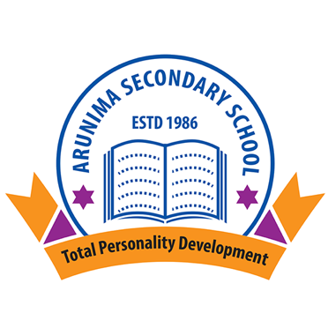

(Affiliated to National Education Board)
Bouddha-6, Kathmandu
A
Project Report on:
- DBMS
- C- Programming
- Web Technology II

2082
Subject Code: 4281
Reg Num:

For the partial fulfillment of the requirement for grade 12 computer science course designed by NEB.

Submitted By:
Name:
Faculty: Management
Section:
Batch: 2081
Year: 2082

…………………………… …………………………….
Internal Examiner External Examiner
(Signature) (Signature)

