**Assignment 7.2**

**Step1: first of all will create a file name create.sql and write down the query on that related to the problem given .and save it as .sql extension. And provide the appropriate loction here it is /home/acadgild/acd/create.sql.**

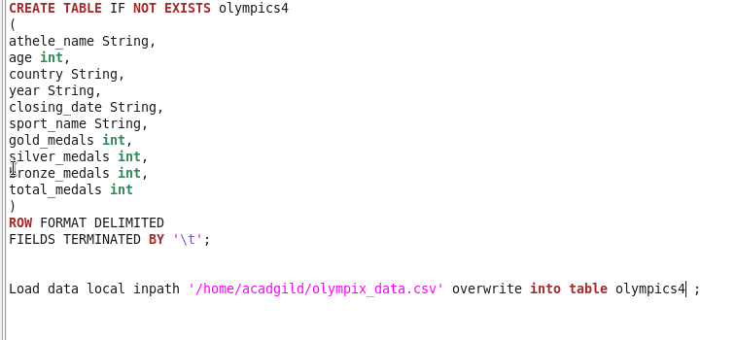

**Step2: use that location to run the query without hive shell and command will be: hive –f /home/acdgild/acd/create.sql**

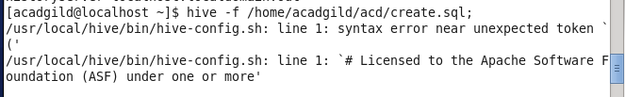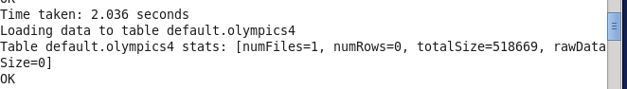

1. **Write a Hive program to find the number of medals won by each country in swimming.**

**Step1: first of all will create a file name create.sql and write down the query on that related to the problem given .and save it as .sql extension. And provide the appropriate loction here it is /home/acadgild/acd/1.sql.**

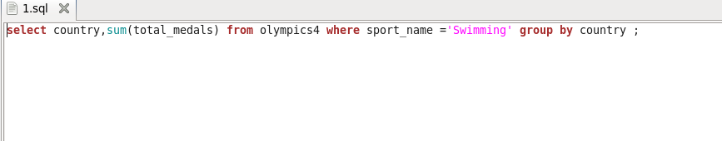

**Step2: use that location to run the query without hive shell and command will be: hive –f /home/acdgild/acd/1.sql**

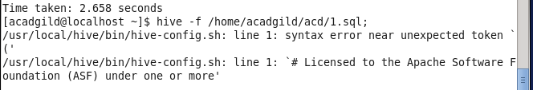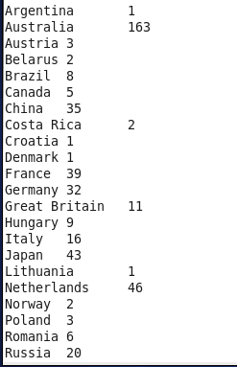

**2)Write a Hive program to find the number of medals that India won year wise.**

**Step1: first of all will create a file name create.sql and write down the query on that related to the problem given .and save it as .sql extension. And provide the appropriate loction here it is /home/acadgild/acd/1.sql.**

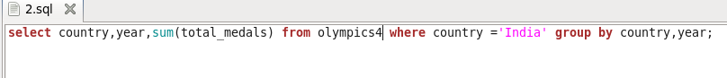

**Step2: use that location to run the query without hive shell and command will be: hive –f /home/acdgild/acd/2.sql**



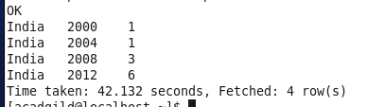

**3)Write a Hive Program to find the total number of medals each country won.**

**Step1: first of all will create a file name create.sql and write down the query on that related to the problem given .and save it as .sql extension. And provide the appropriate loction here it is /home/acadgild/acd/3.sql.**

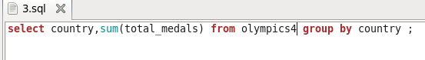

**Step2: use that location to run the query without hive shell and command will be: hive –f /home/acdgild/acd/3.sql**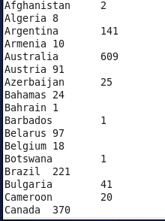

**4)Write a Hive program to find the number of gold medals each country won.**

**Step1: first of all will create a file name create.sql and write down the query on that related to the problem given .and save it as .sql extension. And provide the appropriate loction here it is /home/acadgild/acd/4.sql.**



**Step2: use that location to run the query without hive shell and command will be: hive –f /home/acdgild/acd/4.sql**

