Assignment15
Problem Statement
1.Write a simple program to show inheritance in scala.
2.Write a simple program to show multiple inheritance in scala.
Step:will create a project name ,new→scalaproject

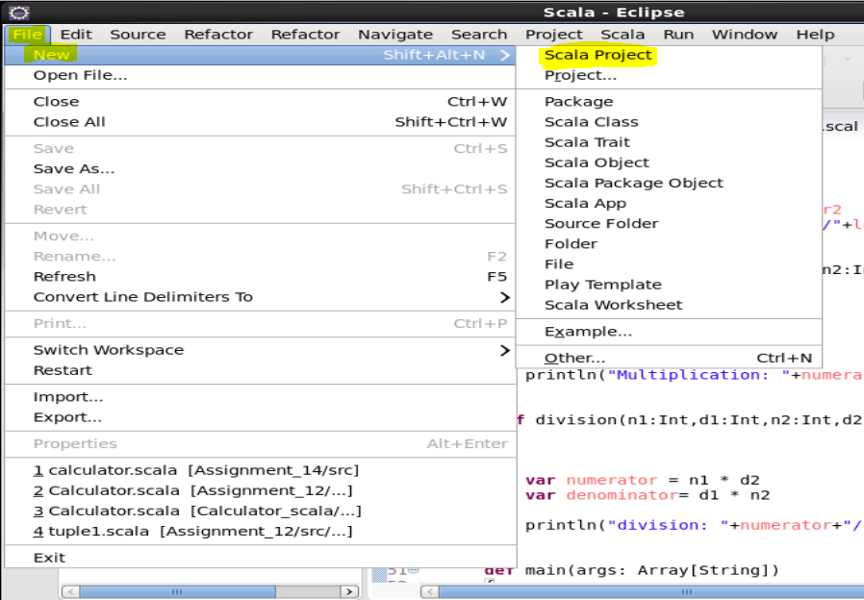

Will give the name to that project as Assignment15 then click next
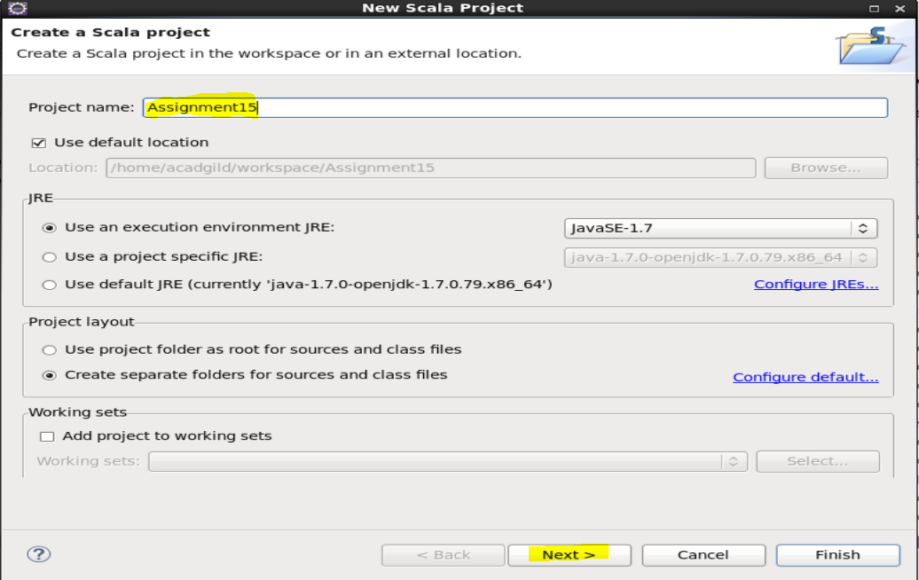

After this this below screen will be seen click on next finsh
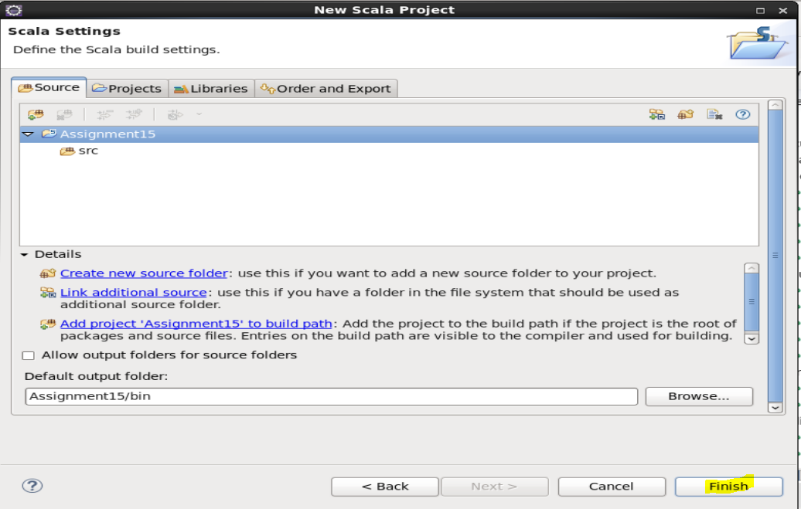
Next will create a scala object name it as SingleInheritance and click on finish
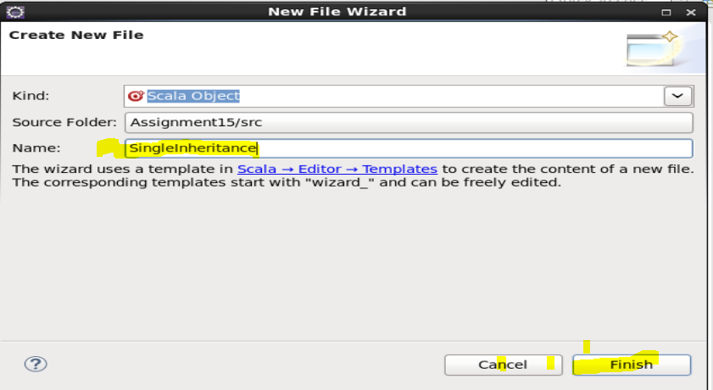

Next will write a code on that scala object as per the requirement
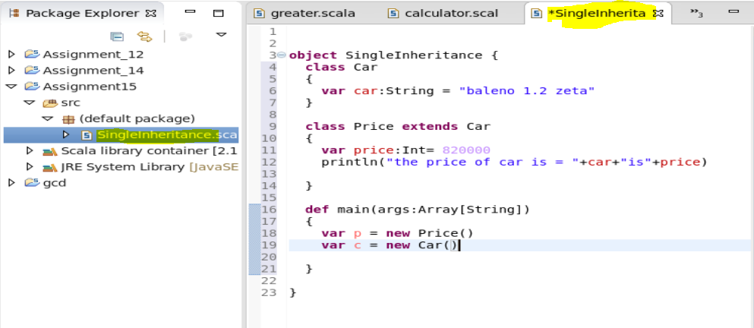
After that will save it and run it as scala Application
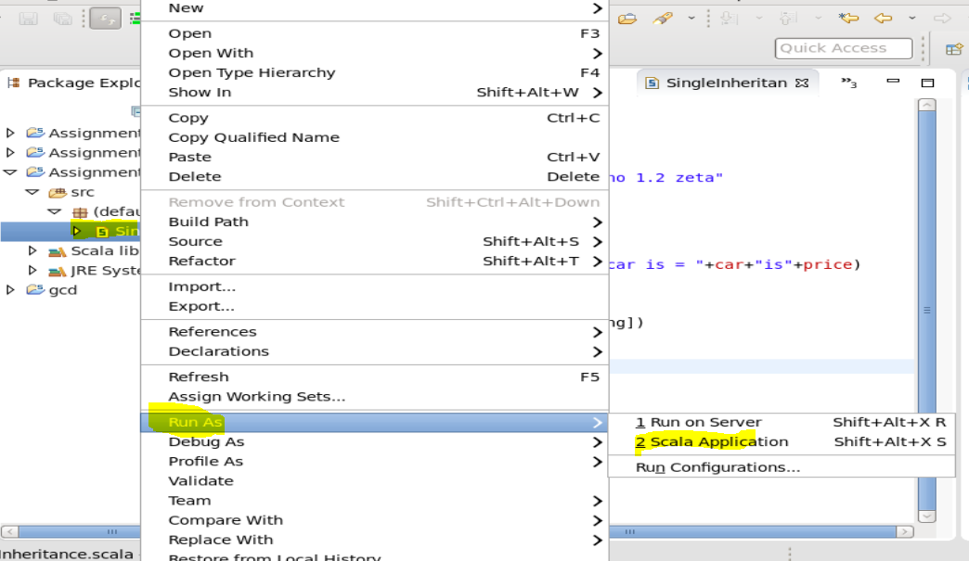

And the output will be as given below
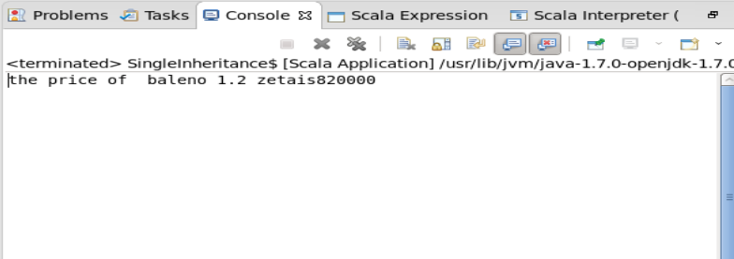

Second Program :
Multiple Inheritance: For this have to create a project name as:Assignment15
Inside which I have created a scala object :a.scala
And write the code for the same program
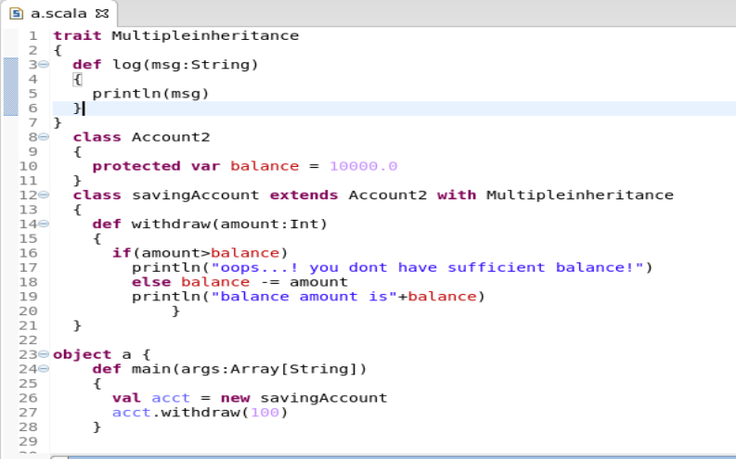

Save the program and run it as scala Application
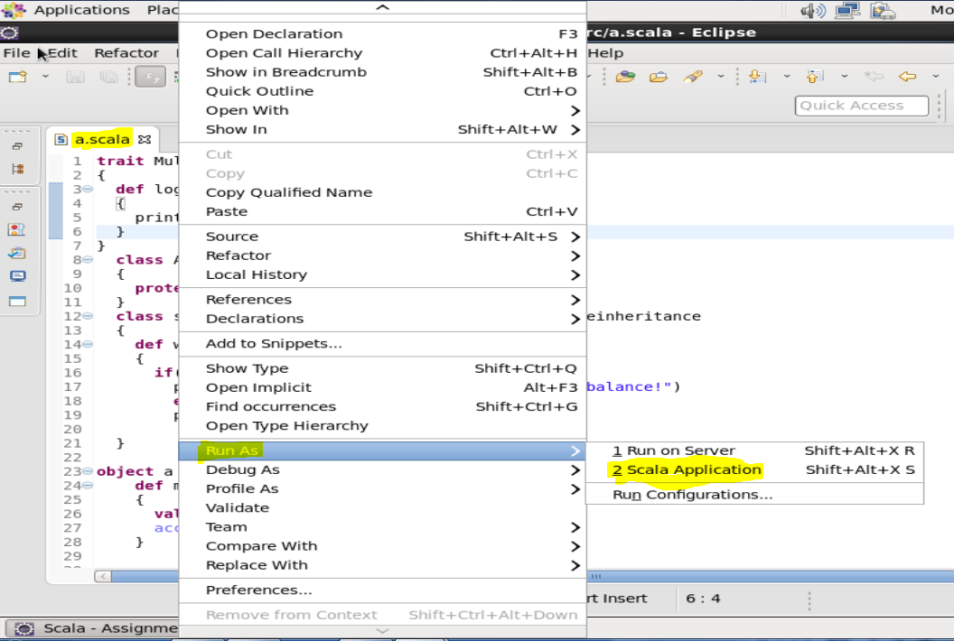
And the output will be as given below
