Dataset Description:
ID,Case Number,Date,Block,IUCR,Primary Type,Description,Location
Description,Arrest,Domestic,Beat,District,Ward,Community Area,FBICode,X Coordinate,Y
Coordinate,Year,Updated On,Latitude,Longitude,Location
5. Problem Statement

First of all have to start all thesevices as given below

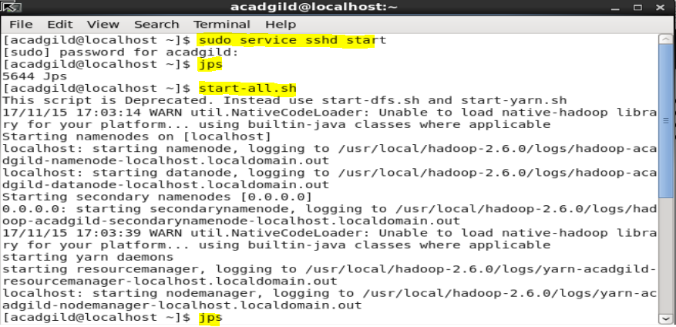

Have to start all the history server as given below to go to the pig shell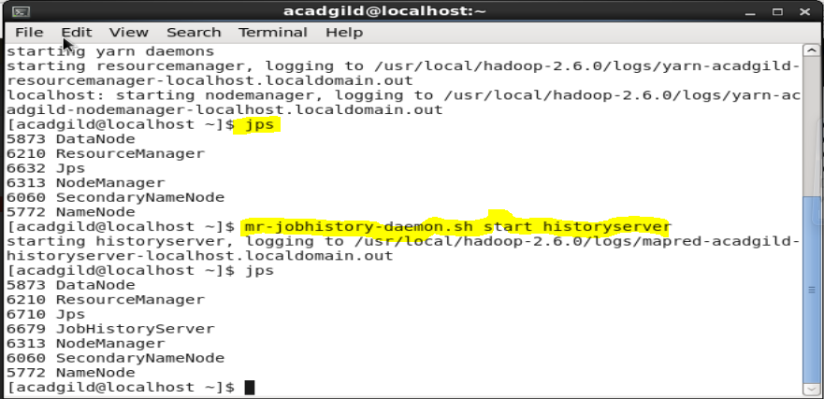

Should give thecommand as pig –x local to go to the local shell or pig to go to the map reduce shell
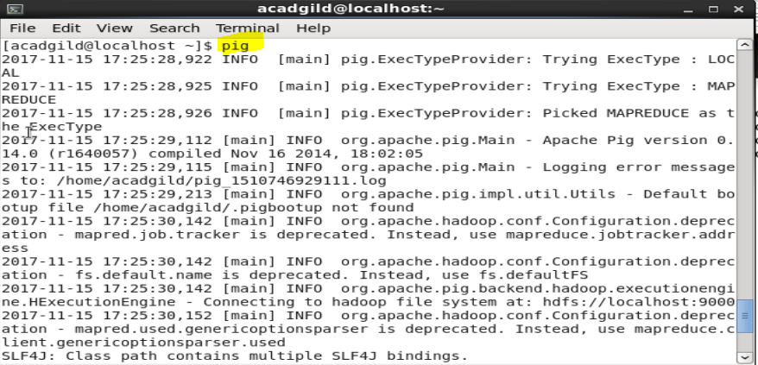
After that will load the file and dataset given to us to the grunt sheel by giving the below command
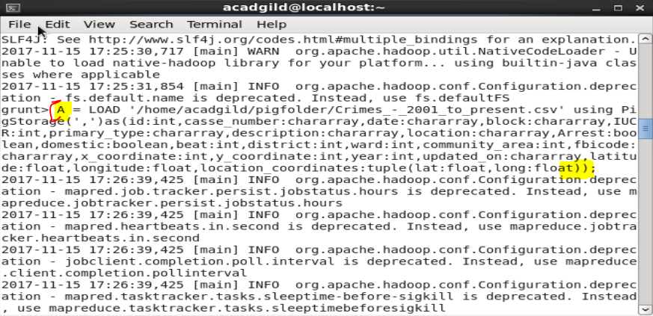
Will register all the jar file as piggybank.jar and other thing which is require for the define path and etc
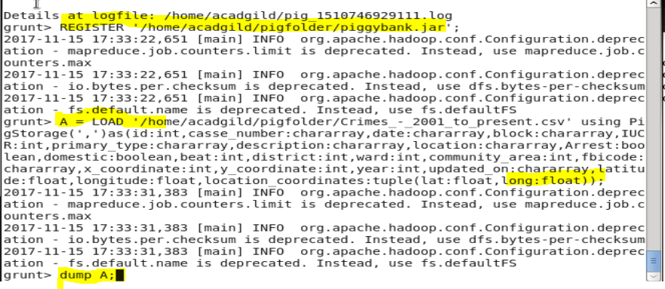

Willdump the A sto see the conent came into A;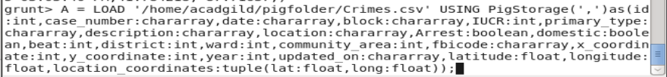
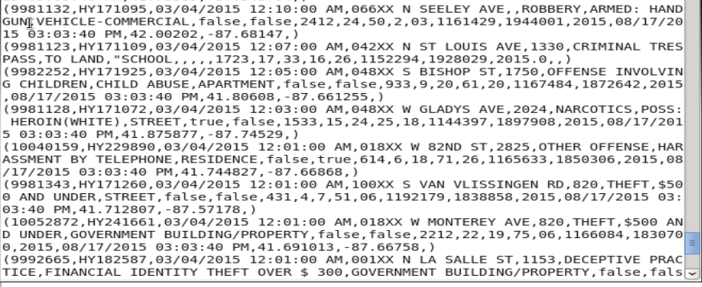
1. Write a MapReduce/Pig program to calculate the number of cases investigated under each
FBI code

Step: we will give the below command to take those field which is required for the query to be solved.
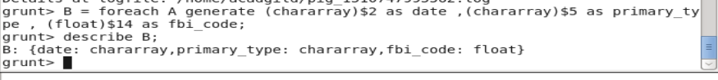
Dump B so that can see the content and field of B.
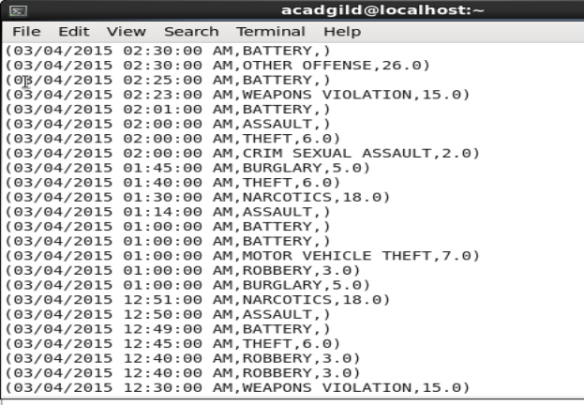

Can filter the component of create C on basis of not ull so to remove unwanted data.
Dump c so to see the data of C;
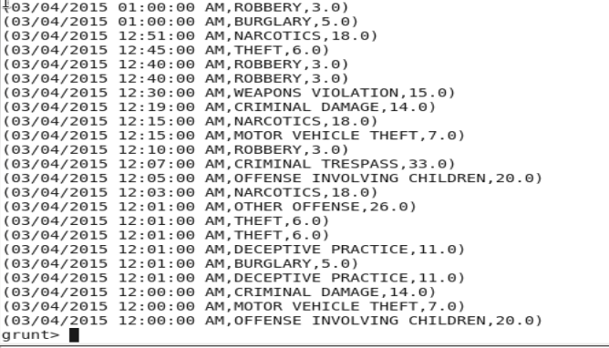
Next will filter the data on basis of that fbi_code

Will dump that As d;

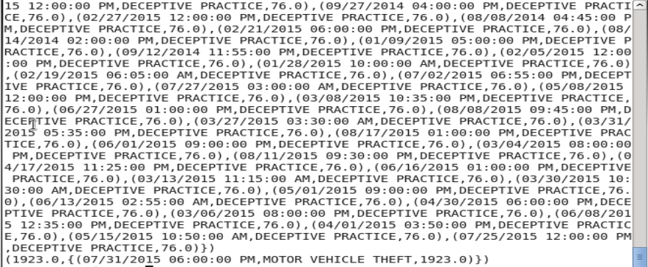

Next will generate count on fbi_code and group on basis of that as E;
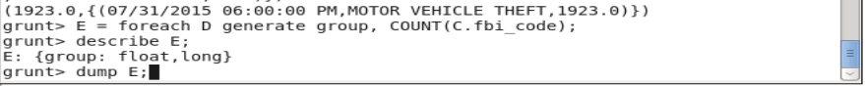
Dump E,to see the content of that;this will be the result of the query.

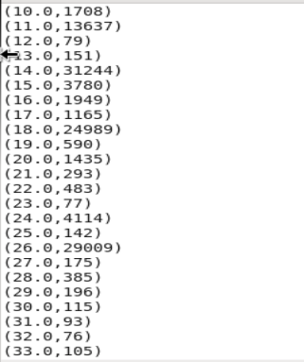

2. Write a MapReduce/Pig program to calculate the number of cases investigated under FBI
code 32.

For the above second problem will filter on the basis of fbi_code which is 32.0
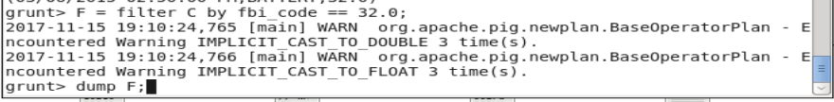
Dump the result that will be the required result.
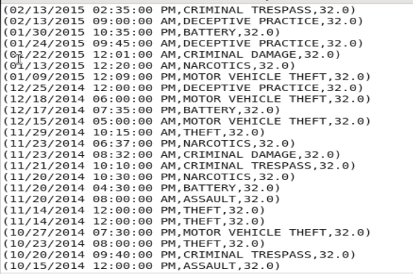
Will grouo the above result on the basis of that fbi_code of 32.0
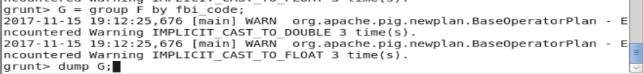
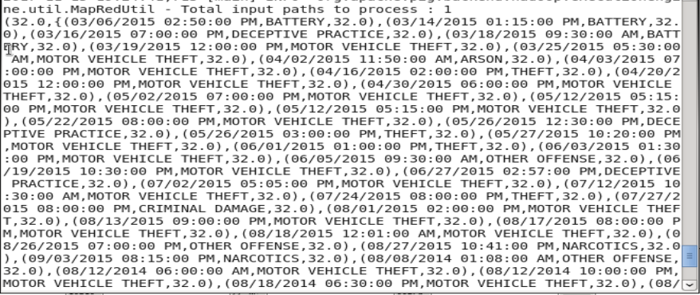

Will generate the count on that fbi_code nd group it together to get the desired resukt of the query.
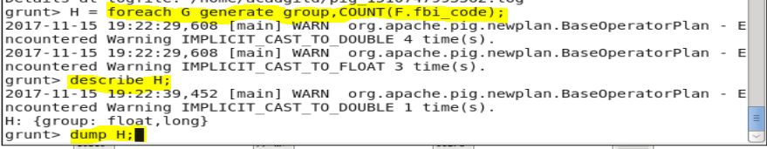
That below is the result of the query.
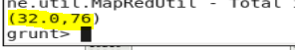
3. Write a MapReduce/Pig program to calculate the number of arrests in theft district wise.
After loading the dataset will generate a file as B1 which contain some required file as that required for the next query solution.
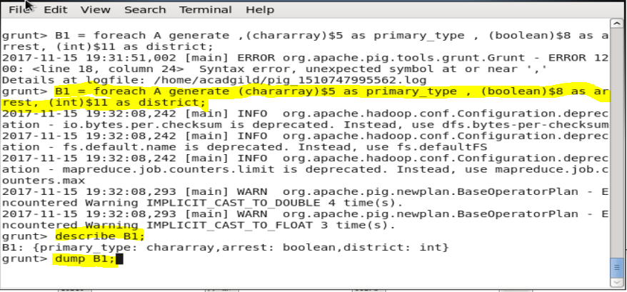
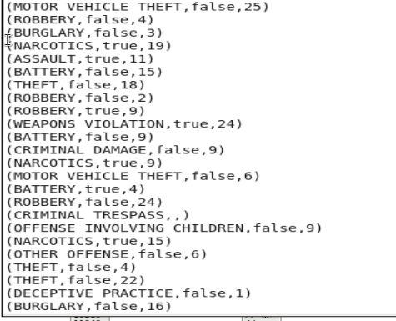
Filter the above file B on the basis of that arrest==true so to get the distibct and valid result
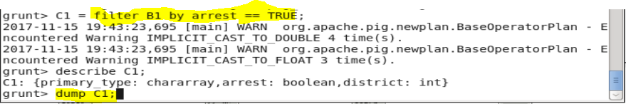
Dump C t get the resukt of above query.
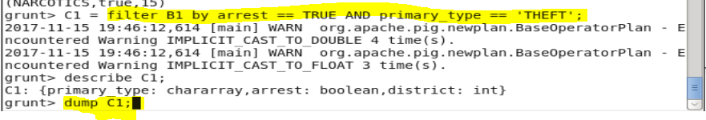
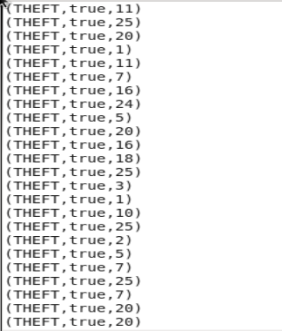
Will next group the resukt of C on basis of that district.
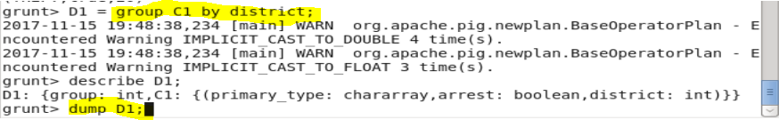
Will dump the result as D.
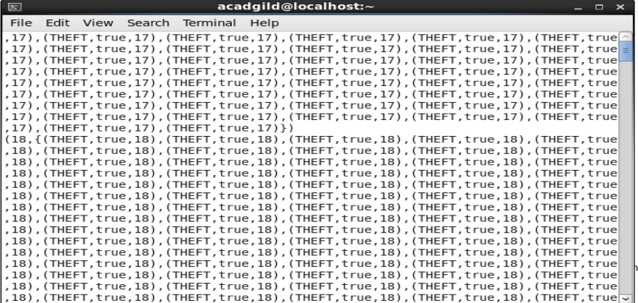

Next will generate the count on basis of the district present and where arrest is true.
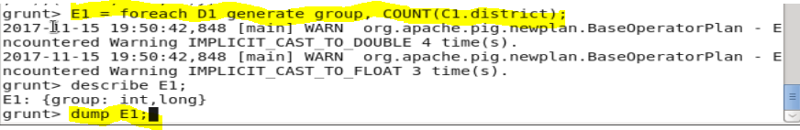
Dump E;that is the requiredanswer of the query.
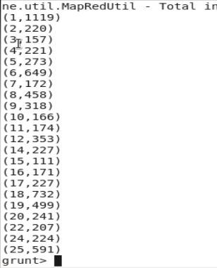
4. Write a MapReduce/Pig program to calculate the number of arrests done between October
2014 and October 2015.
First of all will load the data and generate a new data for all those filed required for the next query.as B.

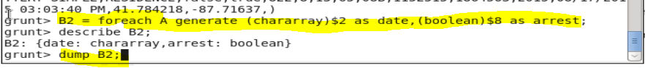
Dump B.
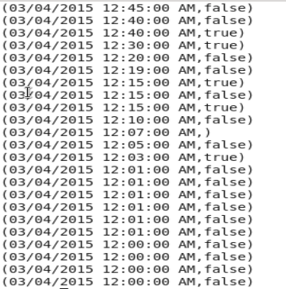
Folter B on Arrest as true and name as C and dump C2.
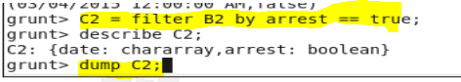
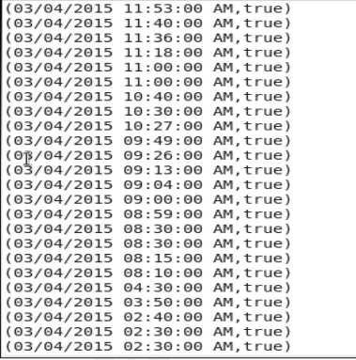
Will generate the data on the basis of date and ,month as required so for that first get a new filed as date and month by creating a substring and getting those two new filed
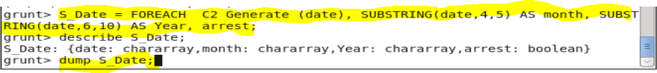
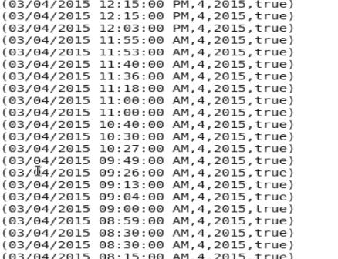

Ahter that will filter on the basis of date and month as required by the query.
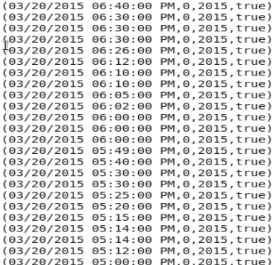
Will group them all and dump them to get the detail of data.
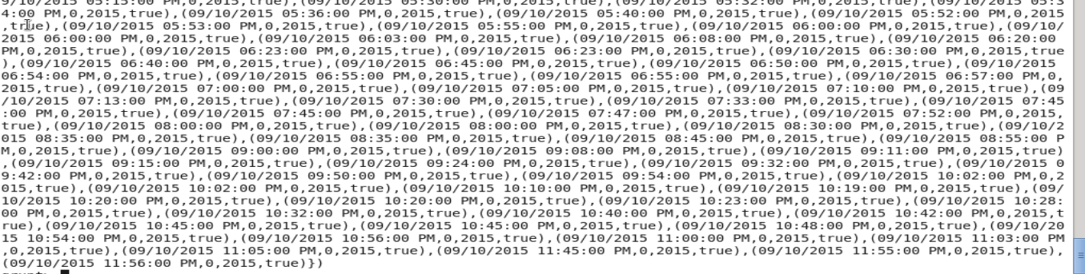

After that will count on that grouo on dasis of the total arrest and dump that will be the required result.
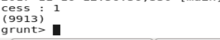
6. Approximate Time to Complete Task

