Assignments 3.3
We have a dataset of sales of different TV sets across different locations.
Records look like:
Samsung|Optima|14|Madhya Pradesh|132401|14200
The fields are arranged like:
Company Name|Product Name|Size in inches|State|Pin Code|Price
There are some invalid records which contain 'NA' in either Company Name or Product Name.
2. Write a Map Reduce program to calculate the total units sold for each Company.

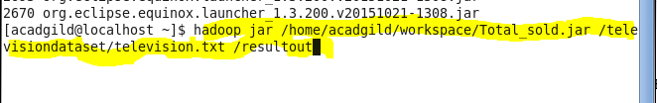

To start the programming in hadoop first we have to start all the services and job history server so will finish that first
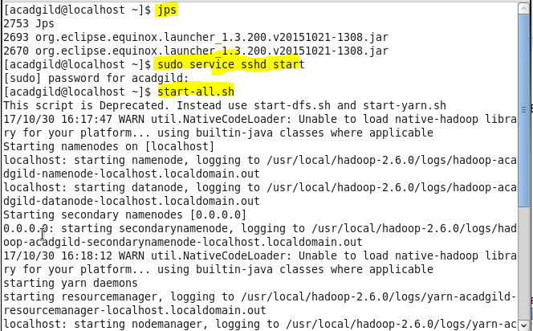

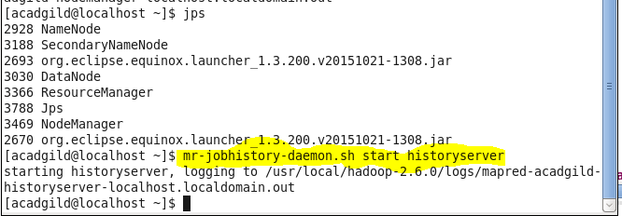
Create a directory and put the dataset into that directory
After creating the directory will put the dayaset into that directory from local using –put command

Can see weather the dataset is present or not using –cat command followed by the location of dataset
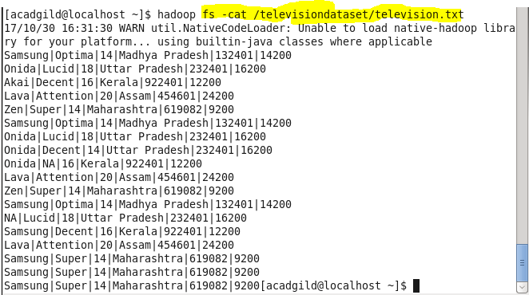

Will code for all the three classes that is
1. Mapper Class

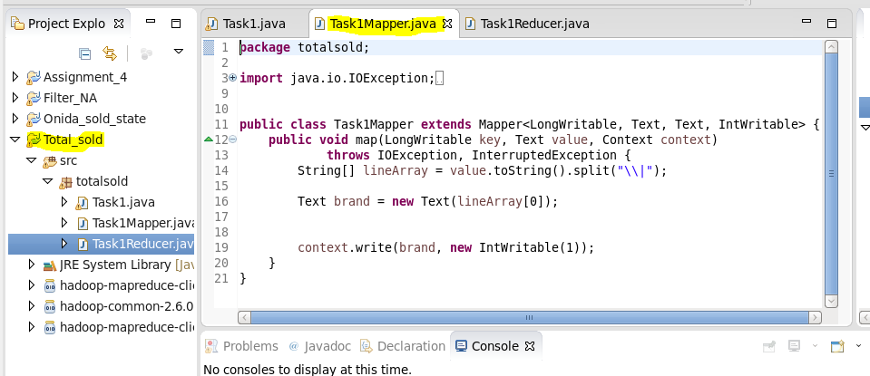

ReducerClass
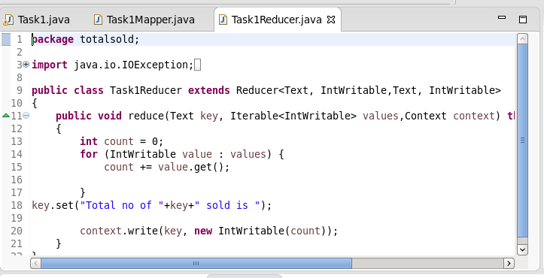
Driver class

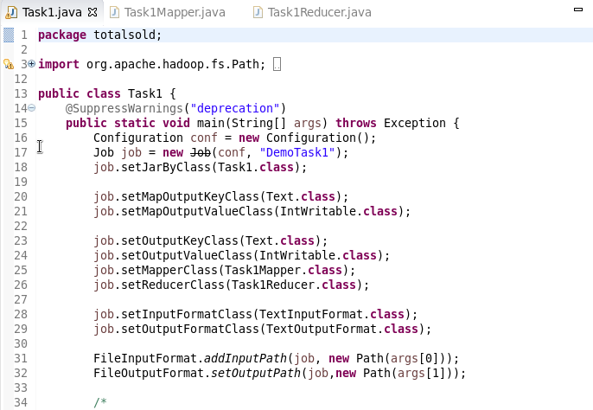
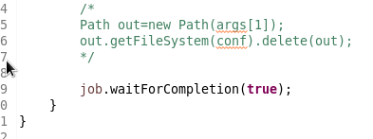

Will create the jar file by right click in classname and click on export then give a name to the export file .and click on next.
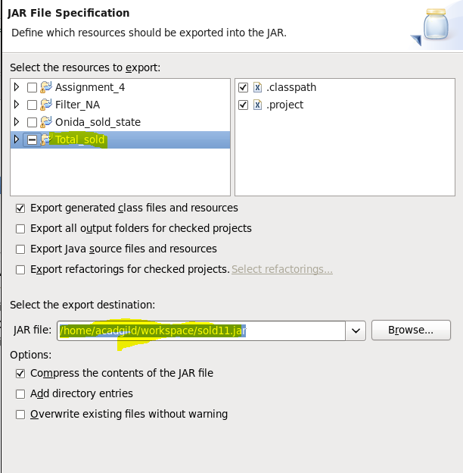

Will now add the main Class without which it will through error
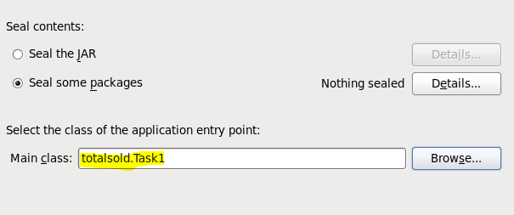
Now open the hadoop terminal and give the below command to add the jar and rum the jar for the used dataset command is : hadoop jar /location of jar /location of dataset /location of output

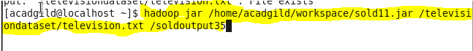

Can see the output using –cat command and first check the output directory will show success and the output file name use that name and see the output

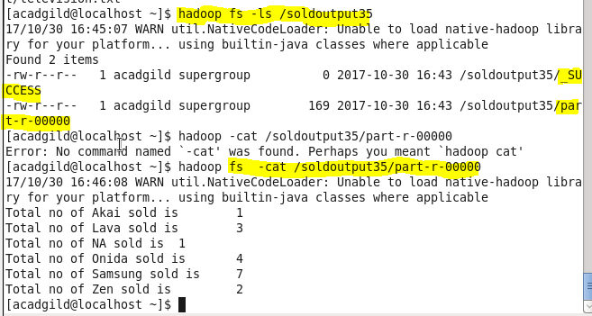

3. Write a Map Reduce program to calculate the total units sold in each state for Onida
company.

For these all the procedure till creation and using dataset will be same.
After thar will create the three classes
1)Mapper Class
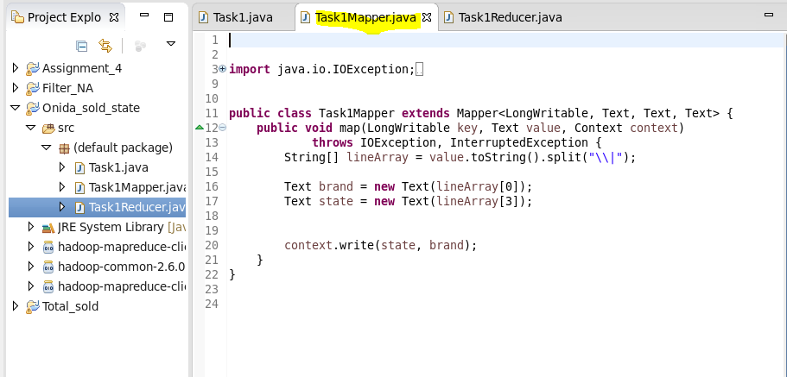
2) Reducer Class
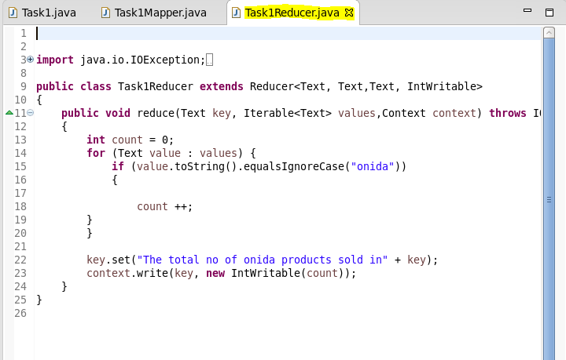
3)Driver Class
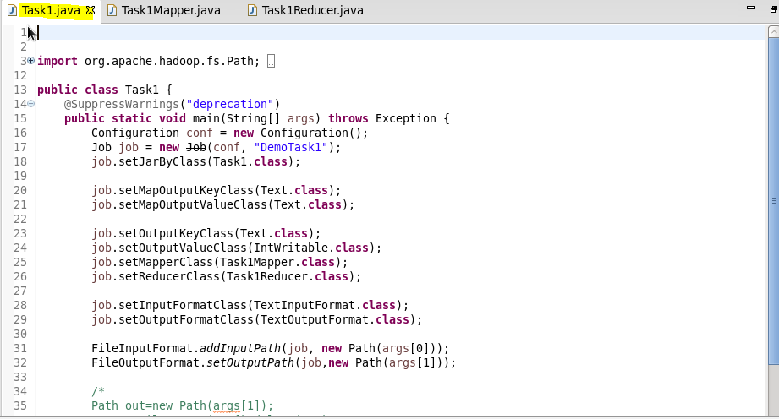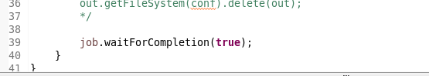
Then will create the jar using the same procedure of jar creation.
Will use that jar in hadoop terminal and rum by providing the output location,input location and location of jar file
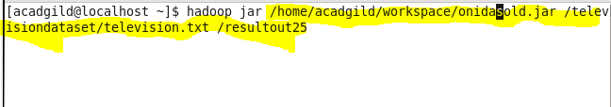
Will execute that command
Then will see that output file with hadoop –fs ls/
Then will find the files present in that directory and will see the output using the –cat command followed by file name.
