Assignment13
Questiom13.1
Create a Scala application to find the GCD of two numbers.
Step1: we will create a project and under that project will create ascala object with a name as GCD.
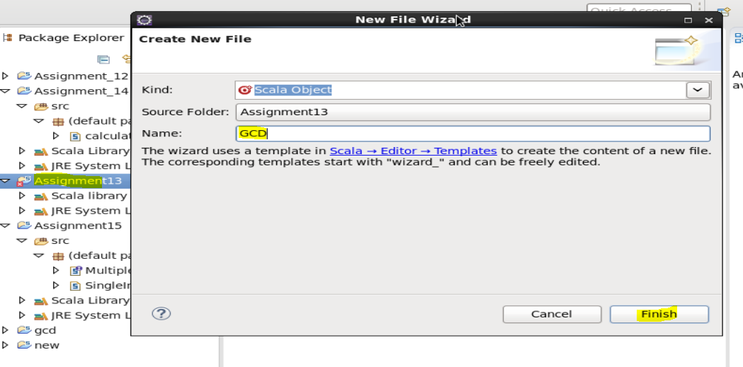
Write the coading in that asper to find out the GCD of the given number.

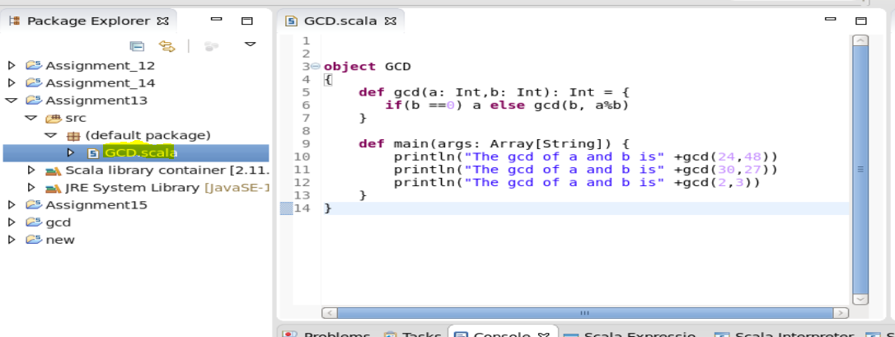

After that go to object name under the project and right click on that and click on run as and next to that click on Scala application.
Project→Objectname→runas→scala application
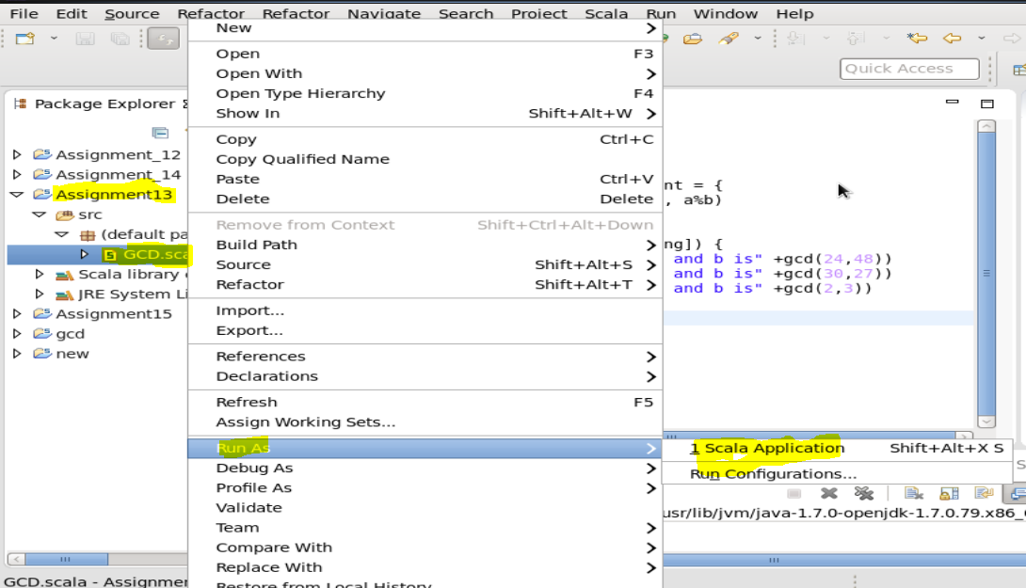
This below will be the desired output of the problem given.
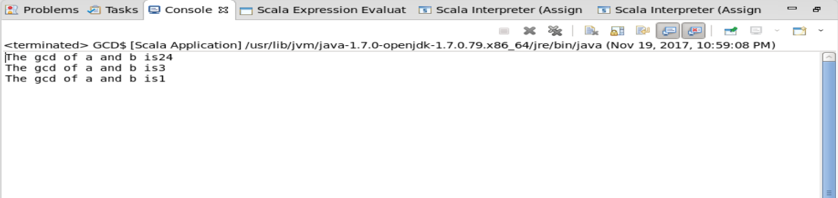

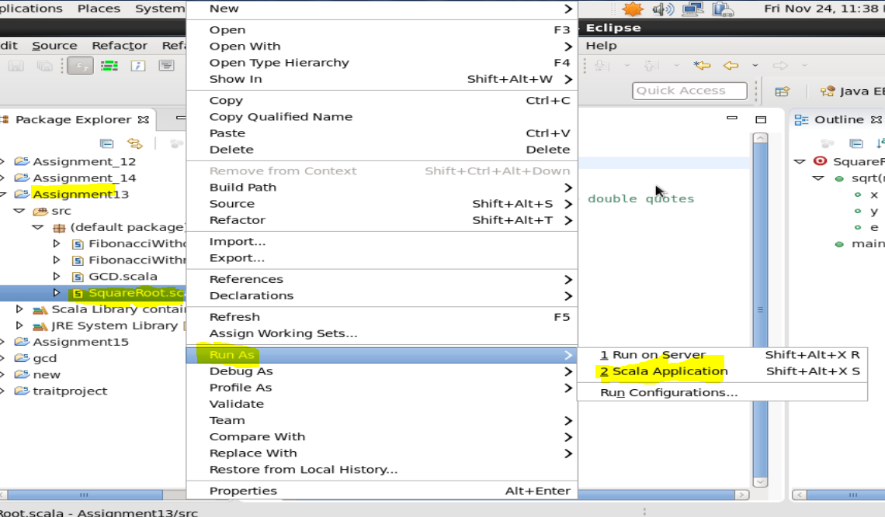
The output will be as

