**Assignment13**

**Problem13.2.1**

**● A Fibonacci series (starting from 1) written in order without any spaces in between, thus**

**producing a sequence of digits.**

**Write a Scala application to find the Nth digit in the sequence.**

**○ Write the function using standard for loop**

**Step: first under aproject will create a object name as Fibonacciwithoutrecurssive**

**New scalaobject🡪name of object🡪finish**

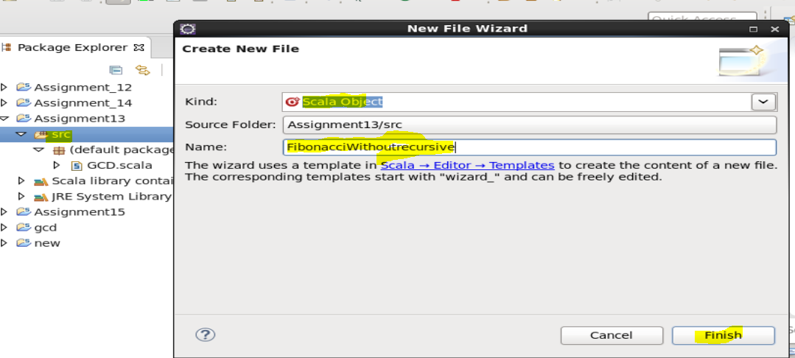

**Write the programming code under the name tab and save it as per the logic**

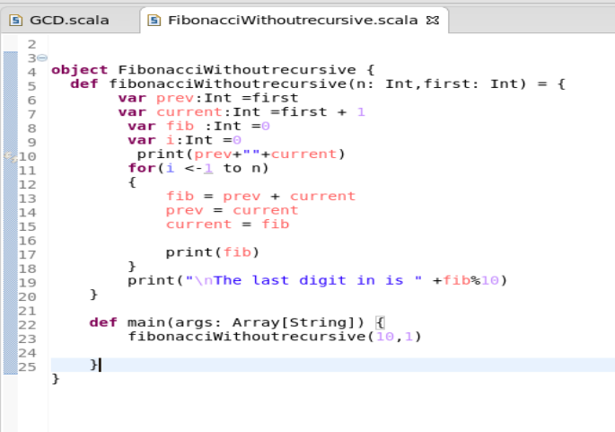

**Run the program as a scala application and below will be the output.**

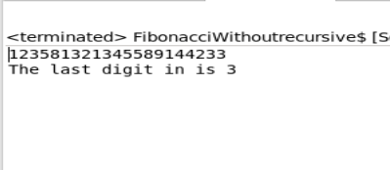

**Questiom13.2.2**

**○ Write the function using recursion**

**Step: we will create a scala object name as FibonacciWithrecurssive and click on finish.**

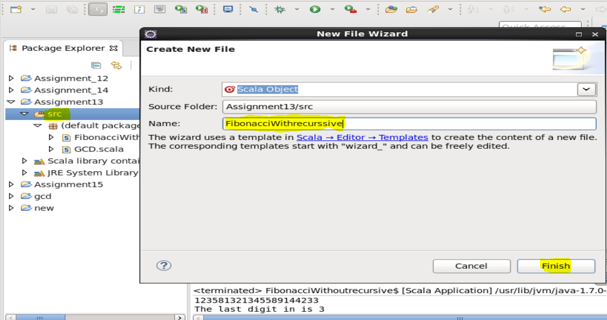

**Write the code in the below tab of the scala object created**

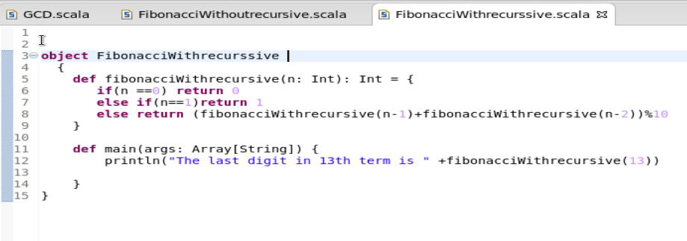

**Save the programm and run as scala application.and below will be the output as per the logic.**

