**Assignment14**

**Create a calculator to work with rational numbers.**

**Requirements:**

**○ It should provide capability to add, subtract, divide and multiply rational**

**numbers**

**○ Create a method to compute GCD (this will come in handy during operations on**

**rational)**

**Step: first of all will create a project and under that project will creta a scala object name as rationalcalculator.**

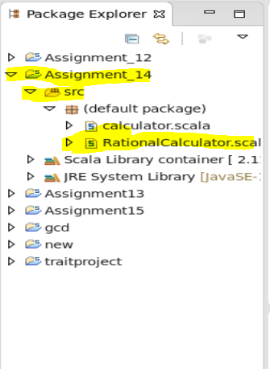

**After this will write the code for rational and whole number calcukation and there greatest common divisor**

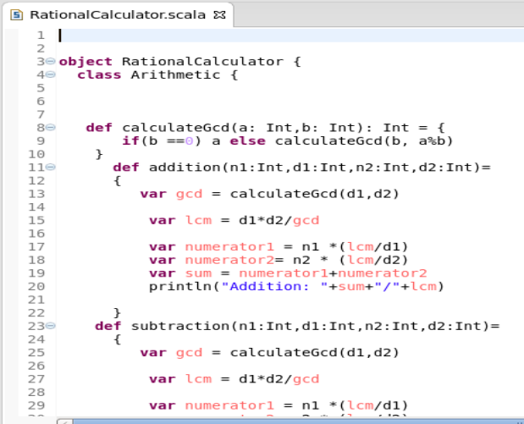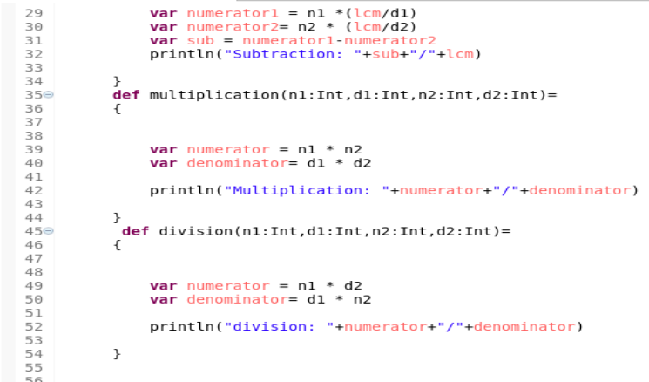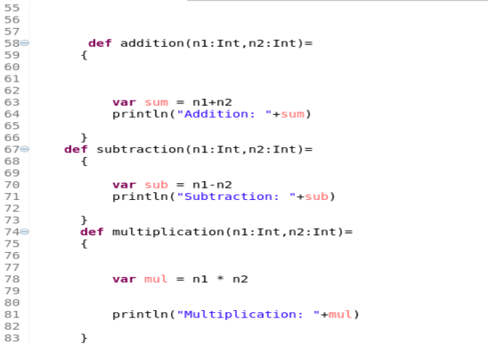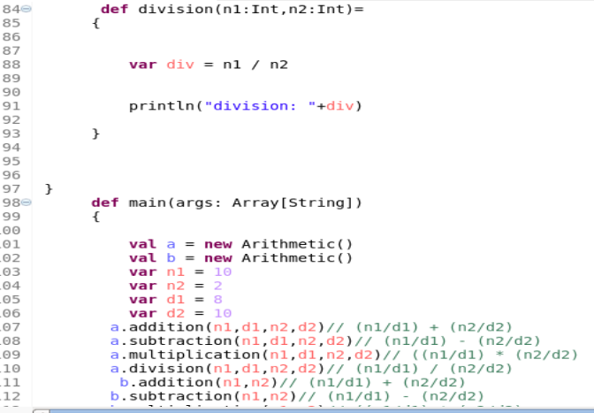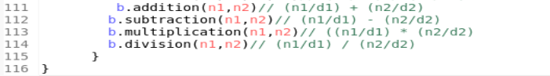

**After the code will save the program and run it as scala application**

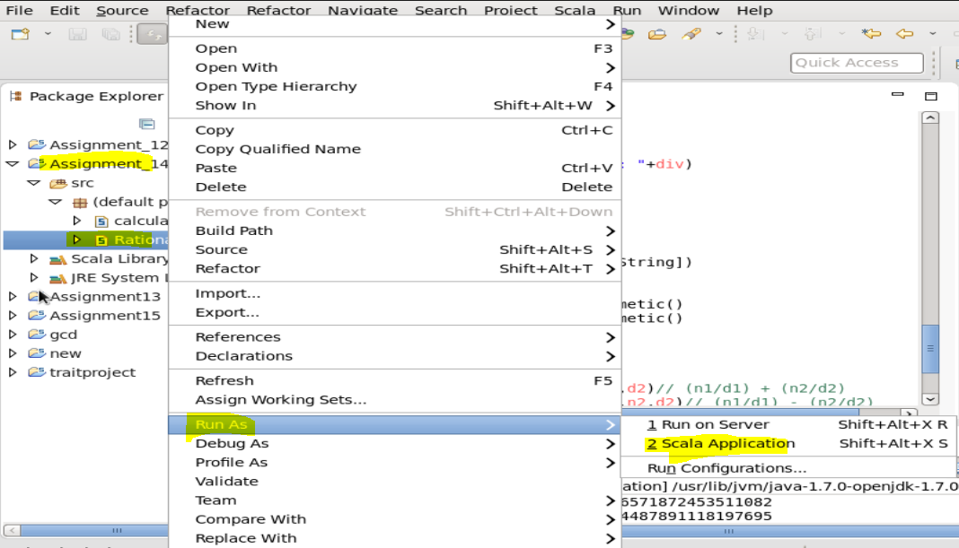

**After this the output will be like**

