**Assignment15.2**

**3.Write a partial function to add three numbers in which one number is constant and two**

**numbers can be passed as inputs and define another method which can take the partial**

**function as input and squares the result.**

**Step: first of all will create a project and inside that project will create a scala object**

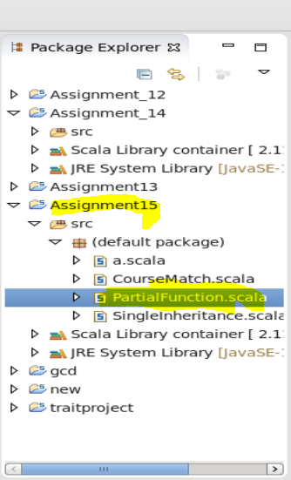

**After that will write the code for the same program as per the logic required for te same**

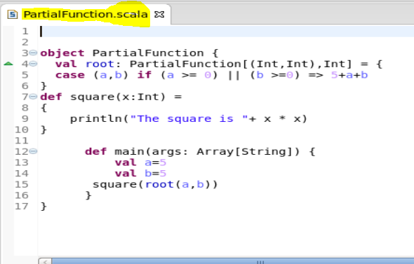

**After that will save the program and run it as scala application**

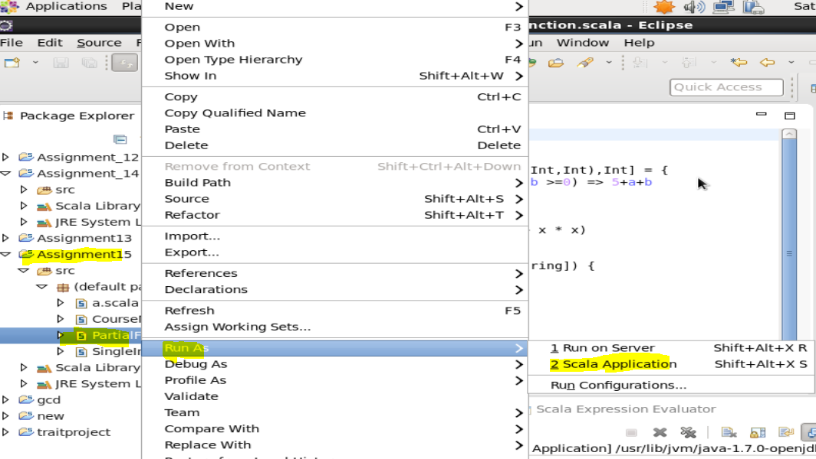

**After that the output will be as**

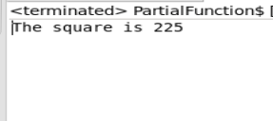

**4.Write a program to print the prices of 4 courses of Acadgild: Android-12999,Big Data**

**Development-17999,Big Data Development-17999,Spark-19999 using match and add a**

**default condition if the user enters any other course.**

**Step: first of all will create a project and inside that project will create a scala object As courseMatch**



**After that will write the code for the same program as per the logic required for the same**

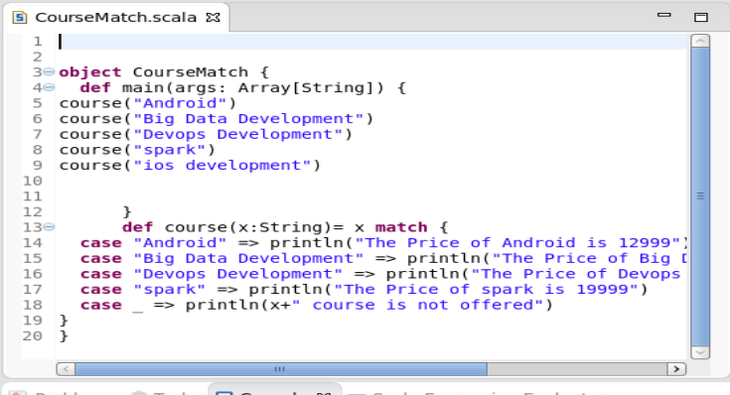

**After that will save the program and run it as scala application**



**After that the output will be as**

