**Assignmet 16.1**

**Given a list of numbers - List[Int] (1, 2, 3, 4, 5, 6, 7, 8, 9, 10)**

**- first of all will create a list of number using the below command**



**After that will create a rdd for the same list using sc.parallelize**



**Will see the number of partition in the same list using .getNumber**

**And can see the content using .collect**

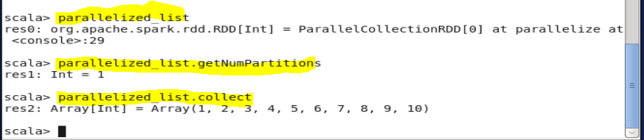

**find the sum of all numbers**

**we can find the sum of that list number using the command as rddlist.sum**



**- find the total elements in the list**

**Can find the total number and that as count of numbr by using command as .count**

**Parallelized_list.count**

**- **

**calculate the average of the numbers in the list**

**next can calculate the average if the list by using the blelow command of dividing the count with the sum of the integers present**



**- find the sum of all the even numbers in the list**

**Can calculate the sum of even number bt first will get the even number by giving the query as divisible by 2 as given below(I =>(i%2==0) and next to that will find the sum using .sim command along with the name of rdd**

