Check whether /user/acadgild directory exists or not in the HDFS.
If it doesn't exist, then create this.Create a directory /user/acadgild/hadoop.
First start the servicesusing the command :sudo service sshd start

Using jps to see what all services are running,then will start all the services using command start-all.sh.
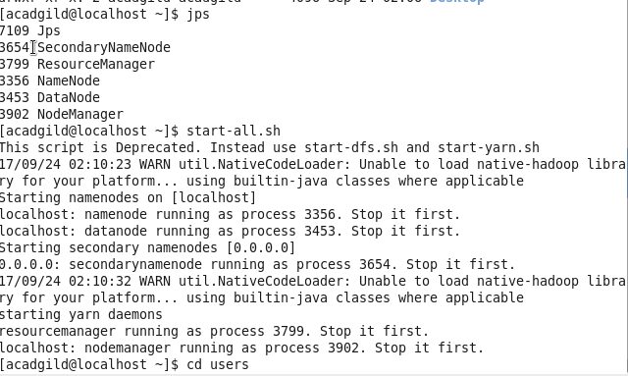

Will check weather user/acadgild/hadoop is present there or not using fs –ls /
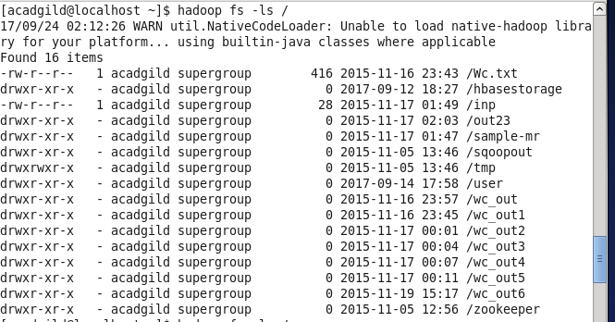
will check haddoop1 is there or not, here it is not present.
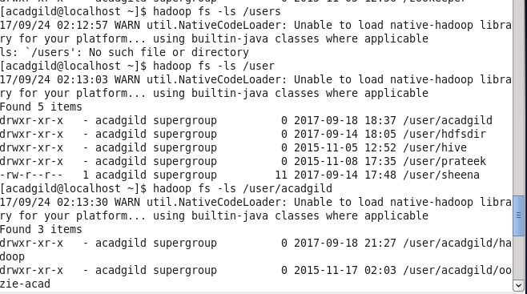

Will create a folder name hadoop1 using -mkdir
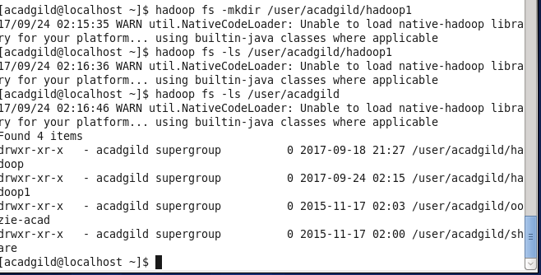

Task2:Create a file in HDFS under directory /user/acadgild/hadoop, with name word-count.txt.
Whatever we type on screen should get appended to the file.
Will create a file name wordcount.txt using -touchz,which will create a file of 0 byte.
2.Now to append file on screen will use echo “what we want to append”|hadoop1 fs-appendT0File – location of file

