Task3:Create a file max-temp.txt in local FS.
Put some 10-15 records of date and temperature example:
dd-mm-yyyy,temperature
Example:
10-01-1990,10
10-02-1991,20
Move this file to HDFS at /user/acadgild/hadoop.

Will create a file using vi command and it will open in edit mode will add all he details of file here.
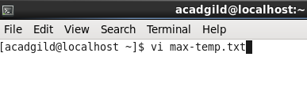
Here is the file with all the details related to the temperature.

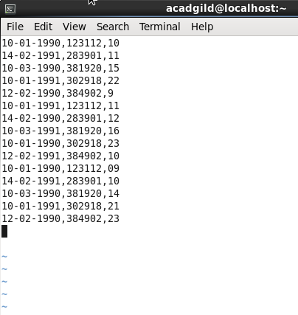

We have to Move this file to HDFS at /user/acadgild/hadoop.so will do using command –moveFromLocal locallocationof source dstinationhdfs location.
2.can verify using –cat along with the location of destination.
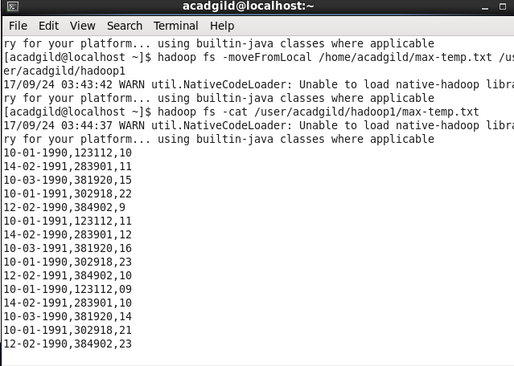

Tasks:4
Change the permission of the file /user/acadgild/hadoop/max-temp.txt, such that
only the owner and the group members have full control over the file.
Others do not have any control over it.
To change the permission have to use command chmod.
For read its 4 for write it 4 and for execute its 1 so for all its together7,so have to give 7 for user ,7 for group and 0 for others since others donot have any permission.

