List the Components of Hadoop 2.x and explain each component in detail.

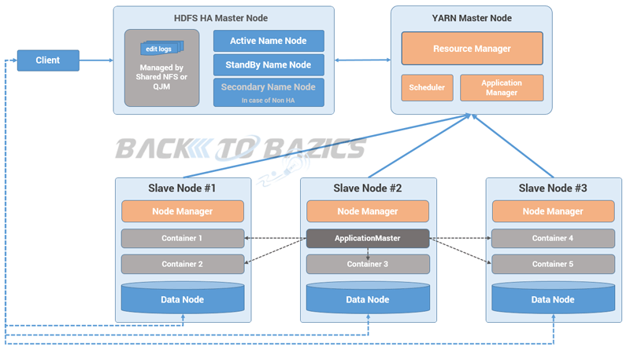

- Hadoop 2.x has some common Hadoop API which can easily be integrated with any third party applications to work with Hadoop
- It has some new Java APIs and features in HDFS and MapReduce which are known as HDFS2 and MR2 respectively
- New architecture has added the architectural features like HDFS High Availability and HDFS Federation
- Hadoop 2.x not using Job Tracker and Task Tracker daemons for resource management now on-wards, it is using YARN (Yet Another Resource Negotiator) for Resource Management

HDFS High Availability (HA)
Problem: As you know in Hadoop 1.x architecture Name Node was a single point of failure, which means if your Name Node daemon is down somehow, you don’t have access to your Hadoop Cluster than after. How to deal with this problem?
Solution: Hadoop 2.x is featured with Name Node HA which is referred as HDFS High Availability (HA).
- Hadoop 2.x supports two Name Nodes at a time one node is active and another is standby node
- Active Name Node handles the client operations in the cluster
- StandBy Name Node manages metadata same as Secondary Name Node in Hadoop 1.x
- When Active Name Node is down, Standby Name Node takes over and will handle the client operations then after
- HDFS HA can be configured by two ways
  - Using Shared NFS Directory
  - Using Quorum Journal Manager

HDFS Federation
Problem: HDFS uses namespaces for managing directories, file and block level information in cluster. Hadoop 1.x architecture was able to manage only single namespace in a whole cluster with the help of the Name Node (which is a single point of failure in Hadoop 1.x). Once that Name Node is down you loose access of full cluster data. It was not possible for partial data availability based on name space.
Solution: Above problem is solved by HDFS Federation i Hadoop 2.x Architecture which allows to manage multiple namespaces by enabling multiple Name Nodes. So on HDFS shell you have multiple directories available but it may be possible that two different directories are managed by two active Name Nodes at a time.

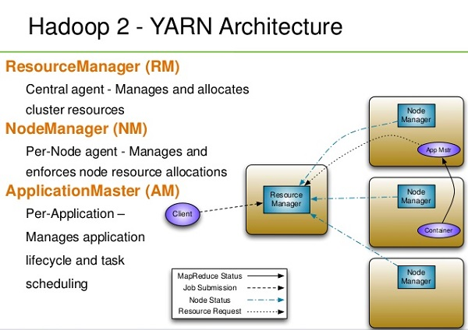

Hadoop 2.x Architecture In Detail
Hadoop2 Architecture has mainly 2 set of daemons
- HDFS 2.x Daemons: Name Node, Secondary Name Node (not required in HA) and Data Nodes
- MapReduce 2.x Daemons (YARN): Resource Manager, Node Manager

HDFS 2.x Daemons
The working methodology of HDFS 2.x daemons is same as it was in Hadoop 1.x Architecture with following differences.
- Hadoop 2.x allows Multiple Name Nodes for HDFS Federation
- New Architecture allows HDFS High Availability mode in which it can have Active and StandBy Name Nodes (No Need of Secondary Name Node in this case)
- Hadoop 2.x Non HA mode has same Name Node and Secondary Name Node working same as in Hadoop 1.x architecture

MapReduce 2.x Daemons (YARN)
MapReduce2 has replace old daemon process Job Tracker and Task Tracker with YARN components Resource Manager and Node Manager respectively. These two components are responsible for executing distributed data computation jobs in Hadoop 2

Resource Manager
- This daemon process runs on master node (may run on the same machine as name node for smaller clusters)
- It is responsible for getting job submitted from client and schedule it on cluster, monitoring running jobs on cluster and allocating proper resources on the slave node
- It communicates with Node Manager daemon process on the slave node to track the resource utilization
- It uses two other processes named Application Manager and Scheduler for MapReduce task and resource management

Node Manager
- This daemon process runs on slave nodes (normally on HDFS Data node machines)
- It is responsible for coordinating with Resource Manager for task scheduling and tracking the resource utilization on the slave node
- It also reports the resource utilization back to the Resource Manager
- It uses other daemon process like Application Master and Container for MapReduce task scheduling and execution on the slave node

ApplicationMaster
The ApplicationMaster is an instance of a framework-specific library that negotiates resources from the ResourceManager and works with the NodeManager to execute and monitor the granted resources (bundled as containers) for a given application. An application can be a process or set of processes, a service, or a description of work.
The ApplicationMaster is run in a container like any other application. The ApplicationsManager, part of the ResourceManager, negotiates for the container in which an application’s ApplicationMaster runs when the application is scheduled by the YarnScheduler.
While an application is running, the ApplicationMaster manages the following:
- Application lifecycle
- Dynamic adjustments to resource consumption
- Execution flow
- Faults
- Providing status and metrics
The ApplicationMaster is architected to support a specific framework, and can be written in any language since its communication with the NodeManagers and the ResourceManager is accomplished using extensible communication protocols. The ApplicationMaster can be customized to extend the framework or run any other code. For this reason, the ApplicationMaster is not considered trustworthy, and is not run as a trusted service.
An ApplicationMaster typically requests resources on multiple nodes to complete a job by sending the ResourceManager requests that include locality preferences and attributes of the containers. When the ResourceManager is able to allocate a resource to the ApplicationMaster, it generates a lease that the ApplicationMaster pulls on a subsequent heartbeat. A security token associated with the lease guarantees its authenticity when the ApplicationManager presents the lease to the NodeManager to gain access to the container.
The Application Master heartbeats to the ResourceManager to communicate its changing resource needs, and to let the ResourceManager know it is still alive. In response, the ResourceManager can return a lease on additional containers on other nodes, or cancel the lease on some containers. The ApplicationMaster can then adjust its execution strategy to fit the increase or decrease in available resources. When cluster resources become scarce, the ResourceManager can also request that the ApplicationMaster relinquish some resources. The ApplicationMaster can move work to other running containers in order to give up resources gracefully.

Containers
A YARN container is a result of a successful resource allocation, meaning that the ResourceManager has granted an application a lease to use a specific set of resources in certain amounts on a specific node. The ApplicationMaster presents the lease to the NodeManager on the node where the container has been allocated, thereby gaining access to the resources.
To launch the container, the ApplicationMaster must provide a container launch context (CLC) that includes the following information:
- Environment variables
- Dependencies (local resources such as data files or shared objects needed prior to launch)
- Security tokens
- The command necessary to create the process the application plans to launch
The CLC makes it possible for the ApplicationMaster to use containers to run a variety of different kinds of work, from simple shell scripts to applications to virtual machines.

