1) Write a java code with the class named ‘acad’ and a method ‘main’. Hard Code the program
with two integers and print the sum of those two.

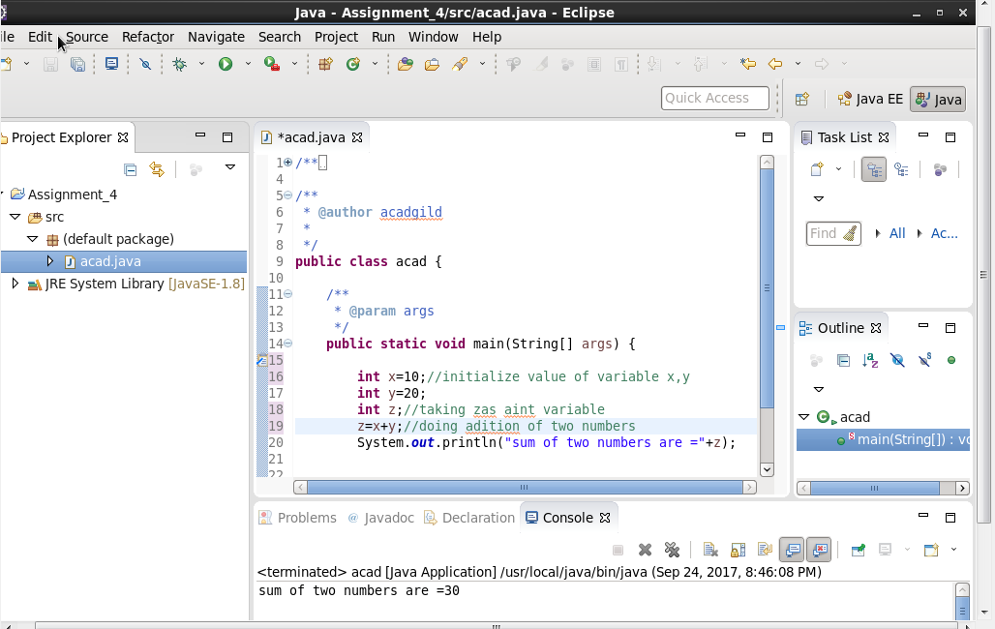

2) Rewrite the above code, where, inputs are provided by the user at runtime and the outputprinted. 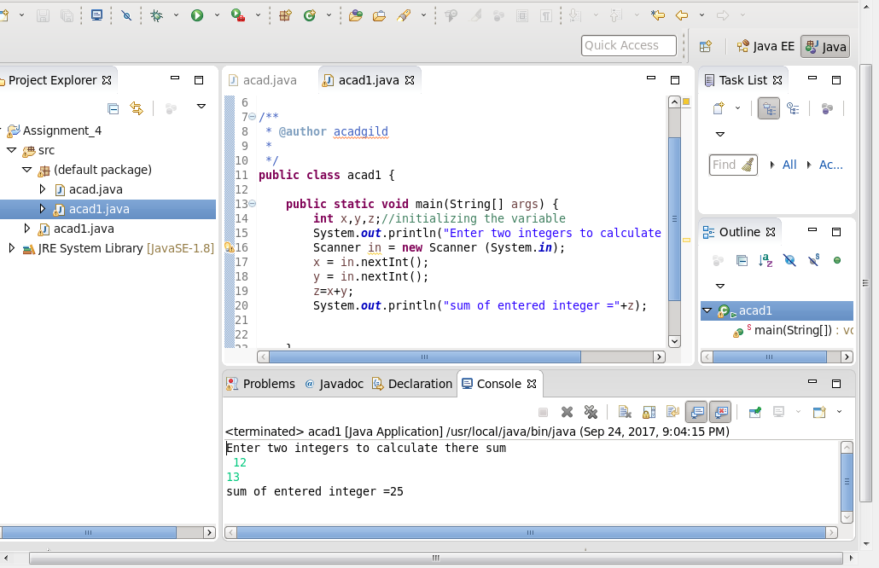

3) Write a program with method name sum() that accepts two parameters from user and print
the sum of two numbers. Output format should be as:

First number is:
Second number is:
Sum is:
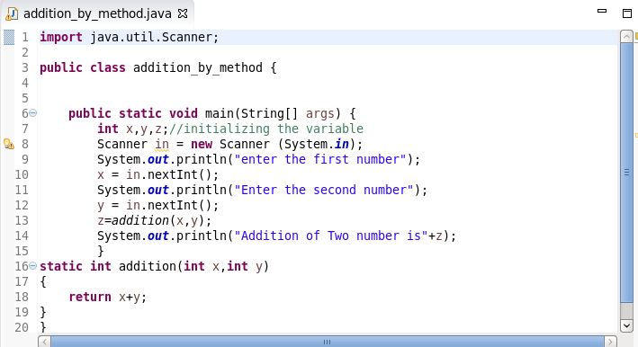
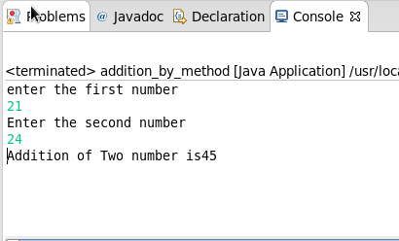

4) Write a program to accepts two numbers from stdin and find all the odd as well as even
numbers present in between them.
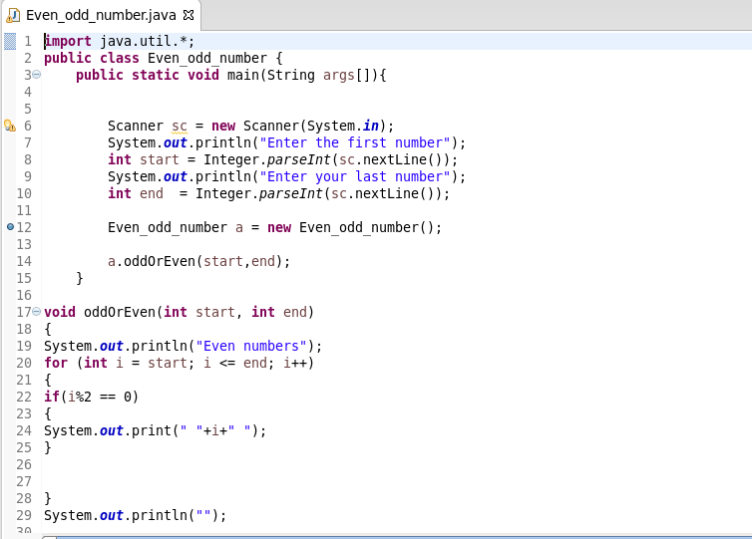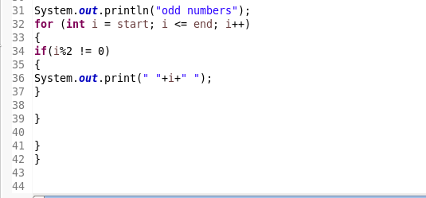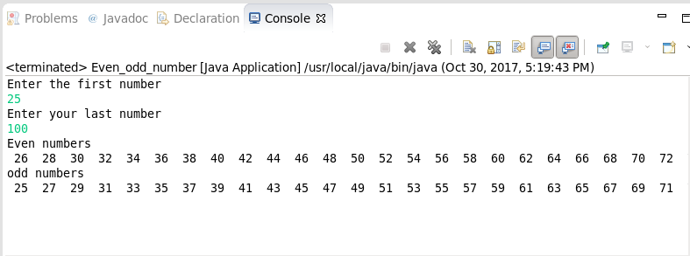
5) Joe is scared to go to school. When her dad asked the reason, joe said she is unable to
complete the task given by her teacher. The task was to find the “first 10 multiples” of the
number entered from stdin . Eg: Input: 3
O/p:
3 x 1 = 3
3 x 2 = 6

.........
.........
.......

....
3 x 10 = 30
Help Joe in completing the task!
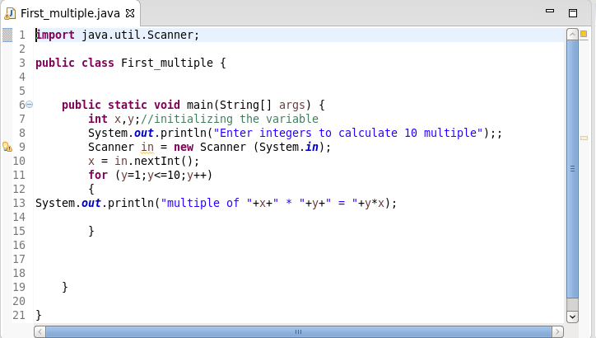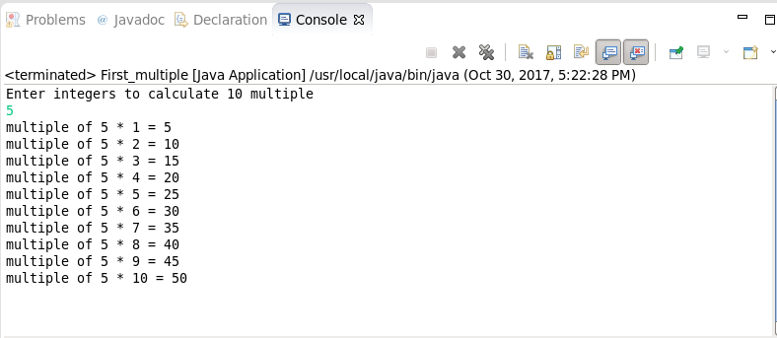

6) Write a program consisting method sum() and demonstrate the concept of method
overloading using this method.
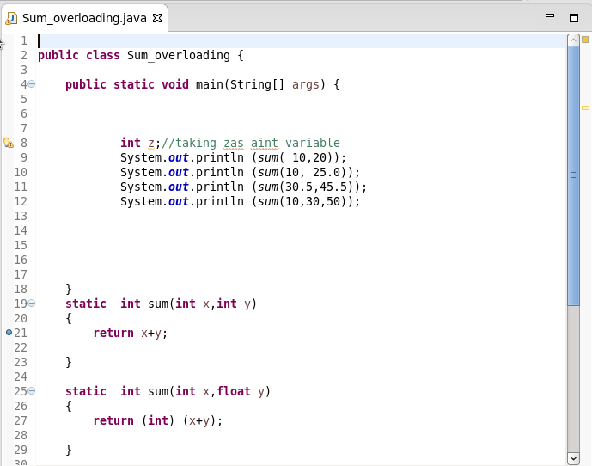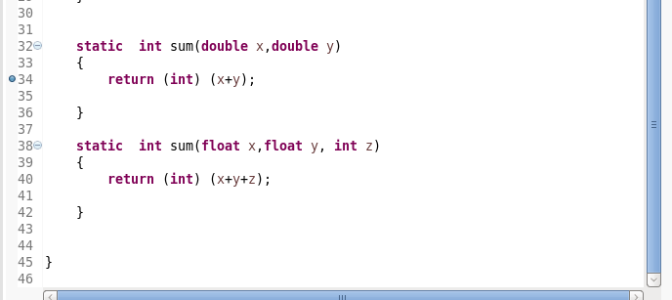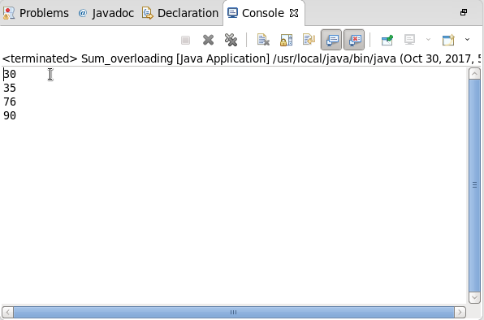
7) Can you overload a method with same return type.? Explain your answer with proper logic.
return type, method name and argument list same.
class Demo
{
public int myMethod(int num1, int num2)
{
System.out.println("First myMethod of class Demo");
return num1+num2;
}
public int myMethod(int var1, int var2)
{
System.out.println("Second myMethod of class Demo");
return var1-var2;
}
}
class Sample4
{
public static void main(String args[])
{
Demo obj1= new Demo();
obj1.myMethod(10,10);
obj1.myMethod(20,12);
}
}
Answer:
It will throw a compilation error: More than one method with same name and argument list cannot be defined in a same class.
Question 2 – return type is different. Method name & argument list same.
class Demo2
{
public double myMethod(int num1, int num2)
{
System.out.println("First myMethod of class Demo");
return num1+num2;
}
public int myMethod(int var1, int var2)
{
System.out.println("Second myMethod of class Demo");
return var1-var2;
}
}
class Sample5
{
public static void main(String args[])
{
Demo2 obj2= new Demo2();
obj2.myMethod(10,10);
obj2.myMethod(20,12);
}
}
Answer:
It will throw a compilation error: More than one method with same name and argument list cannot be given in a class even though their return type is different. Method return type doesn’t matter in case of overloading.
In java, method overloading is not possible by changing the return type of the method only because of ambiguity. Let's see how ambiguity may occur:
- class Adder{
- static int add(int a,int b){return a+b;}
- static double add(int a,int b){return a+b;}
- }
- class TestOverloading3{
- public static void main(String[] args){
- System.out.println(Adder.add(11,11));//ambiguity
- }}
Test it Now
Output:
Compile Time Error: method add(int,int) is already defined in class Adder
System.out.println(Adder.add(11,11)); //Here, how can java determine which sum() method should be called?

8) Write a program in java using Arrays, that sorts the element in descending order.
