Write a program to implement wordcount using Pig.
Share the screenshots of the commands used with its associated output.
We are loading a file called wordfile.txt as line
Using dump command to see the file content.
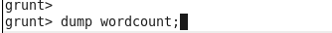
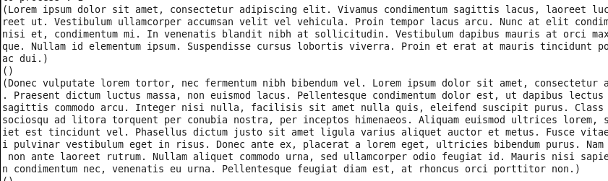
After that we use flatten command to separate the words and put them in column wise nd not in rows. And name them as word for that field and query name as words.
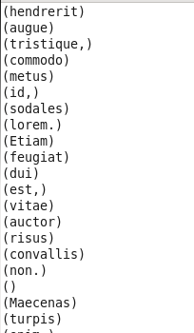
After that we group the records of words file by words fiels that we have created. And then we dump to see the output.
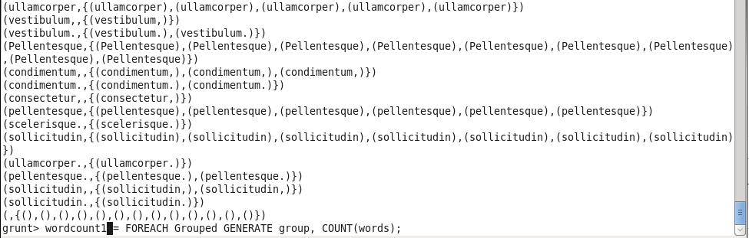
After that we create a group related to word and count the number of occurrence of that word.
