**Problem Statement**

**We have employee_details and employee_expenses files. Use local mode while running Pig and**

**write Pig Latin script to get below results:**

**https://github.com/prateekATacadgild/DatasetsForCognizant/blob/master/employee_details.t**

**xt**

**https://github.com/prateekATacadgild/DatasetsForCognizant/blob/master/employee_expense**

**s.txt**

**(a) Top 5 employees (employee id and employee name) with highest rating. (In case two**

**employees have same rating, employee with name coming first in dictionary should get**

**preference)**

**Load the file from its location to the pig environment.**



**Know the schema of emp_detail using describe command.**

**Load the below command for the solution of given problem.**

1. **We group all together using group command.**
2. **Sort the name and rating on ascending and descending order respectively.**
3. **Limit the record to 5 so only 5 records get display.**
4. **Flatten the result so to get results in tuple and column wise.**

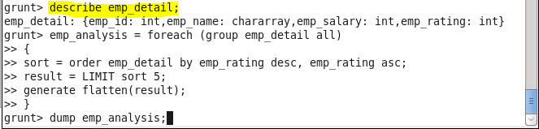

**Dump the emp_analysis so to get the output.**

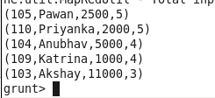

**(b) Top 3 employees (employee id and employee name) with highest salary, whose employee id**

**is an odd number. (In case two employees have same salary, employee with name coming first**

**in dictionary should get preference)**

**Load the file from its location to the pig environment.**



**Filter the records on basis of emp_id which are odd**

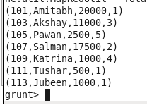

**Load the below command for the solution of given problem.**

1. **We group all together using group command.**
2. **Sort the name and rating on ascending and descending order respectively.**
3. **Limit the record to 3 so only 3 records get display.**
4. **Flatten the result so to get results in tuple and column wise**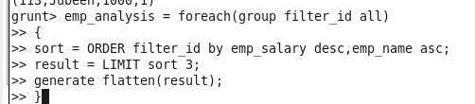

**Dump the emp_analysis so to get the output**

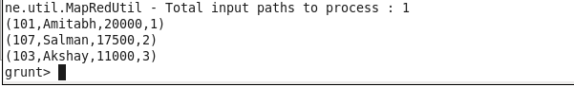

**(c) Employee (employee id and employee name) with maximum expense (In case two**

**employees have same expense, employee with name coming first in dictionary should get**

**preference)**

**Load the file from its location to the pig environment.**



**Load the employee expense file also**

**Dump the file names ad emp_expense.**

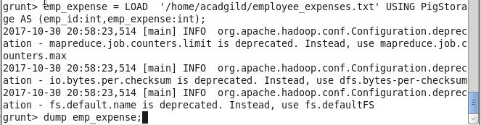

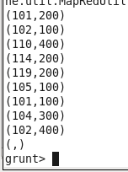

**Join the two table on the basis of there id**

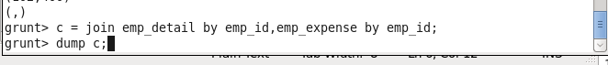

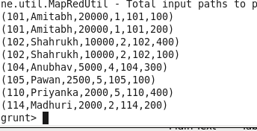

**Order the employee expense**

**And get the output.**

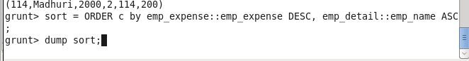

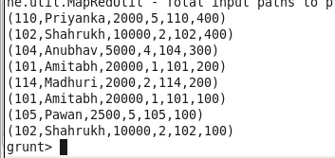

**Generate the emp name and emp id for the result**

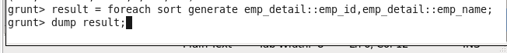

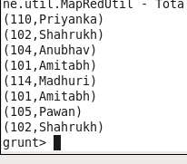

**(d) List of employees (employee id and employee name) having entries in employee_expenses**

**file.**

**Load the file from its location to the pig environment.**



**Load the employee expense file also**

**Dump the file names ad emp_expense.**





**Join the two table on the basis of there id**





**Will get the value duplicate so use distinct to get the distinct value.**





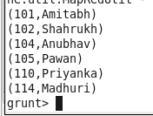

**(e) List of employees (employee id and employee name) having no entry in employee_expenses**

**Load the file from its location to the pig environment.**



**Load the employee expense file also**

**Dump the file names ad emp_expense.**





**Do the left outer join to get all the details of table emp_detail and emp_expense.**



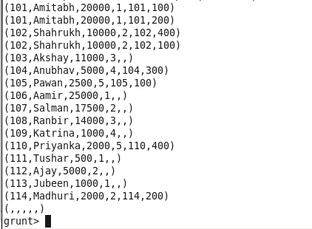

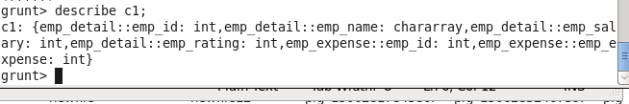

**Filter the record on basis of employee not having in expense table.and dump the table.**



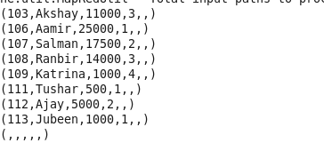

**Will generate a record with only name and id of employee with expense.**

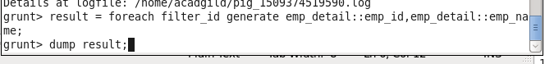

**Will get the output**

