This assignment will help you to consolidate the concepts learnt in the session.
Implement the use case present in below blog link and share the complete steps along with
screenshot(s) from your end.
NOTE: You must submit a word file containing steps and screenshots.
https://acadgild.com/blog/aviation-data-analysis-using-apache-pig/

REGISTER'/home/acadgild/airline_usecase/piggybank.jar';
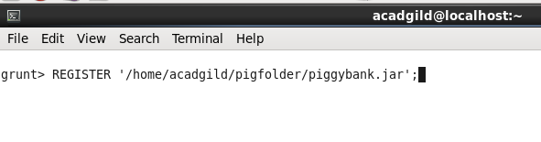
A = load '/home/acadgild/airline_usecase/DelayedFlights.csv' USING org.apache.pig.piggybank.storage.CSVExcelStorage(',','NO_MULTILINE','UNIX','SKIP_INPUT_HEADER');

In relation A, we are loading the dataset using CSVExcelStorage because of its effective technique to handle double quotes and headers.
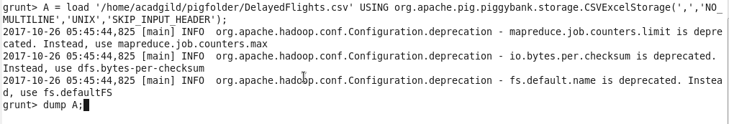
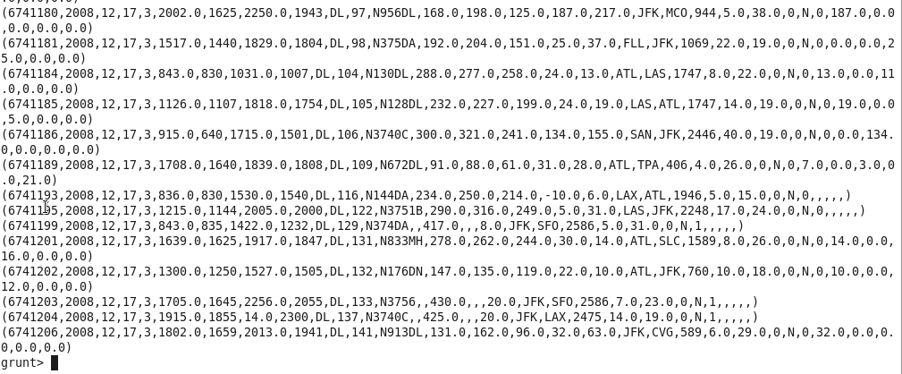

In relation B, we are generating the columns that are required for processing and explicitly typecasting each of them.

B = foreach A generate (int)$1 as year, (int)$10 as flight_num, (chararray)$17 as origin,(chararray) $18 as dest;
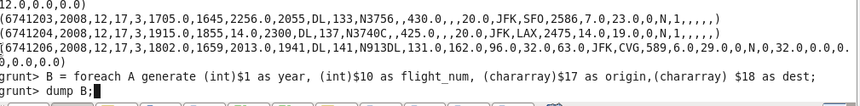
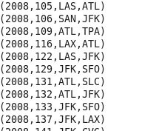

In relation C, we are filtering the null values from the “dest” column.
C = filter B by dest is not null;
In relation D, we are grouping relation C by “dest.”
D = group C by dest;
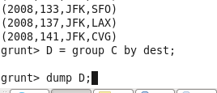
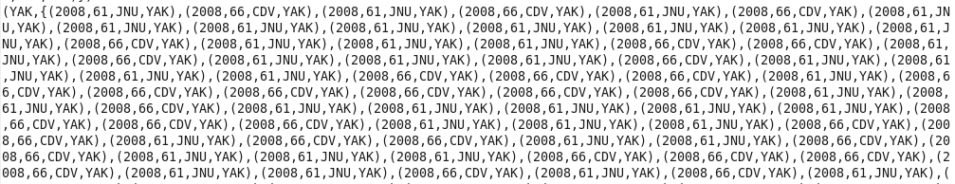
In relation E, we are generating the grouped column and the count of each.
E = foreach D generate group, COUNT(C.dest);
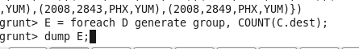
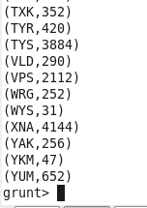
Relation F and Result is used to order and limit the result to top 5.
F = order E by $1 DESC;
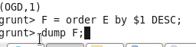
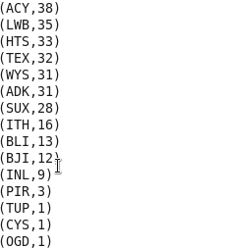

These are the steps to find the top 5 most visited destinations. However, adding few more steps in this process, we will be using another table to find the city name and country as well.
Result = LIMIT F 5;
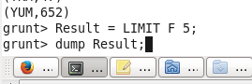
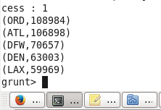

n relation A1, we are loading another table to which we will look-up and find the city as well as the country.
In relation A2, we are generating dest, city, and country from the previous relation.
A1 = load '/home/acadgild/airline_usecase/airports.csv' USING org.apache.pig.piggybank.storage.CSVExcelStorage(',','NO_MULTILINE','UNIX','SKIP_INPUT_HEADER');

A2 = foreach A1 generate (chararray)$0 as dest, (chararray)$2 as city, (chararray)$4 as country;

In relation joined_table, we are joining Result and A2 based on a common column, i.e., “dest”
Finally, using dump, we are printing the result.
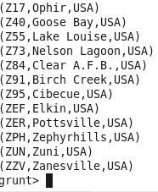
joined_table = join Result by $0, A2 by dest;
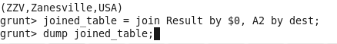
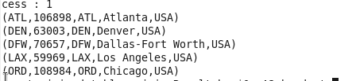

Problem Statement 2
Which month has seen the most number of cancellations due to bad weather?

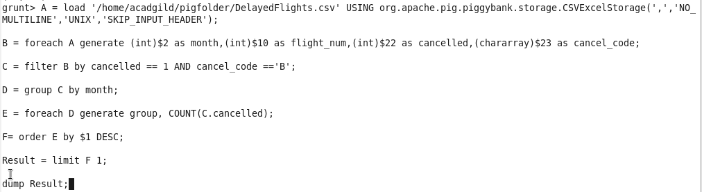

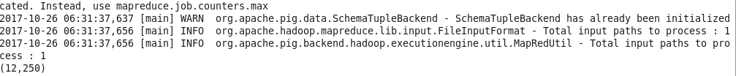
In Line 1: We are registering piggybank jar in order to use the CSVExcelStorage class.
In relation A, we are loading the dataset using CSVExcelStorage because of its effective technique to handle double quotes and header.

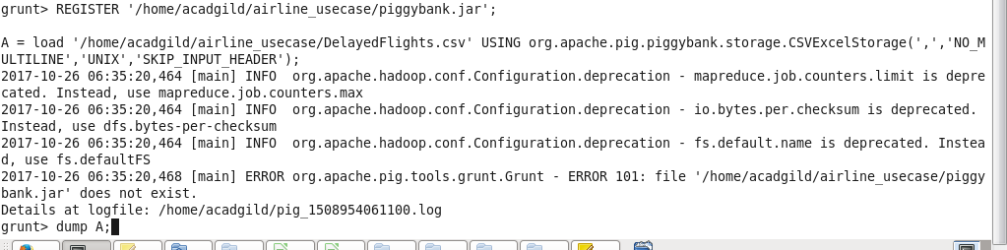

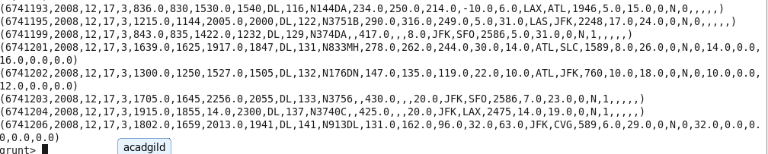
In relation B, we are generating the columns which are required for processing and explicitly typecasting each of them.
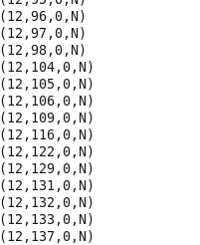
In relation C, we are filtering the data based on cancellation and cancellation code, i.e., canceled = 1 means flight have been canceled and cancel_code = ‘B’ means the reason for cancellation is “weather.” So relation C will point to the data which consists of canceled flights due to bad weather.
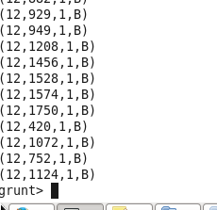

In relation D, we are grouping the relation C based on every month.

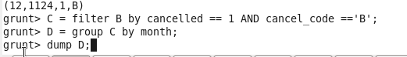
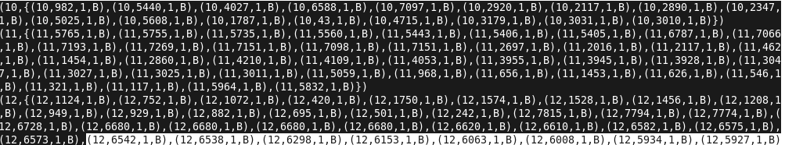

In relation E, we are finding the count of canceled flights every month.
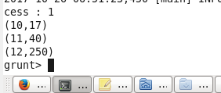

Relation F and Result is for ordering and finding the top month based on cancellation.
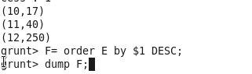
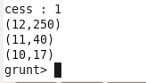

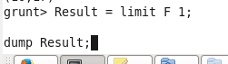

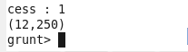

Problem Statement 3
Top ten origins with the highest AVG departure delay
Explanation of first lines are the same as explained in the previous 2 problem statements.
.
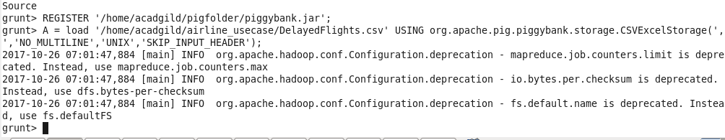
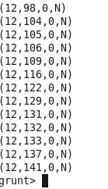

In relation C1, we are removing the null values fields present if any.
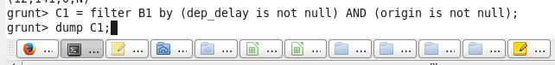

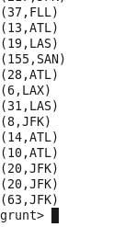

In relation D1, we are grouping the data based on column “origin.”
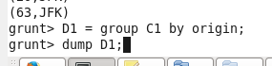
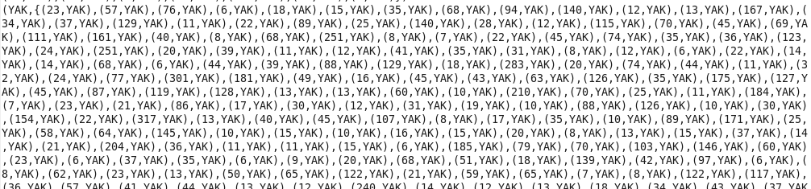

In relation E1, we are finding average delay from each unique origin.

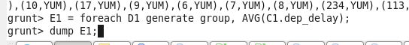
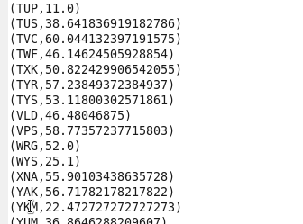

Relations named Result and Top_ten are ordering the results in descending order and printing the top ten values.
These steps are good enough to find the top ten origins with the highest average departure delay.
However, rather than generating just the code of origin, we will be following a few more steps to find some more details like country and city.
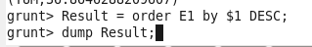
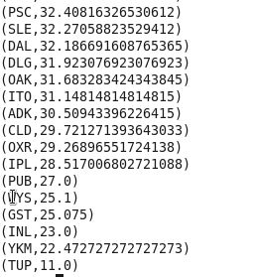

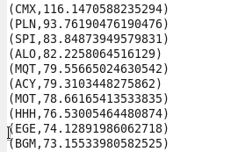

In the relation Lookup, we are loading another table to which we will look up and find the city as well as the country.
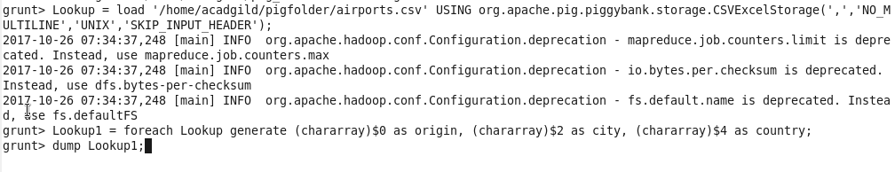 In the relation Lookup1, we are generating the destination, city, and country from the previous relation
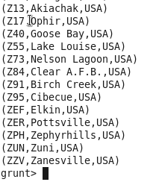

In the relation Joined, we are joining relation Top_ten and Lookup1 based on common a column, i.e., “origin.”

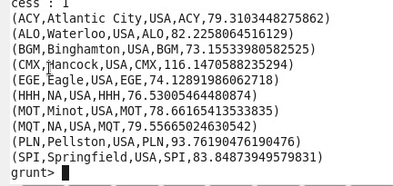

In the relation Final, we are generating required columns from the Joined table.
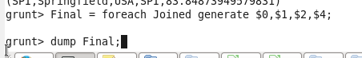

Finally, we are ordering and printing the results
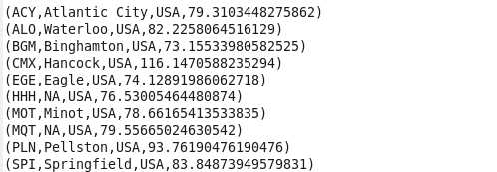
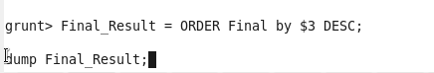
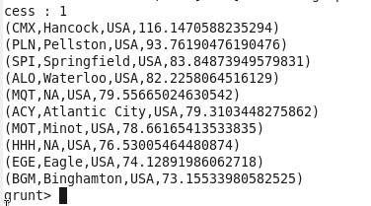

Problem Statement 4
Which route (origin & destination) has seen the maximum diversion?
In Line 1: We are registering piggybank jar in order to use CSVExcelStorage class.
In relation A, we are loading the dataset using CSVExcelStorage because of its effective technique to handle double quotes and headers.
In relation B, we are generating the columns which are required for processing and explicitly type-casting each of them.

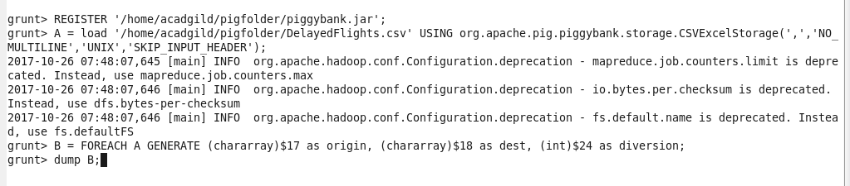
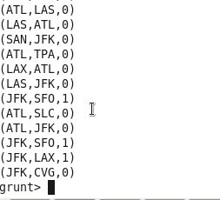

In relation C, we are filtering the data based on “not null” and diversion =1. This will remove the null records, if any, and give the data corresponding to the diversion taken.

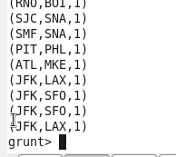
In relation D, we are grouping the data based on origin and destination.
Relation D finds the count of diversion taken per unique origin and destination.
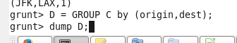
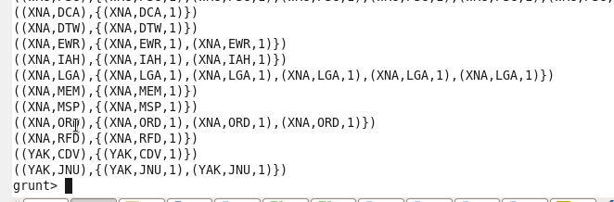

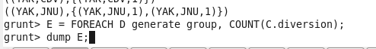
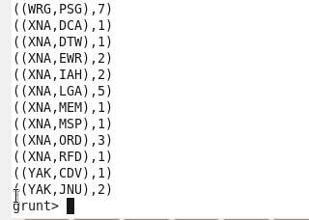

Relations F and Result orders the result and produces top 10 results.


Result orders the result and produces top 10 results.
