2. Problem Statement
Implement the use case present in below blog link and share the complete steps along with
screenshot(s) from your end.
NOTE: You must submit a word file containing steps and screenshots.
https://acadgild.com/blog/pig-use-case-pokemon-data-analysis/
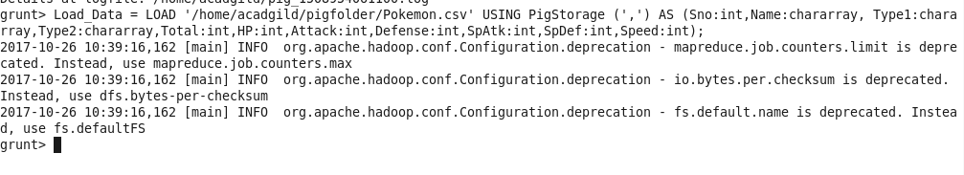

Ques 1: Find the list of players that have been selected in the qualifying round (DEFENCE>55).
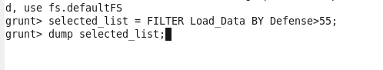
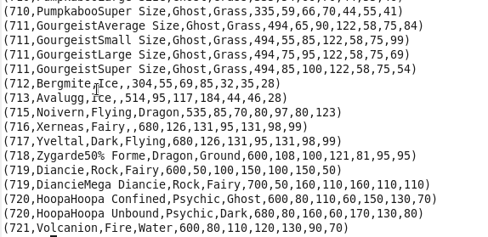
The dataset is filtered, and hence out of all the 800 Pokémons, only 544 are eligible to take part in the tournament. In order to get the count, refer the next problem statement

Ques 2: State the number of players taking part in the competition after getting selected in the qualifying round.
Explanation:
Command
gourp_selcted_list = Group selected_list All;
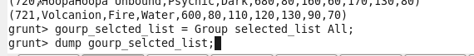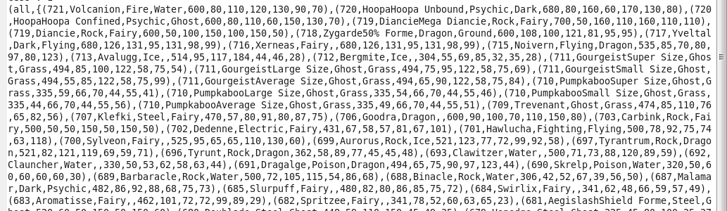
count_selcted_list = foreach gourp_selcted_list GENERATE COUNT(selected_list);
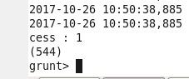
So, All the 544 players taking part will be alphabetically arranged and two teams of 5 Pokémons need to be extracted out randomly from the earlier list.
Seems like,this way we will have 2 lists containing 5 Pokémon each so to fight each other.

Ques 3: Using random() generate random numbers for each Pokémon on the selected list.
random_include1 = foreach selected_list GENERATE RANDOM(),Name,Type1,Type2,Total,HP,Attack,Defense,SpAtk,SpDef,Speed;
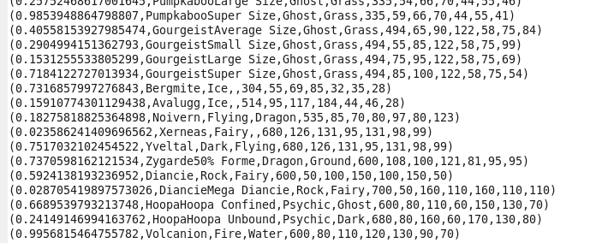Hence sample for the list after adding random numbers:

Ques 4: Arrange the new list in a descending order according to a column randomly.
Explanation: This will give us consequently a layer arranged to pick the random list which 1st player will choose.
Command
random1_desending = ORDER random_include1 BY $0 DESC;
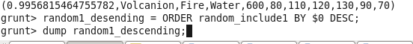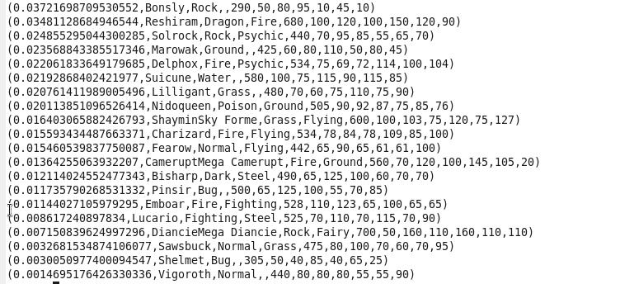

Ques 5: Now on a new relation again associate random numbers for each Pokémon and arrange in descending order according to column random.
Explanation: We will be repeating above two steps again to form the 2nd list.
Command
random_include2 = foreach selected_list GENERATE RANDOM(),Name,Type1,Type2,Total,HP,Attack,Defense,SpAtk,SpDef,Speed;
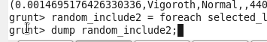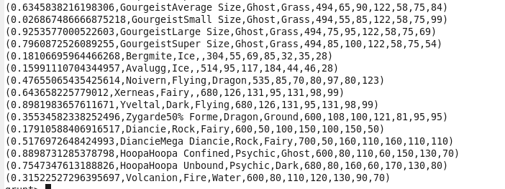

random2_desending = ORDER random_include2 BY $0 DESC;
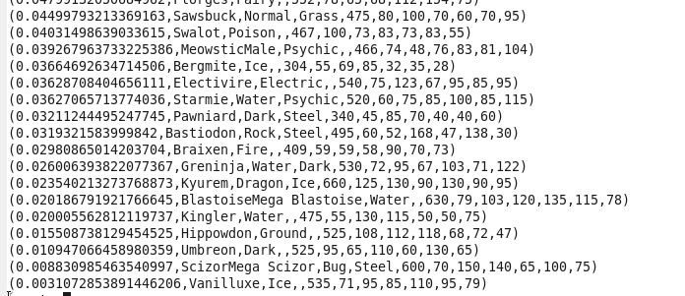

Ques: From the two different descending lists of random Pokémons, select the top 5 Pokémons for 2 different players.
Explanation:
Commands
limit_data_random1_desending = LIMIT random1_desending 5 ;
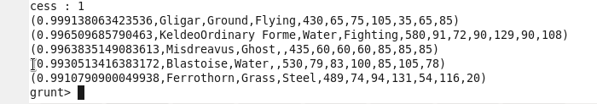
limit_data_random2_desending = LIMIT random2_desending 5 ;
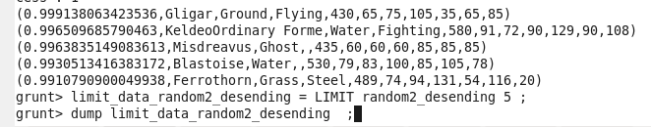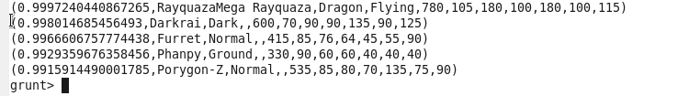

Ques: Store the data on a local drive to announce for the final match. By the name player1 and player2 (only show the NAME and HP).
Explanation:
Commands
filter_only_name1 = foreach limit_data_random1_desending Generate ($1,HP);
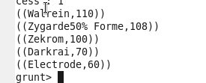
filter_only_name2 = foreach limit_data_random2_desending Generate ($1,HP);
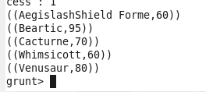
Therefore querying is over using some simple pre-defined functions to get 2 sets of 5 Pokémons, which get select randomly.
In conclusion, let’s store this result in our local system so we can use it as input to our next blog. Especially relevant where we will see UDF using PIG and calculations will be done through user-defined formulas.
STORE limit_data_random1_desending INTO ‘/home/acadgild/Documents/prateek/PIG/player1.txt’;
STORE limit_data_random2_desending INTO ‘/home/acadgild/Documents/prateek/PIG/player2.txt’;

