Create a database named 'custom'.
Create a table named temperature_data inside custom having below fields:
1. date (mm-dd-yyyy) format
2. zip code
3. temperature
The table will be loaded from comma-delimited file.
Load the dataset.txt (which is ',' delimited) in the table.

Step1: We are creating a database named custom here with the command as:create database custom;
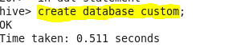
When we give the command show databases;
It wil show all the databases present in hive ,here the one which we have reated will also be shown.
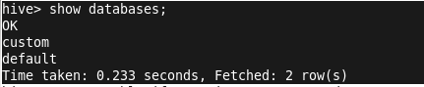

The below command is given to make the current database visible .by making it true.

Here we are using the database custom,by giving the command as use custom;
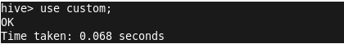
In the below step we are creating a table named as temperature1_data with date as string ,zipcode and temperature.
Create table if not exists temperature1_data(date stribg, zipcode int,temp int) row format delimited fields terminated by ‘,’;
After this we will load the dataset from local to the hive table using command:
Load data local inpath ‘/home/acadgild/acd/dataset_session14.txt’ into table temperature1_data;

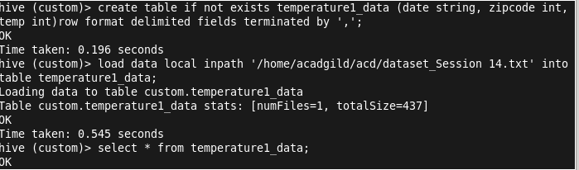
Will give the command select * from temperature1_data;
Will get all the detail and data stored after loading the table.

