Assignment 6.2
1).Fetch date and temperature from temperature_data where zip code is greater than
300000 and less than 399999.
Give the command to solve the above problem:
Select distinct date,temp from temperature1_data where zipocode between 29999 and 399999;
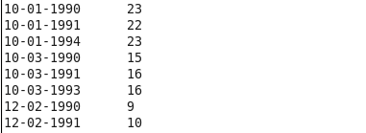
2)Calculate maximum temperature corresponding to every year from temperature_data
table.

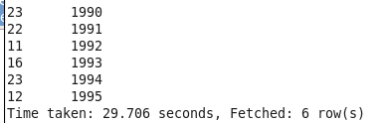

3)Calculate maximum temperature from temperature_data table corresponding to those
years which have at least 2 entries in the table.
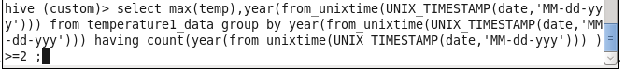
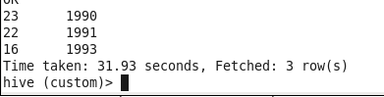
4) Create a view on the top of last query, name it temperature_data_vw.
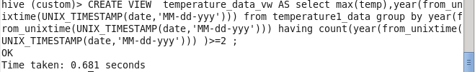
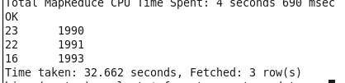
5)Export contents from temperature_data_vw to a file in local file system, such that each
file is '|' delimited.

