● Explain Hive Architecture in Brief.
A system for managing and querying structured data built on top of Hadoop
• Uses Map-Reduce for execution • HDFS for storage • Extensible to other Data Repositories • Key Building Principles: • SQL on structured data as a familiar data warehousing tool • Extensibility (Pluggable map/reduce scripts in the language of your choice, Rich and User Defined data types, User Defined Functions) • Interoperability (Extensible framework to support different file and data formats)
Hive is an ETL and Data warehousing tool developed on top of Hadoop Distributed File System (HDFS) to process structured data, summarize Big Data, and makes querying and analyzing easy. Hive makes job easy for performing operations like
- Data encapsulation
- Ad-hoc queries
- Analysis of huge datasets
Featuresof Hive:
It stores schema in a database and processed data into HDFS
It is designed for OLAP.
It provides SQL type language for querying called HiveQL or HQL.
It is familiar, fast, scalable, and extensible.

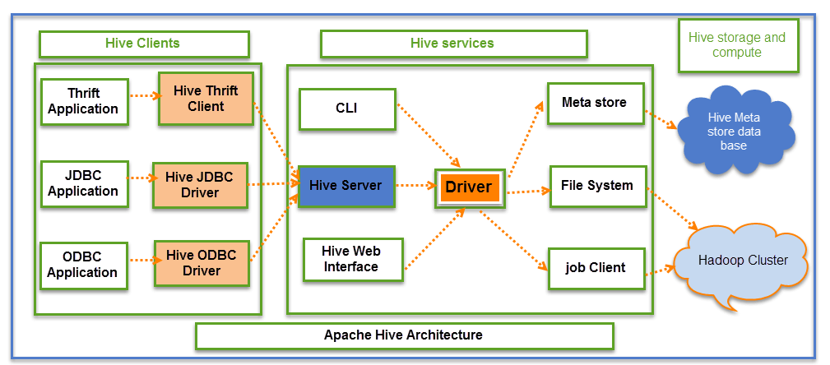

The above screenshot explains the Hive architecture in detail
Hive Consists of Mainly 3 core parts
- Hive Clients
- Hive Services
- Hive Storage and Computing
Hive Clients:
Hive provides different drivers for communication with a different type of applications. For Thrift based applications, it will provide Thrift client for communication.
For Java related applications, it provides JDBC Drivers. Other than any type of applications provided ODBC drivers. These Clients and drivers in turn again communicate with Hive server in the Hive services.

Hive Services:
Client interactions with Hive can be performed through Hive Services. If the client wants to perform any query related operations in Hive, it has to communicate through Hive Services.
CLI is the command line interface acts as Hive service for DDL (Data definition Language) operations. All drivers communicate with Hive server and to the main driver in Hive services as shown in above architecture diagram.
Driver present in the Hive services represents the main driver, and it communicates all type of JDBC, ODBC, and other client specific applications. Driver will process those requests from different applications to meta store and field systems for further processing.
Hive Storage and Computing:
Hive services such as Meta store, File system, and Job Client in turn communicates with Hive storage and performs the following actions
Metadata information of tables created in Hive is stored in Hive "Meta storage database".
Query results and data loaded in the tables are going to be stored in Hadoop cluster on HDFS.

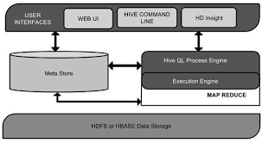

Important characteristics of Hive
- In Hive, tables and databases are created first and then data is loaded into these tables.
- Hive as data warehouse designed for managing and querying only structured data that is stored in tables.
- While dealing with structured data, Map Reduce doesn't have optimization and usability features like UDFs but Hive framework does. Query optimization refers to an effective way of query execution in terms of performance.
- Hive's SQL-inspired language separates the user from the complexity of Map Reduce programming. It reuses familiar concepts from the relational database world, such as tables, rows, columns and schema, etc. for ease of learning.
- Hadoop's programming works on flat files. So, Hive can use directory structures to "partition" data to improve performance on certain queries.
- A new and important component of Hive i.e. Metastore used for storing schema information. This Metastore typically resides in a relational database. We can interact with Hive using methods like
  - Web GUI
  - Java Database Connectivity (JDBC) interface

- Most interactions tend to take place over a command line interface (CLI). Hive provides a CLI to write Hive queries using Hive Query Language(HQL)
- Generally, HQL syntax is similar to the SQL syntax that most data analysts are familiar with. The Sample query below display all the records present in mentioned table name.
  - Sample query : Select * from <TableName>
- Hive supports four file formats those are TEXTFILE, SEQUENCEFILE, ORC and RCFILE(Record Columnar File).
- For single user metadata storage, Hive uses derby database and for multiple user Metadata or shared Metadata case Hive uses MYSQL.

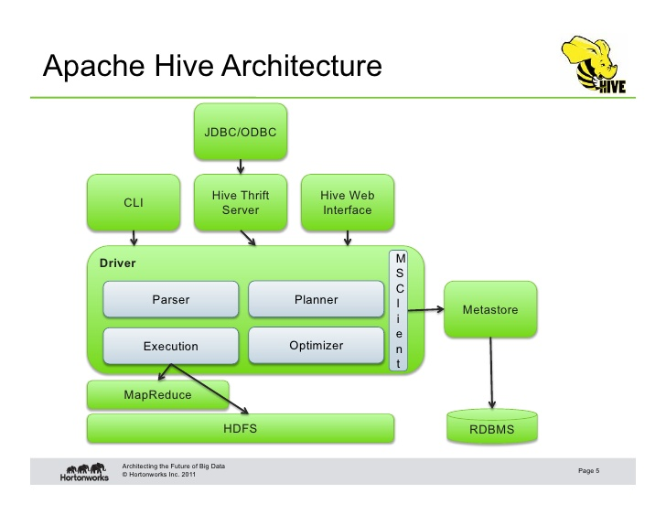
This component diagram contains different units.
The following describes each unit:
Unit Name Operation
User Interface: Hive is a data warehouse infrastructure software that can create interaction between user and HDFS. The user interfaces that Hive supports are Hive Web UI, Hive command line, and Hive HD Insight (In Windows server).
Meta Store: Hive chooses respective database servers to store the schema or Metadata of tables, databases, columns in a table, their data types, and HDFS mapping.

HiveQL Process Engine :HiveQL is similar to SQL for querying on schema info on the Metastore. It is one of the replacements of traditional approach for MapReduce program. Instead of writing MapReduce program in Java, we can write a query for MapReduce job and process it.
Execution Engine :The conjunction part of HiveQL process Engine and MapReduce is Hive Execution Engine. Execution engine processes the query and generates results as same as MapReduce results. It uses the flavor of MapReduce.
HDFS or HBASE :Hadoop distributed file system or HBASE are the data storage techniques to store data into file system.

