Project

MUSIC DATA ANALYSIS

**Music Data Analysis**

**Starting Services:**

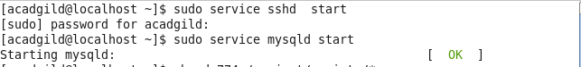

**Permission set:**



**Generating Web and Mobile Data:**

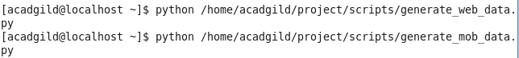

**Starting daemons**



**Creating hbase tables and populating in hive**

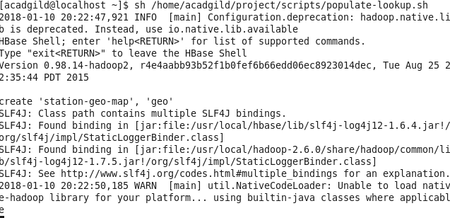

**Created Table user artist in hive**

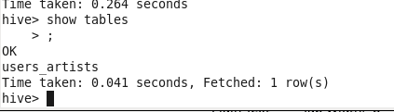

**Data Formatting**



**Formatted input table in hive**

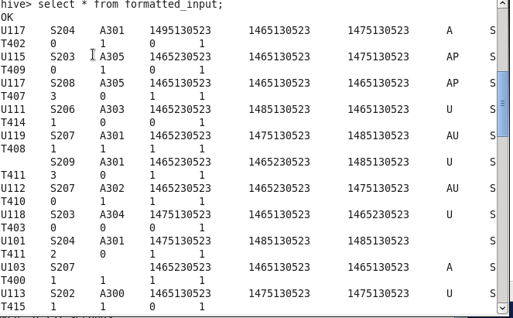

**Creating tables in hive**

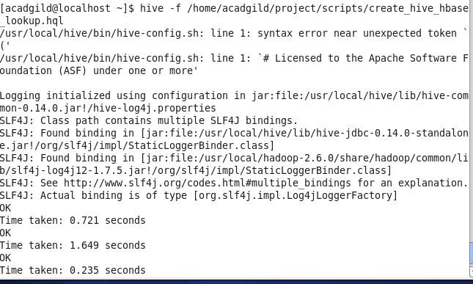

**Created hive tables**

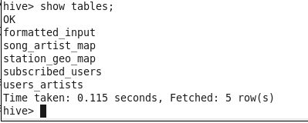

**Data enrichment:**



**Enriched Data:**

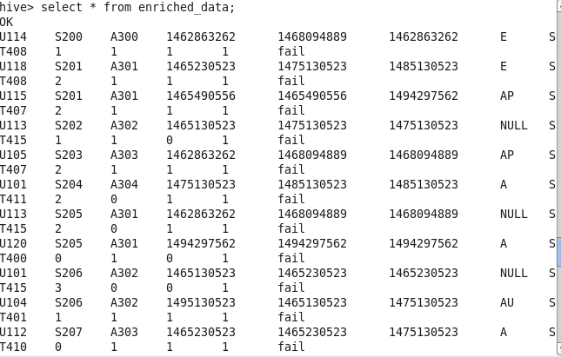

**After Data Analysis created Tables:**

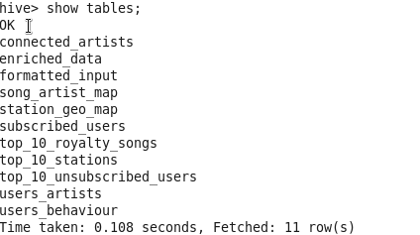

**1. Determine top 10 station_id(s) where maximum number of songs were played, which were**

**liked by unique users.**

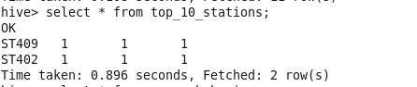

**2. Determine total duration of songs played by each type of user, where type of user can be**

**'subscribed' or 'unsubscribed'. An unsubscribed user is the one whose record is either not**

**present in Subscribed_users lookup table or has subscription_end_date earlier than the**

**timestamp of the song played by him.**

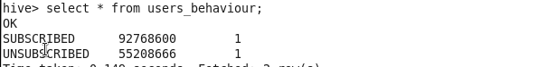

**3. Determine top 10 connected artists. Connected artists are those whose songs are most**

**listened by the unique users who follow them.**

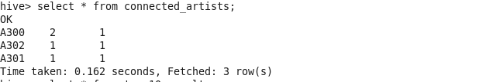

**4. Determine top 10 songs who have generated the maximum revenue. Royalty applies to a**

**song only if it was liked or was completed successfully or both.**

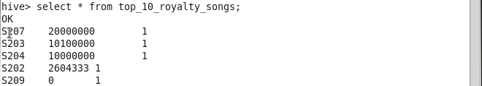

**5. Determine top 10 unsubscribed users who listened to the songs for the longest duration.**

