Project2
1. Find out the districts who achieved 100 percent objective in BPL cards
Export the results to mysql using sqoop
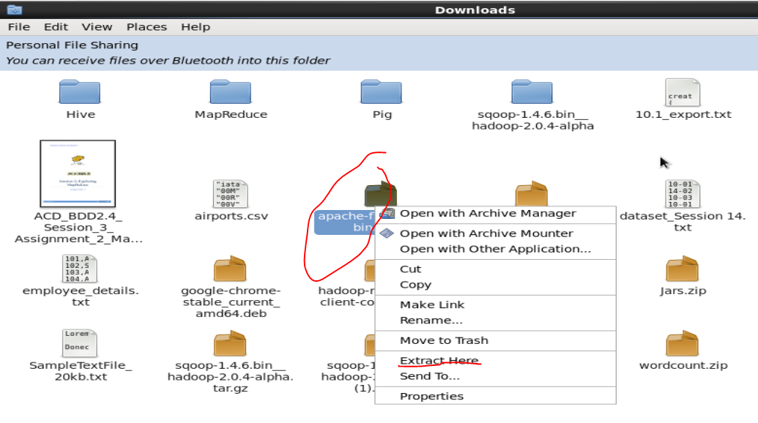1. Find out the districts who achieved 100 percent objective in BPL cards
Export the results to mysql using sqoop
2. Write a Pig UDF to filter the districts which have reached 80% of objectives of BPL cards.
Export the results to MySQL using Sqoop.
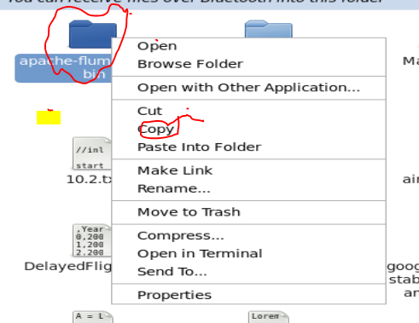

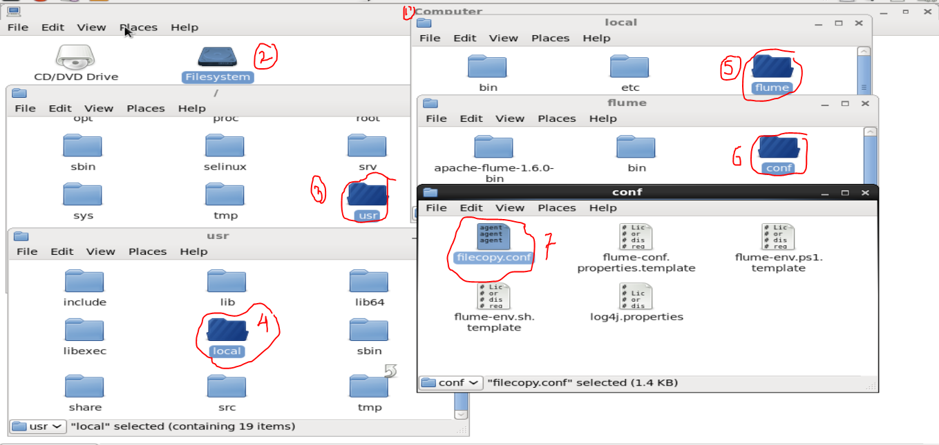
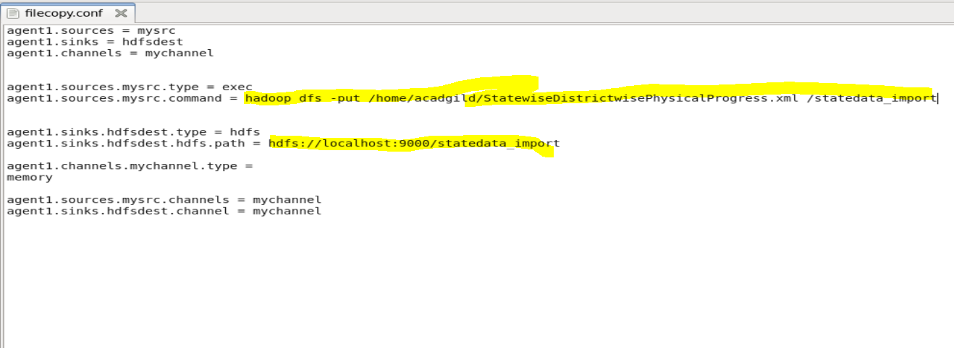
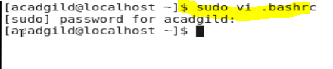

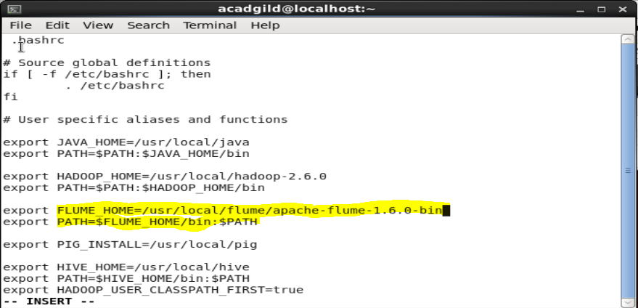
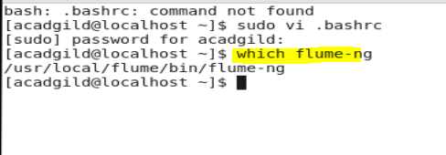
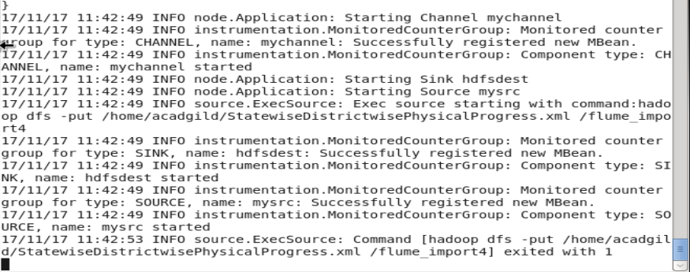
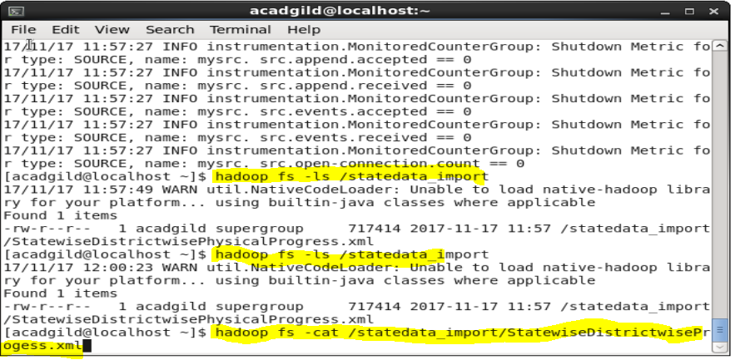

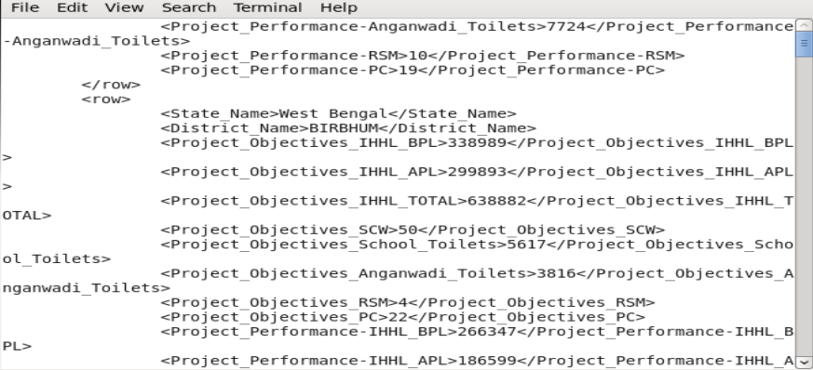

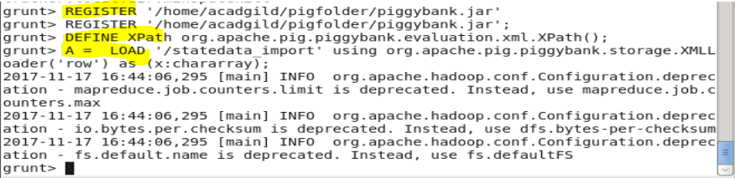
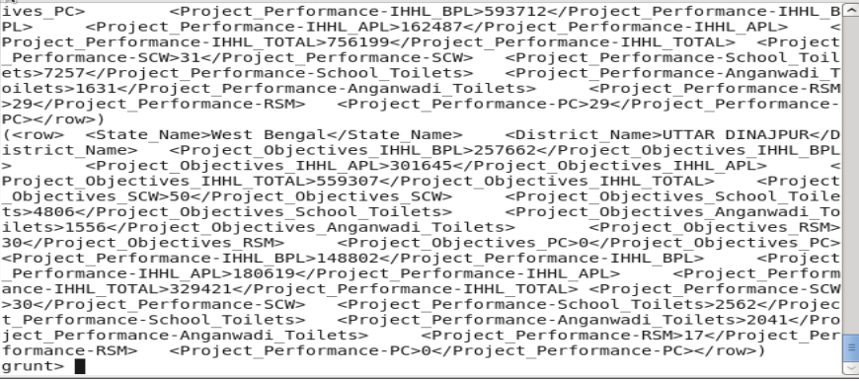
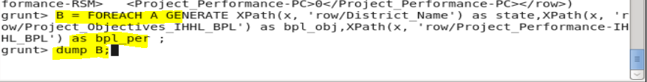
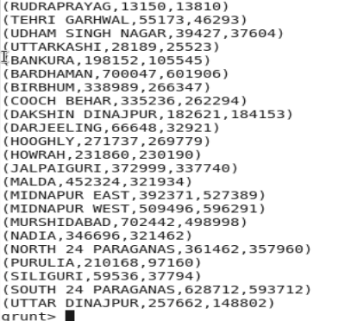
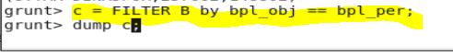
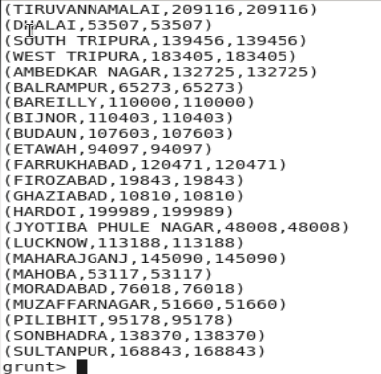

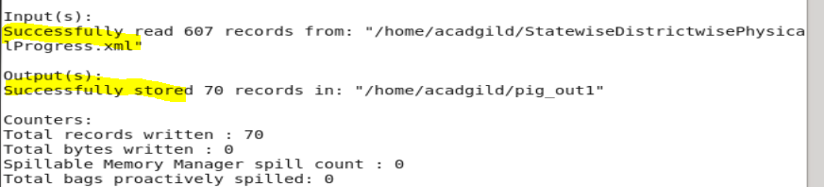
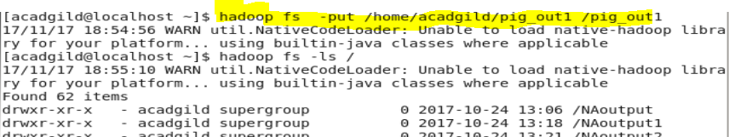
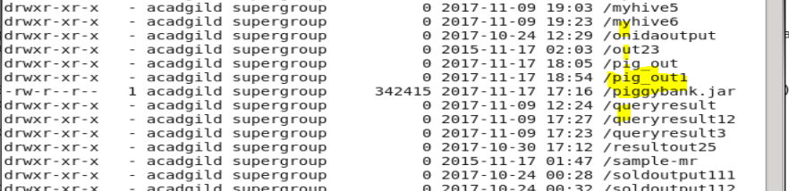

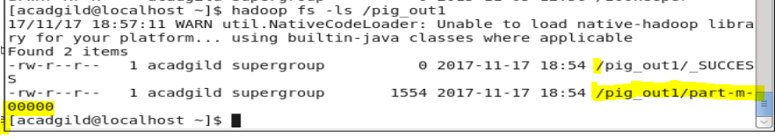

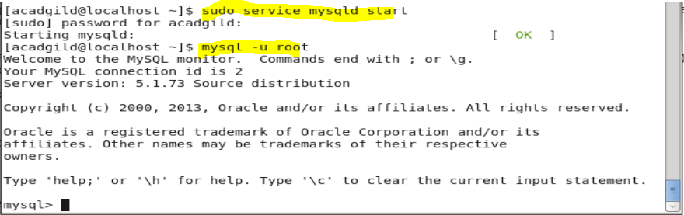
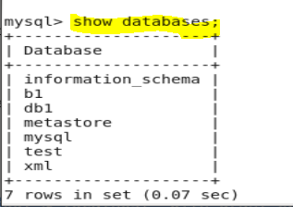

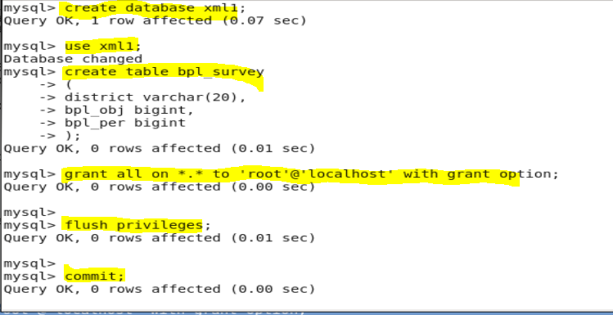
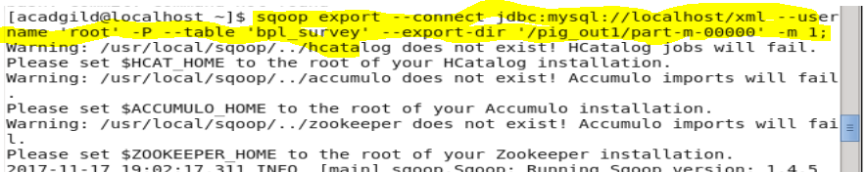

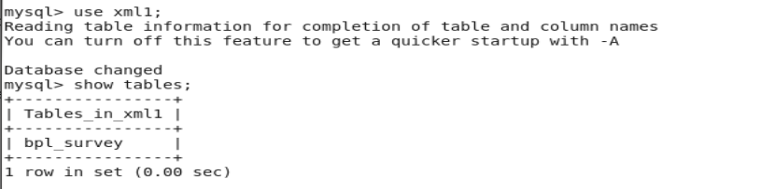

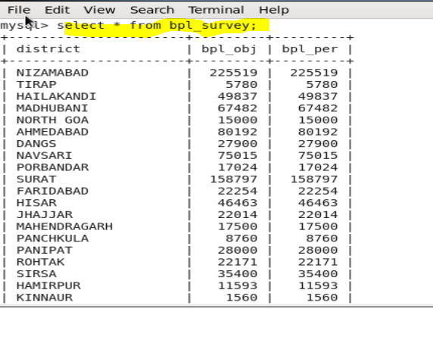
2. Write a Pig UDF to filter the districts which have reached 80% of objectives of BPL cards. Export the results to MySQL using Sqoop.
For this first we have to go to the ecllipse and then will create a udf for the same program tp get 80% work done
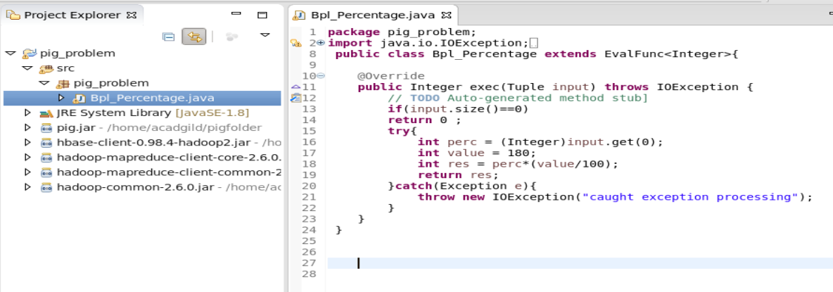
After the udf has been created will right click and click on export
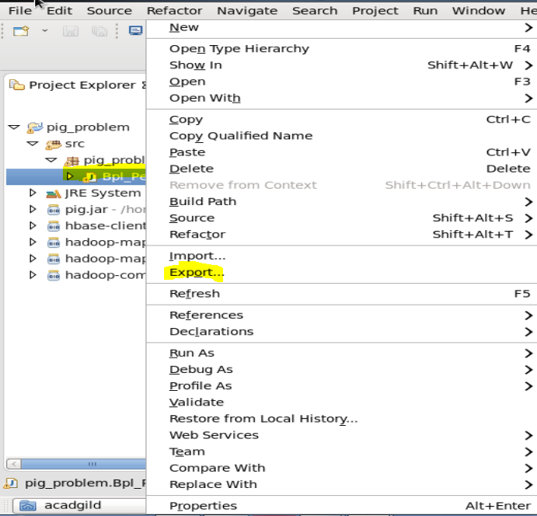
After that will export it as a external jar and will give it a name and a location were we want it to be stored so as to use it in future process
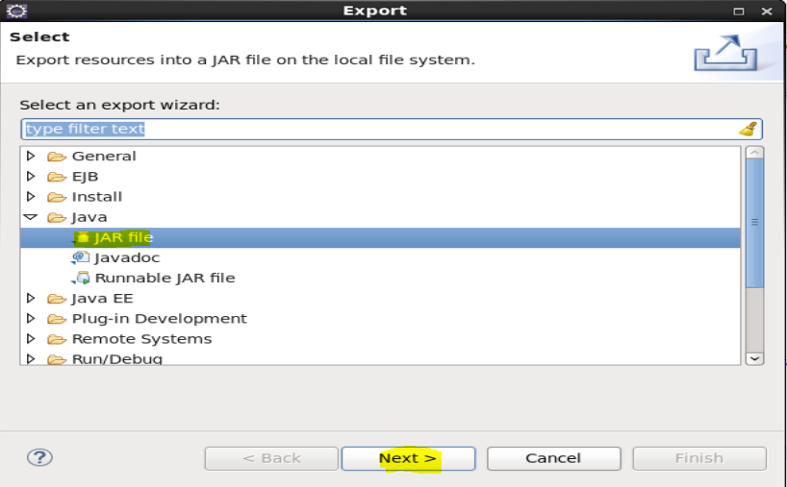

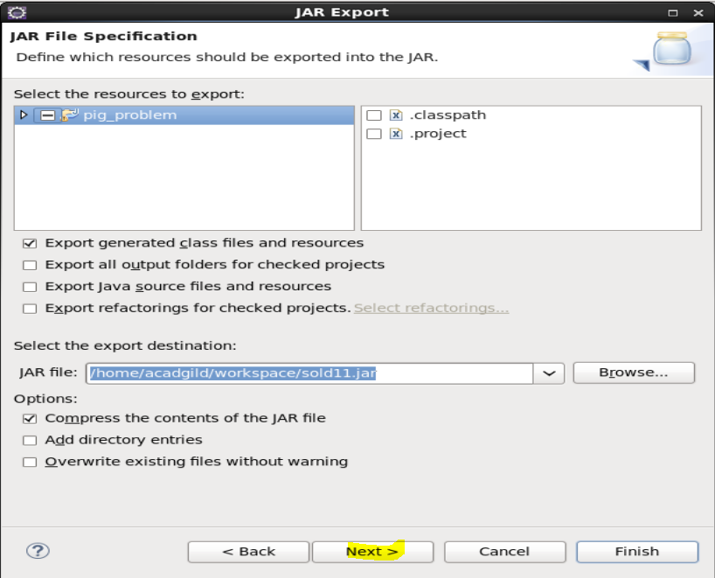

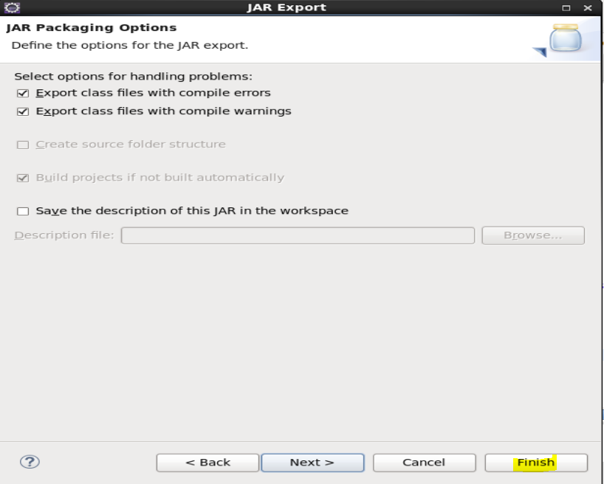
After that will go to the grunt shell and will register that udfto the grunt shell for future process
REGISTER UDF

SCRIPT
As we have loaded A in above will use that and will create a B cosist og fields required for the future process
And then use the udf function created on C with the fileds to get the data
Then will flter the data on basis of greater performance then 80%
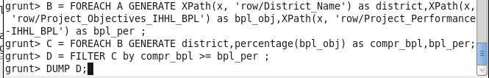

OUTPUT
This will be the desired output for the following
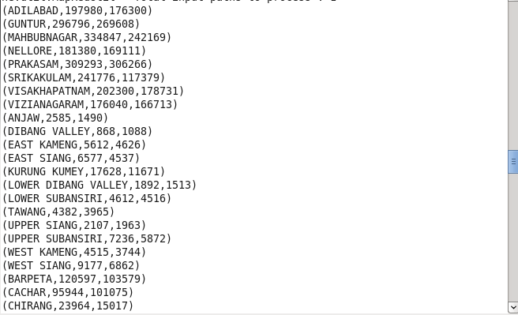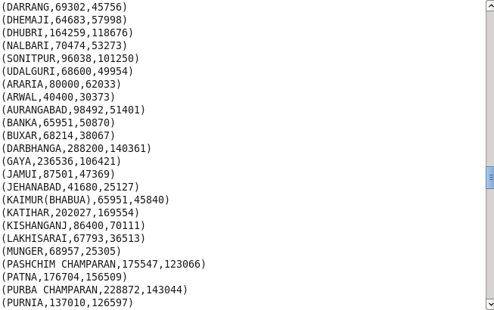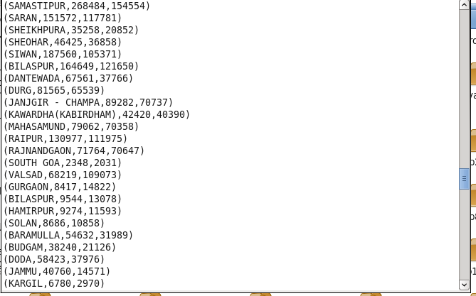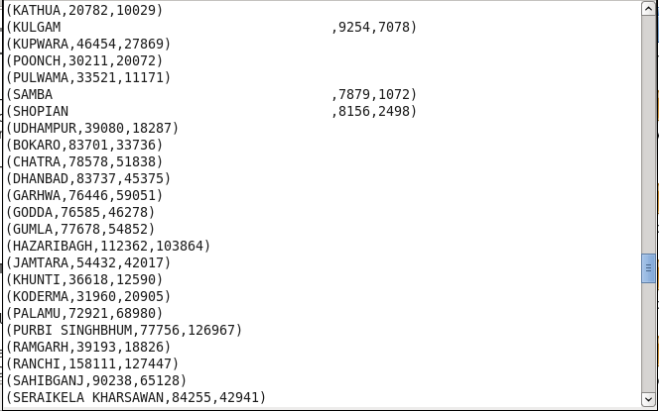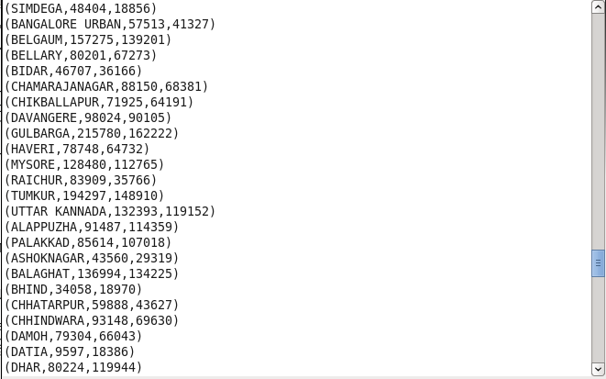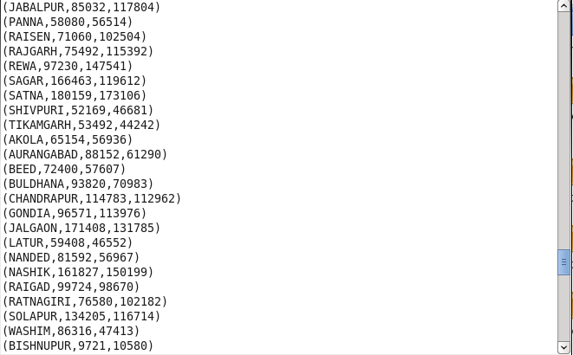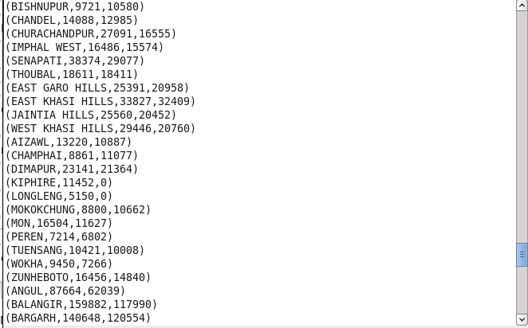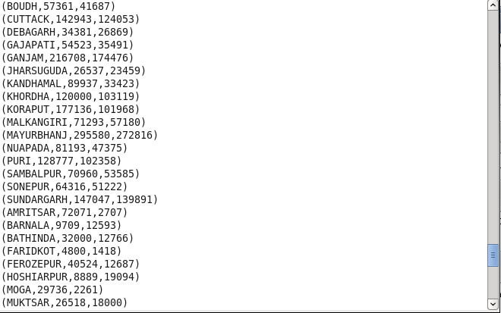

After that will store the result inloaction required by using command STORE.

STORE
Next will go to sql and create a table bpl_progress with all the desired field as in te dataset and as required after the solution store in the shell.
MYSQL
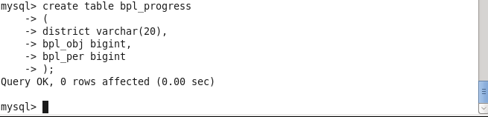
Grant all the permissions to the table.
