Flashing and Data Transfer using external Dev board
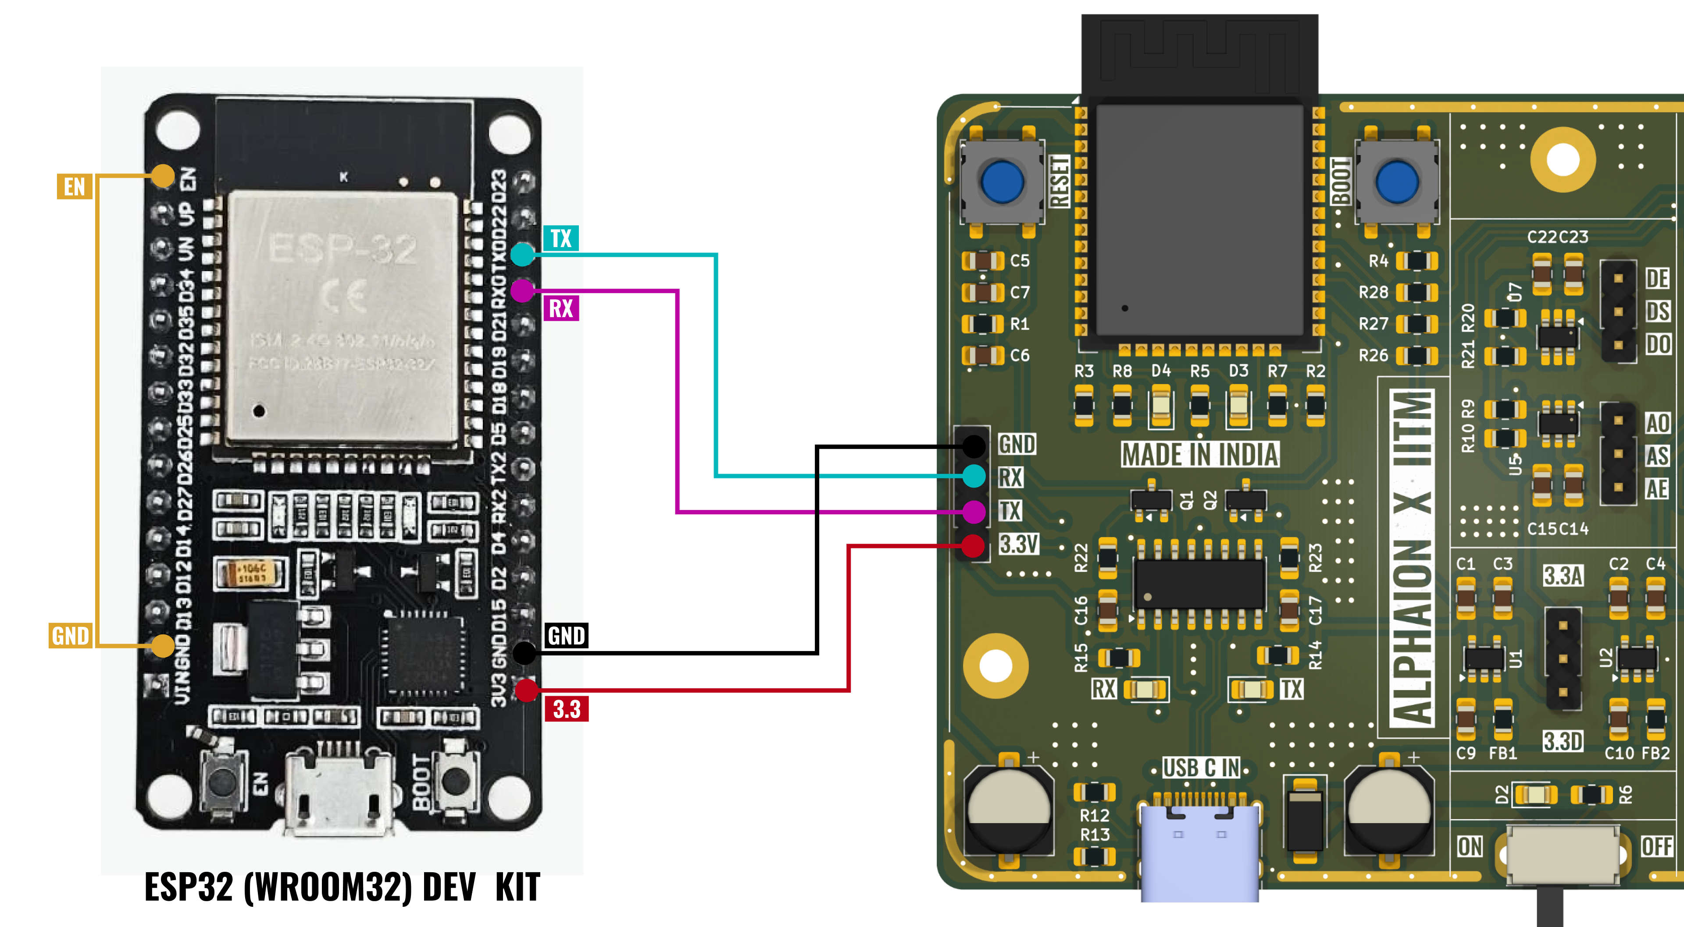
Figure 1:- Connection for flashing the board using external ESP32 Dev Module

Step 1: Make the Hardware Connections
- Connect the external ESP32 DevKit to the onboard ESP32 through the UART interface.
External ESP32 DevKit | Onboard ESP32
TX0 (GPIO1) | RX0 (GPIO3)
RX0 (GPIO3) | TX0 (GPIO1)
GND | GND
- Ensure that TX and RX connections are crossed and that both boards share a common ground.

Step 2: Disable the External ESP32
- Connect the EN pin of the external ESP32 DevKit to GND.
- This disables the external ESP32 microcontroller while keeping its USB-to-UART converter operational.

Step 3: Connect the External DevKit to the Computer
- Connect the external ESP32 DevKit to the computer using a USB cable.
- The external DevKit's USB-to-UART converter will provide the serial communication interface required for firmware uploading.

Step 4: Configure the Arduino IDE
- Open Arduino IDE and select the following settings:
Parameter | Configuration
Board | ESP32 Dev Module
Port | External DevKit COM port
Upload Speed | 115200

Step 5: Enter the Onboard ESP32 into Bootloader Mode
- Follow this sequence:
  - Press and hold the BOOT button on the onboard PCB.
  - Press and release the RESET button.
  - Release the BOOT button.
- The onboard ESP32 is now in bootloader mode and ready to receive firmware.

Step 6: Upload the Firmware
- Open the required Arduino sketch and click the Upload button.
- The firmware will be transferred from the computer through the external DevKit's USB-to-UART converter to the onboard ESP32.

Step 7: Restart the Onboard ESP32
- After successful uploading:
  - Press the RESET button on the onboard PCB.
  - Ensure that the onboard PCB is powered appropriately.
  - The ESP32 will restart and execute the newly uploaded firmware.
For subsequent wired serial communication, retain the required UART connections and ensure that the onboard and external USB-to-UART transmitters do not conflict.

Checking ADC & DAC Address
- Upload the Code ADC_DAC_TEST.ino code to the board
- Open the serial Monitor
- Press the reset button
- Check for the ADC and DAC addresses
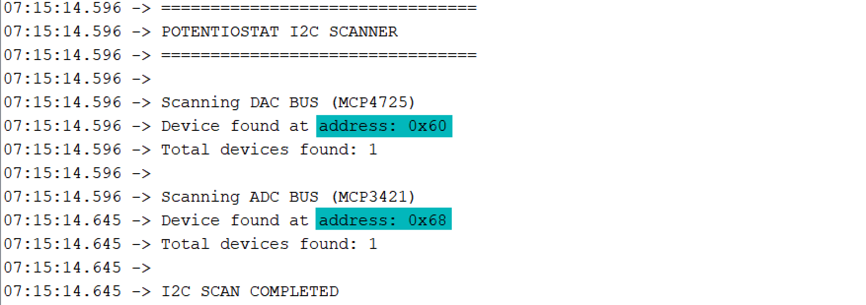
Figure 2:- Serial Monitor Output for the address

Checking Working of ADC MCP3421 (using ESP32 DAC)
- On the board short the DE and AO pins
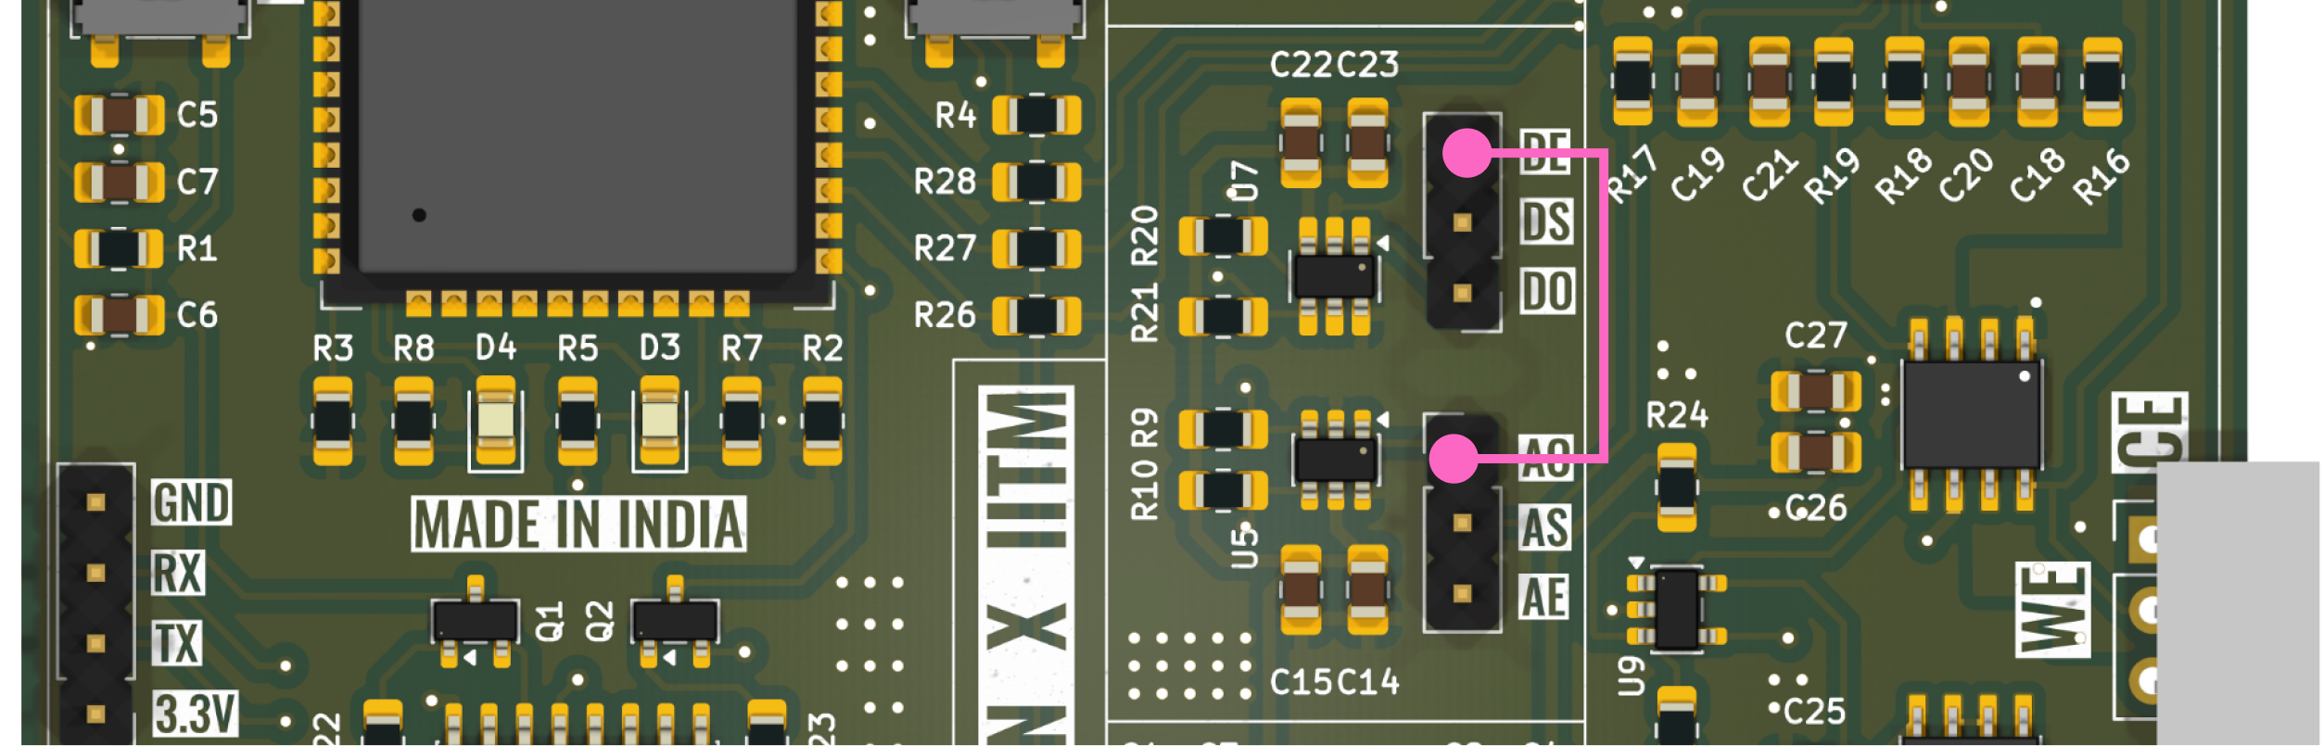
Figure 3:- Connecting the ESP32 DAC to On-board ADC
- Upload the Code MCP3421_TEST.ino code to the board
- Open the Python Script MCP3421_TEST.py
- Check for the COM PORT number in the device manager
- Change the COM PORT value in the Python Code
- Run the python script once the code is uploaded.
- Additionally to check the ADC values disconnect the connection of step 1 to see a flat line in the graph.
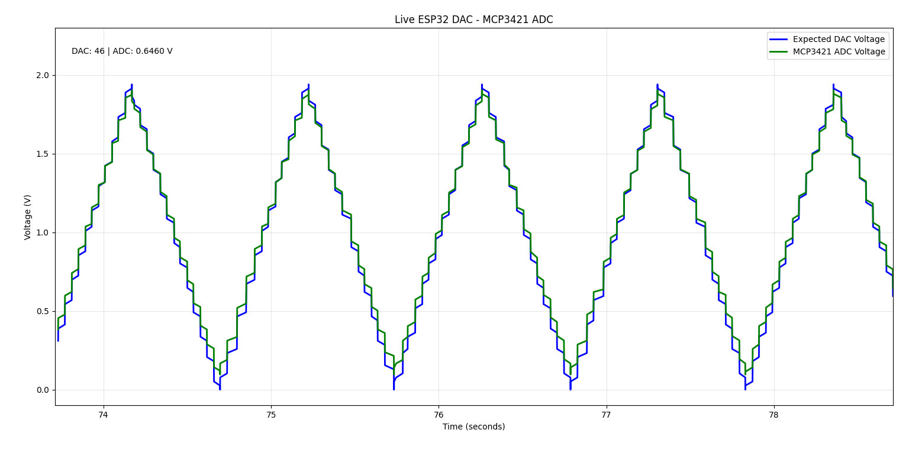
Figure 4:- Expected Output of the MCP3421 ADC test

Checking Working of ADC MCP3421 (using ESP32 DAC)
- On the board short the DE and AO pins
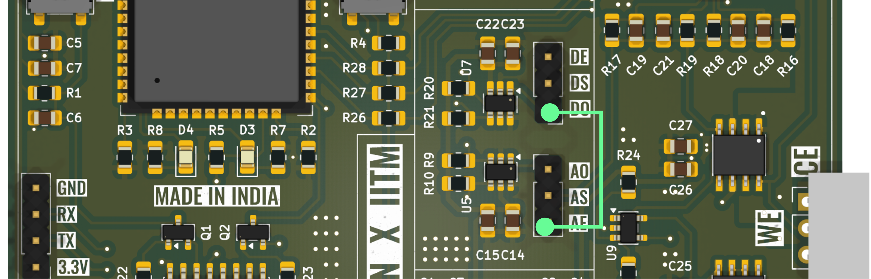
Figure 5:- Connecting the ESP32 ADC to On-board DAC
- Upload the Code MCP7425_TEST.ino code to the board
- Open the Python Script MCP7425_TEST.py
- Check for the COM PORT number in the device manager
- Change the COM PORT value in the Python Code
- Run the python script once the code is uploaded.
- Additionally to check the DAC values disconnect the connection of step 1 to see a flat line in the graph.
Figure 6:- Expected Output of the MCP4725 DAC test

