**Unix file System**

Definition: Logical method of storing information in way such that it can be accessed easily.

File: smallest unit where info is stored

Unix file system organisation

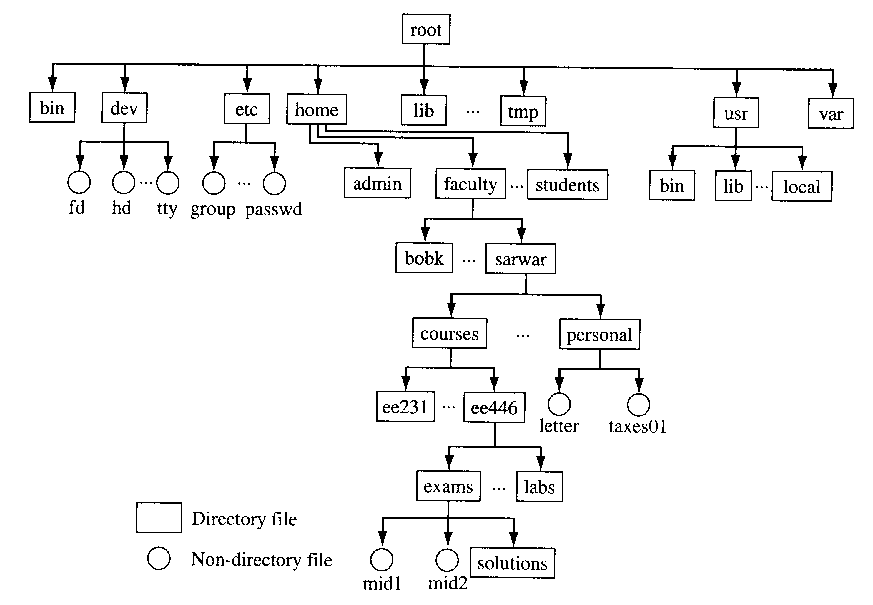

**/** - denotes the root level dir

**/bin** - contains fundamental utilities like ..ls,cd...........

**/boot** – files related to booting

**/dev** - for devices .We used **tty** already.

**/etc** - contains system database

**/home** – home directory for users

**/lib** - contains system libraries

**/usr** -- Includes administrative commands, shared files, library files, and others

**Some basic commands**

**pwd** - path of current working directory

**cd** – change directory

**ls**  - list all files

**ls -al** - list all files with permissions

**cat**  - lists content of file on standerd output

**cp**  - copy

**mv**  - move

**mkdir** - make directory

**rmdir** - remove directory

**rm** - remove

**touch** - used to create blank new file

**sudo** - superuser do

**df** – disc free **du** - disc usage

**diff** - command compares the contents of two files line by line. After analyzing the files, it will output the lines that do not match.

**chmod**  - to change read write permissions

**ping** - to check connectivity with server

**man** - manual instruction of any function