**Serial library in arduino IDE**

**Used for** communication between **arduino** and other devices

The serial port in arduino board we are using(Arduino uno) is **UART**(Universal Asynchronous Receiver/Transmitter)

Rx

receiver

Micro controller

Tx

Transmitter

**Serial data transfer**- When we transfer data one bit at a time

In the following figure info is transferring 1 bit at time between laptop and arduino board

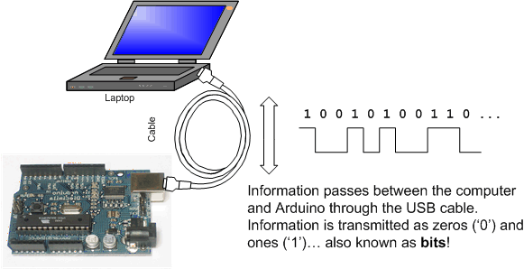

Actually we have seen led’s blinking when we uploaded sketch(compiled) into arduino.

By looking at the following diagram we can recap that the led toward Rx will blink when data is coming to arduino and the Led towards Tx will blink when data is going to other device from arduino.

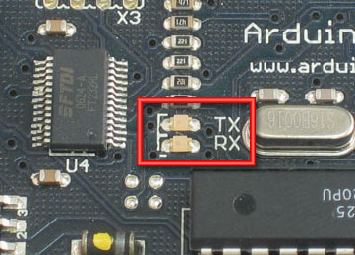

**Some functions of serial library**

1. begin() - sets the baud rate/number of bits per second
2. available() - returns the number of bytes available to read from serial port
3. isListening() - tests if the particular port is still in connection
4. read() - returns the character that was received on rx pin (only one char at a time)
5. print() and println() - similar to java ,used to print on stdout
6. listen() - enables particular serial port to listen
7. write() - writes the data over transmit pin(tx)

**Lets write some code for better understanding**

**This code turns led on based on first letter entered by user. If user enters r then red will turn on**

int redpin 3;

int greenpin 4;

int bluepin 5;

void setup() {

// put your setup code here, to run once:

pinMode(redpin, OUTPUT);

pinMode(greenpin, OUTPUT);

pinMode(bluepin, OUTPUT);

Serial.begin(9600);

Serial.println("Hello world");

}

void loop() {

// put your main code here, to run repeatedly:

if (Serial.available() > 0) //if data availaible to read

{

char c = Serial.read(); //read first byte

switch (c)

{

//if red

case r: digitalWrite(redpin, HIGH);

delay(1000);

digitalWrite(redpin, LOW);

delay(1000);

break;

//if blue

case b: digitalWrite(bluepin, HIGH);

delay(1000);

digitalWrite(bluepin, LOW);

delay(1000);

break;

//if green

case g: digitalWrite(greenpin, HIGH);

delay(1000);

digitalWrite(greenpin, LOW);

delay(1000);

break;

} }}

**I2C and SPI**

Inter integrated circuit and system peripheral interface

Provides simple way of communication between arduino and sensors.

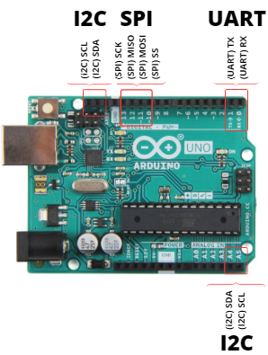

1. Compared to UART, it is similar but I2C are not used for PC – Device communication but are used with your modules and sensors.
2. It is a simple, bidirectional two-wire synchronous serial bus and only 2 wires (SDA and SCL) to transmit information between devices connected to the bus.
3. Here sda for data and scl for clock

**SPI**

1. SPI, which stands for serial peripheral interface, is similar to I2C where it is a different form of serial-communications protocol specially designed for microcontrollers to connect
2. SPI operates at full duplex where data can be sent and received simultaneously.
3. SPI are used in places where speed is important like SD cards, display modules or when info updates and changes quickly like thermometers.

**ULTRA SONIC SENSOR**

**Pin config(**HC-SR04)

|  |  |  |
| --- | --- | --- |
| **Pin Number** | **Pin Name** | **Description** |
| 1 | Vcc | The Vcc pin powers the sensor, typically with +5V |
| 2 | Trigger | Trigger pin is an Input pin. This pin has to be kept high for 10us to initialize measurement by sending US wave. |
| 3 | Echo | Echo pin is an Output pin. This pin goes high for a period of time which will be equal to the time taken for the US wave to return back to the sensor. |
| 4 | Ground | This pin is connected to the Ground of the system. |

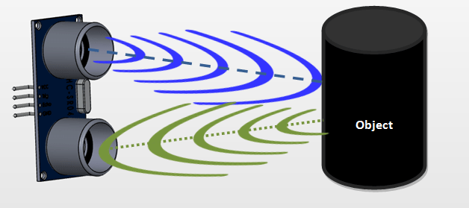

**fritzing circuite for the above**

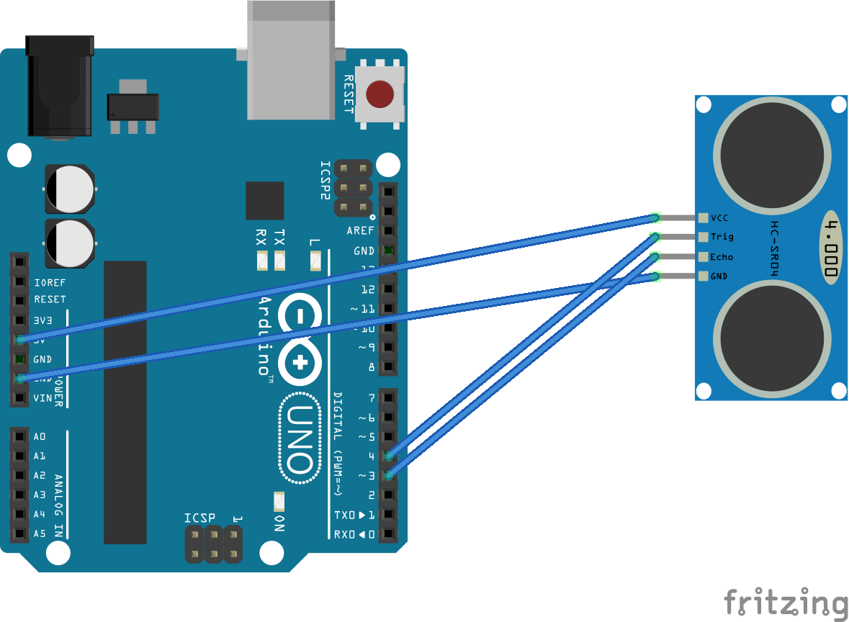

**Hand written note on ultra sonic sensor**

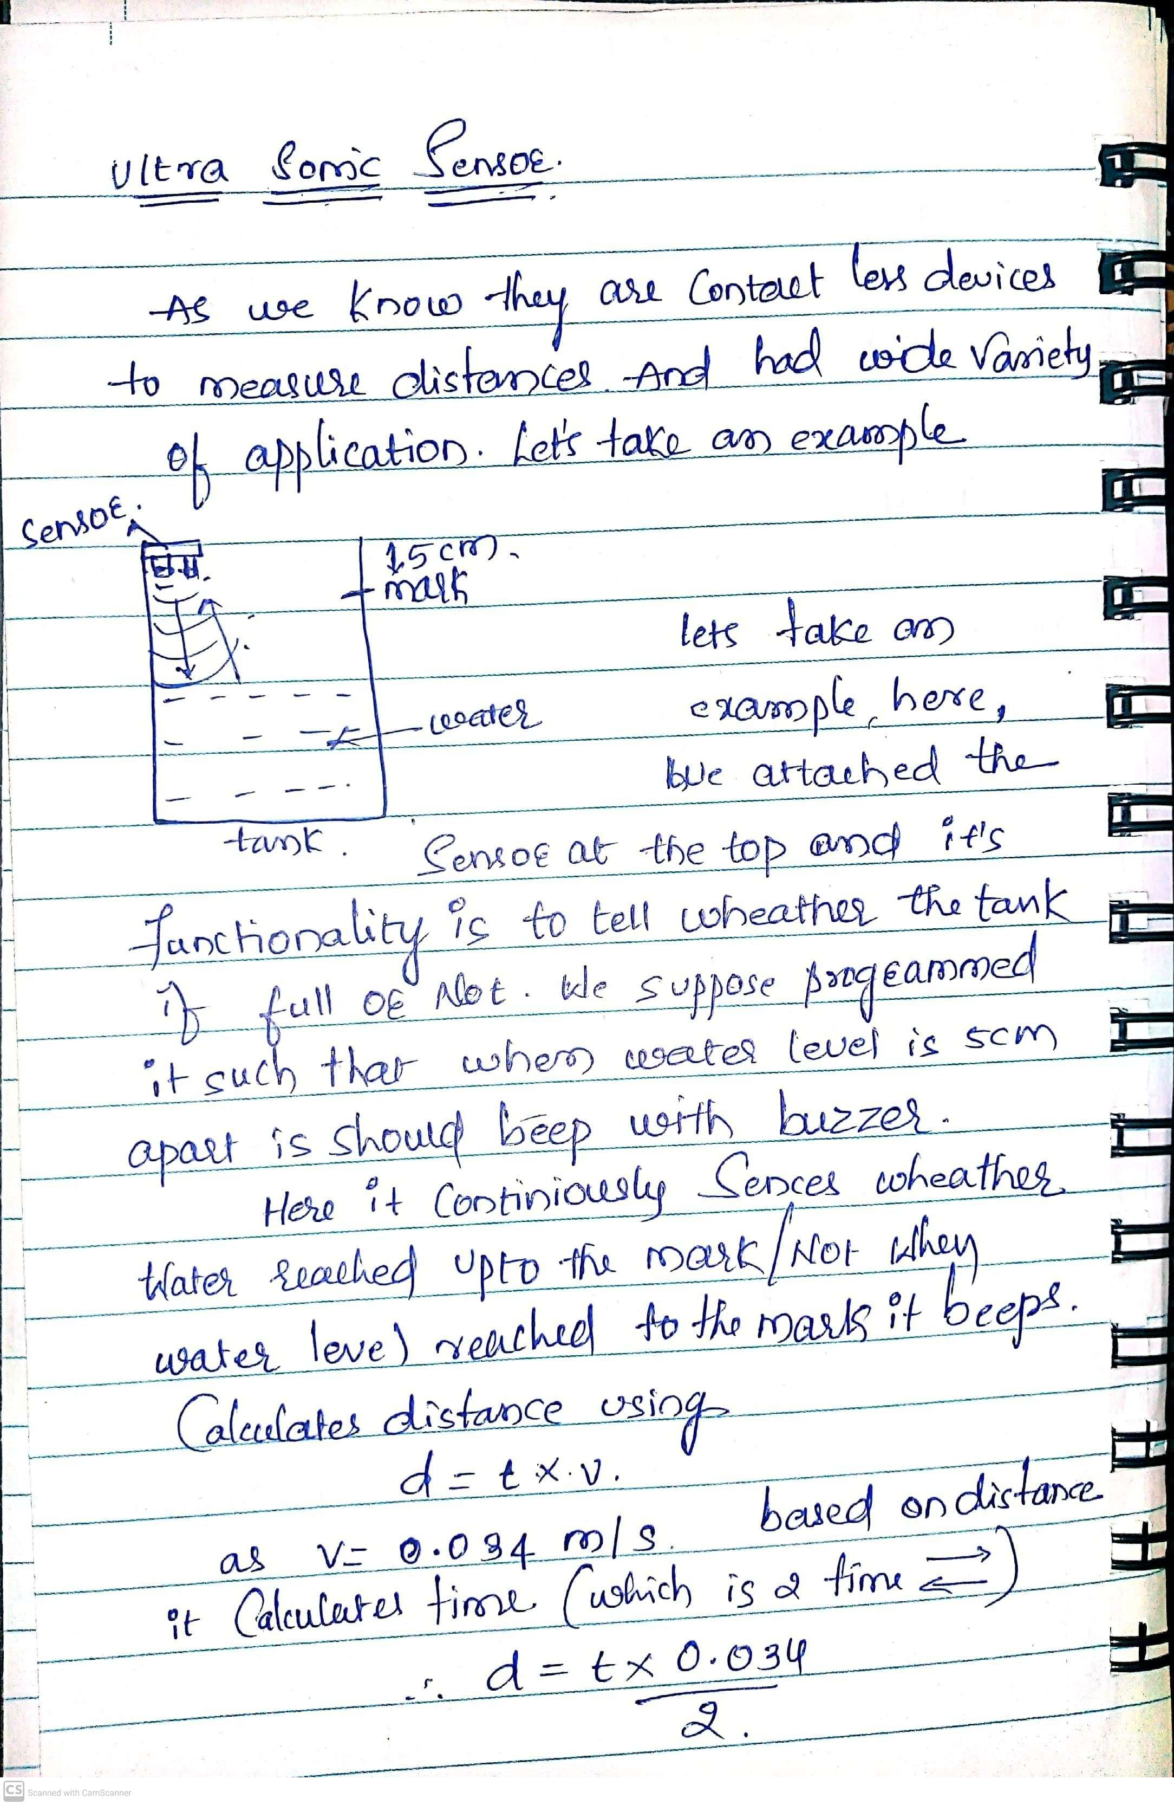

**OLED**

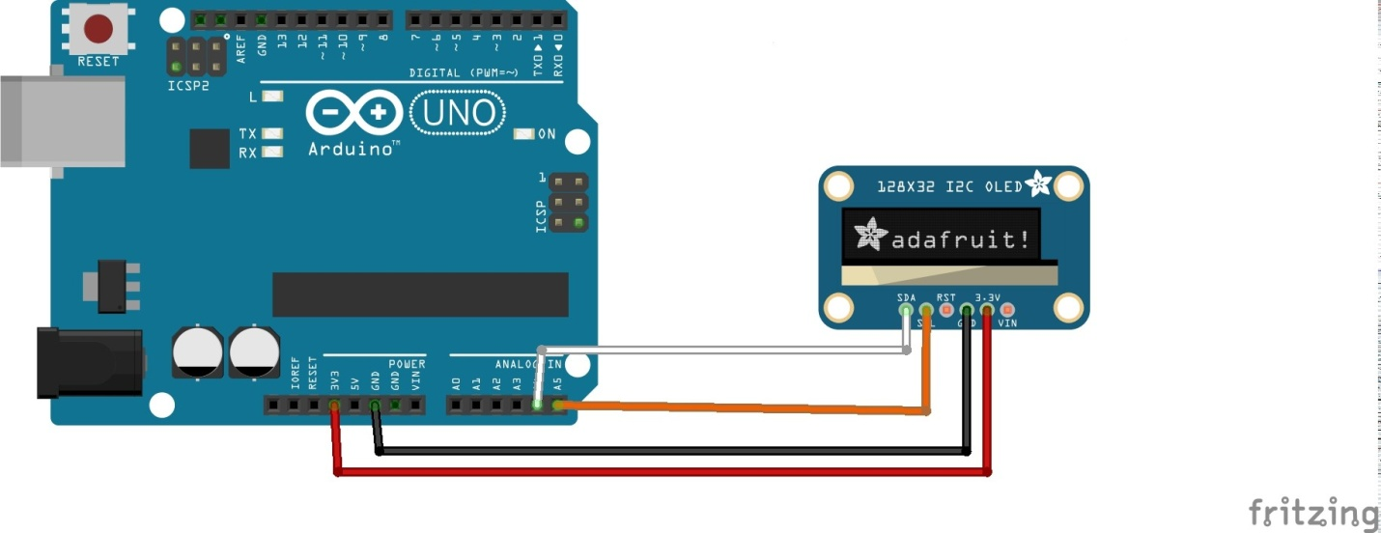

**Code**

#include <Wire.h>

#include <Adafruit_SSD1306.h>

#include <Adafruit_GFX.h>

#define OLED_WIDTH 128

#define OLED_HEIGHT 64

#define OLED_ADDR 0x3C

Adafruit_SSD1306 display(OLED_WIDTH, OLED_HEIGHT);

void setup() {

display.begin(SSD1306_SWITCHCAPVCC, OLED_ADDR);

display.clearDisplay();

display.setTextSize(2);

display.setTextColor(WHITE);

display.setCursor(0, 0);

display.println("hi shreenidhi");

display.setTextSize(2);

display.setTextColor(WHITE);

display.setCursor(1, 17);

display.println("welcome");

display.display();

delay(5000);

}

void loop() {

display.clearDisplay();

display.setTextSize(2);

display.setTextColor(WHITE);

display.setCursor(0, 0);

display.println("shreenidhi");

display.display();

delay(5000);

}