1. how many devices can you connect to hc05 device from arduino?

Ans: Generally Bluetooth can connect up to **eight devices** simultaneously.

1. how many characters you will be print on OLED with various oled sizes and fonts?

Ans:

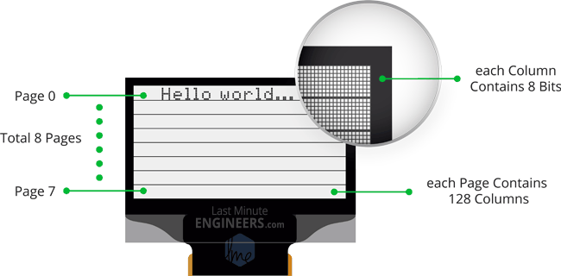

8 pages x 128 segments x 8 bits of data = 8192 bits = 1024 bytes = 1KB memory

If we assume charecters occupy 2 bytes

Charecters per row --- 21

Number of rows --- 7

So total 21x7=147 charecters