**AI Powered Resume Screening and Ranking System**

A Project Report

submitted in partial fulfillment of the requirements

of

AICTE Internship on AI: Transformative Learning

with

TechSaksham – A joint CSR initiative of Microsoft & SAP

by

**Shreeram Prajapati, shreeramprajapati2@gmail.com**

Under the Guidance of

**Saomya Choudhari**

**ACKNOWLEDGEMENT**

I would like to express my sincere gratitude to all those who have guided, supported, and contributed to the successful completion of this project.

First and foremost, I would like to extend my deepest thanks to **Saomya Choudhari Sir**, whose continuous guidance and encouragement have been invaluable throughout this project. His expertise and insights have significantly shaped the direction of my work.

I am also incredibly grateful to **P Raja Sir**, whose mentorship has been crucial in completing the project. His feedback and advice have always been constructive and motivational.

A special thanks to **Pavan Sumohana Sir** for his support during the course of this project. His assistance in providing critical insights and advice has been vital in ensuring the project’s success.

Lastly, I would like to acknowledge **Briit 🇬🇭🇺🇲 (Data Science & AI Mentor on YouTube)** for the online tutorials and resources that helped me understand complex AI and Data Science concepts, which were instrumental in building the system. His YouTube content has been a great source of learning and inspiration for me.

I would also like to thank my family and friends for their constant support and encouragement throughout the project journey.

Thank you all for being a part of this remarkable learning experience.

#### **ABSTRACT**

The **AI-Powered Resume Screening and Ranking System** is a web-based solution designed to automate the process of resume evaluation and provide personalized recommendations for job seekers. By utilizing **AI algorithms** and **Natural Language Processing (NLP)**, the system analyzes resumes uploaded by candidates, extracting key information such as **contact details**, **skills**, **experience level**, and other essential data. Based on this analysis, the system suggests suitable career fields (e.g., **Data Science**, **Web Development**, **Android Development**) aligned with the candidate's expertise.

The system further enhances the candidate's profile by offering **skill recommendations** to improve job prospects and providing suggestions for relevant online courses. Additionally, it evaluates the quality of the resume, assigning a **resume score** based on the inclusion of essential sections such as **Objective**, **Achievements**, **Projects**, and **Hobbies**. Candidates are also provided with **resume writing tips** and **interview preparation videos** to boost their chances of landing a job.

For the **Admin side**, the system integrates with a **MySQL database** to store candidate data. Admin users can view and analyze **candidate profiles**, generate reports, and visualize trends, such as the most common **predicted job fields** and **experience levels**, through **pie charts**.

This project leverages **AI, NLP**, and **data analytics** to streamline the hiring process, making it more efficient for recruiters and offering valuable insights for job seekers. Ultimately, the system helps both **candidates** and **recruiters** achieve better job matching and improved hiring outcomes.

**TABLE OF CONTENT**

**Acknowledgement ………………………………………………………………….**

**Abstract**

**Chapter 1.**  **Introduction**

1.1 Problem Statement

1.2 Motivation

1.3 Objectives

1.4. Scope of the Project

**Chapter 2.**  **Literature Survey**

**Chapter 3.**  **Proposed Methodology**

**Chapter 4.**  **Implementation and Results**

**Chapter 5. Discussion and Conclusion**

**References**

**CHAPTER 1**

**Introduction**

* 1. **Problem Statement:**
* In today's competitive job market, recruiters and hiring managers often face an overwhelming number of resumes to sift through, making it difficult to identify the best candidates efficiently. Traditional resume screening methods are time-consuming and prone to human biases, leading to missed opportunities and suboptimal hiring decisions. As a result, the hiring process can be both inefficient and inconsistent, often delaying talent acquisition and reducing the overall quality of hires.
* The problem being addressed is the lack of an automated, intelligent system to streamline the resume screening and ranking process. Manually reviewing resumes is not only time-consuming but also inefficient, especially when there is a large volume of applications to process. Furthermore, many candidates fail to tailor their resumes according to job requirements, making it even harder for recruiters to quickly assess their qualifications.
* The solution to this problem is to leverage Artificial Intelligence (AI) to create a **Resume Screening and Ranking System** that automates the process of evaluating resumes based on predefined criteria. This system can analyze and rank resumes based on factors such as relevant skills, experience, education, and other key attributes that recruiters typically seek in candidates. The automation of this process will enable recruiters to identify the most qualified candidates quickly and efficiently, reducing the time spent on manual review and ensuring a more objective and fair selection process.
* The significance of this problem is far-reaching. It not only improves the efficiency of the recruitment process but also ensures that the best candidates are selected for the right roles. By integrating AI into the resume screening process, organizations can reduce human bias, streamline recruitment workflows, and improve the overall hiring experience for both recruiters and candidates.
  1. **Motivation:**
* The motivation behind developing the **AI-Powered Resume Screening and Ranking System** stems from the increasing demand for more efficient, unbiased, and automated recruitment solutions in today’s fast-paced job market. With thousands of resumes being submitted for each job posting, recruiters face a significant challenge in manually reviewing each application. This often leads to delays, inconsistent evaluations, and potential bias in the hiring process. The growing need for faster and more accurate recruitment decisions highlights the importance of leveraging technology, specifically Artificial Intelligence (AI), to address these challenges.
* The project was chosen because of its potential to revolutionize the hiring process. Traditionally, screening resumes involves manually going through each document to assess the qualifications, skills, and experience of candidates. This is not only a time-consuming task but also prone to human errors and biases, such as favoring candidates based on subjective impressions rather than objective criteria. An AI-powered system can overcome these limitations by providing a more efficient, fair, and data-driven approach.
* The **potential applications** of this system are vast. It can be used in a variety of industries, including corporate HR departments, recruitment agencies, and job boards. Companies of all sizes—from startups to large enterprises—stand to benefit from automating the initial stages of the hiring process. By ranking resumes based on relevance and fit for a specific role, the system can help identify the best candidates more quickly, reducing the time spent on manual screening and ensuring that no talented individual is overlooked.
* The **impact** of this system is significant. It not only saves time and effort for HR teams but also improves the overall quality of the hiring process. AI ensures that resumes are evaluated based on predefined, data-driven criteria, reducing the impact of human bias and providing candidates with a fairer chance. Ultimately, this project aims to enhance the hiring process, benefiting both recruiters and job seekers by enabling quicker and more accurate job matching.
  1. **Objective:**

The primary objective of this project, **AI-Powered Resume Screening and Ranking System**, is to develop an automated, efficient, and intelligent system that streamlines the recruitment process by evaluating and ranking resumes based on specific job requirements. The key objectives of the project are as follows:

1. **Automate Resume Screening**: To create an AI-driven system that can automatically analyze resumes and filter candidates based on predefined criteria, reducing the time spent on manual resume evaluation.
2. **Rank Resumes by Relevance**: To develop an algorithm that can rank resumes based on their relevance to the job description. The system will assess the alignment of candidate skills, experience, and qualifications with the job requirements.
3. **Skill and Career Path Recommendations**: To provide candidates with personalized career advice by recommending relevant skills, certifications, and courses based on their resume content. This will help candidates enhance their skills and improve their chances of securing a job.
4. **Field-specific Job Recommendations**: To identify the most suitable career field for each candidate based on their resume data, such as Data Science, Web Development, Android Development, UI/UX Design, etc.
5. **Resume Quality Scoring**: To implement a feature that scores the quality of resumes based on factors such as the presence of essential sections (e.g., Objective, Projects, Achievements), formatting, and overall structure. The system will provide tips to improve the resume and enhance the candidate's chances of getting hired.
6. **Provide Data-Driven Insights for Employers**: To allow recruiters and employers to gain insights into the candidates’ resumes, enabling data-driven decision-making and reducing biases in the hiring process.
7. **User-Friendly Interface**: To design a user-friendly interface that allows easy resume uploading, analysis, and visualization of recommendations for both job seekers and recruiters.

By achieving these objectives, the project aims to improve the efficiency, accuracy, and fairness of the resume screening process, benefiting both job seekers and employers.

* 1. **Scope of the Project:**

#### **Scope**:

The **AI-Powered Resume Screening and Ranking System** aims to revolutionize the recruitment process by leveraging artificial intelligence and machine learning. The scope of this project includes:

1. **Resume Parsing**: The system will extract essential information from resumes in PDF format, such as personal details, skills, work experience, education, certifications, and more.
2. **Skill and Qualification Assessment**: The project will assess the candidate's skills and qualifications based on the content extracted from their resumes, and compare them with the requirements of the job roles.
3. **Field-based Career Recommendations**: Based on the extracted data, the system will provide personalized career recommendations, suggesting suitable job fields, skills, and courses to enhance the candidate's prospects in the job market.
4. **Resume Scoring**: The system will generate a resume score based on various factors such as completeness, relevance, formatting, and essential sections (Objective, Projects, Hobbies, etc.), providing candidates with feedback to improve their resumes.
5. **Job Role Fitment**: By analyzing the skills and experience mentioned in the resume, the system will categorize candidates into suitable job roles such as Data Science, Web Development, Android Development, UI/UX Design, etc.
6. **Personalized Course Recommendations**: Based on the identified career field, the system will suggest relevant online courses, certifications, and skills that could improve the candidate’s chances of getting hired.
7. **Database and Reporting**: The system will store user data in a database and allow recruiters to view candidate details and analytics through a user-friendly dashboard. This will also include the option to download reports for further analysis.
8. **Admin Features**: Admin users will have access to detailed data about candidate submissions, including resume scores, predicted fields, and other analytics.

#### **Limitations**:

1. **Data Dependency**: The system’s accuracy depends heavily on the data extracted from resumes, which may not always be standardized or structured. Incomplete or poorly formatted resumes may lead to inaccurate results.
2. **Limitations in AI Model**: While AI and machine learning can offer valuable insights, there may be limitations in detecting subtle nuances in the resume content, which could affect the precision of career recommendations.
3. **Job Role Accuracy**: The system provides career recommendations based on keywords and patterns found in the resumes, but it may not always capture the full breadth of a candidate’s capabilities. Complex job roles may require further manual evaluation.
4. **Resume Format Compatibility**: The current system focuses on parsing PDF resumes, and while it can handle a variety of resume formats, it may not fully support other document types or highly customized formats.
5. **Performance on Large Datasets**: While the system is designed to handle a reasonable amount of data, its performance may be affected when processing large volumes of resumes simultaneously, which could lead to slower response times.
6. **User Skill Interpretation**: The AI-based recommendations depend on the skills listed in the resumes, which may not always reflect the candidate's true abilities, particularly if the candidate has not updated their resume to reflect their latest skills.
7. **Limited Scope for Interview Analysis**: Although the system recommends relevant skills and courses, it does not directly evaluate a candidate’s performance in an interview, which remains an essential aspect of recruitment.

In summary, the scope of the project covers the automation of resume analysis, ranking, and recommendations, but there are certain limitations in the depth of analysis and compatibility with various document formats. The system aims to provide assistance and insights, but human judgment will still play a significant role in the final decision-making process.

**CHAPTER 2**

### 2.1 Literature Survey

This section reviews relevant literature and previous work in the domain of AI-powered resume screening and ranking systems.

#### 2.1 Review of Relevant Literature

Numerous studies have explored the use of Natural Language Processing (NLP) and Machine Learning (ML) in recruitment. Some notable works include:

* Research on NLP-based resume parsing techniques for extracting structured data from unstructured resumes.
* Machine Learning models for job matching based on skill analysis and keyword extraction.
* AI-powered ranking systems that assess candidate suitability based on predefined criteria.

#### 2.2 Existing Models, Techniques, and Methodologies

Several existing methodologies are used in automated resume screening:

* **Rule-based Parsing:** Uses predefined patterns to extract relevant resume details.
* **Machine Learning Approaches:** Utilizes classification and clustering algorithms to predict job fit.
* **Deep Learning Models:** Implement CNNs and RNNs for enhanced text understanding.
* **Database-driven Systems:** Store and retrieve resume information efficiently using SQL/NoSQL databases.

#### 2.3 Gaps and Limitations in Existing Solutions

While current systems offer automated screening, they face several challenges:

* **Lack of Contextual Understanding:** Many models struggle to interpret job descriptions beyond keyword matching.
* **Limited File Format Support:** Some systems only process PDFs and struggle with DOCX or image-based resumes.
* **Bias in AI Models:** Existing models may have biases due to limited training data.
* **Absence of Real-time Feedback:** Candidates do not receive instant suggestions for resume improvement.

**CHAPTER 3**

**Proposed Methodology**

* 1. **System Design**

Provide a **system architecture diagram** to represent the overall workflow of the project. The diagram should depict:

1. **User Interface (Streamlit)**
   * Users can upload their resumes (PDF).
   * Admins can manage data and view analytics.
2. **Resume Parsing & Processing**
   * pdfminer3 extracts text from resumes.
   * pyresparser analyzes resume content.
   * NLTK and spaCy process text data.
3. **Skill & Job Recommendation**
   * Keywords are matched with predefined job roles.
   * Recommended skills and courses are suggested.
4. **Database (MySQL)**
   * User data is stored (name, email, resume score, recommendations).
   * Admins can access and analyze the database.
5. **Visualization & Reporting**
   * Plotly generates charts.
   * Reports can be downloaded in CSV format.
6. **External Integrations**
   * yt_dlp fetches YouTube videos for career guidance.
   * AI-driven recommendations are displayed.

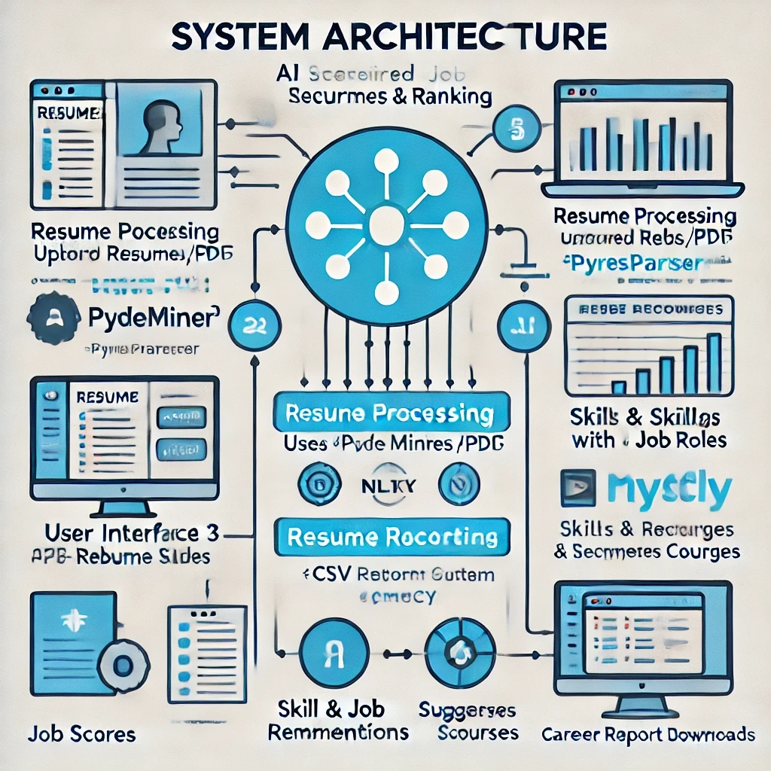

### 3.2 Requirement Specification

This section outlines the hardware and software requirements needed to implement the AI Resume Screening & Ranking System.

#### 3.2.1 Hardware Requirements:

* **Processor:** Intel Core i5 or higher (or equivalent AMD Ryzen)
* **RAM:** 8GB or more (16GB recommended for faster performance)
* **Storage:** Minimum 50GB free space (for database and dependencies)
* **Operating System:** Windows 10/11, macOS, or Linux (Ubuntu preferred)
* **Internet Connection:** Required for fetching online resources and installing dependencies

#### 3.2.2 Software Requirements:

* **Programming Language:** Python 3.12
* **Libraries & Dependencies:**
  + streamlit – for building the web application
  + spacy – for Natural Language Processing (NLP)
  + pymysql – for connecting to the MySQL database
  + pdfminer3 – for extracting text from resumes in PDF format
  + yt_dlp – for fetching YouTube video information
  + nltk – for text processing and stopwords removal
  + pyresparser – for resume parsing
  + plotly.express – for creating data visualizations
  + PIL (Pillow) – for handling images
  + base64 – for encoding data for downloads
* **Database:** MySQL
* **Development Tools:**
  + VS Code (for coding and debugging)
  + MySQL Workbench (for database management)
  + GitHub (for version control)
* **Other Tools:**
  + pip – for package management
  + virtualenv (optional) – for dependency isolation

**CHAPTER 4**

**Implementation and Result**

* 1. 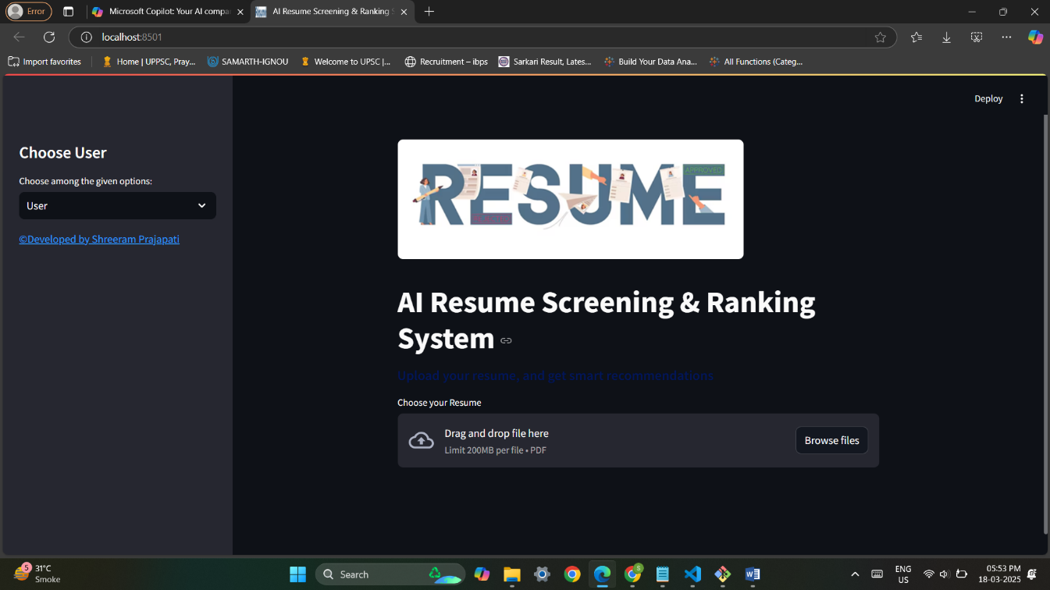 **Snap Shots of Result:**

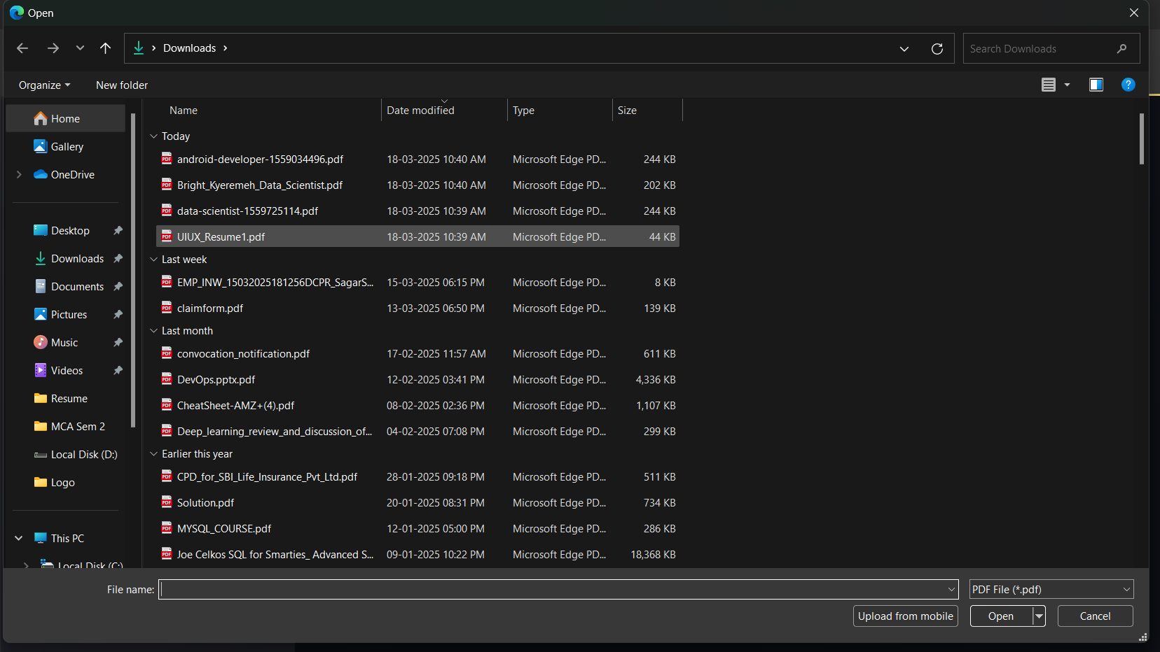**Home Page & Upload pdf file**

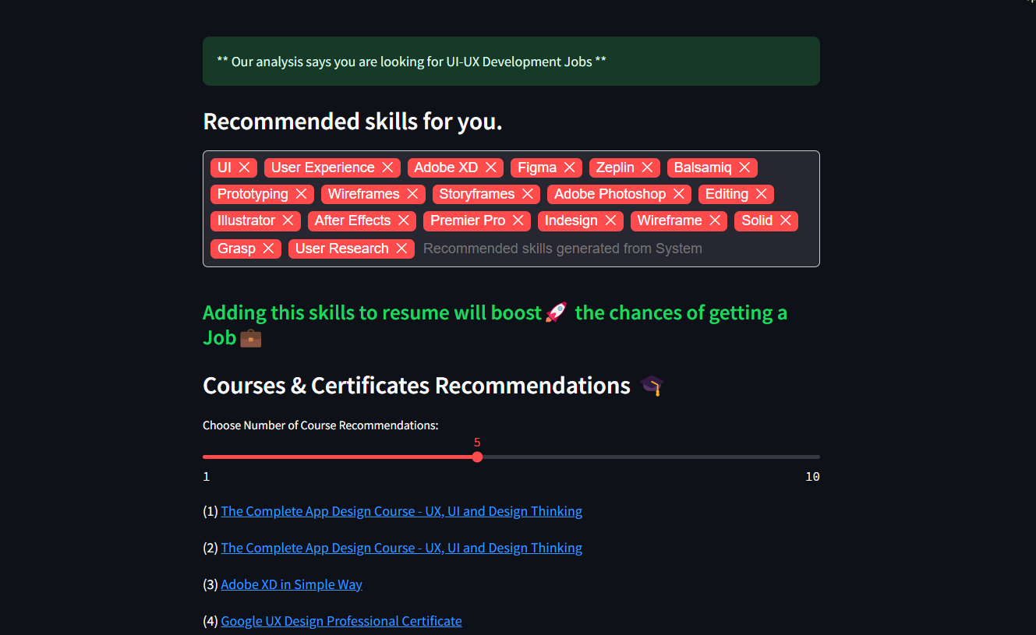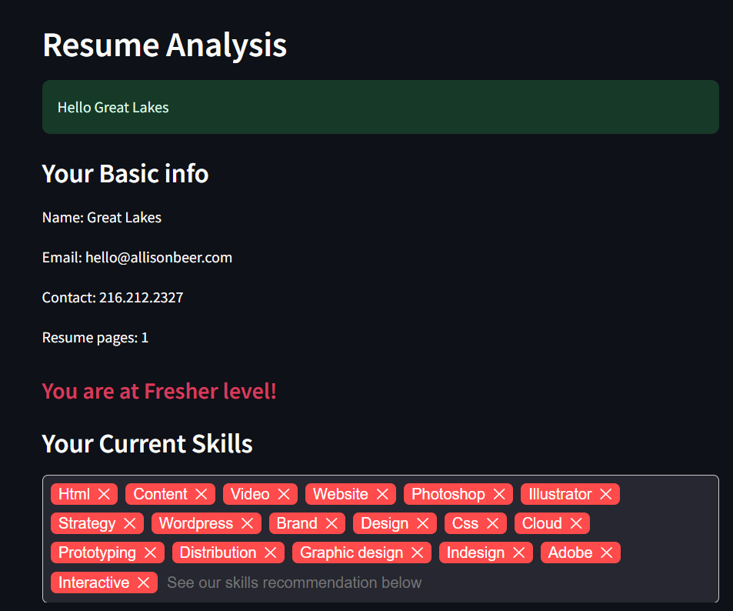

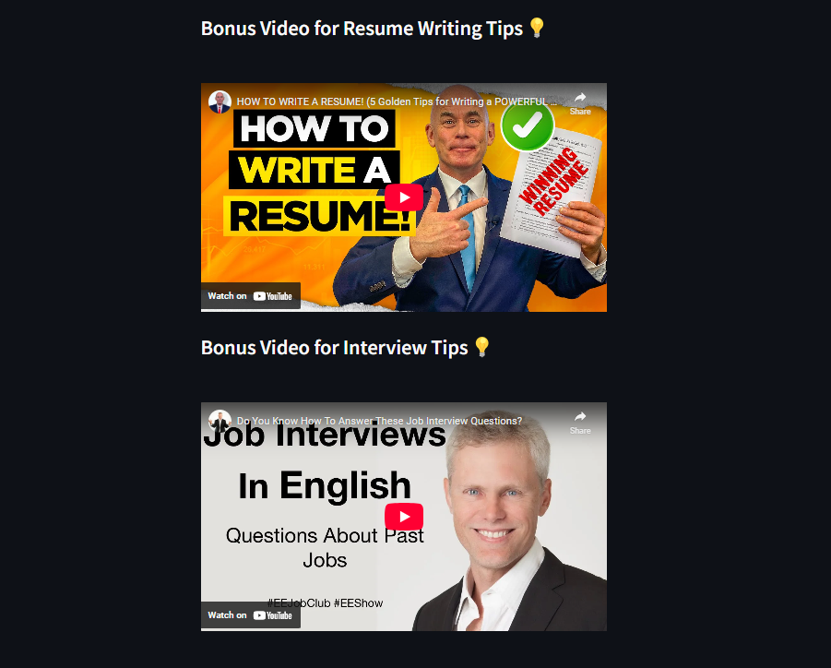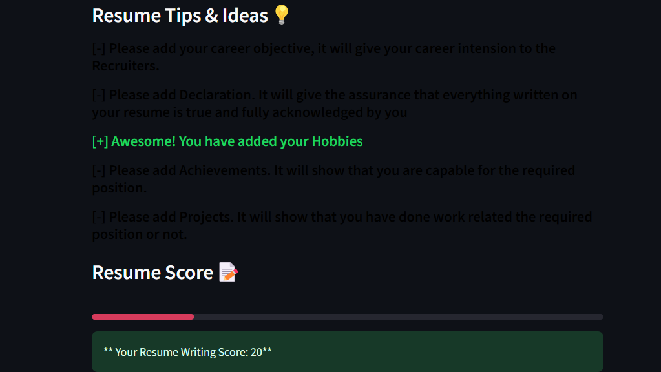

* 1. **GitHub Link for Code:**

https://github.com/shreeram0912/AI-Based-Resume-Screening-Ranking-System-

**CHAPTER 5**

**Discussion and Conclusion**

* 1. **Future Work:**
* To further enhance the AI Resume Screening & Ranking System, the following improvements and developments can be considered:
* **Enhanced NLP Techniques:** Incorporating advanced NLP models like GPT-based analysis for better resume parsing and skill matching.
* **Machine Learning Integration:** Implementing machine learning algorithms to predict job fit based on historical hiring data.
* **Support for More File Formats:** Extending compatibility to process resumes in DOCX, TXT, and other popular formats.
* **Real-time Resume Feedback:** Providing instant suggestions for resume improvements before submission.
* **Expanded Database Support:** Allowing integration with NoSQL databases like MongoDB for scalability.
* **Multilingual Processing:** Supporting multiple languages for international job applicants.
* **AI-based Interview Preparation:** Developing features that generate personalized interview questions based on resume content.
  1. **Conclusion:**

1. The AI Resume Screening & Ranking System has demonstrated its potential in automating and improving the recruitment process. By leveraging natural language processing, data analysis, and visualization techniques, the system provides efficient resume screening, skill recommendations, and career guidance. The project significantly reduces the time spent by recruiters in evaluating resumes while enhancing the chances of candidates securing relevant job opportunities. Future enhancements, such as machine learning-based predictions and multilingual support, can further improve the system’s efficiency and usability, making it a valuable tool for modern hiring practices.

**REFERENCES**

[1]. Saomya Choudhari, for continuous guidance and encouragement, which have been invaluable throughout this project.

[2]. P Raja, for mentorship and constructive feedback that played a crucial role in completing the project.

[3]. Pavan Sumohana, for providing critical insights and advice that contributed to the project's success.

[4]. Briit 🇬🇭🇺🇲 (Data Science & AI Mentor on YouTube), for online tutorials and resources that helped in understanding complex AI and Data Science concepts.

[5]. OpenAI's ChatGPT, for assistance in research, development, and structuring the project effectively.