Document Verification System (DVS) – Stage 6 to Stage 8
Stage 6 — Eligibility Rule Enforcement
F.1 — Stage Overview
Stage 6 applies program-specific eligibility rules to the structured academic data extracted in earlier stages. After confirming that documents are authentic, readable, and internally consistent, the system determines whether the applicant satisfies the academic and administrative requirements for admission to the selected program.
While previous stages verify document validity, Stage 6 verifies candidate eligibility.
For the demonstration scenario used in the DVS prototype, the system evaluates eligibility for the B.Tech Computer Science program.
Stage 6 Input & Output
INPUT:
• Structured academic data extracted in Stage 2
• Cross-document identity validation results from Stage 5

OUTPUT:
• Eligibility rule evaluation results
• Eligibility score
• Pass / Warning / Fail decision

PIPELINE BEHAVIOUR:
If mandatory eligibility criteria are not met, the pipeline marks the application as ineligible and passes the result to Stage 7 for final risk aggregation and decision generation.

F.2 — Eligibility Rule
Each academic program defines a set of eligibility rules that applicants must satisfy. These rules are stored in the system as configurable program policies.
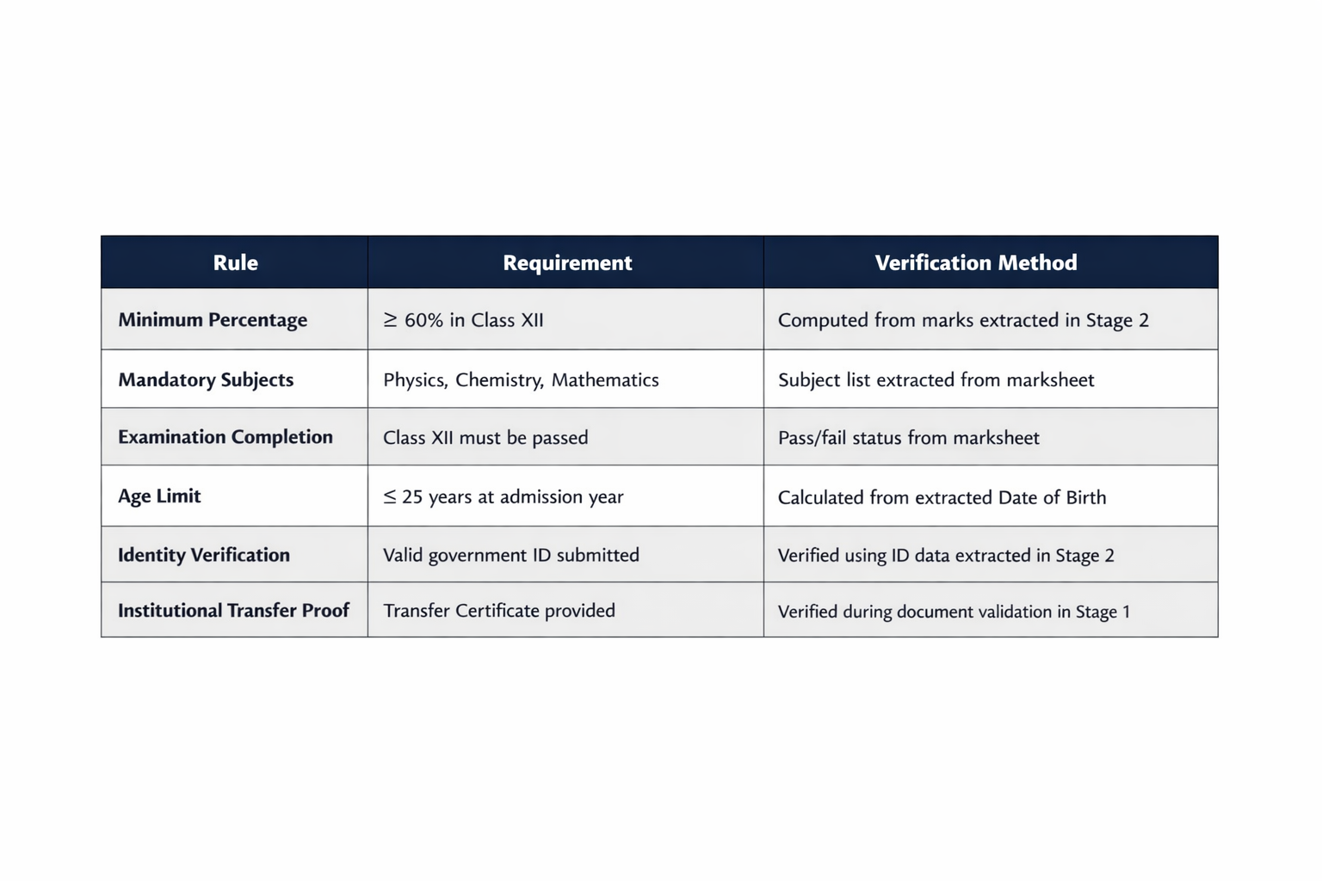
For the B.Tech Computer Science program, the rules include:

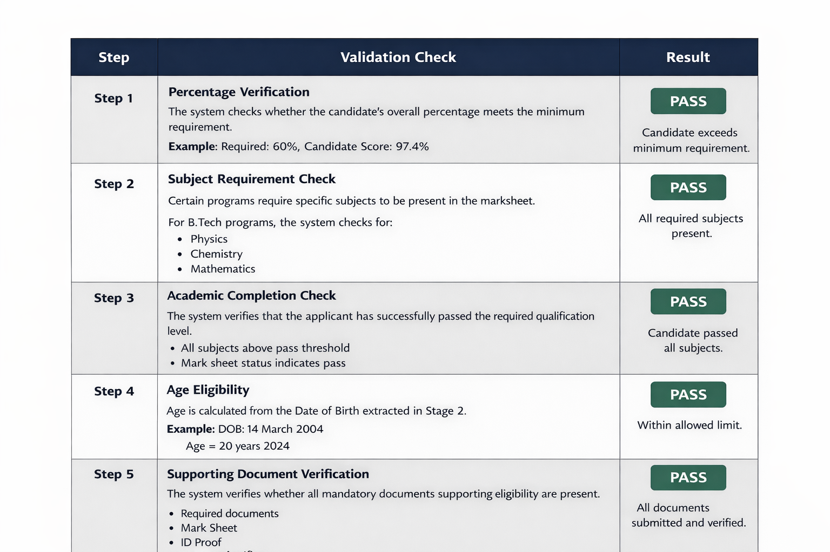
F.3 — Eligibility Validation Process
F.4 — Eligibility Score
After evaluating all eligibility rules, the system calculates an overall eligibility score.
Score Calculation: Eligibility Score = (Number of rules passed ÷ Total rules) × 100
Example
Rules satisfied: 6
Total rules: 6
Eligibility Score = 100%
F.5 — Stage 6 Result Logic
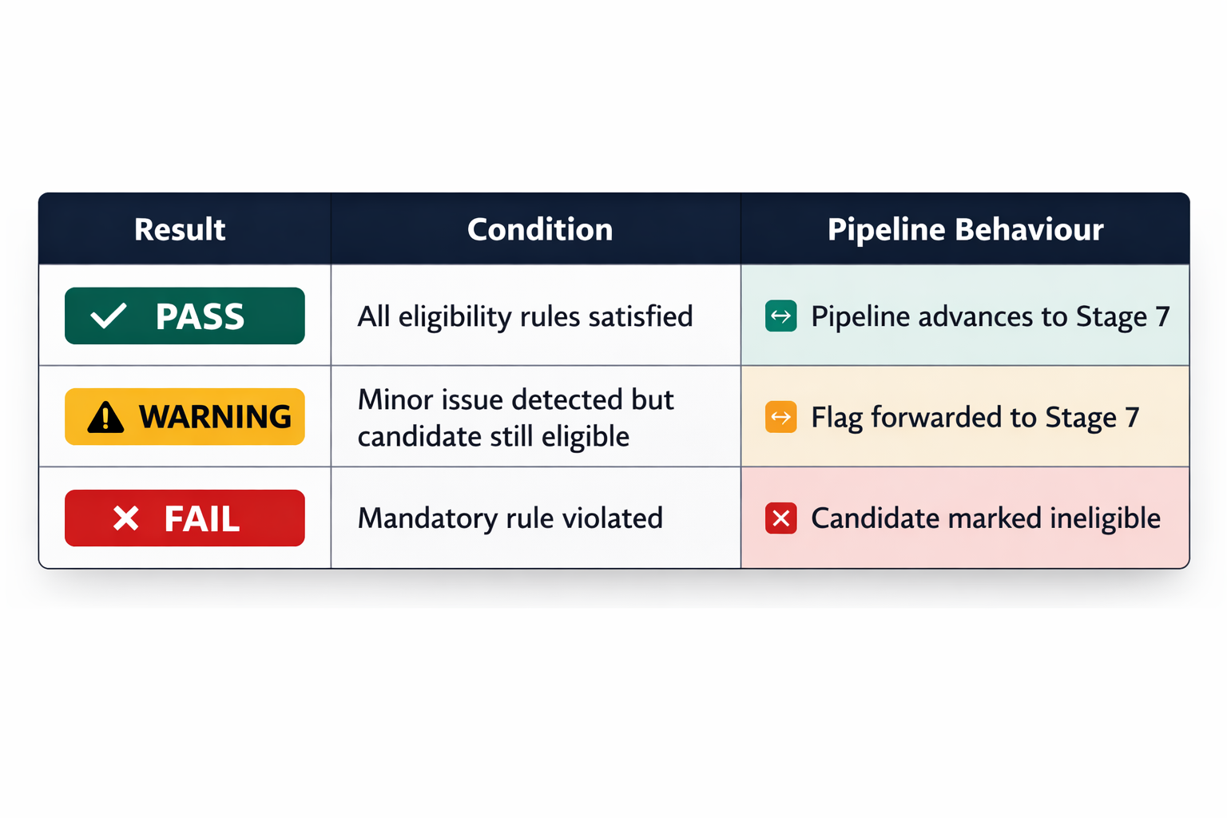
F.6 — Stage 6 Output to Pipeline
At the completion of Stage 6, the system produces:
• Per-rule validation results
• Overall eligibility score
• Eligibility status (Eligible / Ineligible)
• Any warnings generated during rule checks
These results are forwarded to Stage 7, where they are combined with previous stage outcomes to determine the final decision.
STAGE 7 — RISK AGGREGATION & FINAL DECISION
G.1 — Stage Overview
Stage 7 aggregates the results of all previous verification stages to produce a final decision regarding the authenticity and validity of the applicant’s submitted documents.
Each stage contributes signals to a unified risk scoring model.
The system evaluates the following verification layers:
• Document integrity
• OCR extraction confidence
• Structural authenticity
• Academic semantic validity
• Cross-document identity consistency
• Eligibility rule satisfaction
The combined result determines whether the application is:
VALID
INVALID
MANUAL REVIEW
G.2 — Risk Factors Considered
Each verification stage contributes to the overall risk score.
Stage 1 — File validity and clarity
Stage 2 — OCR extraction confidence
Stage 3 — Document authenticity
Stage 4 — Academic logic consistency
Stage 5 — Cross-document identity match
Stage 6 — Eligibility compliance
G.3 — Risk Score Calculation
Each risk signal is assigned a weighted value.
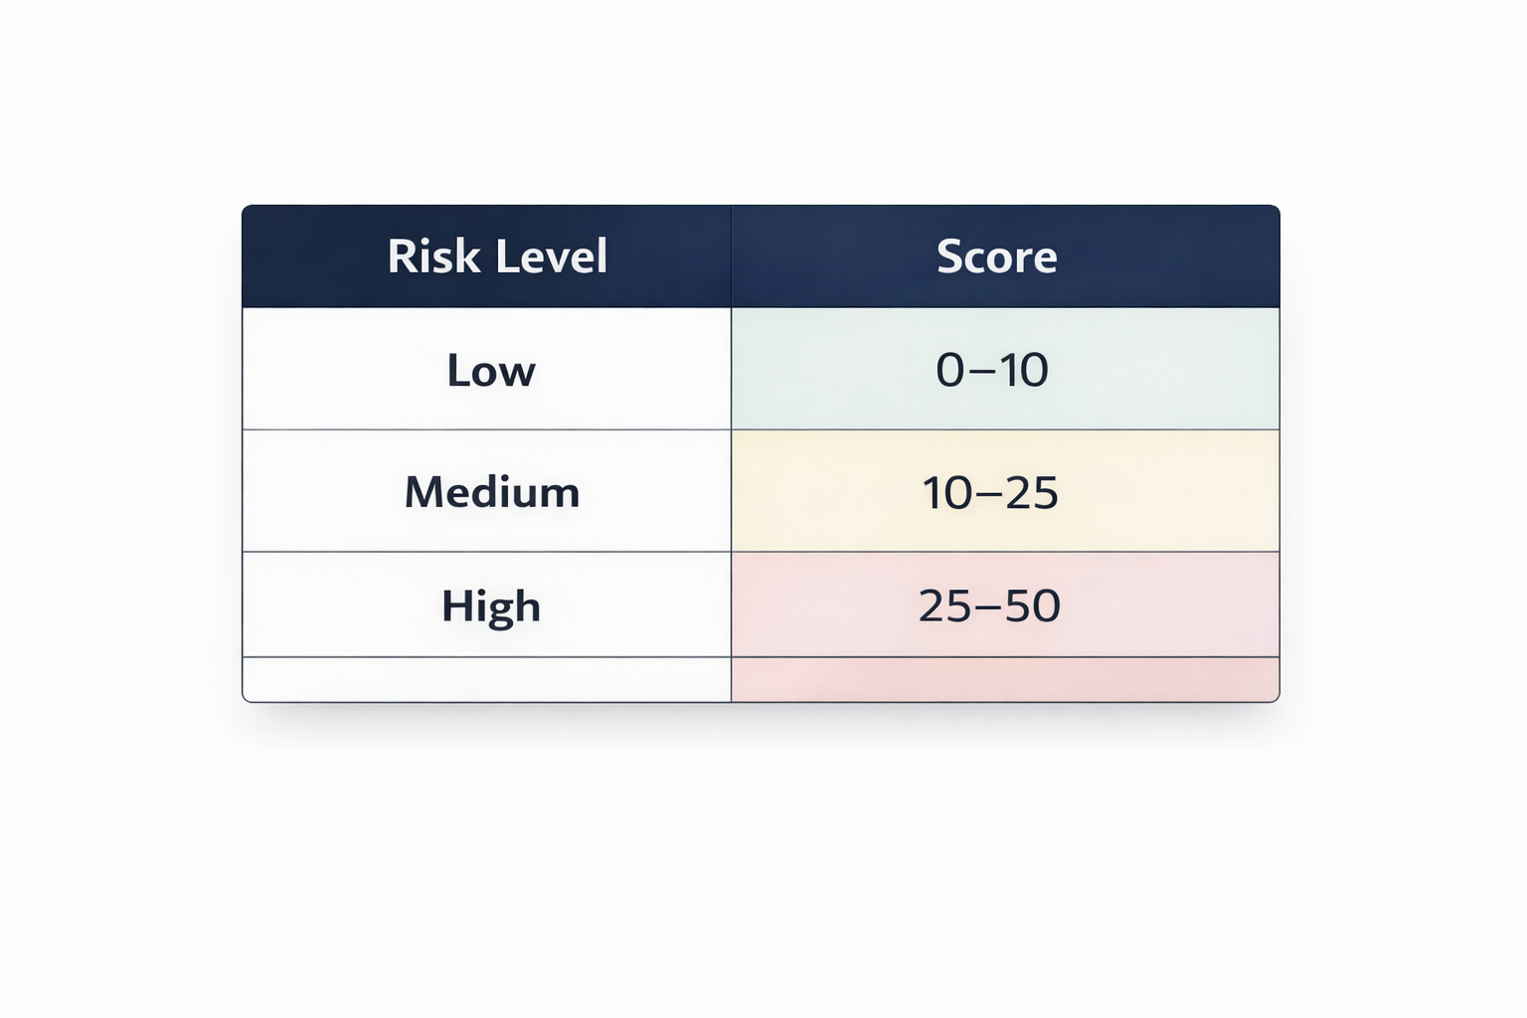
Example weighting model
The total risk score is calculated by combining signals from all stages.
Example
Stage 1 → Low Risk
Stage 2 → Low Risk
Stage 3 → Medium Risk
Stage 4 → Low Risk
Stage 5 → Low Risk
Stage 6 → Low Risk
Total Risk Score = 12%
G.4 — Decision Thresholds
The system converts the risk score into a final decision.
0–30% → VALID
31–60% → MANUAL REVIEW
Above 60% → INVALID
Example:
Risk Score = 12%
Decision = VALID
G.5 — Final Decision Output
For the demonstration scenario:
Decision
VALID — APPROVED
Meaning
• Documents are authentic
• Academic records verified
• Eligibility requirements satisfied
• Risk score below threshold
The application can proceed to the next stage of the admission process.

Stage 8 — Explanation & Applicant Guidance
H.1 — Stage Overview
Stage 8 generates a human-readable explanation of the pipeline’s final decision. While earlier stages operate primarily as automated validation systems, this stage focuses on communication and transparency.
Its purpose is to clearly explain:
• Why the application was approved or rejected
• Which checks passed successfully
• Any warnings or advisory notes
• What actions the applicant should take next
This stage ensures that applicants and administrators can understand the reasoning behind the automated decision.
H.2 — Decision Explanation Generation
The explanation engine composes a structured summary using the results of all previous stages.
Example explanation:
The applicant’s documents were successfully verified through all eight stages of the DVS pipeline. The submitted mark sheet, Aadhaar ID, and transfer certificate were validated for authenticity, clarity, and consistency.
The applicant abc achieved 97.4% in Class XII, satisfying the academic requirements for the B.Tech Computer Science program.
All identity details match across documents and the eligibility rules were fully satisfied.
H.3 — Advisory Notifications
If minor issues were detected earlier in the pipeline, Stage 8 communicates them as advisory notes rather than failures.
Example advisory
Transfer Certificate seal partially unclear than a clearer scan may be requested for administrative records.
Advisories do not affect the final decision but provide recommendations for improving document quality.

H.4 — Applicant Action Guidance
The system provides clear next steps for the applicant.
Example actions
- Submit the official admission application form.
- Upload a clearer scan of the Transfer Certificate if requested.
- Await final admission confirmation from the admissions office.
H.5 — Final Audit Record
The system generates a final audit log summarizing the entire pipeline execution.
Example
Pipeline completed successfully
Stage 1 — Document Check: PASS
Stage 2 — Read & Extract: PASS
Stage 3 — Structural Authenticity: WARNING
Stage 4 — Academic Semantic: PASS
Stage 5 — Cross-Document Consistency: PASS
Stage 6 — Eligibility Rules: PASS
Stage 7 — Final Decision: VALID
Stage 8 — Explanation Generated
This audit record ensures full transparency and traceability for administrative review.

