Smart Parking System
PHASE 4: Development Part 2

In this part we will continue building our project by
Developing the mobile app using Python.
Creating an app that displays realtime parking availability.
Designing app functions to receive and display parking availability data received from the Raspberry Pi.

Developing the mobile app using Python
The parking industry has changed a lot since the development of smart technologies. Traditional parking systems were built on proprietary software platforms that couldn’t connect to other systems and exchange data in real-time. Python doesn't have built-in mobile development capabilities, but there are packages you can use to create mobile applications, like Kivy, PyQt, or even Beeware's Toga library.
The following is the flowchart of the mobie application.
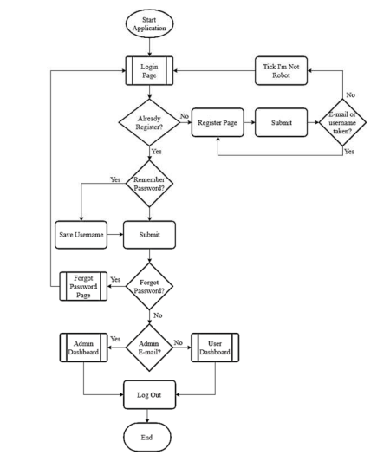

Algorithm:
Sensor and Raspberry Pi Module:
Step 1: Initialize the System (IR Sensors and raspberry Pi)
Step 2: Read sensor status and store in the Database
Step3: Send Sensor Status to Android Application when requested
Step 4: Continue through Step 3
Step 5: Stop
Android Application Module:
Step 1: Start Android App
Step 2: Check connectivity with Server (Raspberry Pi)
Step 3: Request Sensor Status after every time interval
Step4: Continue through Step 3
Step 5: Stop

We can display the car’s imageview using the followiing code:
final boolean occupied = message.getMessage().getAsJsonObject().get("occupied").getAsBoolean();
runOnUiThread(new Runnable() {
public void run() {
if(occupied)
{
carEnterAnimation();
}
else
{
carLeaveAnimation();
}
}
});
private void carEnterAnimation()
{
car.animate().y(parkedCar).setDuration(1500);
occupiedText.setText("Occupied");
}
private void carLeaveAnimation()
{
car.animate().y(outsideCar).setDuration(1500);
occupiedText.setText("Vacant");
}

There are 10 menus that can be view in User Dashboard as listed below:
• Emergency: If there have an emergency occur in parking slot
• Message: User can check message from admin
• Map/Report: To view the parking and report any illegal parking.
• Profile: View user own profile
• Reserve: To reserve the parking with payment.
• Help: For more information regarding the parking.
• History: To see user past booking.
• Status: To view the status of booking.
• Parking View: To view the number of spot and occupied parking
• Log out: For user to log out from the application.
While for Admin Dashboard will have 7 menus that can be used which are:
• Emergency: To view any emergency being reported by user.
• Message: Compose a message to all user of this mobile application.
• Map/Report: To view illegal parking or reserve a spot.
• Price Setting: To change price per hour for the parking.
• Review: To view a user review.
• Parking View: To view number of spot and occupied parking
• Log Out: To end the session.

Basic Components and Development Process for a Real-Time Parking Availability System

The parking inventory tracking system typically comprises three components:
- a parking management server
- IoT hardware platforms (sensors and cameras)
- a mobile app

Sensors are installed at the entrance and exit points of a car park to track the number of vehicles that arrived at the garage and the number of cars that exited the parking structure. The data is calculated against the number of available spaces in the structure and the resulting vacancy is fed back to the app. Every level of the multi-level parking structure and every individual parking spot can be fitted with sensors to provide accurate data about occupied and vacant spots. In the case of on-street parking, sensors can be embedded in the ground.

Code for displaying the available parking lot

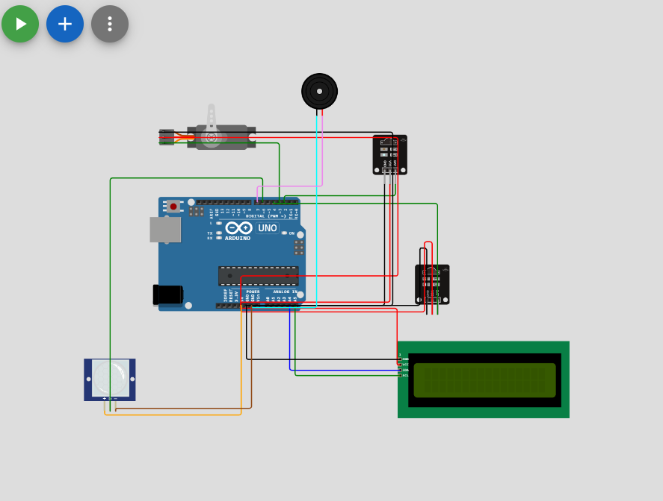

The code can be stimulated in wokwi

#include <Wire.h>
#include <LiquidCrystal_I2C.h>
LiquidCrystal_I2C lcd(0x27, 16, 2);
#include <Servo.h>
Servo myservo1;
int IR1 = 2;
int IR2 = 4;
int SmokeDetectorPin = 6; // Digital pin for the smoke detector
int BuzzerPin = 7; // Digital pin for the buzzer

int Slot = 4; // Enter Total number of parking Slots

bool flag1 = false;
bool flag2 = false;

unsigned long lastLcdUpdate = 0; // Variable to track the time of the last LCD update
unsigned long lcdUpdateInterval = 1000; // Update the LCD every 1000 milliseconds (1 second)

void setup() {
lcd.begin(16, 2); // Initialize LCD with 16 columns and 2 rows
lcd.backlight();
pinMode(IR1, INPUT);
pinMode(IR2, INPUT);
pinMode(SmokeDetectorPin, INPUT);
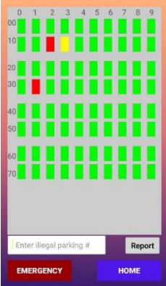
pinMode(BuzzerPin, OUTPUT);

myservo1.attach(3);
myservo1.write(100);

lcd.setCursor(0, 0);
lcd.print(" ARDUINO ");
lcd.setCursor(0, 1);
lcd.print(" PARKING SYSTEM ");
delay(2000);
lcd.clear();

Serial.begin(9600); // Start serial communication for debugging
}

void loop() {
if (digitalRead(IR1) == LOW && !flag1) {
if (Slot > 0) {
flag1 = true;
if (!flag2) {
myservo1.write(0);
Slot--;
}
} else {
displayMessage(" SORRY :( ", " Parking Full ");
}
}

if (digitalRead(IR2) == LOW && !flag2) {
flag2 = true;
if (!flag1) {
myservo1.write(0);
Slot++;
}
}

if (flag1 && flag2) {
delay(1000);
myservo1.write(100);
Serial.println("Servo returned to initial position.");
flag1 = false;
flag2 = false;
}

// Update the LCD display with a delay
if (millis() - lastLcdUpdate >= lcdUpdateInterval) {
updateLcdDisplay();
lastLcdUpdate = millis();
}
}

void updateLcdDisplay() {
if (digitalRead(SmokeDetectorPin) == HIGH) {
displayMessage(" WARNING! ", " Smoke Detected ");
digitalWrite(BuzzerPin, HIGH); // Turn on the buzzer
} else {
displayMessage(" WELCOME! ", "Slot Left: " + String(Slot));
digitalWrite(BuzzerPin, LOW); // Turn off the buzzer
}
}

void displayMessage(const char *line1, const String &line2) {
lcd.clear();
lcd.setCursor(0, 0);
lcd.print(line1);
lcd.setCursor(0, 1);
lcd.print(line2);
}

Functions to receive and display parking availability data received from the Raspberry Pi.

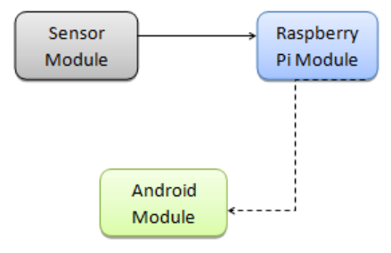

CODE for uploading the data collected from the sensor to Thingspeak

from masterclass import *
distance = 11

w_key = 'AZRMN9ZP5FKLXYLR'
r_key = '17FSCQ4FTX6V4VWM'
channel_id = 83234

ob = Thingspeak(write_api_key=w_key, read_api_key=r_key, channel_id=channel_id)
ob.post_cloud(value1= distance)

The data collected by the ultrasonic sensors and cameras is uploaded to Raspberry Pi.
We will be publishing our parking space’s availability in the main function of our python script. This will be the function that is executed once the script is started. The main function must do the following actions in order.

1.Set up the sensor
2.Perform an initial check on the availability of the parking space
3.Check to see if status has changed (every 5 seconds): If it has changed then publish message of new status. Store this status as the new last updated status.

To set up the sensor we will call the function we defined earlier, setup_sensor(). Next it will do an initial check to see if the parking space is available or vacant. We will define method initial_check() to do this.

We will then have a loop that is executed every 5 seconds to check the new distance reading of the car. If the distance reading obtained by function get_distance() is greater than the length of the parking space, then we can infer that the parking space is vacant. If it is less than the length of the parking space, then we know that the parking space is being occupied by a car.

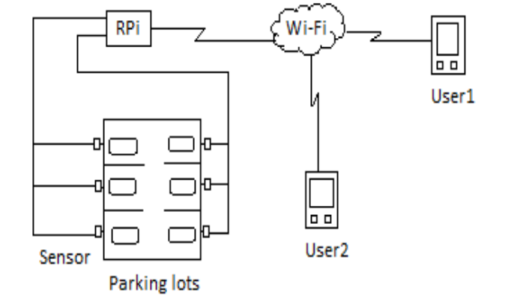

Thus the development part 2 for the smart parking system using IoT is done and documented successfully.

